Beyond Taste: Children’s Attitudes Towards the Colour of Oral Medicines
Elisa Alessandrini¹, Sveinbjorn Gizurarson², Hannah Batchelor³, Sonia Iurian⁴, Sandra Klein⁵, Daniel Schaufelberger⁶, Roy Turner⁷, Jennifer Walsh⁸, Catherine Tuleu¹.
School of Pharmacy, University College London¹, London, UK;
Faculty of Pharmaceutical Sciences, University of Iceland², Reykjavik, Iceland;
Strathclyde Institute of Pharmacy and Biomedical Sciences, University of Strathclyde³, Glasgow, UK;
Department of Pharmaceutical Technology and Biopharmacy, Iuliu Hatieganu University of Medicine and Pharmacy⁴, Cluj-Napoca, Romania;
Department of Pharmacy, University of Greifswald⁵, Greifswald, Germany;
School of Medicine, Neurology, Johns Hopkins University⁶, All Children's Hospital, St. Petersburg, FL, USA;
F. Hoffmann-La Roche Ltd⁷, Grenzacherstrasse 124, 4070 Basel, Switzerland;
Jenny Walsh Consulting Ltd⁸, East Midlands Chamber, Nottingham, UK.
Background and aims. Colour plays an important role in shaping consumer experiences, and in the context of medicines, it may influence patients’ expectations, behaviours, and treatment outcomes. There is limited research on how children respond to medicine colour, despite their increased sensitivity to sensory cues. A previous literature review indicated that colour may affect medicine acceptability in children but highlighted the need for further research (1). This cross-sectional study aimed to fill that gap by directly collecting children’s opinions on the colour of oral medicines through an online survey, targeting a diverse paediatric population across age, health status, and country.
Methods. The survey, developed by UCL School of Pharmacy UCL REC (ID 26765/001) and reviewed by the European Young Persons Advisory Group Network (eYPAGnet), was translated into five languages and distributed via QR codes and anonymous links. Recruitment occurred between September 2024 and April 2025. Participants included children aged 3–18, with parental assistance when needed and parental consent. Responses were analysed using R Studio.
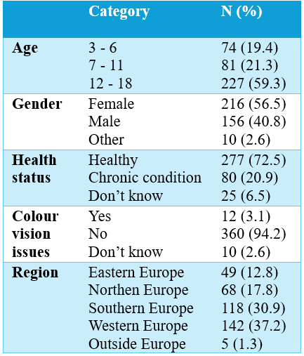
Results. Out of 669 people who accessed the survey, 382 completed it. For liquids, pink (23%), colourless (16.5%), and blue (15.2%) were most preferred. Reasons included appealing look and taste associations (e.g., strawberry for pink). For solids, white (29.1%), pink (18%), and blue (12.5%) led, with neutral appearance and berry-related flavours cited. Statistically significant gender and age differences in preferences emerged, while variations by health, or country were not significant. Ratings for previously used medicines highlighted preference for purple, pink, and blue, while white and colourless received moderate scores.
Conclusion/Discussion. This study offers valuable insight into children’s preferences for medicine colour. Pink and blue were favoured for sweet/flavourful associations, while neutral colours were preferred for being tasteless. These findings can guide paediatric formulation strategies and colour use in children’s medicines.
Table 1. Demographic characteristics.
References:
(1) Alessandrini E. et al (2023) Pharmaceutics 15(7):1992.
Acknowledgements. The authors gratefully thank the members of the eYPAGnet who helped with the translation and distribution of the survey, as well as all the children and parents who took part in the study. Conect4children received funding from the Innovative Medicines Initiative 2 Joint Undertaking under grant agreement No 777389. The Joint Undertaking receives support from the European Union's Horizon 2020 research and innovation programme and EFPIA
Disclaimer. The abstract reflects the author's view.

