**Nucleation and Growth of Low-Dimensional Boron Nitrides via Chemical Vapour Deposition: Insights from Molecular Simulations**

*Alister J. PageA,*

ASchool of Environmental & Life Sciences, University of Newcastle, Callaghan, Australia

Over the last few decades, catalytic chemical vapour deposition (CVD) has matured as a synthetic technique for producing many low-dimensional inorganic nanomaterials, such as carbon nanotubes, graphene and boron nitrides. However, in contrast to carbon nanomaterials, such as graphene and CNTs, little is known regarding the catalytic pathways underpinning CVD synthesis of boron nitride nanomaterials [1].

I will present the first mechanism explaining the nucleation of boron nitride nanotubes (BNNTs) via CVD of boron oxide and ammonia borane, based on reactive molecular dynamics simulations [2,3]. Strikingly, BNNTs nucleate via a ‘network fusion’ mechanism, by which distinct BN fragments first form before ‘clicking’ together on the nanoparticle surface (Figure 1). We also reveal key roles played by H2O and H2 partial pressures and the presence of solid-phase catalytic nanoparticles on this mechanism.

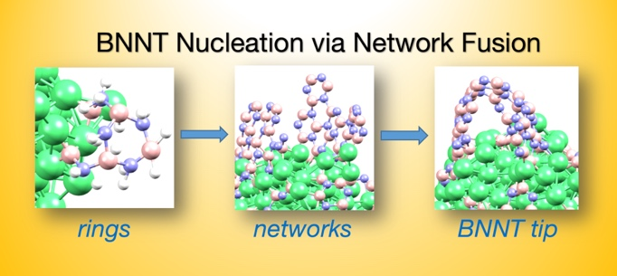

**Figure 1.**Reactive non-equilibrium MD simulations reveal the mechanism of BNNTs on Ni nanoparticles via BN network fusion.

**References**

1. B. McLean, A. J. Page et al., *Phys. Chem. Chem. Phys.* **19** 26466-26494 (2017).
2. B. McLean, G. Webber, A. J. Page, *J. Phys Chem. C*, **122**, 24341-24349 (2018)
3. B. McLean, G. Webber, A. J. Page. *J. Am. Chem. Soc.* In press (2019). DOI: 10.1021/jacs.9b03484