**Supercritical Anti-Solvent Technology in Esomeprazole Solid Dispersions for Improved Dissolution and Bioavailability**

**Nguyen Ngoc Ha Phuong¹, Nguyen Bao Anh¹, Namrah Khan¹, Jeong-Sook Park¹**

¹Department of Physical Pharmacy, College of Pharmacy, Chungnam National University, Daejeon, Republic of Korea.

**Background and aims.** Esomeprazole magnesium (ESM), a salt of esomeprazole (ESO), has low oral bioavailability owing to its poor solubility. This study aimed to enhance its solubility and pharmacokinetics through the development of a solid dispersion (SD) using the supercritical anti-solvent (SAS) technique.

**Methods.** ESM-SAS-SD was prepared using supercritical carbon dioxide (scCO₂) and a combination of polyvinylpyrrolidone K25 (PVP-K25), tocopherol polyethylene glycol 1000 succinate (TPGS), and calcium carbonate (CaCO₃) as excipients. A comparative SD was also prepared using conventional solvent evaporation (ESM-CSE-SD). The formulations were characterized by differential scanning calorimetry (DSC) and scanning electron microscopy (SEM). *In vitro* drug release was assessed using dialysis bag method in phosphate buffer (pH 6.8), while cytotoxicity was evaluated in MDCK cells using MTT assay. Pharmacokinetic studies were conducted in rats following oral administration of 20 mg/kg ESM.

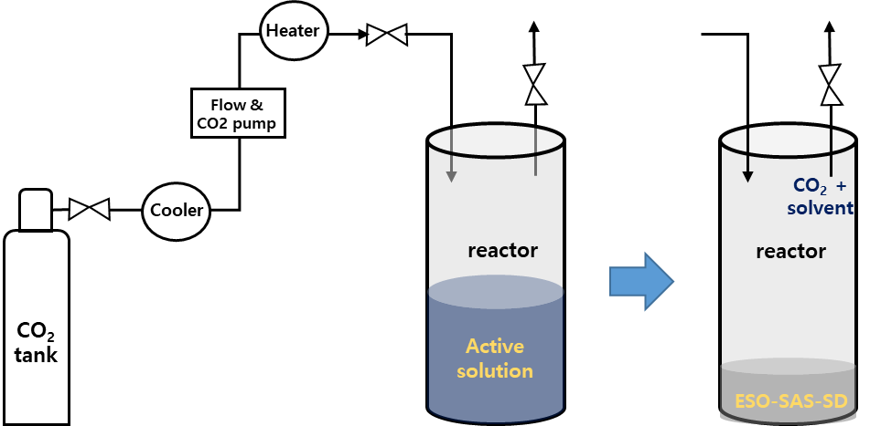

**Figure 1.** Schematic of the experimental process of the SAS method**.**

**Results.** DSC and SEM confirmed that both SD methods transformed ESM from a crystalline to an amorphous state; however, the SAS process resulted in a product with a more porous morphology, leading to a higher dissolution rate of ESM-SAS-SD than that of ESM-CSE-SD. In vitro release of ESM from SAS-based SD reached 91.5% within 30 min, compared to 85.2% for ESM-CSE-SD and only 21.3% for raw ESM powder. Cell viability remained above 95% at 100 μg/mL for all formulations, indicating minimal cytotoxicity. Pharmacokinetic studies revealed that ESM-SAS-SD exhibited the best pharmacokinetic profile among the three tested formulations, showing 2.28-fold (*p < 0.01*) higher AUC₀–∞ and 3.79-fold (*p < 0.001*) higher Cmax compared to ESM powder.

**Conclusion/Discussion.** The SAS-based solid dispersion method significantly improved the dissolution and bioavailability of esomeprazole magnesium (ESM) without increasing cytotoxicity. This solvent-free, scalable approach successfully enhanced the physicochemical and pharmacokinetic properties of ESM, offering a robust formulation strategy for poorly soluble drugs requiring enhanced oral delivery.

**References:**   
(1) Ha, E.-S., Kang, H.-T., Park, H., Kim, S., & Kim, M.-S. (2023). Advanced technology using supercritical fluid for particle production in pharmaceutical continuous manufacturing. *Journal of Pharmaceutical Investigation, 53(3)*, 249–267. <https://doi.org/10.1007/s40005-022-00601-y>  
(2) Kim, J.-S., Park, H., Kang, K.-T., Ha, E.-S., Kim, M.-S., & Hwang, S.-J. (2022). Micronization of a poorly water-soluble drug, fenofibrate, via supercritical-fluid-assisted spray-drying. *Journal of Pharmaceutical Investigation, 52(3)*, 353–366. <https://doi.org/10.1007/s40005-022-00565-z>  
(3) Kim, Y., Park, E. J., Kim, T. W., & Na, D. H. (2021). Recent progress in drug release testing methods of biopolymeric particulate systems. *Pharmaceutics, 13(8)*, 1313. <https://doi.org/10.3390/pharmaceutics13081313>  
(4) Tran, P., & Park, J.-S. (2021). Application of supercritical fluid technology for solid dispersion to enhance solubility and bioavailability of poorly water-soluble drugs*. International Journal of Pharmaceutics, 610,* 121247. <https://doi.org/10.1016/j.ijpharm.2021.121247>