Challenges of conducting trials with Complement inhibitors
Millie Y Wang¹, New Zealand Clinical Research¹, Auckland, New Zealand
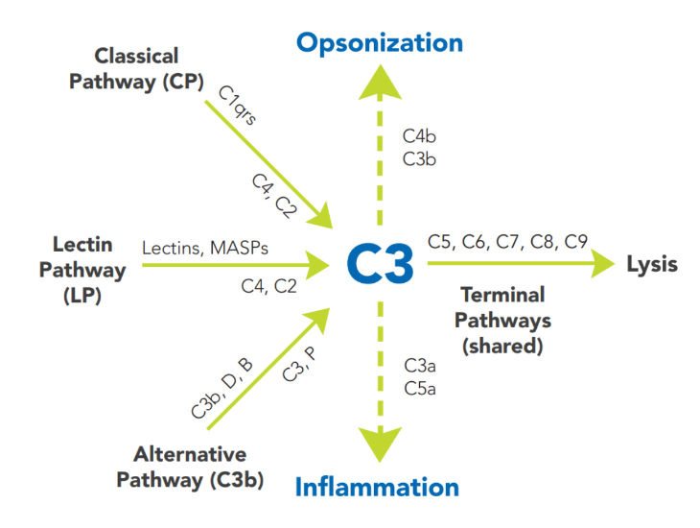
Introduction. Clinical trials involving complement inhibitors may predispose participants to infections caused by encapsulated organisms. This risk is determined by the drug target (proximal / unselective versus distal / selective pathway inhibition) and the varying extent of inhibition with ascending doses. Safety often requires vaccinations and / or prophylactic antibiotics, increasing complexity of the study design.
Aims. To provide an overview of some of the challenges faced when performing complement inhibitor studies at an early phase clinical trials unit.
Methods. A brief summary of the complement pathway and types of complement inhibitor studies will be presented, along with examples of different vaccination and antibiotic regimens. This will be followed by a discussion of the common challenges faced.
Results. Challenges of vaccinations included timing of vaccine administration, as well as vaccine related adverse events. Selection of the best antibiotic regimen for the type of complement inhibition was complicated by limited available evidence. Ease of administration and tolerability had to be considered as well. In addition, there were challenges associated with conditional follow up of participants whose complement levels had not returned to baseline at the end of study.
Discussion. Vaccination was considered the most important step in terms of reducing the risk of infection caused by encapsulated organisms. Haematology patients receiving approved complement inhibitors generally did not require prophylactic antibiotics if they were adequately vaccinated. However, do we have a greater duty of care towards healthy volunteers? With the lack of robust evidence, are we doing more harm than good when administering prolonged courses of prophylactic antibiotics to participants, both individually and from the perspective of antibiotic stewardship? To avoid unblinding, participants often received longer courses of antibiotics than was necessary.

