Meropenem Plasma Concentration and MIC: Early Evaluation in Critically Ill Patients
Delfina Recart¹, Ana Braslavsky², Paula Scibona¹, Agustina Parnisari¹, Gisela Vecchio³, Marisa Sanchez⁴, Vanina Stanek^{4,} Ventura Simonovich¹. Clinical Pharmacology Unit¹; Internal Medicine Research Unit²; Intensive Care and Assistance Unit³; Infectious Diseases Department⁴; Hospital Italiano, Buenos Aires, Argentina.
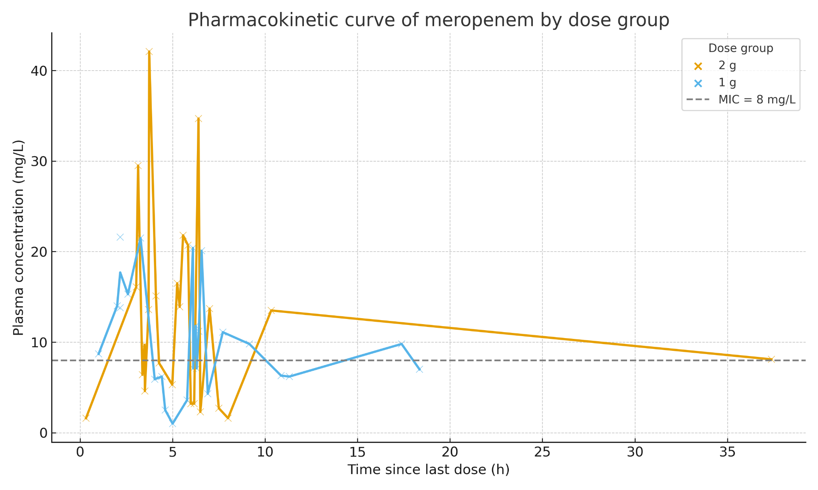
Introduction. In critically ill patients, altered physiology impacts meropenem pharmacokinetics, and evidence on early exposure with empirical dosing is limited. We conducted a prospective study to assess meropenem plasma concentrations during empirical treatment and its relationship with the MIC of common pathogens.
Aims. In the first stage, this study aimed to describe the early pharmacokinetics of meropenem in critically ill patients receiving empirical 1 g or 2 g dosing and to explore the relationship between drug exposure and MIC. The second stage compared both doses to assess if 1 g provides adequate exposure and whether clinical outcomes differ.
Methods. Critically ill adult patients receiving empirical meropenem for ≥24 h were included. A total of 48 plasma samples were obtained from 22 patients: 24 receiving 1 g and 24 receiving 2 g, administered either as a bolus (30 min) or prolonged infusion (3 h). One to two samples per patient were collected at different interdose intervals while empirical therapy continued.
Results. A total of 48 plasma samples from meropenem-treated patients were analyzed. The pharmacokinetic curve based on the time from the last infusion showed distinct profiles according to the dose received: In the 1 g group, plasma concentrations generally declined below the MIC threshold (8 mg/L) within a few hours post-dose. In contrast, the 2 g group maintained higher plasma concentrations over time, with a slower decline and more measurements remaining above the MIC at equivalent time points. Mean concentration-time profiles showed a trend toward higher and more sustained drug exposure in the 2 g group compared to the 1 g group.
Discussion. These preliminary data suggest a dose-dependent pharmacokinetic profile, which could be relevant for optimizing dosing strategies, particularly in patients with severe infections or altered pharmacokinetics.

