**Making dark plasmonic modes visible with an electron beam**

*Saskia FiedlerA, Christian WolffA, Nicolas StengerB, and Asger N. MortensenA*

AUniversity of Southern Denmark, Centre for Nano Optics, Campusvej 55, 5230 Odense M, Denmark; BTechnical University of Denmark, Department of Photonics Engineering, Ørsteds Plads, 2800 Kgs. Lyngby

**Introduction** Optical properties of metallic nanoparticles are well-known to be dominated by localized surface plasmons – collective electron oscillations. While the radiative plasmonic modes have been widely studied, their non-radiative counterpart, the dark plasmonic modes, have not been intensively investigated yet. Due to their lack of net dipole moment, they are not accessible with light at normal incidence. In this work, the dark radial breathing modes (RBM) of Au nanodisks (NDs) have been studied with cathodoluminescence (CL) and electron energy loss spectroscopy (EELS).

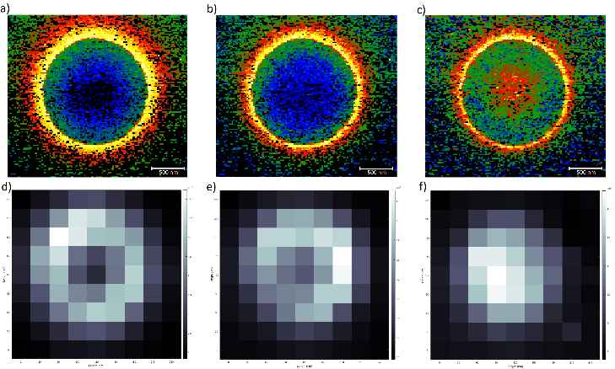

**Fig. 1** Spectral maps of single 20 nm thin monocrystalline Au ND with a diameter of 165 nm dispersed on a 20 nm thin SiN TEM membrane, showing the integrated EELS (upper row) and CL (bottom row) intensity of a) and d) the plasmonic dipolar mode (1.4-1.6 eV), b) and e) the quadrupolar mode (1.75-1.95 eV) and c) and f) the RBM (2.1-2.3 eV).

**Results** High spatial and spectral resolution EELS maps of monocrystalline Au NDs with varying diameters reveal several different spatially distributed plasmonic modes. The EELS and CL results of a 165 nm Au ND are depicted in **Fig. 1**, showing the radiative dipolar mode (a and d) with maximum intensity at the edge of the ND, the quadrupole mode (b and e) with a more confined spatial distribution close to the edge of the ND, and the non-radiative RBM (c and f) concentrated at the centre of the ND. While the observation of dark modes in EELS, which probes the full electromagnetic local density of optical states (EMLDOS) (Losquin 2015), is not surprising, the same modes are also remarkably evident in CL, which only detects the radiative part of the EMLDOS. Similar reports of detecting RBM in CL for Ag NDs larger than 200 nm in diameter (Schmidt 2018) were attributed to retardation effects. However, comparing our experimental results with numeric calculations of EEL- and CL-spectra using the discontinuous Galerkin time-domain method (Matyssek 2011) indicated that the substrate plays an essential role to enhance the visibility of the plasmonic dark modes in CL rather than retardation effects.

**Conclusion** Monocrystalline Au NDs with varying diameters have been investigated by CL and EELS, exhibiting the bright plasmonic dipolar mode but more interestingly, the dark quadrupolar and RBM. While the diameter of the Au NDs showed to mainly affect spectral position of the plasmonic modes, the substrate thickness seems to be responsible for the visibility of the dark mode in the CL spectra.

**References**

[1] Losquin (2015), ACS Photonics, 2, 1619−1627

[2] Schmidt et al. (2018), ACS Photonics, 5, 861−866

[3] C. Matyssek et al. (2011), Photonics Nanostructures: Fundam. Appl. 9, 367

Corresponding author: safi@mci.sdu.dk