Forebrain cFos expression mediated by nociceptin (N/OFQ) in heart failure rats
Helmut B Gottlieb¹, Jorge Medina¹, Serene Sarabia¹, Abraham Baistra¹, Anna Le¹, Saheli Shah¹, Jacob Zuniga¹, Riley Scott¹, and Jessica Bradley². Pharmaceutical Sciences, UIW Feik School of Pharmacy¹, San Antonio, TX, United States; Department Name, UIW School of Osteopathic Medicine², San Antonio, TX, United States.
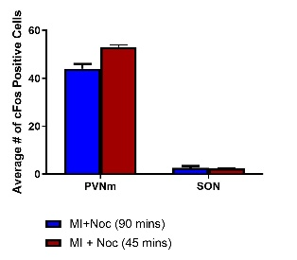
Introduction. ICV administration of the nociceptin/orphanin (N/OFQ) in conscious rats produces hypotension, bradycardia, decrease in renal sympathetic nerve activity and a free water diuresis (increase in urine excretion without concurrent increase in Na⁺ excretion). These physiological effects typically peak at 45 minutes and return to baseline by 60 minutes. cFos is a well-established marker for neuronal activity, with peak expression occurring approximately 90 minutes post-stimulation. This study aims to determine whether changes in cFos expression are due to direct activation or compensatory mechanisms.
Aims. This study examined the changes in cFos expression in the paraventricular nucleus of the hypothalamus (PVN) and supraoptic nucleus (SON) following 45 minutes or 90 minutes ICV microinjection of N/OFQ.
Methods. Urine samples were collected during control (C, 15-min) and after ICV microinjection of saline vehicle (VEH, n=6) or N/OFQ. One group injected with N/OFQ was sacrificed at 45 minutes (10 μg; n= 6) and another at 90 minutes (10 μg; n= 6) post injection. Additional urine samples (every 15-mins) were collected after the ICV injection. The forebrain was processed for c-Fos using a commercially available antibody (Oncogene AB-5 raised in rabbit diluted 1:30,000) and oxytocin (CY3 anti-oxytocin raised in mouse diluted 1:1200).
Results. In VEH-treated animals, renal excretion of water and sodium was not altered. In contrast, N/OFQ produced marked diuresis with minimal alteration to sodium excretion rate. cFos expression was significantly elevated in the PVN parvocellular neurons of 45 minutes group as compared to the 90-minute group (P<0.001). There was also a decrease in cFos expression in the magnocellular PVN neurons of the 45-minute group. There were no changes to cFos expression in the SON.
Discussion. Together, central activation of opioid receptor like-1 by N/OFQ in the PVN appears to contribute to the cardiovascular and renal effects evoked by this agonist. Supported by NIH grant 5R16GM145433

