The Psychological Impact of the COVID-19 Pandemic on the General Population in India: Insights from a Nationwide Survey
Amal Anand¹, Juny Sebastian², Rithika Vakkalaganti Rajesh³, Jisha Myalil Lucca⁴, Royes Joseph⁵
The Center for Pharmacoepidemiology and Treatment Sciences, Rutgers University¹, New Brunswick, NJ, USA; Department of Pharmacy Practice, Gulf Medical University², AJM, UAE; Department of Global Disease Epidemiology, Johns Hopkins University³, Baltimore, MD, USA; Department of Pharmacy Practice^{4,5}, Imam Abdulrahman Bin Faisal University, DMM, Saudi Arabia
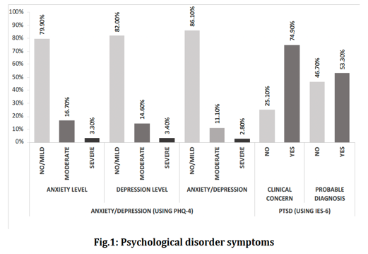
Introduction. A pandemic imposes restrictions in activities and changes to routine that are necessary to prevent the spread of an infectious disease, but these measures can have significant social and economic effects. Thus, this influences the mental health of the general population, as it may restrict activities, change normal routine, affect social and economic wellbeing of them.
Aims. This study aimed to assess the impact of COVID-19 pandemic on mental health of the public in India.
Methods. A cross-sectional web-based study was conducted for a period of 20 days among general population of India, through social media, emails, and online chat platforms, in the year 2020. The study used PHQ-4 and IES-6 scales to measure depression/anxiety and distress respectively. Multiple binary logistic regression was used to explore the relationship of the personal characteristics with the prevalence of self-reported psychiatric illness.
Results. The study enrolled a total of 1257 individuals with representation from all 29 states of India with a mean (SD) age of 29.3 (9.7). Based on the combined PHQ-4 scale, 13.9% (n=174) had reported a moderate-severe level of anxiety or depression. Regarding distress, nearly three-quarters (n=942) had exhibited clinical concern for distress, and more than a half (n=670) met the threshold for probable diagnosis of distress. The study found individuals who lived alone, lived in shared accommodation, or who did not have chronic illness were reported a higher prevalence of anxiety or depression, and accommodation type was associated with the distress level in comparison with their counterparts.
Discussion. Our findings can assist various healthcare professionals and government advisors in strategizing targeted interventions required for combating COVID-19 in India and across the globe. Given the higher risk of pandemic-related psychological illness and its ongoing impact on people, it is crucial for advisors and the population.

