**Development of PBPK Model for Umbelliferone: Intestinal/Hepatic First-Pass Extraction and Extra-Hepatic Phase II Metabolism**

**Ji-Su Kong1**, **Taeyoung Kim**1 and In-Soo Yoon1

Department of Manufacturing Pharmacy, College of Pharmacy and Research Institute for Drug Development1, Pusan National University, Genmjeong-gu, Busan, South Korea

**Background and aims.** Umbelliferone(UMB), a coumarin derivative with broad pharmacological activities, shows poor oral bioavailability primarily due to extensive phase II metabolism and first-pass extraction [1, 2]. It undergoes glucuronidation and sulfation in various organs including liver and intestine. In this study, we report the development of physiologically based pharmacokinetic (PBPK) models in rats and humans to quantitatively assess the contributions of extra-hepatic metabolism and gut/hepatic extraction on systemic disposition.

**Methods.** In vitro, in situ, and in vivo data on solubility, protein binding, intestinal permeability, and metabolism in tissue S9 fractions were integrated. PBPK models were developed in MATLAB SimBiology, incorporating a Q-Gut based intestinal structure and scaling from rat to human physiology [3]. Model parameters were optimized using the observed pharmacokinetic profiles from single-dose intravenous (10–50 mg/kg) and oral (20–100 mg/kg) administrations in rats.

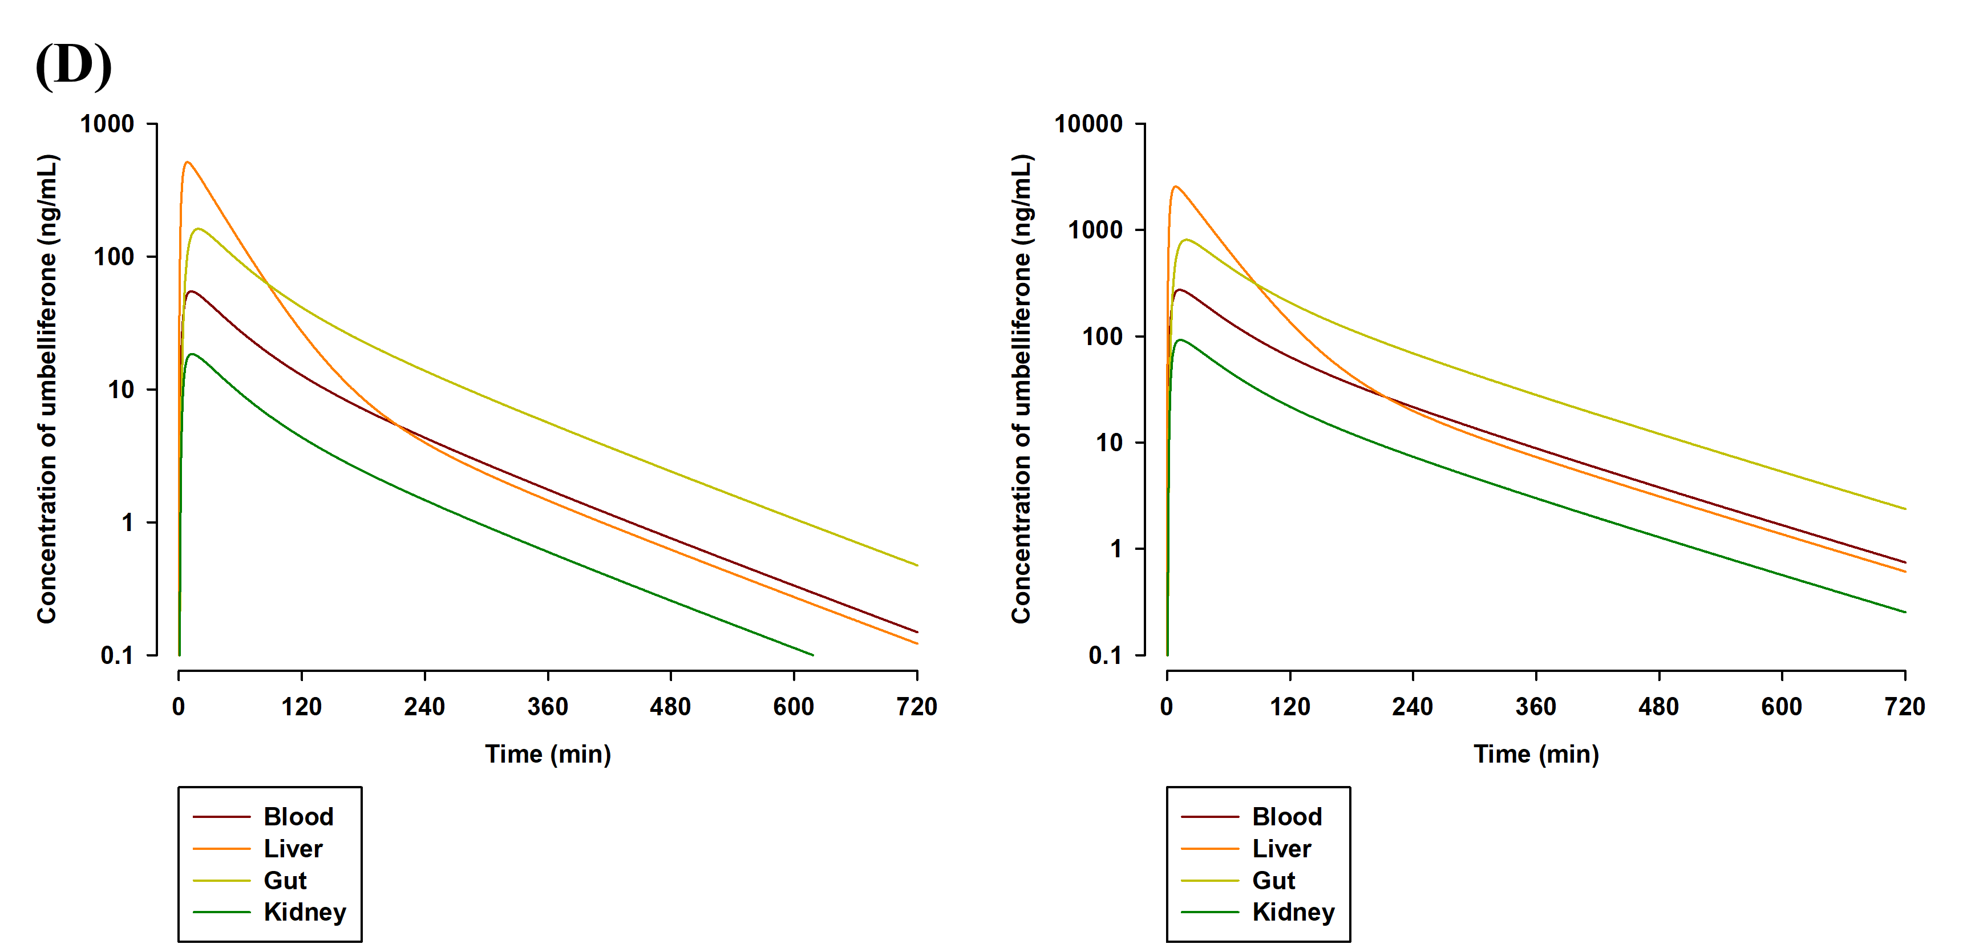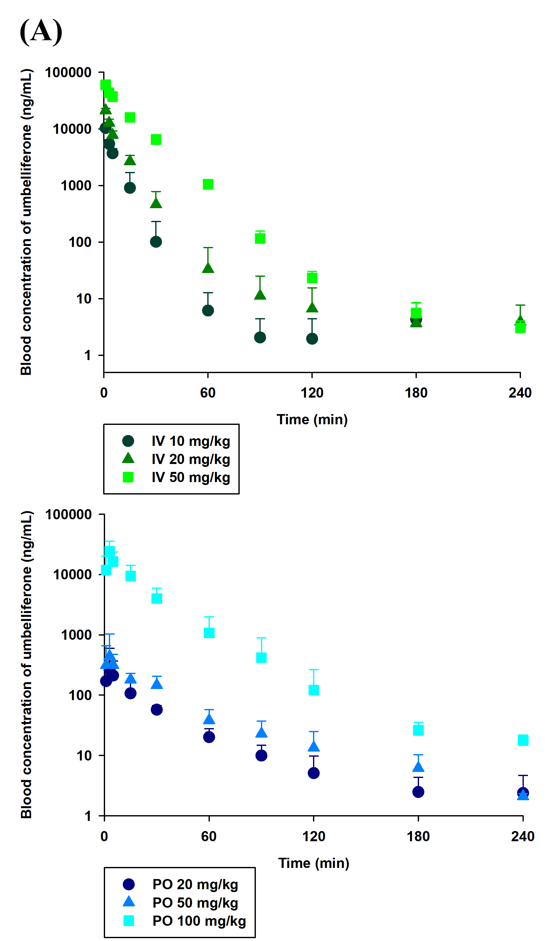**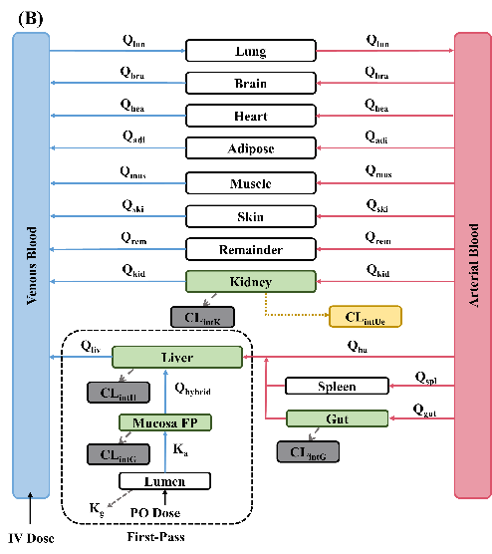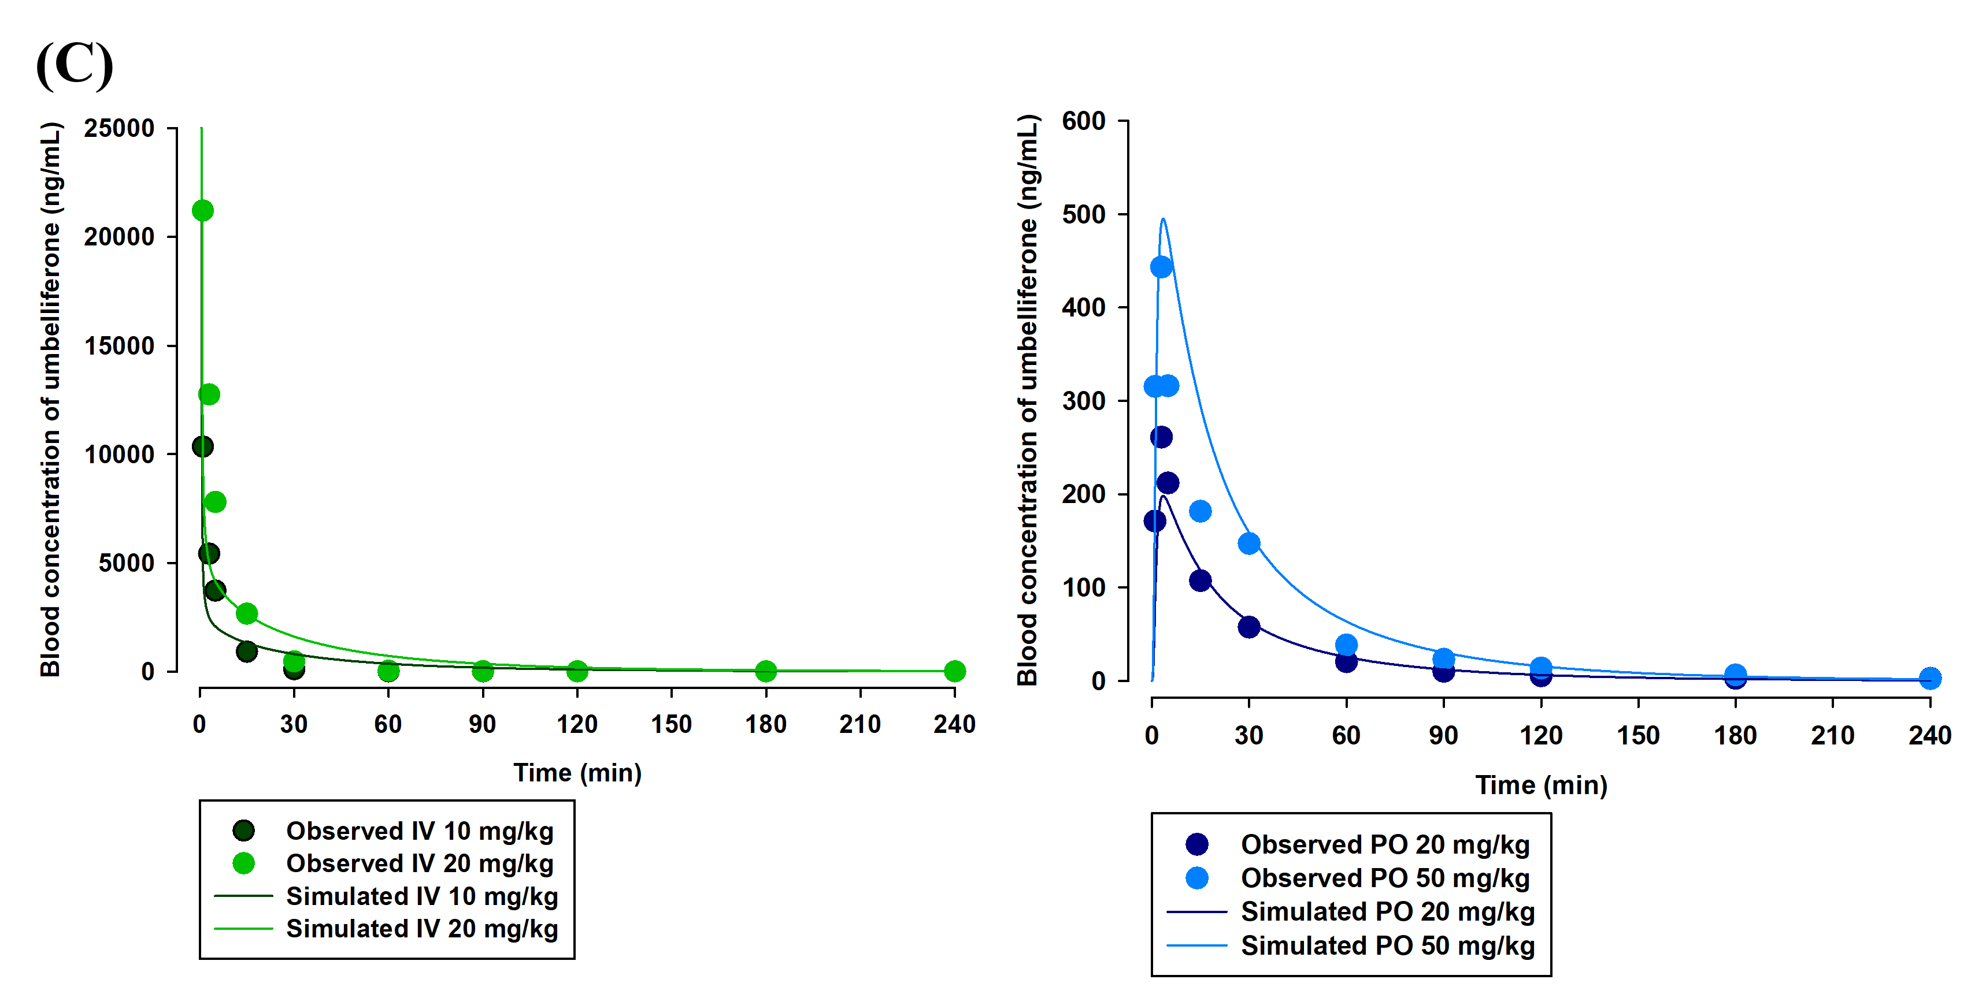Results.** As shown in Figure 1A, UMB exhibited linear pharmacokinetics in rats following intravenous (10–20 mg/kg) and oral (20–50 mg/kg) administration. The developed rat PBPK model (Figure 1B) accurately captured systemic exposure, with AUClast fold-errors ranging from 0.981 to 1.31 (Figure 1C). Human PBPK simulations predicted peak concentrations of 54.0 and 270 ng/mL after 100 and 500 mg oral dosing, respectively (Figure 1D). The models identified route-dependent gut metabolism and hepatic clearance as key contributors to oral bioavailability (F = 4.16–4.29% for rats and 9.32% for humans).

Figure 1. Experimental and simulated pharmacokinetic profiles and model structure for UMB: (A) observed blood concentration–time profiles in rats following intravenous and oral dosing, (B) schematic of the developed whole-body PBPK model, (C) fitted rat profiles after model parameter optimization, and (D) simulated human concentration–time profiles in blood and metabolizing organs after oral administration.

**Conclusion/Discussion.** This study presents the first whole-body PBPK models of UMB in rats and humans, highlighting the significant impact of extrahepatic phase II metabolism and first-pass extraction on its oral bioavailability. The models reliably predicted systemic exposure and demonstrated linear pharmacokinetics without tissue accumulation. After partial modification and validation, the PBPK model may be applied to predict drug interactions involving natural products containing UMB.

**References**

[1] Yang et al. (2008) Zhong Xi Yi Jie He Xue Bao 6:392-398

[2] Wang et al. (2006) In Vitro Cell Dev Biol Anim 42:8-12

[3] Seo SW et al. (2024) J Pharm Investig 54:467–481