Non-precious metal doped nanoporous carbon nanosheet for catalyzing oxygen reduction reaction

Jing Tang^{A}, Yusuke Yamauchi^{A}

^{A}School of Chemical Engineering and Australian Institute for Bioengineering and Nanotechnology (AIBN), The University of Queensland, Brisbane, Australia

Introduction
Considering global warming and other environmental issues, the new-type energy devices, such as fuel cells and lithium-air batteries have been the focus of research. Porous carbons nanosheet have been considered as promising electrode materials due to their excellent virtues such as low cost, designable porous framework, and good electrical conductivity. Lots of synthetic methods have been developed for fabrication of functionalized nanoporous carbon nanosheet with high specific surface areas, tunable and accessible nanopores, high degree of graphitization, and heteroatoms doping.

Methods and Results
In this report, I will report the synthesis of non-precious metal doped carbon-based electrocatalyst for oxygen reduction reaction by integrating template directing methods (Fig.1). First, hollow mesoporous nanoarchitectures composed of ultrafine metal carbide nanoparticles on N-doped carbon nanosheets were explored as an efficient oxygen reduction reaction catalyst.[1] Second, atomically dispersed non-precious metals were introduced into the nitrogen-doped carbon sandwiches to achieve a much higher activity for oxygen reduction reaction which is even close to the benchmark of Pt/C catalyst in alkaline electrolyte.[2] Finally, nitrogen-doped graphene nanomesh shows a unique ultrathin two-dimensional morphology, high porosity, rich and accessible nitrogen-doped active sites, and defective graphene edges, contributing to an unprecedented catalytic activity for oxygen reduction reaction in acid electrolytes.[3]

Discussion and Conclusion
Adjusting the porosity, accessible active sites, and doped heteroatoms are quite effective for increasing the electrocatalytic activity of carbon-based nanosheets. It is promising to explore the non-precious carbon-based catalyst as the substitute for Pt/C in oxygen reduction reaction, then accelerating the development of fuel cell and metal-air batteries.
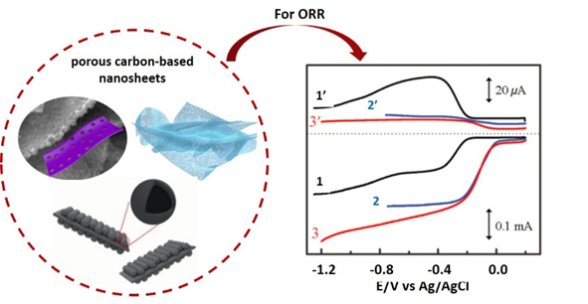
Fig. 1: Carbon-based electrocatalyst for oxygen reduction reaction. The number of 1-3 in right figure represent the pure carbon, heteroatom-doped carbon and Pt/C, respectively.

References
- Guo, Y.; Tang, J.; Henzie, J.; Jiang, B.; Qian, H.; Wang, Z.; Tan, H.; Bando, Y.; Yamauchi, Y. Mater. Horiz. 2017, 4, 1171–1177.
- Tan, H.; Tang, J.; Henzie, J.; Li, Y.; Xu, X.; Chen, T.; Wang, Z.; Wang, J.; Ide, Y.; Bando, Y.; Yamauchi, Y. ACS Nano 2018, 12, 5674–5683.
- Xia, W.; Tang, J.; Li, J.; Zhang, S.; Wu, K.; He, J.; Yamauchi, Y. Angew. Chem. Int. Ed. 2019.

