**Towards Battery Chemistries beyond Lithium Ion Batteries; Ultrafast Sodium/Potassium ion intercalation into hierarchically porous thin carbon shells**

*Asif Mahmood, Prof. Yuan Chen*

School of Chemical and Biomolecular Engineering, The University of Sydney, 2006, Sydney, Australia

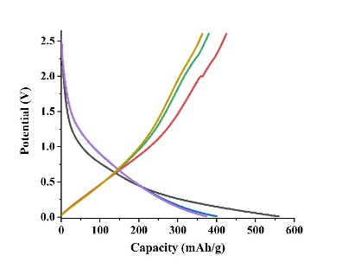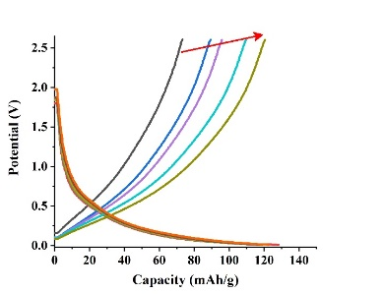The large-scale application of sodium ion (SIB) and potassium ion batteries (KIBs) is primarily limited by poor insertion capability of electrode materials resulting in limited charge storage capacities. It is critical to present alternative solutions towards more active electrode chemistries which can allow deep and fast reversible insertion of Na+/K+ ions. Carbon, being the most abundant and currently commercialized anode material in lithium ion batteries (LIBs), present ideal candidate for commercial SIBs/KIBs. However, the crystalline carbon nanostructures exhibit poor insertion capability of much larger Na+/K+ ions (Na storage capability of 35 mAh/g in comparison to Li storage capability of 372 mAh/g) which must be addressed to design highly efficient SIBs/KIBs. We have recently found that carbon materials with short-order gives better insertion of large metal ions such as Na+/K+ owing to the relaxed carbon interlayer spacing (~0.375 nm) in comparison to long range order where interlayer spacing is necessarily ~0.34 nm.

Interlayer spacing ~0.375 nm

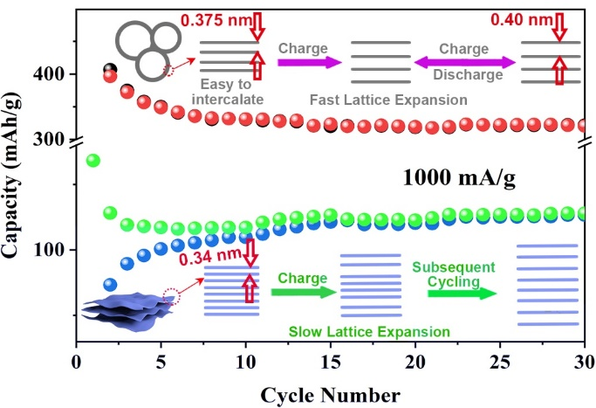We adopted a metal-organic framework (MOF) based methodology to derive hierarchically porous S and N co-doped thin carbon (S,N@C) with shell-like (average shell size ~20-30 nm) morphology for enhanced Na+/K+ storage. The hierarchically porous carbon shells exhibited an average wall thickness of ~8-10 nm with an interlayer spacing of ~0.375 nm. Taking benefit from larger interlayer spacing, hollow shell-like structure and thin shell-wall, the S,N@C exhibited excellent Na+/K+ storage capability without structural degradation with faster mass transport at higher discharge rates. Owing to these advantages, the S,N@C delivered high Na storage capacity of 448 mAh/g at 100 mA/g and maintained discharge capacity up to 337 mAh/g at discharge rate of 1000 mA/g. Owing to shortened diffusion pathways, the S,N@C delivered an unprecedented value of 204 mAh/g and 169 mAh/g at discharge rate of 16000 mA/g and 32000 mA/g respectively, with excellent reversible capacity for much longer cyclic life (~4500 cycles). In addition to excellent Na+ storage capability, the S,N@C exhibited high K+ storage capability with reversible storage capability of 252.8 mAh/g at current density of 1000 mA/g after 80 cycles. The post-electrochemical tests revealed excellent structural stability without any visible agglomeration for rationally designed materials while control carbon samples in comparison exhibited increased rolling of carbon sheets upon reversible charge storage. The post-electrochemical RAMAN analysis revealed a slight red shift after cycling with Na+/K+ ions indicating slight expansion of carbon lattice upon reversible cycling signifying the possibility of relaxation in thin carbon lattice. The methodology paves ways for using carbon as electrode in SIBs/KIBs.

Interlayer spacing ~0.34 nm

**References**

1. A. Mahmood, & Y. Zhao (2019), Adv. Mater., 31, 1805430
2. A. Mahmood, & R. Zou (2018), Small, 14, 1803500
3. X. Jian, A. Mahmood, N. Mahmood (2019), Chem. Eng. J. 364, 578-588
4. H. Tabassum, R. Zou, A. Mahmood, (2018), Adv. Mater., 30, 1705441. Link