Fabrication and Characterization of Loratadine-Loaded Orodispersible Films via Hot-Melt Pneumatic 3D Printing
Hyun Jong Park¹, Seung Yeob Baeg¹, Young Soo Woo¹, Ju Yeon Park¹, Dong Wuk Kim¹
¹College of Pharmacy and Research Institute of Pharmaceutical Sciences, Kyungpook National University, Daegu 41566, Republic of Korea

Background and aims. This study aimed to demonstrate the feasibility of a hot-melt pneumatic (HMP) 3D printing platform for single-step fabrication of orodispersible films (ODFs) containing loratadine (LOR), a BCS class II drug. The goal was to enhance solubility, dissolution rate, and physicochemical properties of LOR without the need for conventional multistep processes.

Methods. Hydrophilic polymers were screened for their solubility-enhancing effects, and drug–polymer compatibility was evaluated using Hansen solubility parameters (HSP). Based on these results, polyethylene oxide 100,000 (PEO), Soluplus®, and D-α-tocopherol polyethylene glycol 1000 succinate (TPGS-1000) were selected. LOR-loaded ODFs (LOR-3DP-ODFs) were fabricated via HMP 3D printing. The film-forming capacity and optimal processing conditions of each composition were assessed. The printed films were characterized for drug content, morphology, thermal behavior, crystallinity, and in vitro dissolution.

Results. LOR-3DP-ODFs were successfully fabricated with uniform drug content. The films exhibited well-defined morphology that closely matched the intended design, as shown in the digital image (Fig. 1). Formulation compositions and physicochemical evaluation results are presented in Table 1. All formulations showed significantly improved and faster drug release compared to raw LOR. Formulation F1 exhibited a ~14-fold increase in drug release (59.5%) in distilled water (Fig. 2a) and released over 85% of the drug within 5 minutes at pH 1.2, outperforming the commercial reference (Fig. 2b). TGA confirmed thermal stability, and XRD indicated conversion to the amorphous form. As the study is ongoing, additional results will be included in the full conference poster presentation.

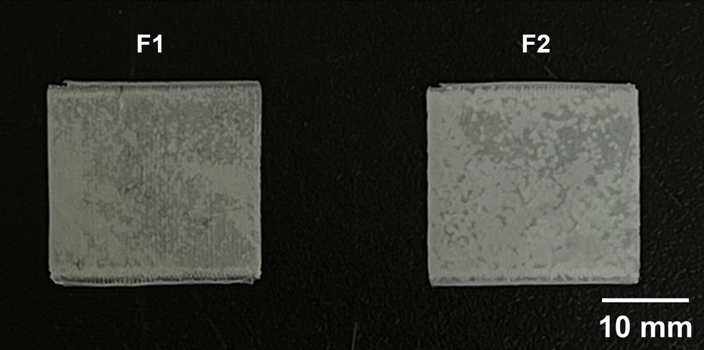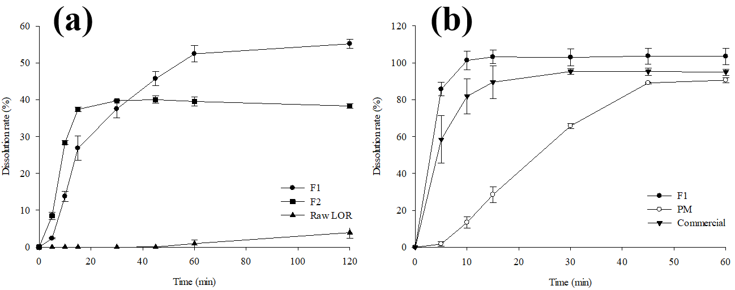
Fig. 1. Digital image of LOR-3DP-ODFs.
Fig. 2. In vitro dissolution profiles: (a) LOR-3DP-ODFs and raw LOR in distilled water; (b) F1, commercial product, and F1-physical mixture in pH 1.2 buffer. Each value represents mean ± SD (n=3).

Table 1. Composition and physicochemical properties of formulations. Each value represents the mean ± SD (n = 3 or 5).
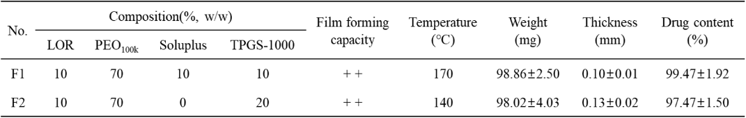

Conclusion/Discussion. This study highlights the potential of single-step HMP 3D printing for formulating poorly water-soluble drugs without complex processing. Formulation optimization has involved screening various compositions and evaluating solubility, physicochemical properties, and in vitro dissolution performance. Further in vitro and in vivo comparisons with marketed products are planned to validate the optimized formulations.

Acknowledgements: This work was supported by the National Research Foundation of Korea (NRF) grants funded by the Korean government (No. 2020R1A5A2017323 and No. 2021R1C1C1010721).

