**Enhancing Properties of MoS2 for Photo Catalyst Applications by using Ferroelectric Materials**

*Dimuthu Wijethunge, Cheng Tang, Chunmei Zhang and Aijun Du*

School of Chemistry, Physics and Mechanical Engineering, Science and Engineering Faculty, Queensland University of Technology, Australia.

**Introduction**

Monolayer MoS2 got attracted by many researchers due to its direct band gap of 1.8 eV[1] , charge carrier mobility and photo catalytic properties[2]. By constructing van der Waals heterostructures (vdW_HTS), both electronic and optical properties of MoS2 can be enhanced. Here we have constructed vdW_HTS by using ferroelectric material (FE) with monolayer MoS2. In2Se3 is used as a FE material due to its high optical absorption and electrical properties[3]. FE materials contain spontaneous polarization and polarization direction can be reversed by applying adequate electrical field. Therefore using FE material in heterostructure will enhance electron transfer and also facilitate the charge separation. In this work we have analysed MoS2/In2Se3 vdW_HTS and observe properties critical to perform well as photo catalyst. The vdW_HTS have shown enhanced optical absorption as well as good charge carrier separation characteristics. Since In2Se3 is FE material, Influence of change of polarization in In2Se3 on MoS2/In2Se3 vdW_HTS Bandstructure is also explored.

**Methods**

Calculations are done using Density functional theory (DFT) using Vienna Ab Initio Simulation Package (VASP). Projector-augmented wave (PAW) method used in the simulations. Generalized gradient approximation (GGA) in accordance to Perdew, Burke, and Ernzerh (PBE) is used for electronic and optical calculations. Corrections are done for van der Waals interactions in heterostructures using DFT-D3 method. 3×X3×X1 gamma centred k-point mesh was used for the geometry relaxations and 5×X5×X1 gamma centred k-point mesh was used for electronic and optical property calculations.

**Results**

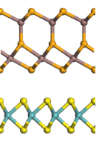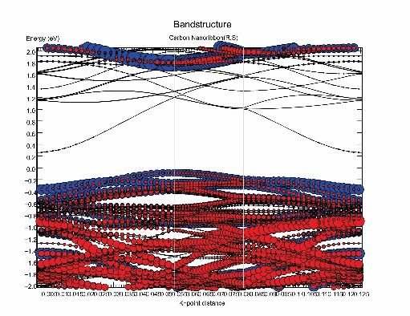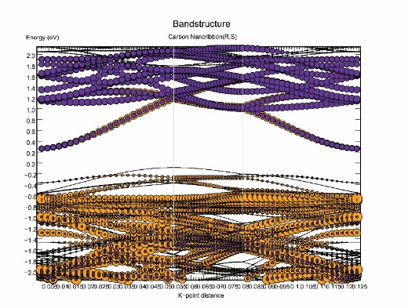

(a)

(b)

(c)

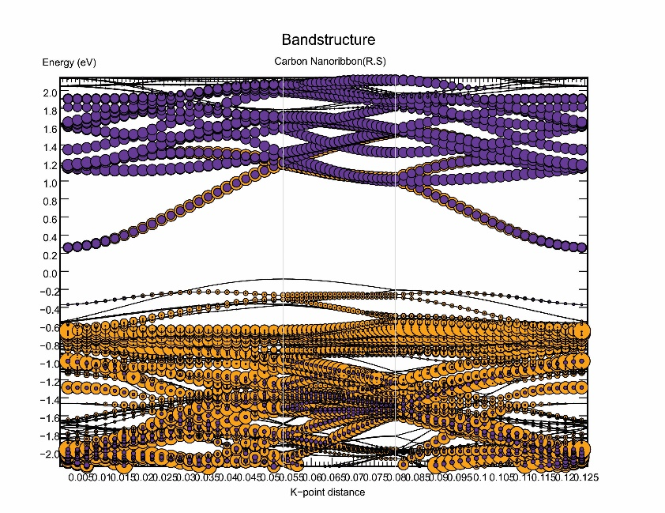

*Figure 1: (a) Side view of MoS2/In2Se3 unit cell geometries (b) MoS2 (c) In2Se3, contributions to electronic bands of MoS2/In2Se3 vdW_HTS.*

According to the figure, valence band is mainly contributed by MoS2 and conduction band is contributed by In2Se3 which facilitates good charge carrier separation. Furthermore reduction in band gap increases the optical absorption and band alignment shows type-2 arrangement which is preferable for heterostructure for photo catalyst applications.

**References**

[1] K. F. Mak, C. Lee, J. Hone, J. Shan, and T. F. Heinz, "Atomically Thin ${\mathrm{MoS}}_{2}$: A New Direct-Gap Semiconductor," *Physical Review Letters,* vol. 105, p. 136805, 09/24/ 2010.

[2] Y.-J. Yuan, H.-W. Lu, Z.-T. Yu, and Z.-G. Zou, "Noble-Metal-Free Molybdenum Disulfide Cocatalyst for Photocatalytic Hydrogen Production," vol. 8, pp. 4113-4127, 2015.

[3] W. Ding, J. Zhu, Z. Wang, Y. Gao, D. Xiao, Y. Gu*, et al.*, "Prediction of intrinsic two-dimensional ferroelectrics in In2Se3 and other III2-VI3 van der Waals materials," *Nature Communications,* vol. 8, p. 14956, 04/07/online 2017.