Quantification of Allostery and Biased Signalling
Celine Valant, Drug Discovery Biology, Monash Institute of Pharmaceutical Sciences, Parkville, VIC, Australia

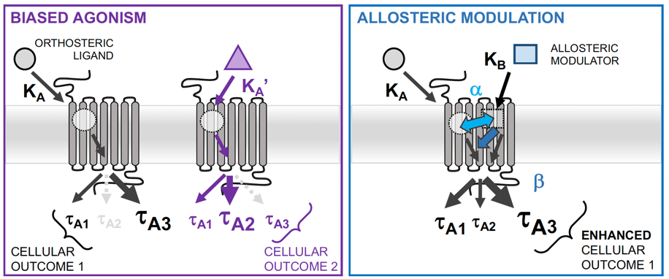
Introduction. Major life science challenges include, understanding how chemicals outside cells signal to proteins inside, how this results in physiological responses, and how dysfunction of these processes leads to pathophysiology. After centuries of relentlessly exploring how receptors are regulated by endogenous and/or drug-like molecules, new ideas have emerged in the field that have completely changed and revitalized it. The first paradigm is biased signalling, which is the ability of structurally distinct ligands to stabilise different pools of receptor conformations leading the distinct cellular outcomes. The second paradigm is allostery, which is the mechanism by which some ligands (synthetic or natural) can recognise and bind different regions of receptors compare to the endogenous hormone (orthosteric) binding site, and consequently alter the physiological responses. However, both allostery and bias are very complex, making reproducibility and description challenging.
Methods. This workshop will use key novel analytical models to analyse and interpret allostery and bias signalling at a major family of GPCR, the muscarinic acetylcholine receptors.
Results. Here, we provide definitions, guidelines and analytical models for any scientists to quantify and report allostery and ligand bias, using data generated in our laboratory.
Discussion. The workshop will also allow any participant to join with their own set of data, exploring either allostery or bias, and the team will assist with data analysis, representation and interpretation.

