**Comparative analysis of microfluidic and thin film hydration methods for nucleic acid-loaded lipid nanoparticles**

Hyeseon Park¹, Jaeseong Lee¹, Jiwoo Hong², **Gayong Shim¹**

School of Systems Biomedical Science1, Soongsil University Department Name, Seoul, Republic of Korea;

School of Mechanical Engineering 2, Soongsil University Department Name, Seoul, Republic of Korea.

**Background and aims.** Lipid nanoparticles (LNPs) are widely used for nucleic acid delivery owing to their biocompatibility and structural similarity to cell membranes. However, traditional production methods such as thin film hydration (TFH) face limitations in uniformity, encapsulation efficiency, and large-scale adaptability. This study aimed to compare cationic LNPs fabricated using a microfluidic herringbone micromixer with cationic liposomes produced via TFH, focusing on physical characteristics, nucleic acid encapsulation, gene silencing efficiency, and biodistribution.

**Methods.** Cationic LNPs and liposomes were prepared with identical lipid compositions. LNPs were synthesized using a 3D-printed herringbone micromixer under various lipid concentrations and flow rate conditions to optimize size and polydispersity. Characterizations included dynamic light scattering, zeta potential analysis, gel retardation, and Ribogreen assays. RNA interference efficiency was evaluated by qRT-PCR targeting GAPDH in HeLa cells. In vivo biodistribution was assessed via IVIS imaging after intravenous administration in mice.

**Results.** Microfluidic LNPs demonstrated superior monodispersity (<100 nm) and higher siRNA encapsulation efficiency (88%) compared to lipoplexes from TFH (<72%). RNase protection assays confirmed enhanced stability of microfluidic LNPs. Despite similar gene silencing effects in vitro, LNPs exhibited lower cytotoxicity and reduced aggregation. In vivo, LNPs showed delayed renal clearance and distinct organ distribution, with increased lung accumulation likely attributable to cationic surface charge and particle integrity.

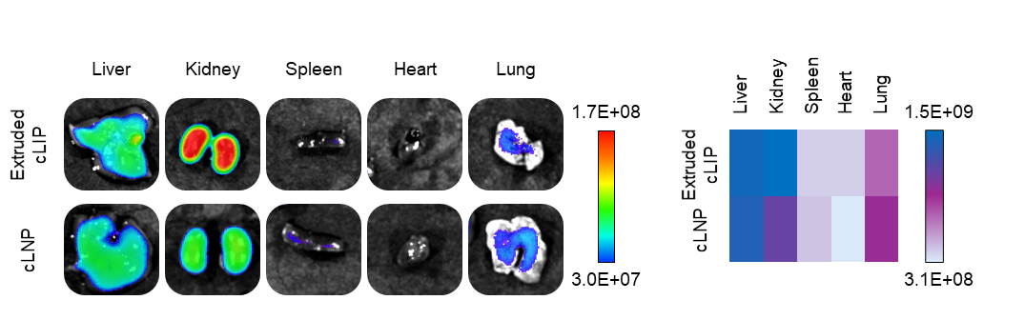

**Figure 1.** Comparative biodistribution profiles of cationic nanoparticles synthesized via microfluidics and thin film hydration.

**Conclusion/Discussion.** The microfluidic method enables controlled, scalable production of cationic LNPs with enhanced nucleic acid encapsulation and stability. These findings support microfluidics as a viable platform for advanced RNA therapeutic manufacturing. Future integration of in-line buffer exchange and targeting modifications could further streamline LNP development for clinical applications.

**Acknowledgements**

This research was supported by the Bio&Medical Technology Development Program of the National Research Foundation (NRF) funded by the Korean government (MSIT) (No. RS-2025-02303064).

**References:**

(1) Park, H., Lee, J., Kang, J., Min, J., Lee, J., Hong, J., Shim, G. (2025) J Pharm Investig 56:112–129

(2) Albertsen, C. H., Kulkarni, J., Witzigmann, D., Lind, M., Petersson, K., Simonsen, J. (2022) Adv Drug Deliv Rev 188:114416