**Effect of Rotation Speed and Flowrate on Powder Evacuation from a Capsule**

**Athiya Azeem1**, Agisilaos Kourmatzis1,2, Gajendra Singh3, Hak-Kim Chan1,4 and Shaokoon Cheng1,5

ASK Scientia Pty Ltd, Sydney, NSW, Australia1

School of Aerospace, Mechanical and Mechatronics Engineering (AMME), University of Sydney2, Sydney, NSW, Australia;

School of Engineering, IIT Mandi, Mandi, India3;

Sydney Pharmacy School, the University of Sydney, Sydney, Australia4

School of Engineering, Macquarie University, Sydney, Australia5

**Background and aims.** A common design configuration for dry powder inhalers is the inclusion of a capsule inside a swirling chamber that enables the capsule to rotate about its minor axis. Despite the prevalence of these devices, their performance remains poorly understood. Previous experimental research has typically focused on measuring the emitted particle size distribution however few studies have considered internal phenomena beyond direct imaging of capsule motion. In this study, a custom device was utilised to enable direct imaging of internal powder dynamics while emulating features of commercial devices. The device was designed to decouple the effects of rotation speed from flow rate and remove the impact of capsule collisions.

**Methods.** An optically accessible device containing a capsule, as shown in Figure 1 was affixed to a rotating platform that was actuated by a motor at three speeds of 3000 RPM, 7000 RPM and 15000 RPM for two flowrates, 30 SLPM and 50 SLPM. High-speed microscopic backlit images were taken at the field of view (FOV) shown in Figure 1 which were analysed to obtain velocity measurements. Respitose® (SV010) was utilised as the lack of agglomeration facilitated particle tracking upon evacuation.

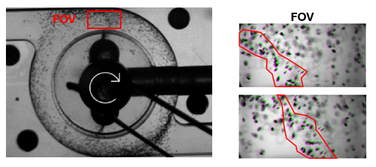

Figure 1: Left – Macroscopic image of optically accessible dispersion device with microscopic FOV shown. Right – Sample microscopic images of FOV. Evacuating particles marked within the red outline.

**Results.** From the images obtained, particle tracking velocimetry was applied to extract the velocity of particles currently evacuating from the capsule. Evacuating particles were found to have a higher radial velocity than those passing through the FOV in the swirling flow. Studies to date have suggested that increasing rotation speed should result in greater outflow rate [1] however this was not reflected in an increase in exit velocity in this study. Furthermore, regardless of flowrate or rotation speed SV010 particles were shown to maintain a consistent distribution of evacuating velocity.

Figure 2: SV010 Evacuation velocity for 30 SLPM (left) and 50 SLPM (right).

**Conclusion/Discussion.** Evacuation velocity of SV010 exiting a capsule was found to be consistent despite changes in rotation speed and flow rate independently. Capsule rotation has been known to push the internal arrangement of powder towards the apertures at the capsule ends. Once this has occurred collisions are needed to rearrange the internal particles and enhance evacuation.

**References:** 1. Almeida, L.C., et al., Capsule-Based dry powder inhaler evaluation using CFD-DEM simulations and next generation impactor data. Eur J Pharm Sci, 2022. 175: p. 106226.