**Co-sputtered nanofins for polarization and angular control**

*Caleb EstherbyA, Matthew C TaiA, Angus R GentleA,* *Matthew D ArnoldA,   
Michael B CortieA*

AMathematics and Physical Sciences, University of Technology Sydney, Ultimo, Australia

The ability to manipulate the absorption and emission of a surface is desirable for a number of applications.

Recently we demonstrated strong polarization and directional absorption in the visible and near-infrared using nanofins co-sputtering under appropriate conditions (Tai et al 2018). The structures were thermally stable in inert atmosphere.

Production of vanadium-based alloy with a post-anneal in low-pressure air produced thermally switchable coatings with integrated emission change controlled by deposition thickness (Gentle et al 2018), with strong angular dependence.

Here we explore further possibilities of this platform, including growth variations, optimization of optical design, and polarization at thermal wavelengths.

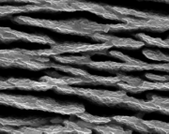 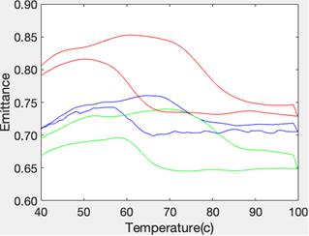

Fig 1. Micrograph of VO2 nanofins (left), and the thermal emittance hysteresis of VO2 nanofins (right) under various oxidation times.

Corresponding author: Matthew.Arnold-1@uts.edu.au

**References**

1. M.C. Tai, A.R. Gentle, M.D. Arnold and M.B. Cortie, Nanotechnology, 2018, 29, 105702.
2. A.R. Gentle, M. C. Tai, S. White, M.D. Arnold, M.B. Cortie and G.B. Smith, Proc SPIE, 2018, 10759, L1-10.