Drug screening for ERO1α inhibitors identifies resveratrol as a potent candidate
Kamilla Khojayeva¹, Mohamad Aljofan^{1,2}. Department of Biomedical Sciences, School of Medicine, Nazarbayev University¹, Astana, Kazakhstan; Drug Discovery and Development, Center of Life Sciences, National Laboratory Astana², Astana, Kazakhstan.
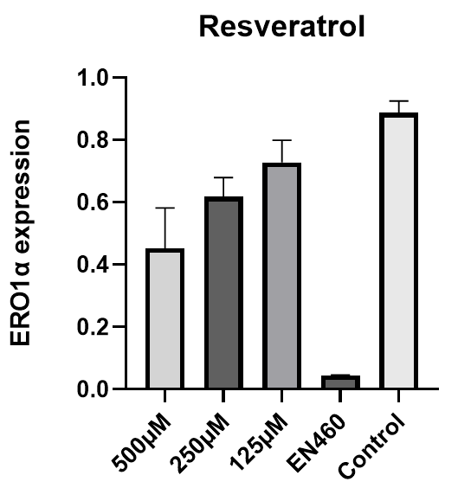
Introduction. Endoplasmic reticulum oxidoreductin-1α (ERO1α) is an oxidase that regulates disulfide bond formation and redox homeostasis (Chen et al, 2024). Its overexpression has been linked to tumor progression and poor prognosis in cancer (Johnson et al, 2020), making it a potential therapeutic target.
Aims. To screen candidate drugs for their ability to inhibit ERO1α and reduce oxidative stress in breast cancer cells.
Methods. Several drug candidates screened for their potential inhibition of ERO1α in MDA-MB-231 cells. Cell viability determined using MTT assay, ERO1α protein expression measured by Western blot, and Reactive Oxygen Species (ROS) evaluated by d-ROMs test.
Results. Resveratrol reduced ERO1α protein expression, and activity in a dose-dependent manner with an IC₅₀ of 250 μmol/L. Compared with the control (0.89 ± 0.07), ERO1α levels decreased at 250 μmol/L (0.62 ± 0.11, p<0.05) and 500 μmol/L (0.45 ± 0.13, p<0.05). ROS levels also declined in a concentration-dependent manner.
Discussion. Resveratrol effectively reduced both ERO1α expression and ROS levels in MDA-MB-231 cells in a dose-dependent manner. Given the role of ERO1α in tumor progression, resveratrol emerges as a promising candidate for targeting ERO1α-driven pathways in breast cancer.

Chen P et al (2024) J Exp Clin Cancer Res. 43:71.
Johnson BD et al (2020) J Cancer Immunol 2:103–115

