Effects of Salvianolic acid A on the heart failure
Lianhua Fang, Awaguli Dawutia, Tianyi Yuan, Shoubao Wang, Yang Lu, Guanhua Du*.
State Key Laboratory of Bioactive Substances and Functions of Natural Medicines, Institute of Materia Medica, Chinese Academy of Medical Sciences and Peking Union Medical College, Beijing, China.

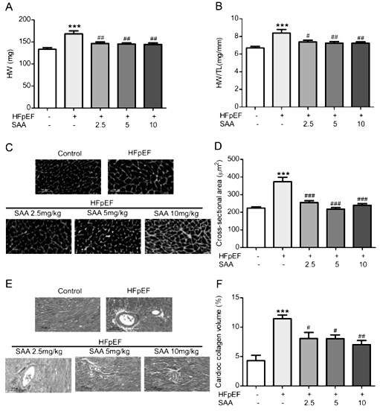
Introduction. Heart failure with preserved ejection fraction (HFpEF) is a morbid, mortal, and common syndrome for which lack of evidence-based therapies. As a main active components of Salvia miltiorrhiza Burge, Salvianolic acid A (SAA) exerts good cardioprotective effects.
Aims. We investigated whether SAA possessed therapeutic activity against HFpEF and explored the potential mechanism.
Methods. HFpEF mice were established infusing a combination of high-fat diet (HFD) and Nω-nitro-L-arginine methyl ester (L-NAME) for 14 weeks. In the 10th week, the HFpEF mice were given SAA (2.5, 5, 10 mg/kg) via oral gavage for four weeks. The body weight, blood pressure, blood lipids, glucose tolerance, exercise performance, cardiac systolic/diastolic function, cardiac pathophysiological changes, and inflammatory factors were assessed.
Results. SAA reduced risk factors of HFpEF, such as body weight gain, glucose intolerance, lipid disorders, but not blood pressure, and increased exercise tolerance of HFpEF mice. Moreover, SAA not only relieved myocardial hypertrophy and fibrosis by reducing interventricular septal wall thickness, left ventricular posterior wall thickness, left ventricular mass, heart index, cardiomyocyte cross-sectional area and cardiac collagen content, but also improved cardiac diastolic function via reducing E/E’ ratio. On the other hand, SAA inhibited TLR2/TLR4-mediated Myd88 activation and its downstream molecules TRAF6 and IRAK4, which decreases the release of proinflammatory cytokines and mediators through NF-κB and p38 MAPK pathways.
Discussion. SAA could attenuate obese and hypertension-induced cardiac disfunction and cardiac inflammation in HFpEF mice, which provides evidence for SAA as a potential drug for treatment of HFpEF in clinic.
Acknowledgements. National Natural Science Foundation of China (No. 82073853), CAMS Innovation Fund for Medical Sciences (2021-I2M-1-005).

