Improving silicosis screening using chemical biomarkers in exhaled breath
Paris C Papagianis, Claudia Sim, Simon G Royce, Varuni W Premaratne, Jane E Bourke. Department of Pharmacology, Biomedicine Discovery Institute, Monash University, Clayton, VIC, Australia.

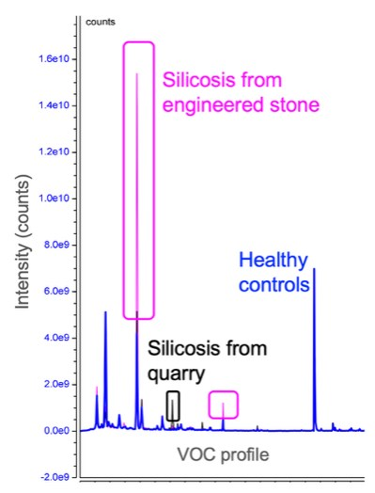
Introduction. Silicosis is the most serious occupational disease since asbestos. It is incurable. Screening for silicosis is costly, requiring time off work for lung function tests and radiology in hospitals. Diagnosis is delayed by poor screening compliance and lack of sensitivity, with up to 36% of cases missed by radiology. Easy and accurate workplace-based screening tools are urgently required. We propose a new screening solution using portable breath testing based on volatile organic compounds (VOC), an approach previously validated for lung cancer.
Aims. To identify a unique profile of silicosis-specific VOC biomarkers in the breath. Methods. Recruitment of subjects diagnosed with silicosis and healthy, age- and sex-matched controls to provide breath samples is ongoing. Sampling involves normal breathing into desorption tubes via a mouthpiece (Owlstone Medical, UK) for 15 minutes. All detectable VOCs collected in breath samples undergo unbiased analyses by Gas Chromatography-Mass Spectrometry (GCMS) to identify differentially expressed VOCs, accounting for covariates including occupation and smoking status. Results. To date, we have recruited 10 controls (all M, 1 current/9 never smoker) and 7 patients with silicosis (6M/1F, 4 ex-/3 never smoker) resulting from engineered stone (N=5), quarry (N=1) or multiple occupational exposure (N=1). Our pilot GCMS findings highlight unique breath chemicals in workers with engineered stone (pink) or quarry (black) silicosis, compared to a healthy age-matched control (blue; Figure). Discussion. We demonstrate unique chemical signatures in silicosis patients from different occupations and different to controls. This is the first step in validating an
innovative, portable screening breath test for silica exposed or diagnosed workers. We will validate our panel of silicosis VOC markers in our full pilot cohort (N=30/group, due for completion end 2025). In future, we aim to identify undiagnosed workers at high-risk to address limitations in screening. Additionally, a validated breath test could track disease progression and responses to pharmacological interventions for this currently incurable occupational disease.

