**Controlled Release of Prednisone from Silk Fibroin Microneedles Targets 11β-hydroxysteroid Dehydrogenase Type 1 Enzyme (11β-HSD1) For Hypertrophic Scars Treatment**

**Qinghan Tang1,2,** Ruihan Jiang1,2, Kevin Tsai3, Mark Cooper3, Yiwei Wang2,3,4

Jiangsu Provincial Engineering Research Center of TCM External Medication Development and Application, Nanjing University of Chinese Medicine1, Nanjing, Jiangsu, PR China.

School of Pharmacy, Nanjing University of Chinese Medicine2, Nanjing, Jiangsu, Jiangsu, PR China.

ANZAC Research Institute, Concord Hospital, The University of Sydney3, Concord West, NSW, Australia.

Jiangsu Collaborative Innovation Center of Chinese Medicinal Resources Industrialization, Nanjing University of Chinese Medicine4, Nanjing, Jiangsu, PR China.

**Background and aims.** Hypertrophic scars (HS), characterized by excessive fibroblast activation, myofibroblast differentiation, and abnormal collagen deposition, can lead to symptoms such as itching, pain, and joint dysfunction. Current intralesional glucocorticoid injections are limited by uneven drug distribution, local tissue atrophy, pigmentation changes, pain, poor patient compliance, and systemic side effects. To address these challenges, we developed a double-layer microneedle system targets local glucocorticoid metabolism within HS. This system co-delivers prednisone (an inactive glucocorticoid) and an 11β-HSD1 agonist, enabling the scar tissue's endogenous 11β-hydroxysteroid dehydrogenase type 1 (11β-HSD1) enzyme to locally convert prednisone into its active form.

**Methods.** Silk fibroin microneedles were fabricated using a vacuum injection technique. The morphology was examined via scanning electron microscopy (SEM), and mechanical strength was evaluted using a force-displacement testing system. In vitro skin penetration capability was assessed on rat skin using methylene blue and H&E staining. The modulation of 11β-HSD1 and the anti-scarring efficacy were verified through molecular docking, fibroblast cell culture, a murine hypertrophic scar model, and a global 11β-HSD1-deficient mouse model.

**Results.** A double-layer microneedle patch with a smooth surface topography (Figure 1) and sufficient mechanical strength was successfully developed. *In vitro* evaluations demonstrated: 1) effective penetration through the epidermis into rat dermis, and 2) sustained release of both therapeutics over 7 days. Cellular assays showed no cytotoxicity and revealed reduced expression of Type I collagen and α-SMA expression. In HS animal models, histological analysis indicated decreased scar thickness and collagen deposition, while molecular studies confirmed activation of the 11β-HSD1 pathway and downregulation of HS biomarkers.

**Conclusion.** By targeting 11β-HSD1-mediated local glucocorticoid metabolism, the double-layer microneedle enables precise intralesional delivery and enhanced therapeutic efficacy in HS treatment. This approach boosts scar tissue 11β-HSD1 activity, promoting the rapid enzymatic conversion of prednisone to prednisolone and resulting in a synergistic therapeutic effect.

**References:**

(1) Tsai K H Y, Shi H K, Parungao R J, et al. Skin 11β-hydroxysteroid dehydrogenase type 1 enzyme expression regulates burn wound healing and can be targeted to modify scar characteristics [J]. Burns & Trauma, 2023, 11: tkac052

(2) Zhang Q, Shi L, He H, et al. Down-Regulating Scar Formation by Microneedles Directly via a Mechanical Communication Pathway [J]. ACS nano, 2022, 16(7): 10163-78.

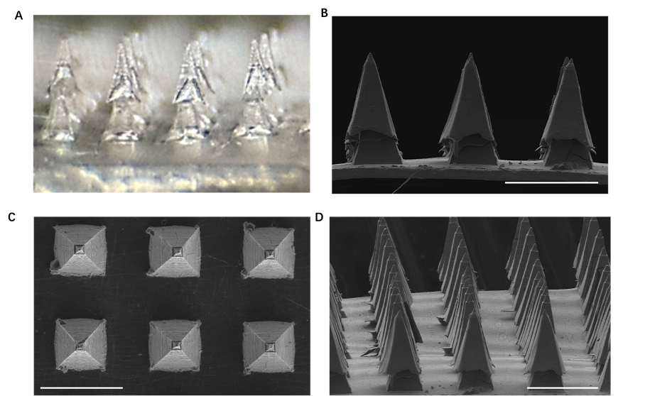

**Figure 1.** Microscopy and SEM images of double-layer microneedles. (A) Optical photos of double-layer microneedles; SEM image of (B-D) double-layer microneedles (scale: 500 μm)