Extended abstract guide for authors

Presenting Author
Professional Title, Affiliation, Location
Second Author
Professional Title, Affiliation, Location

Abstract: An extended abstract should be between 500 and 1,000 words in length. Limited to a maximum of two (2) pages. If you are describing a study or a piece of research, give a concise summary of what the research is about, how the study was undertaken, what was discovered, the significance of the results and a conclusion. If your paper is about a project, the extended abstract to include; an introduction providing background, research problem or overall description on the project, and justification (the "so what?"). If required, provide a methodology that provides essential details on design, data collection, and analysis techniques and summarise the major findings supported by data, figures, or tables. The extended abstraction should include a conclusion with summary of findings and limitations and future work. Abbreviations must be provided in full.

Font for the main body of the abstract to be Arial 10pt with single spacing and title Arial 14pt. Please provide a double space after abstract: and Keywords: as per this template. Normal margins 2.54mm all round with a left gutter of 0.5cm.

Figures should be clear, legible and have a 0.75pt solid line border.

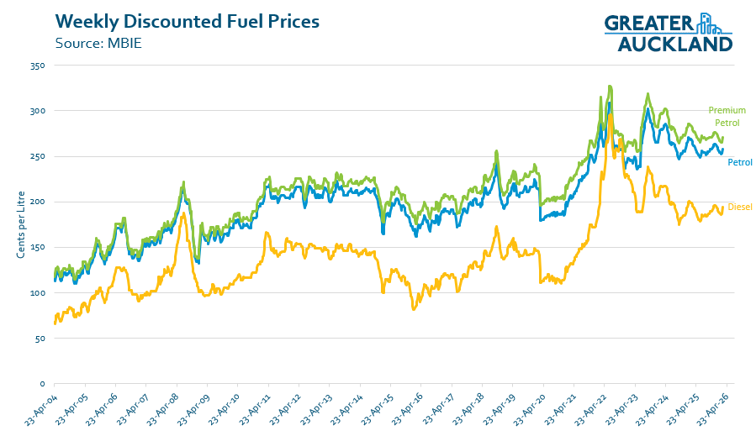
Figure 1. Weekly discounted fuel prices

Keywords: Bridge renewal, Asset management, Risk management.

