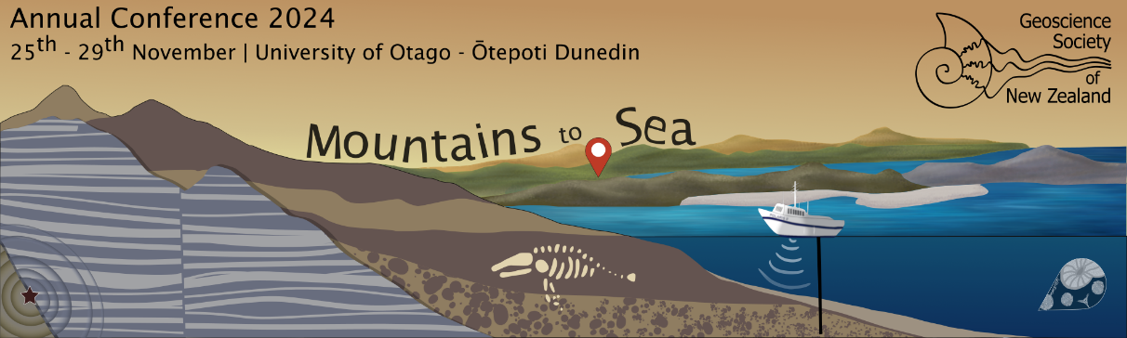
GSNZ 2024 Conference - Call for Sessions Submission Form

Thank you for helping to shape the GSNZ 2024 conference programme by offering to run a session. By submitting a session proposal, you are signalling that you are willing to actively encourage abstract submissions from colleagues, review the abstracts submitted to your session between approx 7 - 21 August 2024 (exact dates tbc) and chair the oral session at conference.

Return this form to Conferences & Events Ltd gsnz@confer.co.nz by the submission deadline of 27 May 2024. Submissions will be considered by the programme committee and you will be notified in early June 2024.

For further info please contact Ali Howard or Luxor McGowan, Conferences & Events Ltd, gsnz@confer.co.nz 04 384 1511.

Session Title
Lead convenor and
co-conveners:
first name, surname, organisation, email address

Delete the themes from this list that DO NOT apply to your session: | 1. Tectonics and magmatism  2. Geosciences and society  3. Environmental change: past, present and future  4. Applied geosciences: geotechnical, resources and technologies
Description of the session aim and content for the programme subcommittee
(limit 150 words)

Description of the session for the website
(limit 100 words)

Intended presentations format (poster only OR oral + poster)
Any website or links relevant to the session

