Practicalities of the use of Fayalite slags for Recovery of metals from Urban Wastes
Chen, J., Nicol, S., Hogg, B., Jak, E., and Nikolic, S.
The quantity of post-consumer “waste” materials generated each year is rapidly increasing. These materials can contain significant quantities of critical metals and present an environmental challenge if landfilled. The ISACYCLE™ technology is a proven solution for the processing of these materials. In the ISACYCLE™ furnace, the post-consumer materials are processed to recover energy along with any contained critical metals, in the form of a base metal alloy or matte. In addition, a clean aggregate (slag) is generated, which has the potential to be used for a range of applications in the construction industry. This slag is commonly based on a fayalite slag but is modified to manage the complex feed. This paper will review the fayalite slag system and the theoretical modifications required for treating urban wastes. Slags from an ISACYCLE™ furnace processing urban wastes have been sampled and characterised. The chemistry of these samples will be reviewed and compared to the expected theoretical modifications required.
Introduction
Critical metals are important for modern societies, with many of them used in niche applications. One of these applications is electronics, both consumer and non-consumer electronics. The critical metals in electronics include copper, nickel, tin, zinc, lead, and precious metals. Currently 17% of tin, 21% of silver and 7% of gold produced annually is used in electronics. To move towards a sustainable society and circular economy, end of life electronics (E-Scrap) need to be responsibly processed to recover these critical metals.
ISASMELT™ technology is well established as one of the leading technologies for secondary copper smelting. The ISASMELT™ Technology was developed at Mount Isa Mines, in Queensland Australia, through rigorous lab testing, pilot testing, and demonstration-scale plant trials. This resulted in the first commercial ISASMELT™ plant being constructed in 1991. The technology was initially developed to process primary copper concentrates and primary lead concentrates, but it was quickly identified that the technology was able to be used for smelting and/or converting most primary and secondary base metal feed materials. The leading E-Scrap recyclers in Europe, Aurubis Lunen and Umicore Hoboken, both use ISASMELT™ Technology to recover critical metals from these types of feed materials – and have done for more than 20 years. The ISASMELT™ Technology is adaptable and suited to both continuous and batch processing of secondary base metal feeds, with the batch processing route enabling both smelting and converting to occur in a single vessel.
This paper will investigate an industrial slag from an ISACYCLE™ furnace.
Sampling
Dip bar-quenched slag samples were taken during reduction smelting and converting stage from a ISACYCLE™ furnace. The samples were mounted in epoxy resin and cross-sections were prepared using conventional metallographic techniques.
Analytical Methods
EPMA
Quantitative elemental analyses were carried out using a JEOL 8530F Plus field emission electron microprobe housed at the Centre for Advanced Microscopy, The Australian National University. The analysis parameters included an acceleration voltage of 15 kV, a probe current of 80 nA, and a spot size ranging from 1 to 30 µm. achieving a detection limit better than 100 wt ppm for all elements analysed. Given the complex chemical composition of the samples, special attention was given to minimizing spectral interferences using the protocol developed by Chen et al. [1]
LA-ICP-MS
The concentrations of minor/trace elements in the slag were measured by Laser Ablation ICP-MS on an Agilent Technologies 7700 quadrupole mass spectrometer coupled to a Lambda Physik (λ = 193 nm) laser ablation system at the Research School of Earth Sciences, The Australian National University. A 80 mJ output energy and 81 μm diameter spot-size was chosen for the quantitative spot analysis. Data acquisition involved a background pre- and post- ablation for 15 s. The isotopes measured were: 29Si, ⁵⁹Co, ⁶⁰Ni, ⁶³Cu, ⁷⁵As, ¹¹⁸Sn, ¹²¹Sb and ²⁰⁶Pb. Si concentrations determined by EPMA were used as the internal standard and the NIST reference glass SRM 610 was used as the primary standard. Reference glass SRM 612 was monitored as secondary standards. The data obtained were reduced using the Iolite v4 software package.
Results
Microstructure of the samples
A typical microstructure of a reduction smelting slag sample is shown in Figure 1. Microstructural analysis indicated that phases present in the system at the temperature include slag, spinel and entrained copper metal. Measurement of the slag phase composition was conducted at the slag-dip bar interface where the slag was best quenched.
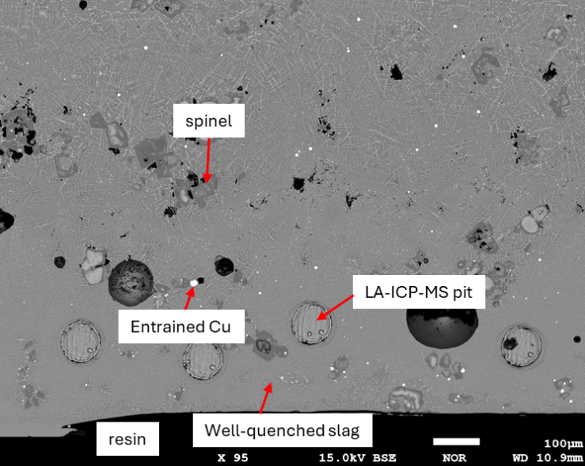
Figure 1 Typical microstructure of a smelting slag
Slag composition
As shown in Figure 2, the composition of the slag phase presented in the reduction smelting stage was plotted on the liquidus projection of the multicomponent system in equilibrium with metallic Cu and Fe onto the Al₂O₃-“FeO”-SiO₂-CaO pseudoternary section calculated by FACSAGE [2] using the current thermodynamic database developed by Prostakova et. al and Shishin et. al [3,4]. The measured liquid slag phase composition projected onto the section is in the spinel primary phase field and corresponds approximately to the liquidus temperature of ~1350ºC and corresponds to ~ 10 wt% spinel at equilibrium at the process temperature of ~ 1250ºC.
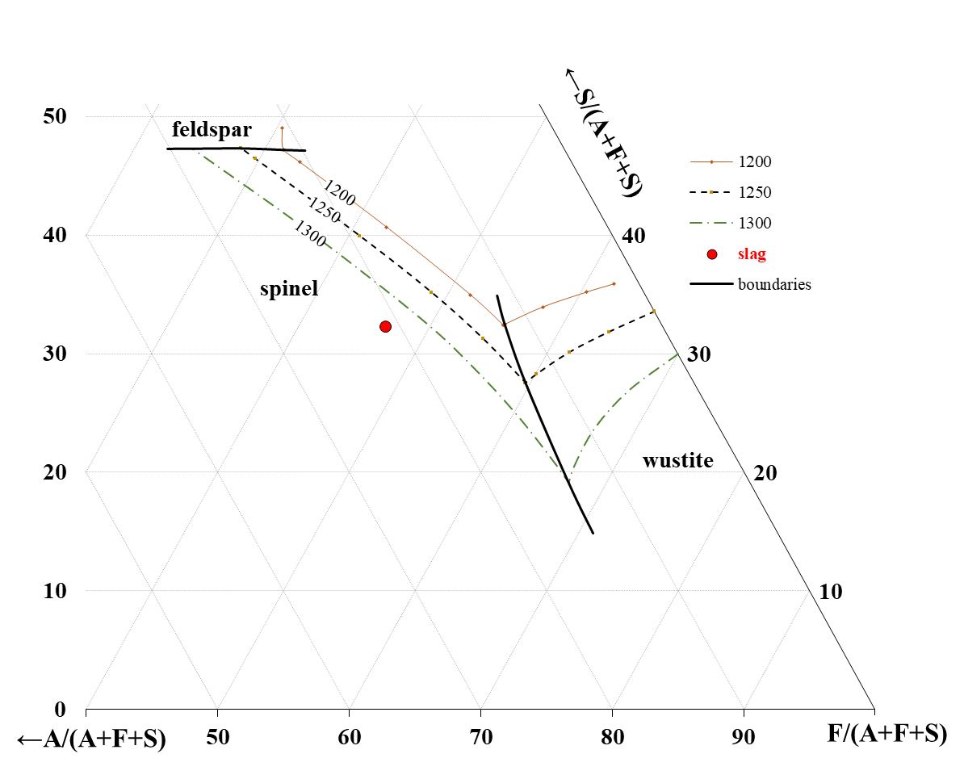
Figure 2 Liquidus projection of the multicomponent system in equilibrium with metallic Cu and Fe onto the Al₂O₃-“FeO”-SiO₂-CaO pseudoternary section at a fixed CaO concentration, calculated with the current thermodynamic database [3,4].
Minor element concentration in the slag phase after reduction smelting by LA-ICP-MS
Selected minor element concentrations measured by LA-ICP-MS in the slag phase are reported in Table 1. The values for the minor elements in Cu metal phase were approximately estimated from the LA-ICP-MS readings. It can be seen the Cu dissolved in the slag is as low as ~2000 ppm while all other minor elements are less than ~400ppm.
Table 1. Minor element concentration in the slag phase after reduction smelting
Element | Co | Ni | Cu | As | Sn | Sb | Pb
Concentration (ppm) | 212 | 38 | 2221 | 4.75 | 334 | 0.39 | 76

Distribution Coefficient of selected element
The calculated distribution coefficients (L_{slag/metal}) for the minor elements in the system at 1250°C as a function of Fe dissolved in metallic copper predicted with the thermodynamic database developed by the authors [3,4] are presented in Figure 3. The predicted sequence of minor element distribution coefficients (L) is Co > Pb > Sn > Ni > Sb, and these findings align with the sequence of values estimated from the measurements.
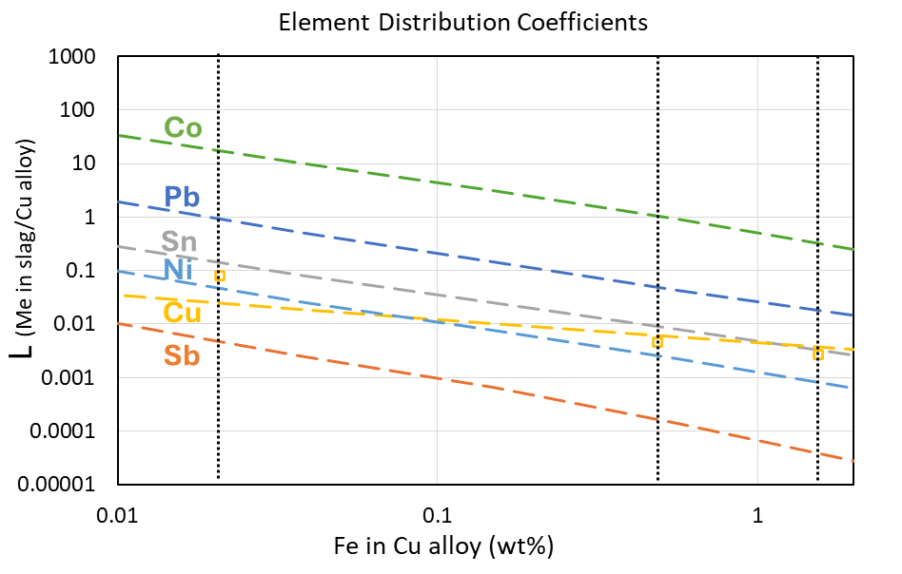
Figure 3 The calculated distribution coefficients of selected minor elements as a function of Fe in Cu alloy in the present study. The measured distribution coefficients of Cu between slag and Cu alloy at different stages of the smelting/converting are also plotted on the diagram (open squares).
Summary of findings
- Microstructural analysis indicated that phases present in the system at the temperature include slag, spinel and entrained copper metal suggesting the spinel primary phase field
- The predicted liquidus temperature of the slag phase presented in the reduction smelting slag is significantly higher (~100ºC) than observed.
- The slag phase after reduction smelting contains very low level of minor elements.
- Th sequence of minor element distribution coefficients (L_{slag/metal}) is found to be Co > Pb > Sn > Ni > Sb; the measured distribution coefficient of selected elements at different stages of the smelting process follow the trend predicted by FACTSAGE using the UQPY private database.
- The distribution coefficients (L) of minor elements between slag and Cu metal are strongly affected by the oxygen potential in the process – higher the PO2, the less Fe in Cu metal and the higher L.
References
- Chen, J., Fallah-Mehrjardi, A., Specht, A., & O’Neill, H. S. C. (2022). Measurement of minor element distributions in complex copper converting slags using quantitative microanalysis techniques. JOM, 1-10.
- Bale, C. W., Chartrand, P., Degterov, S. A., Eriksson, G., Hack, K., Mahfoud, R. B., ... & Petersen, S. (2002). FactSage thermochemical software and databases. Calphad, 26(2), 189-228.
- Prostakova, V., Shishin, D., Shevchenko, M., & Jak, E. (2019). Thermodynamic optimization of the Al2O3–FeO–Fe2O3–SiO2 oxide system. Calphad, 67, 101680.
- Shishin, D., Hidayat, T., & Jak, E. (2020). Thermodynamic assessment of the CaO–Cu2O–FeO–Fe2O3 system. Calphad, 68, 101715.

