Resource Estimation in Domains with Soft Boundaries Utilizing Non-Stationary Estimation

M Liang1

1.Senior Mining Consultant, Dassault Systemes - GEOVIA, Brisbane QLD 4000. Email: [Min.LIANG@3ds.com](mailto:Min.LIANG@3ds.com)

Keywords: Estimation domains, soft boundary, non-stationary variogram, moving average

# ABSTRACT

During the exploration phase of mining projects, a crucial aspect is defining and modeling the geology and mineral resources of a given area. Geology modeling relies on sample information and geological expertise to delineate various geological domains based on features such as lithology, mineralogy, and alteration. Commonly employed techniques for this domain partitioning encompass wireframing, radial basis functions, and machine learning clustering.

Effective resource evaluation necessitates the prior identification of geological domains. Within these domains, it's imperative that the grade of interest demonstrates a consistent and uniform spatial distribution to ensure precise estimation. Traditionally, within each domain, deposit grades are estimated independently using techniques like ordinary kriging or inverse distance weighting, utilizing only samples from within that domain for variogram calculation and estimation. However, this conventional approach assumes a hard boundary, implying no spatial correlation of grades across adjacent domains. Yet, in geological contexts such as porphyry copper mineralization, there often exists a gradual transition between domains, indicating a more nuanced, soft boundary.

Drawing from existing literature on contact analysis, the nature of the boundary between two domains can be discerned through examination of the local mean concerning the distance to the boundary or through covariance and cross-covariance analysis between domains. However, the latter method necessitates a comprehension of co-regionalization, a concept not widely applied in industry practices. Therefore, this article will focus on analyzing the local mean concerning the distance to the boundary between adjacent domains to delineate these boundaries. Figure 1 illustrates the contact analysis of domains with both hard and soft boundaries.

In cases where soft boundaries are observed, such as in scenarios b and c in Figure 1, it's notable that the local average grade varies with distance to the contact, thereby defying the stationary hypothesis. To accommodate such variability, a non-stationary model is justified, offering a more comprehensive framework capable of accommodating location-dependent spatial structures.

In the non-stationary case, A random function Z(x) can be decomposed as sum of a drift component m(x) and a zero-mean random residual e(x):

Z(x) = m(x) + e(x).

The non-stationarity can be introduced in the drift component, the stochastic component or both.

This study focuses on resource estimate within domains with soft boundary. We propose three approaches for incorporating non-stationarity in estimation:

1. Considering non-stationarity in the mean of the grade, where the local mean, varying with distance to the contact, is combined with estimated residuals obtained through kriging.
2. Considering non-stationarity in the variogram model, where variogram parameters change as a function of distance to the boundary, and ordinary kriging is used to obtain grade estimates.
3. Combining non-stationarity in both the variogram model and mean, wherein a non-stationary variogram is used to estimate random residuals, which are then added to the local mean for the final estimate.

We illustrate these methodologies using a porphyry copper mineralization example and compare their performance with traditional ordinary kriging in domains with hard boundaries through cross-validation. Our findings demonstrate the effectiveness of these approaches in accurately estimating resources in domains with soft boundaries, thereby enhancing the precision of resource evaluation in mining projects.

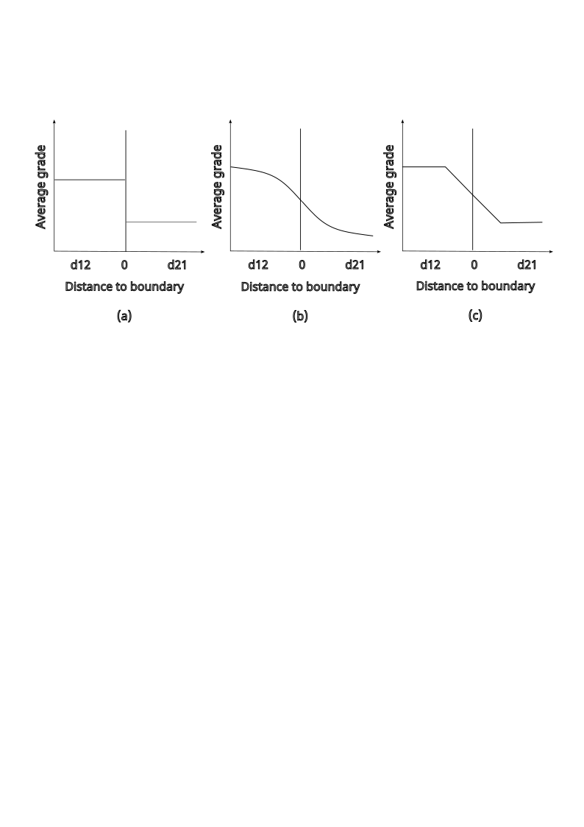

Figure 1. Contact plot for hard boundary (a) and soft boundary (b) (c).