Modelling Social Effects of Blasting in Sustainable Mine Planning Using Machine Learning Techniques: A Case Study
M. Aghdamigargari¹, S. Avane², A. Anani³, S. O. Adewuyi⁴

1.PhD student, Department of Mining and Geological Engineering, University of Arizona, Tucson AZ 85721, USA, Email: mehriaghdami@arizona.edu
2. PhD student, Department of Mining and Geological Engineering, University of Arizona, Tucson AZ 85721, USA, Email: sylvesteravane@arizona.edu
3.Associate professor, Department of Mining and Geological Engineering, University of Arizona, Tucson AZ 85721, USA, Email: angelinaanani@arizona.edu
4.Postdoc, Department of Mining and Geological Engineering, University of Arizona, Tucson AZ 85721, USA, Email: sadewuyi@arizona.edu

Keywords: Blasting impact, Vibration, Sustainable mine planning, Machine learning techniques

ABSTRACT
Traditional mine planning has primarily focused on economic and operational objectives, often overlooking the significant impacts of mining activities on surrounding communities. Today, it is essential for mining operations to assess their activities against sustainable mining criteria to ensure environmental and social responsibility. Blasting, an indispensable part of mining, poses substantial challenges to nearby communities due to its adverse effects, such as vibration, noise, and fly rock. This research addresses these social impacts by developing a predictive framework to assess the effects of blasting, focusing on vibrations. By integrating machine learning models with data from real mining operations, this study aims to quantify and predict the social outcomes of different blasting schedules. Initial efforts involve collecting data on blasting parameters such as Total charge and distance to train and validate the predictive model. Using a Deep Neural Network (DNN) it was demonstrated that there is a strong negative correlation between Peak Particle Velocity (PPV) and scaled distance. This approach offers a novel contribution to mine planning by providing a comprehensive framework that balances community well-being with operational efficiency. Future work could incorporate this model into production scheduling to support sustainable mine planning, reducing adverse social impacts while optimizing Net Present Value (NPV).

introduction
Blasting is a crucial operation in mining projects, playing a key role in breaking rock masses to facilitate excavation. However, it also generates ground vibrations that can negatively impact nearby structures, the environment, and local communities. Predicting these vibrations before blasting can aid in designing blasts that minimize adverse effects. The USBM empirical equation (Equation 1) has long been the primary traditional method for estimating Peak Particle Velocity (PPV), a key measure of blast-induced vibration. In this equation, the parameters K and b are determined using various regression techniques based on blasting datasets that include PPV and scaled distance (SD), as defined in Equation (2). Here, W represents the maximum charge weight per delay, and D denotes the distance between the blast site and monitoring points.
PPV=K(SD)^{b} (1)
SD=(D/W)^{1/2} (2)
While the USBM empirical equation provides a straightforward initial estimation of blast-induced vibrations, its accuracy is often limited in complex scenarios due to its reliance on only a few parameters. As a result, it may not always yield optimal predictions. In recent years, machine learning (ML) techniques have emerged as powerful alternatives for PPV prediction, offering enhanced accuracy by incorporating additional factors such as geological conditions, which traditional methods overlook.
Key parameters influencing blast-induced ground vibrations include the distance between the blast site and monitoring points, maximum charge per delay, burden, spacing, and blasthole depth. Among ML techniques, Artificial Neural Networks (ANNs), particularly the feed-forward back-propagation neural network (BPNN), have been widely adopted due to their ability to capture complex nonlinear relationships between input variables and PPV.
Das, Sinha and Ganguly (2019) developed an ANN model utilizing 248 data samples collected from three coal mines with varying geo-mining conditions. The model achieved a correlation coefficient of 0.96 between the predicted and measured PPV values, significantly outperforming the traditional empirical model, which had a correlation coefficient of 0.63. This highlights the superior predictive accuracy of ANN compared to conventional methods.
Integrating multiple machine learning algorithms can also improve predictive performance. Hosseini et al. (2023) used ANN with Extreme Gradient Boosting (XGBoost) to introduce an ensemble modelling approach for PPV estimation. The effectiveness of the base models was assessed using various validation metrics, including the coefficient of determination (R²), root mean square error (RMSE), mean absolute error (MAE), variance accounted for (VAF), and overall accuracy. The results demonstrated that the ensemble model provided higher prediction accuracy compared to the best-performing individual models.
In recent years, in addition to ANNs, various other machine learning algorithms, such as Support Vector Machine (SVM), K-Nearest Neighbours (KNN), and Random Forest (RF), have been implemented and compared for vibration prediction (Chandrahas et al., 2022; Nguyen, Bui and Drebenstedt, 2023).
Among various types of neural networks, the multi-layer perceptron (MLP) is a form of feedforward neural network and serves as the foundation for deep learning, enhancing the performance of ANNs. MLP employs the backpropagation algorithm for training, making it a powerful supervised learning technique capable of handling nonlinear problems effectively.
When an MLP network incorporates multiple hidden layers and deep learning techniques, it is referred to as a deep neural network (DNN). A DNN consists of at least three layers: an input layer, one or more hidden layers, and an output layer. In the input layer, neurons function as receptors, transmitting information to the hidden layers. The hidden layer neurons process and learn from the data by performing calculations and adjusting the connection weights between them. These weighted values are then passed to the output layer, where the final predictions are generated and displayed (Brownlee, 2018).
Nguyen et al. (2021) applied a hybrid DNN framework combined with several nature-inspired optimization algorithms (Harris Hawks Optimization (HHOA), Whale Optimization (WOA), and Particle Swarm Optimization (PSO)) to predict vibration in an open pit coal mines. Using 229 blasting events as the dataset and two hidden layer in MLP, the hybrid models outperformed individual DNNs, with the HHOA-DNN achieving the highest accuracy (R² = 0.93, MSE = 2.361). The study demonstrated the importance of features such as explosive charge, monitoring distance, and time delay​. In another study Wang et al. (2022) developed an long short-term memory (LSTM) model to predict the full waveform of blast-induced vibrations. Unlike models that focus only on PPV, this approach captured temporal and spatial complexities. The dataset included 20 simulated and real-world blasting events. This method provided improved accuracy in capturing vibration duration and frequency, addressing gaps left by traditional models​. As models like LSTM also captured temporal characteristics of vibrations, they extended applicability beyond static PPV prediction​​. Jansrud (2024) in a master's thesis, demonstrated the superiority of a DNN model over the USBM empirical model in predicting PPV. The DNN model, trained on a 9724 rows of data points from a mining company, and evaluation was conducted using three statistics criteria, R², MSE, and MAE. The network they used consists of nine neurons in the input layer corresponding to nine features of the dataset including Site, Blast ID, Scaled Distance, Distance, Maximum Instantaneous Charge, Blast Direction, Timeframe, Groundwater presence (binary), and PPV, as the target variable for prediction.​It also had three and one hidden and output layers to predict PPV.
The new idea improved predictive accuracy by over 70% compared to the industry standard. The research highlighted the utility of advanced DNN architectures to capture complex variable interactions​.
DNNs approaches have revolutionized the prediction of blast-induced vibrations by offering greater accuracy and incorporating a wider range of features compared to traditional methods. Integrating these models into mining operations can significantly improve social and environmental safety, ensure regulatory compliance, and enhance operational efficiency. This study applies DNNs to an open pit mine as a new case study, providing insights into their applicability in diverse mining environments.
The remainder of this paper is organized as follows: The next section outlines the research methodology employed in this study. The results and discussion section presents the model findings and comparative analysis. The final section provides conclusions and explores future research opportunities.

Methodology
The data for blast-induced ground vibration was collected from a large copper mine in Arizona, United States. After data cleaning and preprocessing, records from 90 blasting events were retained, including key parameters such as burden, spacing, depth, distance, total charge, and charge weight per delay. Ground vibration measurements were recorded using Mini Seis III Pro devices. Based on this data, the scaled distance was calculated, and the aforementioned parameters, along with scaled distance, were used as input variables for a ML model to predict PPV as the output.
Figure 1 illustrates the main steps of this study. First, a DNN with three hidden layers was trained to predict PPV. The network consisted of seven neurons in the input layer (corresponding to the seven input variables) and one neuron in the output layer. The three hidden layers contained 128, 64, and 32 neurons, respectively. At the next step, the USBM empirical equation was applied as a second method for PPV prediction. In this approach, least squares regression was used to estimate the unknown parameters b and k, fitting the model to the data. Finally, the performance of both methods was compared to evaluate their predictive accuracy.

3 hidden layers (128, 64, 32)
Comparison
Data collection & Preprocessing
90 blasting data
DNN Model
USBM Model
Estimate b & K
(least square regression)

FIG 1- Methodology

Results and discussion
Using the DNN method, 80% of the dataset is allocated for training. The network is trained in a supervised manner using the backpropagation algorithm to optimize a multi-layer feedforward network. Before training begins, the data undergoes preprocessing, which includes normalizing both input and output values to improve model performance and stability. Additionally, the top 1% and bottom 1% of the data are removed from the analysis to eliminate potential outliers and enhance model accuracy. Leaky ReLU is employed as the activation function across all layers, with an alpha value of 0.01, ensuring a more stable learning process. The correlation matrix in Figure 2 shows a visual representation of the relationships between different variables in the dataset. The colour intensity reflects the strength of the correlation, with the scale on the right indicating that red shades signify positive correlations, blue shades represent negative correlations, and light grey indicates little to no correlation. The matrix highlights the following key relationships:
- PPV and scaled distance exhibit a strong negative correlation (-0.68), represented by the dark blue colour. This indicates that as scaled distance increases, PPV tends to decrease, and vice versa.
- PPV and Spacing/Burden show a moderate negative correlation (-0.25 and -0.27, respectively), depicted in medium blue, suggesting a slight inverse relationship.
- PPV’s correlation with other variables is weak, as evidenced by the light colours, implying that PPV has minimal linear association with most other features in the dataset.
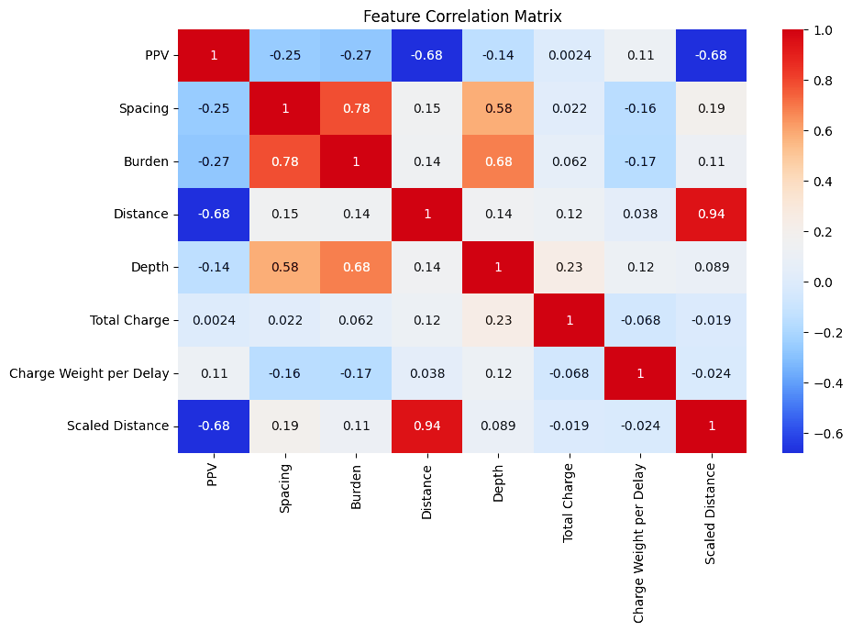
FIG 2- Feature correlation matrix
The scatter plot in Figure 3 presents the predicted PPV vs true PPV, suggesting that the model is capturing the relationship between input features and PPV reasonably well. However, some scatter around the ideal y = x line indicates prediction errors and the possibility for improvement in model accuracy.

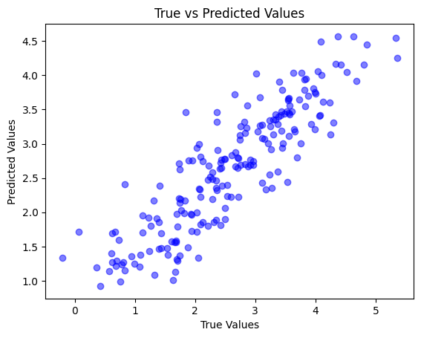

FIG 3- predicted PPV vs true PPV

In the second phase, Implementing the empirical method, using the same data set, we tried to fit a curve between the scale distance and PPV using least square regression which resulted in equation 3:
PPV=270 (SD)^{-1.68} (3)
where K = 270 and b = -1.68.
Finally, we employed various statistical metrics to assess both methods and compare their performance in predicting PPV. The results are displayed in Table 1.

TABLE 1- Evaluation results of the DNN model compared to USBM model
Evaluation metrics | DNN model | USBM empirical equation
Root Mean Square Error (RMSE) | 0.3333 | 0.4432
Mean Absolute Error (MAE) | 0.2118 | 0.3641
R² | 0.7589 | 0.4167

From the table, it can be observed that the DNN method outperforms USBM across all three statistical measures, indicating its superior predictive capability. The lower errors for DNN suggest improved accuracy and reliability in capturing the underlying patterns of the dataset. Also, an increase in the R² value indicates that the DNN model outperforms the empirical equation and can explain more than 75% of the variability in this blast vibration data.

CONCLUSIONS
This research established a predictive framework to evaluate the impact of blast-induced vibration, a key social consequence of mining operations. By utilizing DNN, the study revealed a strong inverse relationship between PPV and scaled distance in 90 blast data. Also, the result of comparative evaluation highlights the effectiveness of deep learning-based approaches in enhancing prediction accuracy compared to traditional methods like USBM. However, the model developed in this study is not the most accurate for predicting PPV. By incorporating more data, we can improve the R² value and reduce errors, leading to a more robust model capable of capturing a broader range of data. Additionally, in future work, this predictive model can be integrated with mine planning optimization to promote socially sustainable mining practices, ultimately enhancing the relationship between mining companies and local communities.

REFERENCES
Brownlee, J., 2018. Deep learning for time series forecasting: predict the future with MLPs, CNNs and LSTMs in Python. Machine Learning Mastery.
Chandrahas, N.S., Choudhary, B.S., Teja, M.V., Venkataramayya, M.S. and Prasad, N.K., 2022. XG boost algorithm to simultaneous prediction of rock fragmentation and induced ground vibration using unique blast data. Applied Sciences, 12(10), p.5269.
Das, A., Sinha, S. and Ganguly, S., 2019. Development of a blast-induced vibration prediction model using an artificial neural network. Journal of the Southern African Institute of Mining and Metallurgy, 119(2), pp.187-200.
Hosseini, S., Pourmirzaee, R., Armaghani, D.J. and Sabri Sabri, M.M., 2023. Prediction of ground vibration due to mine blasting in a surface lead–zinc mine using machine learning ensemble techniques. Scientific Reports, 13(1), p.6591.
Jansrud, G., 2024. Enhancing Prediction of Blast-Induced Ground Vibrations through Machine Learning (Master's thesis, UiT Norges arktiske universitet).
Nguyen, H., Bui, X.N. and Drebenstedt, C., 2023. Machine Learning Algorithms for Data Enrichment: A Promising Solution for Enhancing Accuracy in Predicting Blast-Induced Ground Vibration in Open-Pit Mines. Inżynieria Mineralna.
Nguyen, H., Bui, X.N., Tran, Q.H., Nguyen, D.A., Hoa, L.T.T., Le, Q.T. and Giang, L.T.H., 2021. Predicting blast-induced ground vibration in open-pit mines using different nature-inspired optimization algorithms and deep neural network. Natural resources research, 30, pp.4695-4717.
Wang, Y., Zheng, G., Li, Y. and Zhang, F., 2022. Full waveform prediction of blasting vibration using deep learning. Sustainability, 14(13), p.8200.

