PhotonAssay – Efficient & Bulk Gold Analysis in the Modern World

C. D. Tremblay1, J. Tickner2, D. Treasure3, A. Oteri4 and G. Wheeler5

1.

Postdoctoral Fellow, CSIRO, Kensington, WA 6151. Email:Chenoa.tremblay@csiro.au

2.

Chief Technology Officer, Chrysos Corporation, Adelaide SA 5064 Email:james.tickner@chrysos.com.au

3.

Chief Executive Officer, Chrysos Corporation, Adelaide SA 5064 Email:dirk.treasure@chrysos.com.au

4.

Technical Manager, MinAnalytical Laboratory, Canning Vale, WA 6155. Email:Anthony.oteri@mlsa.com.au

5.

Director, MinAnalytical Laboratory, Canning Vale, WA 6155. Email:Gary.Wheeler@mlsa.com.au

# ABSTRACT

The new ChrysosTM PhotonAssay Max technology uses high-energy X-rays to directly measure gold in bulk ore samples, combined with fully robotic sample handling to keep up with the high demands of the mining industry. Testing on a large suite of certified reference materials demonstrates that accurate gold values can be determined over a wide range of concentrations, with a detection limit down to 0.03 ppm.

PhotonAssay is a non-destructive technique that does not require gold to be liberated from gangue material before analysis, meaning that samples can be prepared with larger particle sizes, reducing losses of gold that can occur through smearing onto the surface of pulverising equipment.

Through analysis of suites of material from drill sites across Australia, we have found that results determined by PhotonAssay on drill core and reverse circulation drilling samples crushed to a top-size of 2-3 mm generally correlate at a level of 97 percent or better with traditional fire assay values. For sites with particularly coarse gold, it is advantageous to further reduce the particle size before sampling for assay, but the much larger PhotonAssay sample size (400-500 g approximately) significantly reduces sampling errors compared to traditional 25-50 g fire-assay. Statistical tests show that results from fire-assay and PhotonAssay can be used interchangeably during a drilling program. We present detailed results from several case studies to illustrate these findings.

The combination of simplified sample preparation and reduced sampling errors are of immediate benefit to geologists responsible for resource definition and grade control analyses. Significantly reduced turn-around times, lowered staffing requirements and the removal of the use of toxic reagents, such as lead, are additional benefits offered by the new technology.

# Introduction

The accurate measurement of gold in mineral ore samples is essential across the entire value chain, from exploration and resource definition through to grade control, blending, plant monitoring and final product evaluation. Traditionally, chemical methods such as fire-assay and cyanide or acid-leach have been used for routine measurement of gold. These require extensive sample preparation, skilled technicians, and use caustic or toxic reagents that can present health and environmental challenges.

PhotonAssay is a novel X-ray based method that directly and non-destructively measures gold in large samples. In this paper, we introduce the technology and present the results of extensive testing that we have performed to demonstrate its efficacy for mining applications.

The paper is structured as follows.

First, we describe the technology and the physics principles by which it operates. We present test results obtained using certified reference materials that demonstrate the precision and accuracy of the instrument.

Next, we discuss sample preparation and sampling errors, illustrated by comparing PhotonAssay and fire-assay measurements on sample suites from 10 drill sites prepared using different crushing and pulverising approaches.

We then present two real-world case-studies that focus on materials from two mining operations, one with finely disseminated gold and one with extremely coarse, “nuggety” material. We discuss how different sample preparation protocols can be used to successfully assay these material types.

Last, we describe an unusual application that relies on the non-destructive nature of the PhotonAssay method, namely analysis of whole core pieces that are to be used for training an ore-sorting system.

# PhotonASSAY TeChnology

PhotonAssay uses the basic principle of gamma-activation analysis, also known as photon activation analysis, to measure the content of gold and other elements inside bulk mineral ore (Tickner *et al*, 2017).

Samples, typically weighing about 0.5 kg, are packaged inside a 350 mL sealed plastic jar in which they remain throughout the measurement process (Figure 1).



Figure 1: Typical PhotonAssay sample presentation (jar lid removed to display contents of approximately 0.45kg subsample).

The sample is exposed to an intense, high-energy X-ray beam produced by a linear accelerator. The accelerator energy is 8.5 MeV, which is about 100 times higher than the energies typically used for conventional X-ray fluorescence (XRF) analysis. The X-ray energy is high enough to induce short-lived changes in the nuclear structure of some elements, producing unstable isotopes. These isotopes have half-lives typically ranging from seconds to minutes and when they decay, produce characteristic gamma-ray signatures that can be measured and counted. The gamma-ray intensity can then be related back to the concentration of the responsible element.

Consider the case of gold, which in nature consists entirely of the isotope 197Au. X-rays excite a so-called meta-state in the 197Au nucleus with a half-life of 7.73 s; this state decays and emits a gamma-ray having an energy of 279 keV:

${}_{}^{\text{197}}{\text{Au}}\underset{→}{\text{X-ray}}{}_{}^{\text{197M}}{\text{Au}\underset{→}{\text{7.73 s}}{}_{}^{\text{197}}{\text{Au}}\text{+γ(279 keV)}}$

In practical operation, a detection cycle comprises a 15 s irradiation period followed by a 15 s measurement. Repeating the process and averaging the results improves the measurement precision. A standard gold analysis (SGA) uses two cycles which affords an overall throughput of 72 samples per hour. Improved precision can be achieved by increasing the number of detection cycles, at the cost of throughput. The entire process is fully automated, with operators required only to load and unload samples from the instrument (Figure 2).



Figure 2. PhotonAssay instrument. Samples are loaded onto the input conveyor (left) and retrieved from the output conveyor (right) once analysis is complete. The control console (centre) provides an overview of operations.

Both the incident X-rays and the emitted 279 keV gamma-ray are highly penetrating in typical ores, meaning that the entire volume of material inside the sample jar is measured. The X-rays and gamma-rays also easily pass through the plastic container, so the material can remain packaged throughout the irradiation and measurement steps, reducing the risk of cross-contamination between samples.

The analysis is also insensitive to the particle size of the material being assayed, so rock chips or even larger individual rocks can be measured. In practice, sampling considerations, discussed at length in the following sections, dictate the maximum acceptable particle size. The measurement is also insensitive to the sample matrix, meaning that different rock types, process materials, solutions and carbon pulps can be assayed with equal felicity.

X-ray levels outside the unit are low enough for operators to safely work nearby without requiring any special precautions or monitoring. Similarly, residual activity in the samples in negligible and assayed materials can be safely handled, stored, disposed of or sent for other testing as required.

# INSTRUMENT ASSAY PERFORMANCe

Initial validation of the performance of the PhotonAssay technology was carried out during factory testing. Certified reference materials (CRMs) are ideal for establishing instrument performance, as they consist of finely pulverised, highly uniform material with accurately known gold contents. As such, they allow instrument precision and accuracy to be determined without consideration of sampling errors.

A large suite of CRMs was procured from 4 manufacturers: Ore Research & Exploration (OREAS), Rocklabs, Gannet Holdings and African Mineral Standards (AMIS). The materials were chosen to cover a wide range of gold grades (0.065-322 ppm) and ore matrix types, including silicate ores, sulphide ores, and gold, gold-copper and polymetallic process concentrates.

Figure 3 presents a graphical comparison of gold grades determined using PhotonAssay and the certified grades supplied by the manufacturers, generally estimated from a round-robin comparison of fire-assay results provided by a large number of reputable laboratories. Over nearly four orders of magnitude in gold grade (left plot), excellent linearity is observed using a single instrument calibration. Good performance is also obtained for samples significantly below 1 ppm concentration (right plot).

For samples with low levels of the elements Uranium (U), Thorium (Th) and Barium (Ba), the 3-sigma detection limit for gold with a standard 2-cycle analysis is below 0.03 ppm. Here, ‘low’ means a combined U + Th level of less than 5 ppm and a Ba level below 1000 ppm. Elevated levels of these interfering elements increase the detection limit, as they are activated by the X-ray beam and increase background levels beneath the gold gamma-ray signal. However, they do not preclude sample analysis.

|  |  |
| --- | --- |
|  |  |

Figure 3. Comparison of PhotonAssay (y-axis) and certified gold grades (x-axis) for CRM samples provided by four manufacturers. The left-hand plot shows results for all samples on a log-log scale, with grades marked in powers of 10; the right-hand plot emphasises performance for lower-grade samples on a linear-linear scale.

The instrument’s precision (1 standard-deviation values) is about 8 percent relative at 0.3 ppm, 4 percent relative at 1.0 ppm and better than 2.5 percent at grades above about 3 ppm. Again, significantly elevated levels of U, Th or Ba decrease precision, particularly at grades below 1 ppm.

# Sampling CONSIDERATIONs

Any measured sample is assumed to be representative of the larger mass of ore from which it is drawn. Historically, significant work has gone into developing best practices for sampling gold-bearing materials from the drill site to the laboratory, and from the laboratory to the assay aliquot (Lyman, 2011).

For mining and exploration work, most gold analysis is performed by fire-assay at a commercial or on-site laboratory. Fire-assay is a process of separating gold from the gangue or commercially worthless material through fusion with lead-based flux, separating the waste from the lead, and then melting the lead to reveal a silver “prill” of encapsulated gold. The industry standard is to use 5 to 50 g of sample, depending on levels of sulphur or nickel present and the size of the pots that go into the fusion furnace. The maximum weight of about 50 g means that sampling considerations dictate that the original bulk sample needs to be broken down to a nominal size of 75 µm before the assay aliquot is taken.

A sequential particle-size and sample-mass reduction process is used by most Australian laboratories, where the received material is initially broken down to a 15 mm top-size, before being crushed to 2-3 mm. In general, there is an agreement that breakdown to a 2-3 mm particle top-size is advisable before any sampling takes place. A sub-sample of 2-3 mm material, typically 1-3 kg, is then drawn for pulverisation. The pulverising continues until approximately 90 percent of material passes 75 µm, with the proportion slightly dependant on the host rock characterisation. Whilst the pulverisation step is required for effective sampling of the small fire-assay aliquot, gold is malleable and so there is a risk of loss of gold through smearing and transfer to grinding equipment.

An important part of testing the applicability of PhotonAssay to gold analysis in mineral samples is to explore similarities and differences in sampling requirements compared to conventional fire-assay. In particular, does the larger sample volume (450 g) allow for simplified sampling protocols to be used without loss of precision?

François-Bongarçon and Gy (2002) suggest that best practice is to measure sampling variance at different particle sizes for a given ore body is through analysis of sub-samples, rather than relying on theoretical equations. The sampling tree method proposed by François-Bongarçon (1995) and explored further by Minnitt (2007a, 2007b), Minnitt and Assibey-Bonsu (2010) utilises large quantities of drill sample that are analysed at different particle sizes to determine the gold concentration and fundamental errors. This is traditionally done using a large number of fire-assay analyses, with the final gold values obtained through flame atomic absorption or gravimetric analysis.

The non-destructive nature of PhotonAssay analysis and the large sample size measured mean that we can follow the sample tree method without the errors introduced by working with different aliquots; allowing a smaller overall number of samples to be used. Working with mining companies across Australia, we analysed samples by PhotonAssay that had been prepared to different particle sizes before sampling and looked at the correlation with fire assay results performed on separate aliquots of pulverised 75 µm material.

The larger sample size measured using the PhotonAssay machine is useful for reducing the fundamental sampling error (Gy, 1973). An investigation was performed to determine if a reduction in sample preparation, namely removing the pulverisation step to reduce time, cost and possible gold loss through smearing, is possible without adversely affecting sampling accuracy.

Approximately 1200 samples from 10 different drill sites were used in the study, with multiple PhotonAssay and fire-assay aliquots prepared from each sample. Figure 4 presents results for one drill-site, where PhotonAssay analysis results statistically matched those of fire-assay irrespective of the particle size.

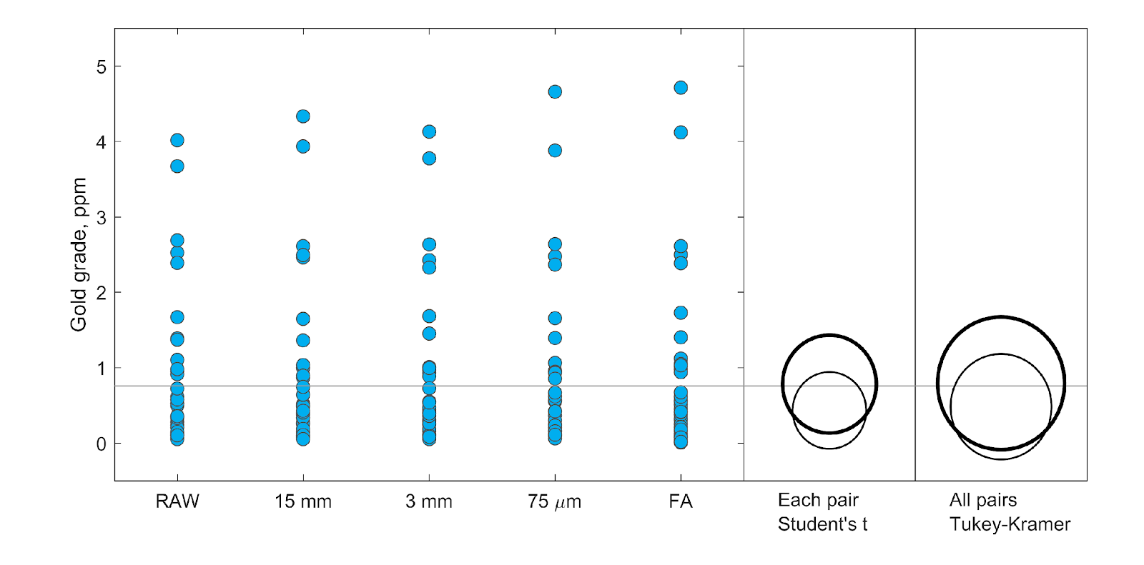

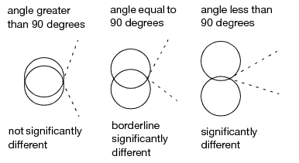

Figure 4: (Left) One-way analysis of variance diagram comparing grade distributions obtained for a suite of reverse circulation materials via PhotonAssay (RAW, 15mm, 3mm, 75um) and fire assay. (Right) Visualisation of results of Student's t-test and Tukey-Kramer HST means comparison test. The size of the circles represents the variance and their positions relate to the statistical similarity as explained in the top right panel.

Table 1 summarises the results obtained for all 10 sites. Although excellent correlations were often observed even when PhotonAssay was used to measure very coarse material (as received, or ‘RAW’ and 15 mm crushed), in general better agreement was found when the material particle top size was reduced to at least 2-3 mm. For two of the 10 sites (A and C), pulverisation was required to achieve a strong correlation.

Overall, the MinAnalytical laboratory team operating the unit concluded in an ISO/NATA validation process that PhotonAssay analysis done on 3 mm top-size mineral samples normally provides a consistent and repeatable result, with pulverising required for some ore types (discussed more below). The PhotonAssay results can also be used interchangeably with gold values determined by fire-assay, as long as the gold concentrations are at least two times the detection limit of the PhotonAssay system (>0.06ppm).

Table 1: Correlations (adjusted R2 values multiplied by 100) between fire-assay and PhotonAssay gold grade measurements for sample suites obtained from 10 Australian drill sites. A value of 100 represents a perfect correlation.

|  |  |  |  |  |  |
| --- | --- | --- | --- | --- | --- |
| **Drill site\*** | **Sample Type\*\*** | **PhotonAssay aliquot top-size** | | | |
| **RAW** | **15 mm** | **3 mm** | **75 μm** |
| **A** | RC | 79.4 | 81 | 97.8 | 96.7 |
| **B** | RC | NR | NR | NR | 99.1 |
| **C** | DC | NR | 13.1 | 85.1 | 98.9 |
| **D** | Umpire | NR | NR | 88.3 | 98.3 |
| **E** | DC | NR | 98.2 | 99.1 | 99.8 |
| **F** | RC | 97.8 | 98.6 | 98.0 | 99.2 |
| **G** | RC | 99.9 | 99.2 | 99.7 | 99.9 |
| **H** | DC | NR | 95.4 | 98.6 | NR |
| **I** | DC | NR | NR | 97.1 | 99.8 |
| **J** | Umpire | NR | NR | 82.4 | NR |

* Drill site codes are randomised throughout this report to maintain client anonymity.

**RC = Reverse Circulation drilling; DC = Drill Core; Umpire = 2-3mm rejects from another laboratory.

NR = No result was generated.

# Real world ApplicationS

There are many types of gold ore deposits with particular characteristics that must be considered when deciding on an analysis strategy. In particular, knowledge of whether gold is finely or coarsely distributed is essential for determining what might be considered a representative sample size. We worked with mining companies that had deposits with both coarse and fine dissemination of gold. Coarse dissemination is often diagnosed when more variability in repeat measurements performed on different aliquots is observed, whereas fine dissemination is typically associated with repeatable gold values less than 10 percent through most gold grades. The following sections illustrate two case studies of the PhotonAssay instrument’s performance when gold dissemination is considered, and the benefits of going to a larger assay sample size.

## Analysis of a Finely Disseminated Deposit

Finely disseminated ore bodies tend to include micrometre-sized gold particles distributed within the ore material. This means that a 3-6 kg sample submitted to a laboratory from a drill site can be easily homogenised during the crushing and pulverisation stages, resulting in highly repeatable analyses.

When analysis is done by fire-assay, repeat 50 g aliquots will typically exhibit measured grade variations of less than 10 percent over a gold grade range from 0.01 ppm to over 10 ppm. Higher gold concentrations typically suggest macro-sized gold particles distributed within the ore, so repeatability can become poorer. As gold is malleable at room temperature, attempts to homogenise the sample with pulverisation results in the gold particles smearing rather than reducing in size, making it more difficult to improve uniformity.

Figure 5 compares PhotonAssay and fire-assay analyses on different aliquots drawn from samples taken from a finely disseminated deposit. The results show strong linear correlation, with an R2 coefficient greater than 0.99. When samples from multiple drill sites with similarly micron-sized gold particles were analysed, R2 values ranged from 0.984 to 0.996.

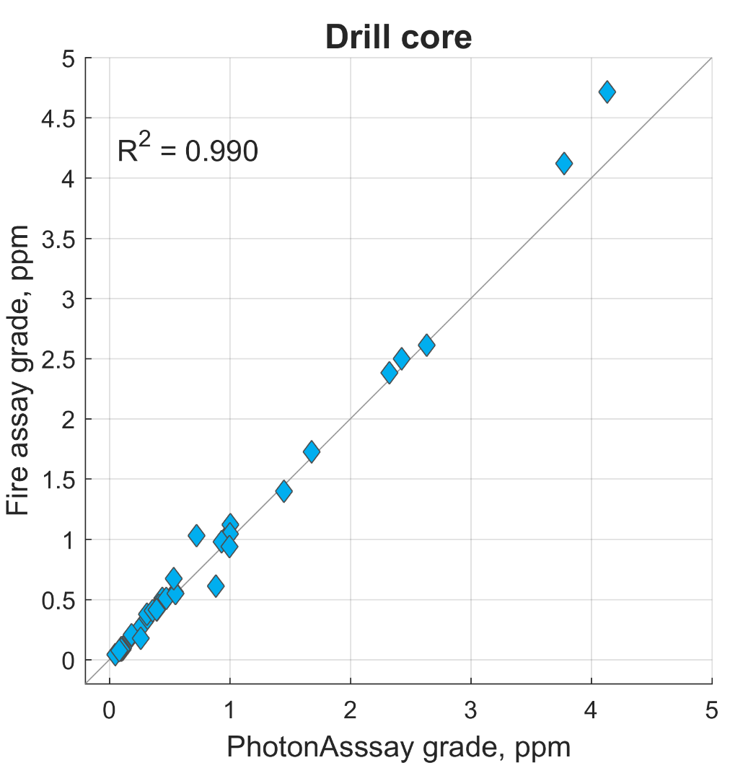 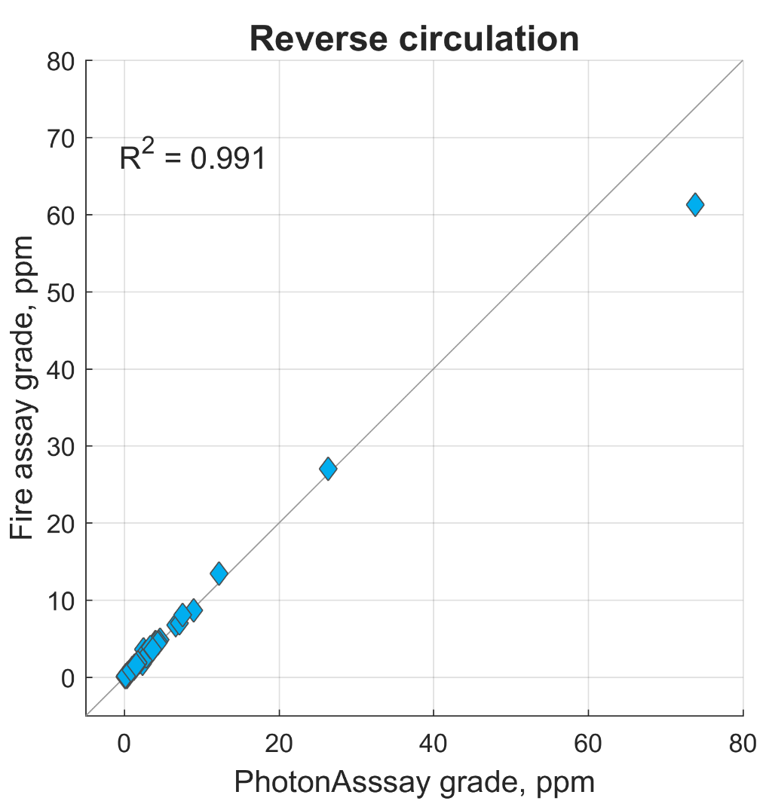

Figure 5: Fire-assay versus PhotonAssay correlation plots for drill-core samples (left) and reverse circulation drilling samples (right). PhotonAssay data are the average of measurements of two aliquots with a 2--3 mm top-size. Fire-assay data are the average of five aliquots.

Even with finely disseminated gold, PhotonAssay results show a smaller internal variance at grades above 0.06 ppm due to the larger sample size (Figure 6).

A major benefit of the PhotonAssay method is that it can provide results across a larger dynamic range (0.03-350 ppm for standard analysis, extensible to 35,000 ppm by reducing the X-ray beam power) in comparison to traditional fire-assay paired with a flame atomic absorption analyser (0.005-100 ppm). Also, as it is non-destructive, the same aliquot can be measured multiple times without damaging the sample.

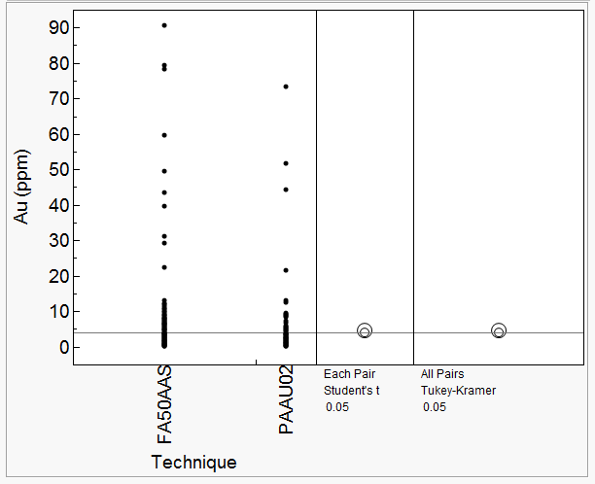

Figure 6: Comparison of PhotonAssay (SGA) and Fire Assay (FA50AAS) by analysis of variance (right) and pair analysis (left). Similar to Figure 4, the overlapping circles of the Student’s t-test and Tukey-Kramer HST pairs analysis suggest there are no significant differences in the results. The size of the circles represents the variance in the same set of samples with different aliquots analysed.

## Analysis of Coarse Gold Deposits

Coarse-grained gold deposits are typically characterised by having macro-sized gold grains or veins running through the ore body. When coarsely disseminated gold exists, the grade variance when the sample aliquot size is small compared to the bulk sample is greater than for finely disseminated gold (Figure 7). Therefore, either the gold particle size needs to be reduced, or analysis needs to be performed on larger sample sizes to obtain a representative value of the gold grade.

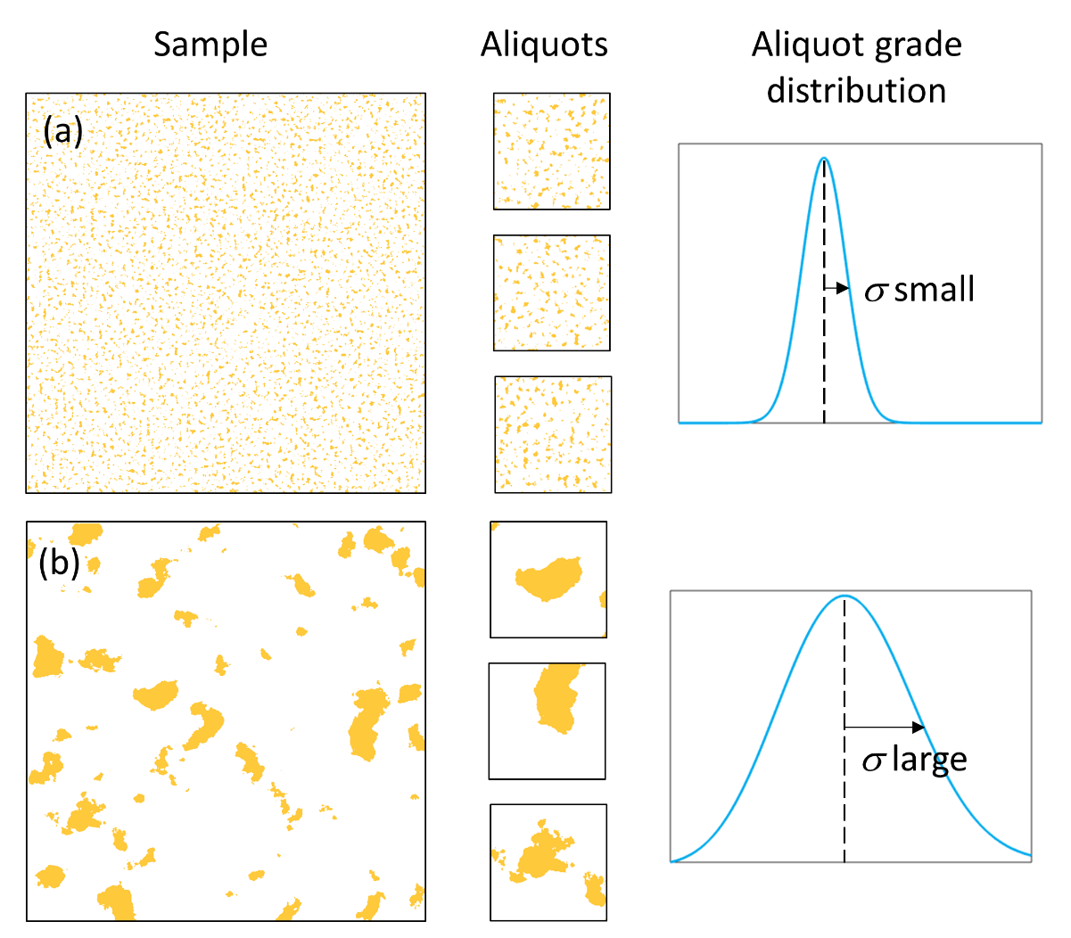

Figure 7: Illustration of aliquots from samples with finely disseminated gold (a) and coarse gold (b). The resulting distribution in gold concentrations are shown on the right.

A large suite of approximately 1450 samples was procured from an Australian mine site known to have an extremely coarse gold distribution. The samples, which comprised half NQ sized diamond core, were crushed to a top size of 10 mm and then pulverised in an LM5 mill to achieve a particle size of 90 percent passing 75 µm. Splits of the pulp were taken for PhotonAssay and 25 g fire-assay (FA25).

Comparison of the results are shown in Figure 8. The left-hand plot shows a pairwise comparison of the two assay methods. The right-hand plot illustrates the grade distribution, plotting PhotonAssay grade (solid line) and fire-assay grade (points) as a function of sample number, after sorting all samples according to the PhotonAssay grade.

Overall, results from the two assay methods are in good agreement, with an R2 value of 0.953 and no systematic differences in the grade population. However, a significant number of samples show large differences in gold value: for about 10 percent of the supplied samples, the fire-assay and PhotonAssay results differed by more than 25 percent.

This is not an uncommon finding in coarse gold deposits and some mining companies have dealt this by having the samples analysed by either cyanide leach or screen fire assays. Lyman *et al* (2016) suggests that the best way to reduce sampling errors is by using a pulverising and leach process in which a crushed drill sample is placed into sealed containers and pulverised whilst simultaneously undergoing a cyanide leach.

The process of cyanide leach (or gold cyanidation) was first developed in 1783 and is a well- understood and robust method for extracting gold. However, cyanide salts are extremely toxic and the pulverise and leach process produces significant waste. Quantitative results also require a follow-up fire-assay on residual solids to detect any undissolved gold.



Figure 8: Pairwise comparison of PhotonAssay and fire-assay grades for a large, coarse-gold sample suite (left). Grade distribution (right), with PhotonAssay and fire-assay grades plotted as a function of sample number, after samples have been sorted by PhotonAssay grade.

A screen fire assay is done by taking about 1 kg of pulverised sample and passing it through a screen mesh. The plus fraction (the material left on top of the screen) is expected to contain the macro-sized gold and is analysed to extinction. The minus fraction (the material that passes through the screen) is expected to hold the micron-sized gold grains and to be fairly homogeneous. The minus fraction is analysed in duplicate. The gold value is then calculated from a weighted average of the plus and minus fractions. Although this technique is very effective, it is more time consuming and costly.

To explore the observed PhotonAssay versus fire-assay discrepancies, 62 samples from the original suite showing the largest discrepancies were re-analysed by screened fire-assay. Figure 9 plots the results from this exercise.

Blue points indicate the PhotonAssay to fire-assay grade ratio for the 25 g fire-assay measurements; gold points indicate the PhotonAssay to screened fire-assay ratio. The vertical lines connect the two ratios calculated for each individual sample. The PhotonAssay results agree much better with the screened fire-assay results than the 25 g regular fire-assay measurements, due to the much larger mass sample aliquots used for the former analyses compared to the latter.



Figure 9. Comparison of 25g fire-assay (FA25) and screened fire-assay (SFA) and PhotonAssay results for selected subset of samples. The ratio of the FA25 (blue points) and SFA (gold points) grade values to the PhotonAssay value is plotted as a function of the mean grade for each sample. The vertical lines connect corresponding fire-assay measurements for each sample.

The larger sample size of the PhotonAssay instrument allows for accurate analysis with a similar sample size used for screen fire-assays or cyanide leach, but without the use of toxic chemicals or time-consuming preparation.

## Analysis of Core Samples

Over the past 5-8 years, there has been growing interest in the prospects of sorting ore prior to comminution to reject gangue, reduce energy and water usage and improve plant throughput. Many current ore-sorting systems depend on readily-measurable rock characteristics such as colour, size or infrared reflectance rather than direct measurement of the concentration of the gold itself (Kleine *et al,* 2010). It therefore becomes important to “train” the sorting system by developing correlations between these properties and the actual gold concentration.

PhotonAssay provides a non-destructive way of analysing rock or core pieces for their gold content; these samples can then be used to train the sorting system. In contrast, using traditional destructive techniques such as fire-assay, the geologist must rely on finding two similar samples (halves of a split core, for example), assaying one and assuming that the properties of the other are similar.

To look at the reliability of using PhotonAssay to measure single rock pieces, two experimental programs were performed using core samples from two drilling programs. In the first test, approximately 400 samples of diamond core were broken up into pieces that fitted inside a standard sample jar, with the remaining space padded with silica sand. The concentration of gold in the core pieces was then back-calculated based on the known dilution factor. The core pieces were then run through the ore-sorting system. The data were found to be qualitatively accurate and the relative gold values were consistent with historical information on the ore.

A second test was performed to evaluate the quantitative accuracy of the PhotonAssay measurements. After analysing core pieces via PhotonAssay, the samples were pulverised and re-measured using fire-assay. As shown in Figure 11, the correlation of samples with grades above 0.2 ppm is 99.9 percent. The difference in the values was consistent with the errors of the two assay techniques and no bias was evident.

R2=0.9988

Figure 11: Plot of PhotonAssay gold values measured using whole core pieces versus the gold concentration determined by fire-assay after the core is pulverised. The blue line shows the linear correlation between the two techniques. The gold data points show the grade difference between the two methods, indicating that no bias is present.

# CONCLUSIONS

PhotonAssay is a novel, high-energy X-ray method for gold analysis that provides fast, accurate, fully automated and non-destructive measurements on large ore samples. The method uses no chemical reagents and produces no waste.

Performance testing on certified reference materials (CRMs) shows that the technique can accurately reproduce gold grades determined using traditional methods such as fire-assay. The method is insensitive to most ore matrix types and demonstrates excellent linearity over grades ranging from about 0.06 to more than 300 ppm. By reducing the operating X-ray power, measurements up to percent levels (35,000 ppm) of gold can be made.

Extensive testing on real ores provided by more than 20 companies shows that PhotonAssay produces results that are consistent and interchangeable with those from fire-assay. The method has been ISO/NATA certified, and grade results have been included in JORC and NI43-101 compliant reports.

For ore deposits with fine gold dissemination, the large sample size allows accurate results to be obtained with minimal sample preparation, namely crushing to a top-size of 2-3 mm. For deposits with a higher fraction of coarse gold, it is preferable to pulverise the sample to a top-size of 75 µm before drawing the assay aliquot. For such difficult-to-sample ores, PhotonAssay produces results that are significantly more precise than those obtained using a traditional 25-50 g fire-assay analysis. In these cases, PhotonAssay results compare better with gold concentrations obtained using screen fire-assay, but with significantly lower costs and faster turn-around times.

The non-destructive nature of the analysis allows for novel applications, including the preparation of calibrated rock samples for ore-sorting.

# ACKNOWLEDGEMENTS

The authors would like to gratefully acknowledge the support of staff at Ausdrill Limited, MinAnalytical Laboratory Services and Chrysos Corporation for their help in setting up and running the trials described in this paper. We would also like to thank the numerous Australian and international companies that provided the samples and reference materials used in this study.

# REFERENCES

François-Bongarçon, D. “Sampling in the Mining Industry Theory and Practice”, Volume1: Course Notes, University of Witwatersrand, 1995

François-Bongarçon, D. and Gy P.M. “The most common error in applying ‘Gy’s Formula’ in the theory of mineral sampling, and the history of the liberation factor” JSAIMM, 2002, 102, p475-480

Gy, P.M. “The sampling of broken ores--A review of principles and practice”, Geological, Mining, and Metallurgical Sapling, 1973, p194-205

Kleine, C. et. al. “XRT sorting of massive quartz sulphide type gold ore*.” International Conference on Sensor Based Sorting*, 2010

Lyman, G. J. “Theory of Sampling”, WCSB Sampling, 2011, p1-21

Lyman, G. J., Robertson, I. G., and Day T. “The Simple Facts about Sampling Gold Ores” AUSIMM Operators’ Conference, 2016, p1-14

Minnitt, R.C.A, Rice, P.M., and Spangenberg, C. “Part 1: Understanding the components of the fundamental sampling error: a key to good sampling practice”, JSAIMM, 2007a, 107, p505-511

Minnitt, R.C.A, Rice, P.M., and Spangenberg, C. “Part 2: Experimental calibration of sampling parameters K and alpha for Gy’s formula by the sampling tree method”, JSAIMM, 2007b, 107, p513-518

Minnitt, R.C.A and Assibey-Bonsu, W. “A comparison between the duplicate series analysis method and the heterogeneity test as methods for calculating sampling constants, K and alpha” JSAIMM, 2010, 110, p251-268

J. Tickner, B. Ganly, B. Lovric, J. O'Dwyer (2017). “Improving the sensitivity and accuracy of gamma activation analysis for Gold”, Applied Radiation and Isotopes 122 (2017) 28–36