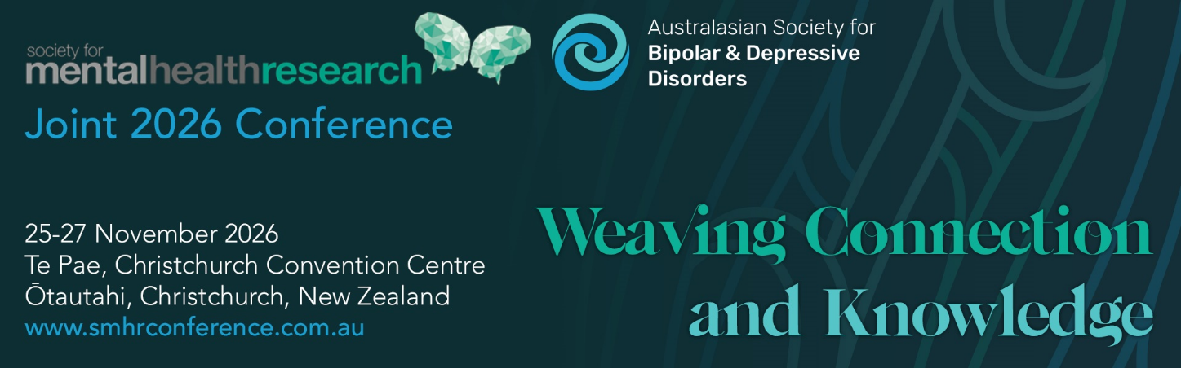

EMCR Bursary Application Form

SMHR will be providing 5 x $1000 bursaries to assist EMCRs with attendance at the Joint 2026 SMHR and ASBDD conference. These bursaries are in addition to the usual travel grants and are separable from the EMCR awards.

Nominee Details

Title
Name
Institution/s
Position/s
State
Current member of SMHR? | Yes No

Criteria for the Award
- Financial member of SMHR at the time of application
- An email or letter from supervisor to confirm PHD student/EMCR status and any institutional contribution
- CV required

Obligations: Nominees are required to attend the Joint 2026 SMHR and ASBDD conference
We welcome applications from all EMCRS. If oversubscribed, preference will be given to those with a significant distance or cost to travel, and those who would be unable to attend the conference without this support (eg those with no institutional support for travel).

Provide a justified budget, including any institution contribution to travel/attendance.

Explain the significance of your presentation to the conference theme and your prior involvement with SMHR (150 words)

How do you plan to make the most of your conference attendance (150 words)

Applications should be uploaded via the website with the file format:
“2026_AWARD NAME_APPLICANT SURNAME.PDF”

Due date: 29 June 2026 by 5pm AEST

Applications must be made on this form and will not be accepted after the deadline.

Successful applicants will be advised by late July.

