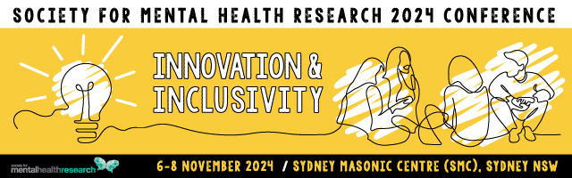

SMHR Founders Medal 2024

This award was named in honour of the four founders of SMHR: Professors Scott Henderson, Issy Pilowsky, Graham Burrows and Peter Beaumont. The medal is awarded to persons who, over their entire careers, have made a contribution of significance to mental health research.
Nominee

Title
Name
Institution/s
Position/s
Current member of SMHR? | Yes No
Is the Nominee aware of the nomination? | Yes No
Is the Nominee available to present at  the 2024 SMHR Annual Conference? | Yes No

Nominator

Title
Name
Institution/s
Position/s
Current member of SMHR? | Yes No
Relationship to nominee?

Criteria for Founders Medal
The nominee will be a financial member of SMHR at the time of nomination. This award is evaluated using NHMRC category descriptors for track record and is based on publications, grants, impact and contribution to SMHR. These details are to be provided by the Nominator. These criteria are judged by the SMHR Executive Committee.

Details of Award
The awardee will be presented with a medal and a certificate and payment of conference registration fees at the 2024 annual SMHR conference. The awardee will be featured on the SMHR website.

Obligations
The successful applicant is required to present at the 2024 SMHR Conference. The time and place for the presentation is determined in consultation with the Conference Local Organising Committee.

Award Sponsor
Society for Mental Health Research

Nominator’s statement
Statement of contribution to and impact on mental health research (500 words)

Statement of contribution to SMHR (200 words)

Publications and their impact (200 words)

Grant history and significance (200 words)

Applications should be uploaded via the website with the file format 2024_AWARD NAME_APPLICANT SURNAME.PDF “

Due date: 30 August 2024 by 5pm AEST

Applications must be made on this form and will not be accepted after the deadline.

Successful applicants will be advised by late September 2024.

