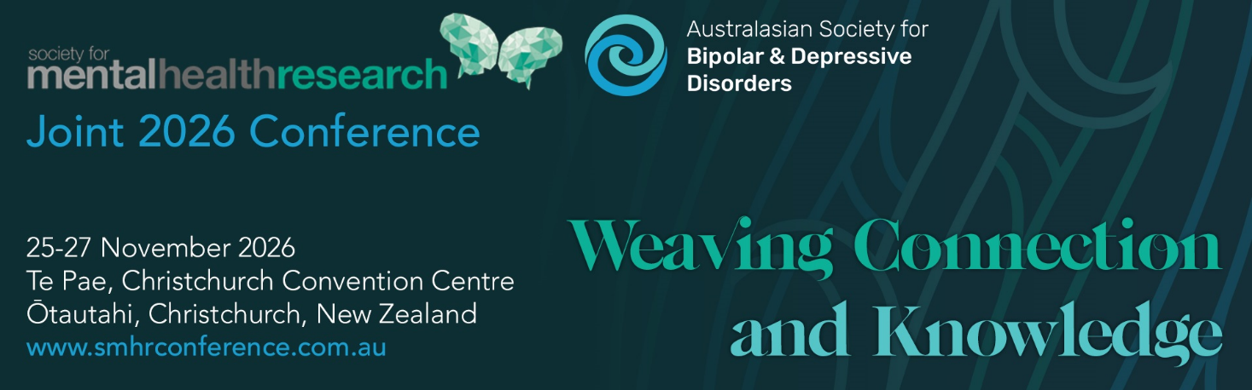

SMHR Early Career Scholar Award 2026

This award is for a researcher early in their career (no more than 2 years’ post PhD submission) to facilitate attendance at the Joint 2026 SMHR and ASBDD conference to present their work.

Nominee

Title
Name
Institution/s
Position/s
Date PhD conferred
Current member of SMHR | Yes No
The nominee can attend the Joint 2026 SMHR and ASBDD conference. | Yes No

Criteria for the Award: The nominee must be a financial member of SMHR. The award is evaluated using NHMRC category descriptors for track record and is based on publications, grants, and impact. Nominees must be within 2 years (as at 31st March 2026) from the date of the letter advising that their doctoral thesis was passed, unless career disruptions exist. Contribution to SMHR will also be considered. Persons on the SMHR Executive are not eligible for this award.
Details of the Award: The award includes a certificate, $1000 travel support (contingent on attendance) as well as complimentary conference registration at the Joint 2026 SMHR and ASBDD conference. The awardee will be featured on the SMHR website.
Obligations: The successful applicant is required to attend the Joint 2026 SMHR and ASBDD conference. They will also be given the option of presenting at the Conference in Christchurch.
Award Sponsor: The Society for Mental Health Research

Explain any career disruption (200 words)

Contribution to SMHR (200 words)

Curriculum vitae (1 page)

Include the following: career summary, research grants and fellowships, impact of research, collaborations and community engagement, and professional involvement.

Top 5 publications

Publication 1

Reason for selection:

Publication 2

Reason for selection:

Publication 3

Reason for selection:

Publication 4

Reason for selection:

Publication 5

Reason for selection:

Applications should be uploaded via the website with the file format:
“2026_AWARD NAME_APPLICANT SURNAME.PDF”

Due date: 29 June 2026 by 5pm AEST

Applications must be made on this form and will not be accepted after the deadline.

Successful applicants will be advised by late July.

