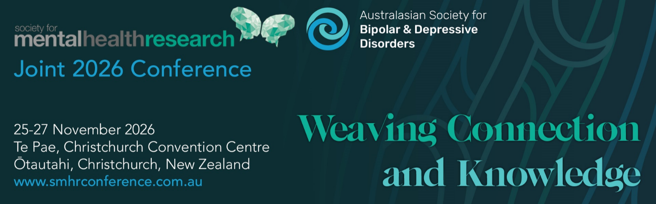

SMHR Oration Award 2026

This award is bestowed to persons who are prominent or rising to prominence in the Australian and New Zealand mental health research community.
Nominee

Title
Name
Institution/s
Position/s
Current member of SMHR? | Yes | No
Is the Nominee aware of the nomination? | Yes | No
Is the Nominee available to  present an Oration at the Joint 2026 SMHR and ASBDD conference? | Yes | No

Nominator

Title
Name
Institution/s
Position/s

Current member of SMHR? | Yes No
Relationship to nominee?

Criteria for the Award: The award is evaluated using NHMRC category descriptors for track record and is based on publications, grants and impact. These details are to be provided by the Nominator. These criteria are judged by the SMHR Executive Committee.

Details of Award: The awardee will be presented with a medal and a certificate, $1000 travel support (contingent on attendance) as well as complimentary conference registration at the Joint 2026 SMHR and ASBDD conference. The awardee and their work will be featured on the SMHR website.
Obligations: The successful applicant is required to present an oration at the Joint 2026 SMHR and ASBDD conference. The time and place for the presentation is determined in consultation with the Conference Organising Committee.

Nominator’s statement

Statement of contribution to and impact on mental health research (500 words)

Publications and their impact (200 words)

Grant history and significance (200 words)

Applications should be uploaded via the website with the file format:
“2026_AWARD NAME_APPLICANT SURNAME.PDF”

Due date: 29 June 2026 by 5pm AEST

Applications must be made on this form and will not be accepted after the deadline.

Successful applicants will be advised by late July.

