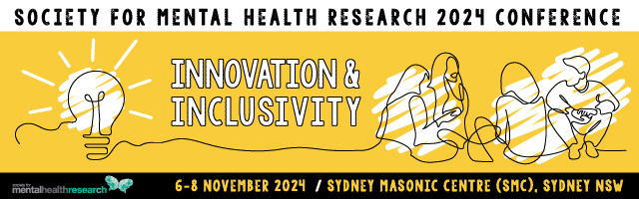

**Rising Star Award 2024**

This award is bestowed to a “Rising Star” in mental health research. That is, a person whose work is beginning to make a significant impact on the national and international scene, reflecting either scientific excellence or public impact (or both).

Nominee

|  |  |
| --- | --- |
| Title |  |
| Name |  |
| Institution/s |  |
| Position/s |  |
| Current member of SMHR? | Yes No |
| Is the Nominee able to attend the 2024  SMHR Annual Conference? | Yes No |
| Date PhD Conferred |  |

Criteria for the Award

The nominee will be a current financial SMHR member. The award is evaluated using NHMRC category descriptors for track record and is based on publications, grants, and impact. It is expected that the nominee is at least 2 years and less than 7 years (as at 31st March 2024) from the date of the letter advising that their doctoral thesis was passed, unless career disruptions exist. Contribution to SMHR will also be considered.

Details of the Award

The award includes a certificate and payment of conference registration fees at the 2024 annual SMHR conference. The awardee will be featured on the SMHR website, and asked to participate in a short podcast about their work that will be posted on the SMHR website.

Obligations

The award winner will attend the 2024 Conference. They will also be given the option of presenting at the 2024 Conference in Sydney.

Explain any career disruptions (200 words)

Contribution to SMHR (200 words)

Curriculum Vitae (1 page)

Include the following: career summary, research grants and fellowships, impact of research, collaborations and community engagement, and professional involvement.

# Publication 1

Reason for selection:

# Publication 2

Reason for selection:

Reason for selection:

# Publication 4

Reason for selection:

Reason for selection:

Applications should be uploaded via the website with the file format 2024_AWARD NAME_APPLICANT SURNAME.PDF “

**Due date:** **30 August 2024 by 5pm AEST**

*Applications must be made on this form and will not be accepted after the deadline.*

Successful applicants will be advised by late September 2024.