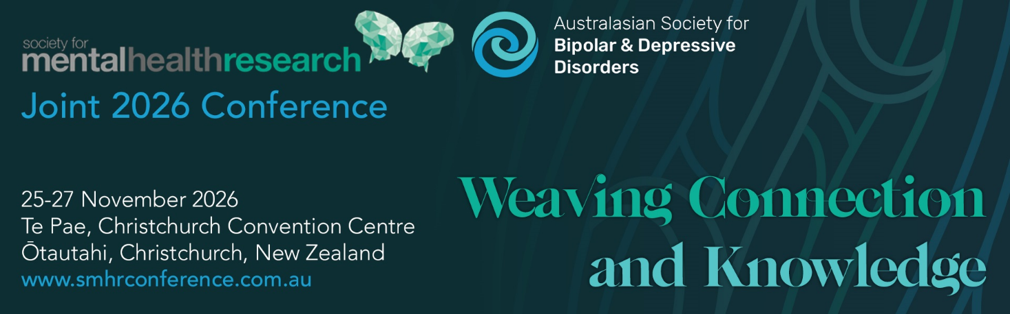

SMHR Carer Travel Scholarship

2x $1000 Carer Travel Scholarship will be available for students and early-mid career researchers who are the primary carer of one or more children under 5 years of age, to assist in the care of children while the recipient attends the conference
Nominee Details

Name
Institution/s
Position/s

Criteria for the Award:
• Financial member of SMHR at the time of application
• Current PhD student or graduated from PhD within past 10 years (letter of conferral received after 30/11/2016)
• Primary carer of one or more children under 5 years of age.
• The award can be used in whatever way is best for the recipient’s personal circumstances (e.g. it could be used to fund a companion to join them at the conference to look after a child/ren, or for additional days of childcare)
Obligations: The successful applicant is required to attend the 2026 SMHR Conference.

Please briefly explain your previous contribution to SMHR (100 words max)

**Please attach a one-page CV to support your application

Eligibility
Please ensure you complete the eligibility details below. Incomplete applications will not be considered for the award.

Declaration

I declare that:
- I am the primary carer of one or more children under 5 years of age
- I have attached a one-page CV.

Signed:
Date:

Applications should be uploaded via the website with the file format: “2026_AWARD NAME_APPLICANT SURNAME.PDF”

Due date: 29 June 2026 by 5pm AEST

Applications must be made on this form and will not be accepted after the deadline.

Successful applicants will be advised by late July.

