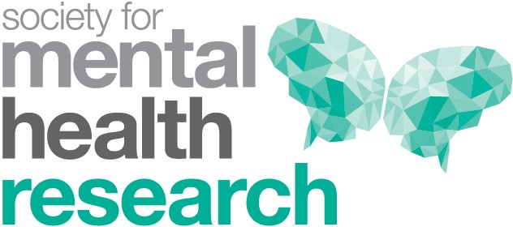

Australian Rotary Health (ARH) Mental Health “Impact” Award 2025
This award recognises excellence in knowledge dissemination and research translation. The prize is open to persons or organisations who demonstrate outstanding effort to disseminate knowledge about evidence‐based interventions in mental health and implement research findings into policy and practice.

Nominee (individual)

Title
Name
Institution/s
Position/s
Is the nominee willing to record a talk for the SMHR website?

Criteria for Award
The award is open to all researchers, clinicians and consumers and organisations who seek to
advance the availability of evidence-based interventions for those who are experiencing mental
illness in the Australian community. The entry should describe the activity, the target audience
and the evidence base for the research/knowledge that is being promoted. It should also
describe the impact that their activity has had and how this was measured.

These details are to be provided by the Nominator. These criteria are judged by a panel of three, with one nominated by Rotary and two by the SMHR Executive.
Details of Award
The award consists of a plaque and travel support of $3000 to attend the SMHR conference.

Obligations
The nominee must be a financial member of SMHR. The successful applicant is required to record a talk that will be able to be used by SMHR and ARH as well as attend the conference in Sydney to receive the award. The successful applicant is also required to be available for no less than three speaking engagements over the ensuing 12 months. (Note that if the future speaking engagements are not held in the town or city where the successful applicant lives, then the Australian Rotary Health will cover the cost of airfare and accommodation).

Award Sponsor
Australian Rotary Health

Statement of contribution to and impact on mental health knowledge dissemination or research translation

Information relating to the activity (200 words max)

Who is the target audience for the activity? (200 words max)

What is the evidence base for the research/knowledge which is being promoted, and its impact? (500 words max)

Applications should be uploaded via the website with the file format 2025_AWARD NAME_APPLICANT SURNAME.PDF “

Due date: 29 August 2025 by 5pm AEST

Applications must be made on this form and will not be accepted after the deadline.

Successful applicants will be advised by late September.
The award will be presented by Australian Rotary Health at the 2025 SMHR Conference in Adelaide.

