INSTRUCTIONS FOR full papers for   
CLEAN INDOOR AIR FOR ALL Conference

Jack Smith1 and Brian E. Jones2

1 2 Thomastown Rd, Christchurch, 8543, New Zealand

2 CRAS Systems, Bishopdale, Christchurch, 8543, New Zealand

Abstract (Abstract heading style)

Insert abstract for paper here (use abstract text style). Do not exceed 300 words. Include the main purpose of the paper and the principal conclusions.

Include a list of keywords, after the abstract. Use a single column down to the end of the abstract, then leave 7 mm (20 pt) space below and use two columns for the rest of the paper.

*Keywords*: list up to 4 keywords.

# Page Format

## Length of manuscript

Manuscripts must not exceed six pages (excluding appendices). Papers can be less than 6 pages but must convey sufficient information – see also “Extended abstract template”.

## Paper Layout

A4 (297 × 210 mm). Margins should be as follows: top 20 mm; bottom 20 mm; sides 20 mm; space between columns 8 mm. The summary is indented an additional 25 mm from the left and right paper edges.

Use two columns for the rest of the paper (except for any unavoidably wide tables or illustrations).

# Type Specifications

## Headings

Heading specifications are stored as ‘styles’ in the sample MS Word document provided by the conference organisers. If you have to enter them manually, they are as follows:

* Paper title: 16 pt Arial font, all capitals, centred (Title style).
* Authors’ names: 12 pt Arial, sentence case, spaced 2.5 mm (or 7 pt) beneath the title (Author style).
* Authors’ affiliations and addresses: 9 pt Arial (Author address style).
* Abstract heading: 12 pt Arial, sentence case, 7 mm (=20 pt) space above and 1 mm (3 pt) below (Abstract heading style).
* Main section headings: 12 pt Arial bold, numbered (with hanging indent), sentence case, left justified. (Stored as Heading 1 style in the MS Word document). 14 pt space above and 3 pt space below.
* First-level subheadings: 11 pt Arial, numbered (with hanging indent), sentence case, left justified. 10 pt space above and 3 pt space below (Heading 2 style).
* Second-level subheadings: 10 pt Arial italic, num­bered (with hanging indent), sentence case, left justified. 7 pt space above and 2 pt space below (Heading 3 style).

### Here is an example second-level subheading (Heading 3)

* Acknowledgements etc heading: 12 pt Arial, sentence case, 7 mm (=20 pt) space above and 1 mm (3 pt) below. Left aligned. (Acknow style).

## Body Text

* 10 pt Arial, justified, spacing of 3 pts after each paragraph (Normal style).
* Fully justify each line, hyphenating if necessary.
* Insert only a single space after a sentence.
* Avoid hyphens at the ends of two or more con­secutive lines.
* Use bullets (bullet style) similarly to here, with the minimum spacing (3 pt) between them to provide clear separation.

1. Avoid widows and orphans.

# Content

## Title

The title should be as concise as possible - generally no more than two lines.

## Abstract

Do not exceed 300 words. Include the main purpose of the paper and the principal conclusions.

End the summary with a list of keywords, as above.

## Notation

If necessary for clarity, you may include a glossary of mathematical symbols *etc*. under an unnumbered heading ‘Notation’ before the main text.

## Body of the Manuscript

### Units

Use SI units wherever appropriate. Use slashes as in ‘m/s’ rather than ‘ms-1’ except where confusion may arise.

### Equations

Number all equations at the right edge of their column.

$A=πr^{2}$ (1)

Equations should fit in a single column, even if they span two lines.

### Illustrations

Illustrations should mostly fit in a single column, as below with a spacing of 12 before and 10 below the illustration (Illustration style). All illustrations should be referred to in the text, as in the case of this reference to Figure 1.

A numbered caption in 10 pt roman type should be placed below each illustration with paragraph spacing of 12 points after the caption (use caption style), as in the example below. Captions should be concise, leaving full explanation to the text. The width of text should be at least 10 mm narrower than the full column. Captions with more than two lines usually look better as justified text rather than centred.

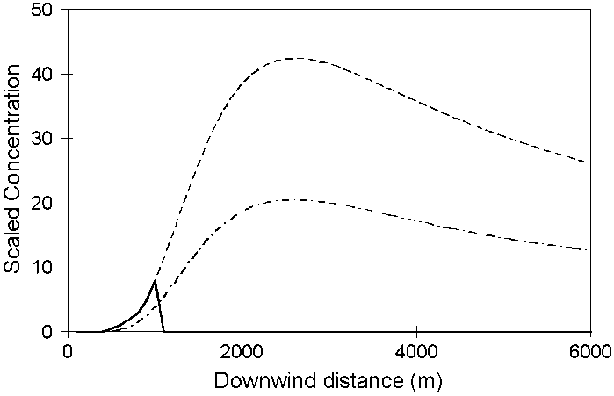

Figure 1. Example illustration (Caption style).

Figures or images should be inserted using the Insert-Picture option in Word. This will fit them to the width of the column and in line with the text. This avoids the problem of floating images. Figures are generally best saved as .png files and images as .jpg files before inserting them. A maximum image width of 1000 pixels for the saved png/jpg files is generally more than adequate for this conference paper format. The size of your document should not exceed 10 MB.

### Tables

Tables may span one or two columns. If necessary, a large table may be presented in ‘landscape’ orientation, i.e. rotated with the top of the table on the left-hand side of the page.

Table 1. Example of table

|  |  |  |
| --- | --- | --- |
| **Grid** | **Colour** | **Flavour** |
| Inner | Red | Raspberry |
| Outer | Green | Apple |

Table captions should be at the top of each table, but otherwise conform to the specifications for illustrations.

### Citations and List of References

Please take great care to ensure references are properly and fully included in your manuscript. They are the most common source of drafting faults in papers.

The Harvard system (AGPS 1994) should be used for citing publications in the text and listing their details at the end of the manuscript. A brief summary follows:

Generally, a textual citation requires only the name of the author (or authors) and the year of publication (with no comma between the two). Page numbers may be included where appropriate, as in ‘Milligan (1955, pp. 245-7)’.

Citations may be made by referring to the authors in mid-sentence, as in Sellers and Secombe (1957, 1958a, 1958b) or Milligan *et al*. (in press), but should preferably appear at the end of the sentence as here (Secombe & Sellers 1956, Milligan 1961).

The term ‘pers. comm.’ should not be used. Contrib­utions of this kind should appear in an Acknow­ledg­ment at the end of the paper.

All references cited should be listed at the end of the paper (or prior to any Appendix, if included). See the ‘References’ section of this paper for examples of listing references. More detail is provided by AGPS (1994).

### Commercial Products and Services

The conference proceedings are not intended as a marketing opportunity and should not be treated as such. Brand names, trade marks, logos *etc.* should only be used where they are important to the understanding of the paper.

Any claims about the performance or quality of a product or service should not use superlatives but be demonstrated by data.

# Licence to Use Copyright

By submitting a paper or extended abstract for presentation at the Clean Indoor Air for ALL Conference, as author, you grant the following license to the Clean Air Society of Australia and New Zealand (CASANZ). As author you retain copyright of the paper, in addition to the moral rights as entitled as author of the material. In consideration for the publication of the paper the author grants CASANZ a non-exclusive right to: publish, reproduce, distribute, display and store the abstract in all forms, formats and media now known or as developed in the future, including print, electronic and digital forms.

The author warrants that the paper is original work and does not infringe the intellectual property rights of any other person or entity and cannot be construed as plagiarising any other published work and that the paper has not been published previously.

If the research and/or presentation was prepared jointly with other authors, it is warranted that the author has been authorised by all co-authors to accept on their behalf, and to agree on their behalf the order of names in the publication of the abstract.

The paper contains no statement that is abusive, defamatory, libellous, obscene, fraudulent, nor in any way infringes the rights of others, nor is in any other way unlawful or in violation of applicable laws.

To view the full License to Use Copyright Policy, visit the CASANZ website.

Acknowledgments

Acknowledgment by the author of the use of material from an outside source is a condition of such use, as well as a courtesy. Wherever possible, it should be made not only in the acknowledgments section but also at the place or places in the text where the material is included.

References

See Section 3.4.5 for rules of citing and listing references. Note the use of hanging indents below (Use references style). Double quotation marks should only be used within single quotation marks. Don’t follow the example in this paper and fail to include the reference for papers cited in the text,

AGPS (Australian Govt Publishing Service) 1994, *Style Manual for Authors, Editors and Printers*, AGPS, Canberra.

Baker R. 1995, ‘Risk management and risk assessment in air quality standards setting’, *Clean Air (Aust.)* **25**:62-7*.*

Dahl R. 1986, *Two Fables*, ill. G. Dean, Viking (Penguin), Harmondsworth.

Kuschel G. and Foster E. 1996, ‘The Christchurch emissions inventory as an air quality management tool’, *Proceedings of the 13th International Clean Air and Environment Conference, Adelaide, 1996*, Clean Air Society of Australia & New Zealand, Eastwood, NSW, Australia, pp. 180-185.

Milligan T.C., Secombe H. & Sellers P. 1986, ‘Particle Pollution in Woy Woy, NSW’, *Clean Air (Aust.)* **145**:233-8.

Appendix

This is where you would insert any appendix. Multiple appendixes should be labelled A, B, C, Appendices can be additional to the 6 page limit but should not exceed 2 pages, ie. total length of paper with appendices should not exceed 8 pages)