IUFRO Field Trip Friday 13-Sunday 15 September – Provisional Itinerary
Time | From | To | Approximate Travel Time | Notes
Friday 13 September
12.30 – 1.50 pm | Waitangi - Copthorne | Whangarei Falls | 1 hr 20 mins
1.50 - 2.05 pm | Comfort Stop /lunch
2.05 - 5.05 pm | Whangarei Falls | Bombay Hills Rest stop (BP Rest Stop) | 3 hours
2.05 - 5.05 pm | Whangarei Falls | Auckland Airport | 3 hours | Option for those not going on post conference tour to disembark.
5.05 - 5.15 pm | Comfort Stop
5.15 – 6.25 pm | Bombay Hills Rest stop (BP Rest Stop) | Good George, Hamilton | 1 hour 10 min | Set menu included in cost – special dietary requirements will be catered for.
6.25 - 7.25 pm | Dinner |  |  | 1 hour
7.25 – 9.10 pm | Good George, Hamilton | Sudima, Rotorua | 1 hour 45 min
Saturday 14 September
9.30 – 9.45 am | Sudima Rotorua | Scion | 15 minutes
9.45 - 10.05am | Visit Scion’s award-winning building Te Whare Nui O Tuteata  Potential welcome with Scion’s Te Ao Maori team
10.05 – 11.30am | Visit Scion labs: lab demonstrations, research discussions. |  |  | Walk to nursery from lab.
11.45 - 12.15pm | Visit Scion’s research nursery |  |  | Walk back to Whare Nui o Tuteata.
12.30 - 1 pm | Lunch – Packed lunch provided |  |  | Comfort stop.
 | RNC in the field:
- - 2.30 pm | Scion | Whakarewarewa Forest – observe disease | 15 min
1.15 – 2.30 pm | Walk to forest site to discuss red needle cast (5-10min walk)
2.30 – 2.45 pm | Whakarewarewa Forest | Te Puia | 10 min | Guided Tour and entry fee included in cost.
3.00 - 4.15 pm | Te Puia - Te Rā Guided experience
4.15 – 4.30 pm | Te Puia | Sudima | 15 min
4.30 – 7pm | Free time  Allow 15-20 minutes to walk to Brew
7 – 8.30pm | Dinner at Brew Craft Beer Pub, 1103 Tutanekai st - “Eat Street” |  |  | Own expense
8.30 - 9.30pm | Own time to explore – see information packs about different evening activities for discussion over dinner |  |  | Own expense. Possible examples of activities:  - Redwoods Nightlights Treewalk (closes 10pm)  - Wai Ariki Hot Springs & Spa (closes 10.30 pm  - Polynesian Spa (closes 11 pm)
Sunday 15 September
8.30 -11.30 am | Rotorua | Auckland International Airport | 3 hrs 30 min  (2 hours 40 min) | Neet to be at the international airport by 11.30 am to allow people to catch afternoon flights out.

Paihia-Rotorua Friday 13
6 hr 22 min (466 km)
Copthorne Hotel and Resort Bay of Islands
Sudima Lake Rotorua
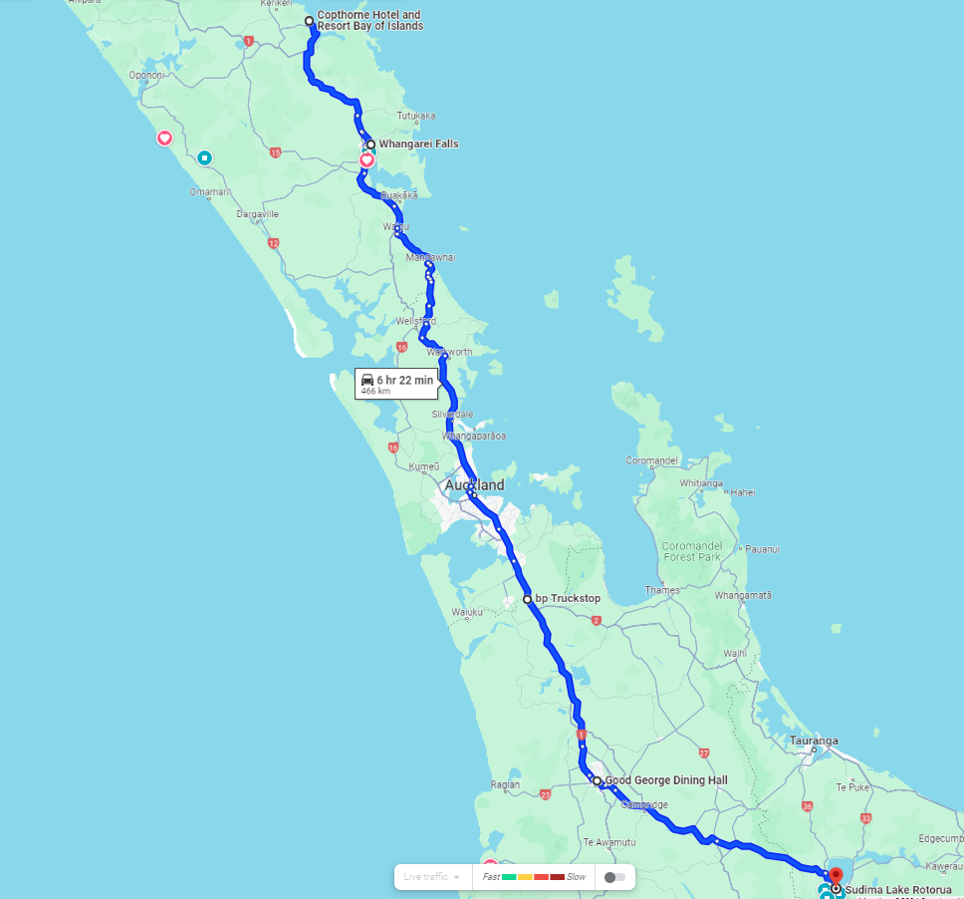

Walking tour of Rotorua (4.2 km)- Optional