

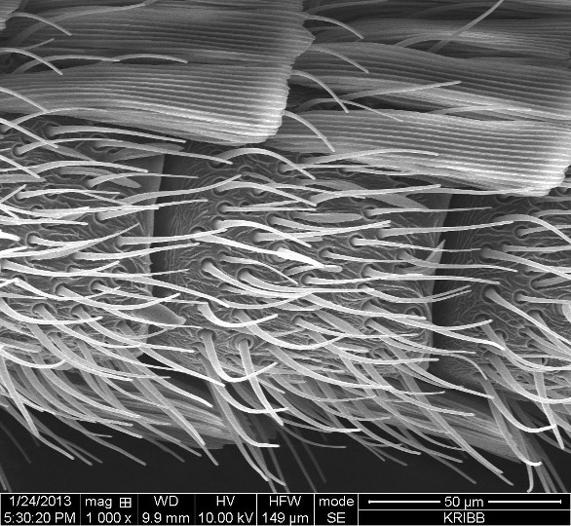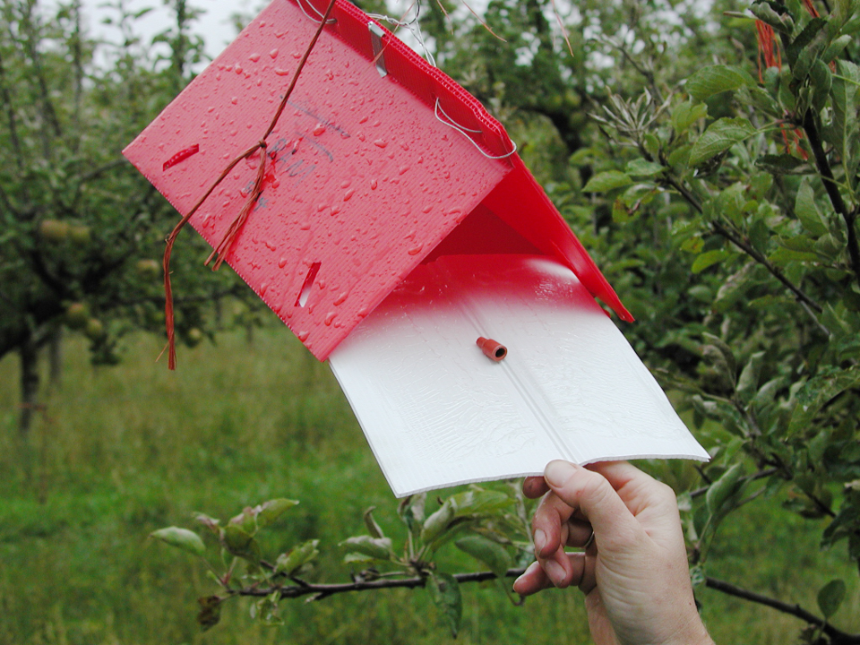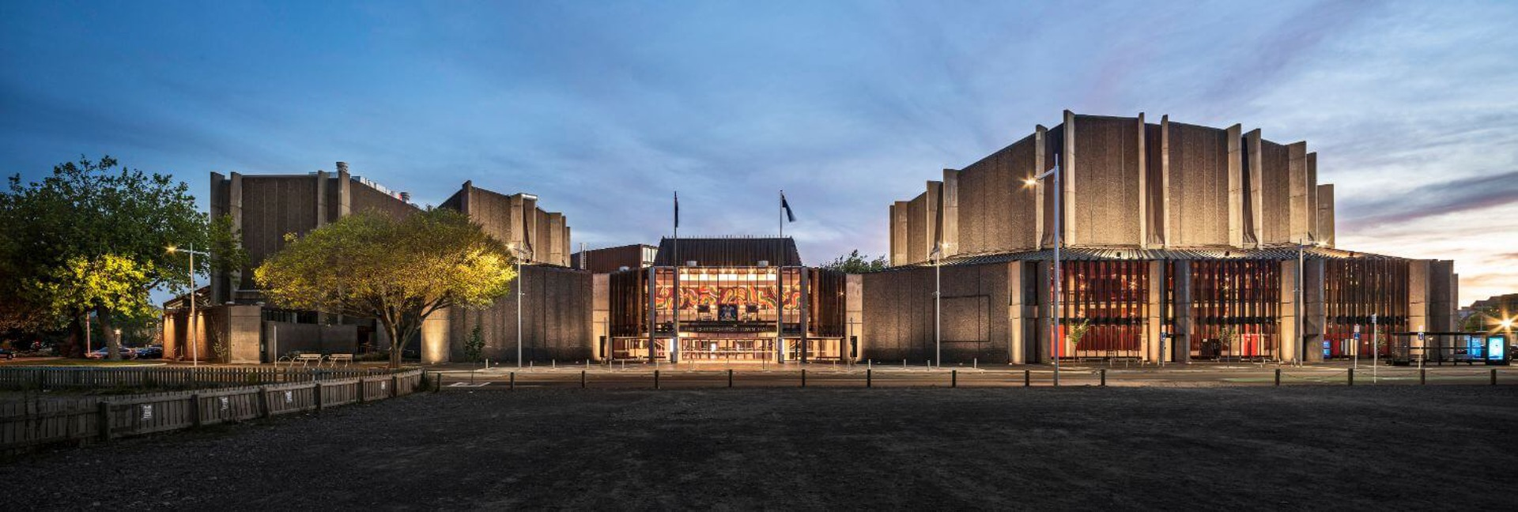

SPONSORSHIP PROSPECTUS

### OVERVIEW

**ISCE-APACE 20252025 Joint Conference of the International Society of Chemical Ecology and the Asia-Pacific Association of Chemical Ecologists**

This quadrennial event, jointly organized by ISCE and APACE, will bring together students, research scientists, and stakeholders from around the globe to explore the dynamic field of chemical ecology. Set against the backdrop of Christchurch, the vibrant "Garden City," attendees will have the opportunity to engage in stimulating discussions and presentations on a wide range of topics of chemical ecology—from molecular interactions to ecosystem dynamics, from fundamental understanding to practical applications, and from psychological aspects to societal impacts.

Please join us for an enriching experience in the southern, green, and pristine landscape of Aotearoa New Zealand. We look forward to your participation in this exciting scientific gathering!

### CONFERENCE VENUE

Christchurch Town Hall

Christchurch

New Zealand

[Website](https://www.venuesotautahi.co.nz/hire/christchurch-town-hall)

### CONTACT

ISCE-APACE 2025

Plant & Food Research

120 Mt Albert Road

Auckland 1025

New Zealand

C/- Yvonne McDiarmid

Email: [events@plantandfood.co.nz](mailto:events@plantandfood.co.nz)

Phone: (+64) 09 925 7042

### Major sponsorship packages

|  |  |  |  |  |  |  |  |
| --- | --- | --- | --- | --- | --- | --- | --- |
|  | Platinum (1 only) NZ$15,000 | Gold NZ$10,000 | | Silver NZ$5,500 | | Bronze NZ3,000 | |
| **Acknowledgement** | | | | | | | |
| Acknowledged at the opening/closing sessions | ✓ | | ✓ | | ✓ | | ✓ |
| **Presentation opportunity** | | | | | | | |
| Opportunity to present to delegates (4 min) | ✓ | |  | |  | |  |
| **Logo & Name Inclusions** | | | | | | | |
| Logo on delegate name badge | ✓ | |  | |  | |  |
| Logo on attendance certificate | ✓ | |  | |  | |  |
| Logo on the conference website with link to the company’s website | ✓ | | ✓ | | ✓ | | ✓ |
| Logo to be displayed on the sponsors slide at the conference | ✓ | | ✓ | | ✓ | | ✓ |
| Logo featured on all conference  e-newsletters | ✓ | | ✓ | |  | |  |
| **Conference App** | | | | | | | |
| Advertisement via Banner Ad in Conference App (artwork to be supplied by sponsor) | ✓ | |  | |  | |  |
| Company logo displayed | ✓ | | ✓ | | ✓ | | ✓ |
| **Exhibition Booth** | | | | | | | |
| 3m x 2.4m space – exhibitor to bring their own free-standing display | 3m x 2.4m  space | | 3m x 2.4m  space | |  | |  |
| **Conference Registrations** | | | | | | | |
| Includes: access to conference, daily catering, Welcome Reception and Conference Dinner | 2 | | 1 | | 1 | |  |
| **Sponsors’ Giveaway Table** | | | | | | | |
| Opportunity to provide flyer/item on table | ✓ 3 items | | ✓ 2 items | | ✓ 1 item | |  |

### Additional sponsorship opportunities

#### Session/workshop Sponsor – NZ$3,000

* Opportunity to contribute to the workshop (in negotiation with program committee)
* Exclusive naming rights to the sponsored workshop
* Company banner displayed during workshop
* Acknowledgement as a sponsor in the conference app
* Acknowledgment in all plenary session on sponsors slide
* Logo on conference website with a link to your homepage
* Opportunity to place a promotional flyer/item on the sponsors’ giveaway table

#### Sponsors’ Giveaway Table – NZ$1,000

* Company name/logo in the conference handbook
* Opportunity to place a promotional flyer/item on the sponsors giveaway table
* Acknowledgment on sponsors’ slide
* Logo on the conference website with a link to your homepage

#### International Keynote Speakers – NZ$4,000

* Naming rights to the sponsored keynote’s session
* Acknowledgement as a sponsor in the conference app
* Acknowledgment in all plenary session on sponsors’ slide
* Logo on conference website with a link to your homepage
* Opportunity to place a promotional flyer/item on the sponsors’ giveaway table

#### Student Poster Prize ($1,000) and Student Speaker Prize ($1,000) – NZ$2,000

* Logo on website
* Acknowledgement as a sponsor in the conference app
* Acknowledgment in all plenary session on sponsors slide

#### Welcome Reception (1 ONLY) – NZ$4,500

* Two complimentary tickets to the welcome reception
* Opportunity to display company banners in the welcome reception area
* Verbal acknowledgement of sponsorship at the welcome reception
* Acknowledgement as a sponsor in the conference app
* Logo on conference website with a link to your homepage
* Opportunity for company representative to welcome delegates at the reception   
  (3 minutes)
* Opportunity to give gift bags to all delegates as they leave the welcome reception (to be supplied by sponsor with organising committee approval required)

#### Dinner Sponsor (1 ONLY) – NZ$5,500

This is an opportunity for a sponsor to host the conference dinner.

* Exclusive naming rights to the conference dinner
* Logo will be prominently displayed on conference dinner menus
* Opportunity to make a welcome speech at the conference dinner (maximum of 4 minutes)
* Company banner prominently displayed at the dinner (provided by sponsor)
* One complimentary registration which includes: lunches, morning and afternoon tea, Welcome Reception ticket, Conference Dinner ticket and the opportunity to participate in sessions
* Logo on conference website with a link to your homepage
* Acknowledgement as a sponsor in the conference app
* Acknowledgment in all plenary session on sponsors’ slide
* Opportunity to place an A4 promotional flyer / item on the sponsors giveaway table

#### Day Catering NZ$1,500

* Naming rights for the full day catering (morning/afternoon tea and lunch)
* Logos displayed on catering tables
* Acknowledgement as a sponsor in the conference app
* Logo on the conference website with a link to your homepage
* Acknowledgment in all plenary session on sponsors’ slide
* Opportunity a promotional flyer / item on the sponsors giveaway table

#### Lanyards NZ$2,500

* Company name/logo printed on lanyards (single colour print)
* Acknowledgement as a sponsor in the conference app
* Acknowledgment in all plenary session on sponsors’ slide
* Company logo on the conference website with a link to your homepage

#### Conference Notepads and Pens – NZ$1,000

Sponsor to supply notepads & pens

* Pads and pens to be placed on the sponsors giveaway table
* Acknowledgement as a sponsor in the conference app
* Logo on conference website with a link to your homepage

### TAILORED PACKAGES

We would be delighted to assist in the development of a tailored package for your company if none of the listed opportunities suit your promotional activities.

If you would like to discuss a tailored sponsorship package please do not hesitate to contact Yvonne McDiarmid, Events & Sponsorship Manager, c/- Plant & Food Research, [events@plantandfood.co.nz](mailto:yvonne.mcdiarmid@plantandfood.co.nz) or (+64) 09 925 7042.

If you would like to become a sponsor please complete the Sponsorship/Exhibition Acceptance Form at the end of this document and email to [events@plantandfood.co.nz](mailto:events@plantandfood.co.nz)

### EXHIBITION OPPORTUNITIES

#### Exhibition Space – NZ$1,700

* 150 word company listing in the conference app
* Listing on the conference website as an exhibitor and a link to your homepage
* 3m x 2.4m space – exhibitor to bring their own free standing display
  + one trestle table and two chairs supplied on request
* Two Exhibitor Passes – includes:
  + Attendance at the welcome reception
  + Morning tea, lunch and afternoon tea
  + Name badge for registrant
  + Delegate bag

#### Extra Exhibition Pass Registrations – NZ$375

Please contact events@plantandfood.co.nz to organize extra exhibitor passes.

**Note:** Exhibition passes do not include attendance at conference sessions or the conference dinner. Tickets to the conference dinner may be purchased separately from the Events Manager – events@plantandfood.co.nz.

If you would like to become an exhibitor please complete the Sponsorship/Exhibition Acceptance Form at the end of this document.

GENERAL INFORMATION

All prices quoted are in New Zealand dollars and are GST exclusive.

Sponsors will be informed of all deadlines for the provision of information or materials through regular email updates and the conference website. The deadlines for delivery or supply of materials, information or artwork are not negotiable. In the event that materials, information or artwork required by Conference Logistics are not received by the designated due date, their use for their intended purpose cannot be guaranteed. The value of these entitlements will not be refunded in this circumstance.

The acceptance of the application shall be at the discretion of the organising committee, and upon acceptance, becomes a contract. By completing and signing the application, the undersigned agrees to comply with, and be subject to, the terms and conditions plus cancellation policy contained in this document. The Organisers (ISCE-APACE 2025 Organising Committee) reserve the right to refuse or deny any application.

### Terms & conditions

1. All sponsorships are non-exclusive and non-negotiable. Sponsorship will be allocated on receipt of the signed application form and deposit.
2. Application for sponsorship must be made in writing using the designated application form. Confirmation will be provided to confirm the booking, together with a tax invoice for the full amount.
3. Cheques should be payable to The New Zealand Institute for Plant & Food Research Ltd and must be drawn in New Zealand dollars. All monies must be received prior to the event. No company will be listed as a Sponsor or Exhibitor in any convention material until full payment and an application form have been received by the organisers.
4. No Exhibitor shall commence dismantling or packing product before the end of the final break on the last day of the convention. It is the responsibility of each Exhibitor to have material packed, identified and cleared for shipment by the closing of the conference registration desk. The Organisers will not be held responsible for any items left behind.
5. The Sponsor/Exhibitor undertakes that they will not hold any events or social functions on the same date or time as official Conference Program sessions or social functions.
6. The Organisers (who for the purposes of this clause include the ISCE-APACE 2025 Organising Committee, its members, affiliates, employees, agents and the conference host), have the right to postpone or cancel the conference at their sole discretion, for any reason, and shall under no circumstances be liable for direct, indirect or consequential losses or damages resulting from such delay or cancellation. (See Cancellation Policy below).
7. The Organisers reserve the right to rearrange the floor plan and/or relocate any exhibit without notice. The Organisers will not discount or refund for any facilities not used or required.

### Cancellation policy

A Sponsor/Exhibitor will receive a full refund less an administration fee of $50 if notice of cancellation is received by the organisers before 26 July 2025. No refunds will be made for cancellations received after this date. The Organisers may at their discretion consider refunding cancelled exhibition area bookings if they manage to successfully resell the cancelled exhibition area bookings.

Cancellations must be made in writing and forwarded to:

ISCE-APACE 2025 Organising Committee

Events & Sponsorship Manager

Plant & Food Research

120 Mt Albert Road

Auckland 1025

New Zealand

c/- Yvonne McDiarmid

Email: [events@plantandfood.co.nz](mailto:events@plantandfood.co.nz)

#### COVID-19 and Force Majeure

The Organisers may at their sole discretion cancel or postpone the conference due to difficulties/restrictions in travel or in holding the conference as a result of a “*force majeure* event” (which includes all events out of the Organisers’ control including but not limited to, earthquake, volcano, government interference, difficulties caused by the COVID 19 pandemic and the response of government or airlines to the pandemic or other *force majeure* event).

If the Organisers postpone the conference due to a *force majeure* event, all Sponsors/Exhibitors will be given the opportunity to carry over their sponsorship/exhibition booking to the new date without penalty or may on application and at the sole discretion of the organisers receive a refund.

If the Organisers cancel the conference due to a *force majeure* event, all Sponsors/Exhibitors will be refunded in full.

### Liability

Sponsors assume entire responsibility and hereby agree to protect, indemnify, defend and hold the Organisers (who for the purposes of this clause include the ISCE-APACE 2025 Organising Committee, its members, affiliates, employees, agents and the conference host) harmless against all claims, losses and damages to persons or property, government charges or fines and attorney fees arising from or caused by the sponsor’s installation, removal, maintenance, occupancy or use of conference premises or a part thereof, excluding any such liability caused by the sole negligence of Organisers.

The Organisers make no representation, warranty or guarantee as to the number of visitors to the exhibition and shall not be liable therefor. Equally the Organisers make no representation, warranty or guarantee as to the level of commercial activity generated by the exhibition and will not be liable therefor.

To the extent allowed by law, the Organisers (including the ISCE-APACE 2025 Organising Committee, its members, affiliates, employees, agents and the conference host) are only liable under, or in relation to this sponsorship proposal or the conference for actual loss suffered as the direct result of the Organiser’s wilful default. In any event, the Organisers’ liability to any Sponsor or Exhibitor is limited to a sum equivalent in aggregate to the total amount actually paid by that person to the Organisers.

### Insurance

All Exhibitors are strongly urged to obtain insurance coverage against damage or loss and public liability insurance against injury to the person or property of others. Exhibition materials should be covered from the time they are shipped, through move-in, exhibit dates, move-out and until all materials have been received at the point of origin. The Exhibitor assumes the entire responsibility and liability for losses, damages and claims arising out of injury or damage to Exhibitor’s display, equipment and other property brought upon the premises of the venue and shall indemnify and hold harmless the Organisers (including the ISCE-APACE 2025 Organising Committee, its members, affiliates, employees, agents and the conference host) from any and all such abuses, damages and claims.

### Compliance

The Exhibitor agrees to abide by and comply with the rules and regulations including any amendments that the organising committee may make from time to time. The Exhibitor further assumes all responsibility for compliance with all pertinent laws, ordinances, regulations and codes of duly authorised local, state and federal governing bodies concerning fire, safety and health as well as the rules and regulations of the venue.

SPONSORSHIP ACCEPTANCE FORM

|  |  |
| --- | --- |
| Contact Name: |  |
| Company Name (for Invoice): |  |
| Postal Address: (for Invoice): |  |
|  |  |
|  |  |
|  |  |

|  |  |  |  |  |  |  |  |  |
| --- | --- | --- | --- | --- | --- | --- | --- | --- |
| Telephone number: | | |  | | | Mobile number: |  | |
| Email: | |  | | | | | |
| Sponsorship requested: | | | |  | | | |
|  | | | | |  | | |
|  | | | |  | | | |
| Cost: |  | | | | | | | |

|  |  |
| --- | --- |
| Signature: |  |

I have read, understood and agree to the terms and conditions and cancellation policy as stated in the Sponsorship Prospectus (please tick).

**Return to:**

Yvonne McDiarmid

Events & Operations Manager Plant & Food Research   
Private Bag 92169

Auckland 1142

New Zealand

Email: [Yvonne.mcdiarmid@plantandfood.co.nz](mailto:Yvonne.mcdiarmid@plantandfood.co.nz)

Fax: +64 9 925 7002

Tel: +64 9 925 7042

