Saving Bridges One Joint at a Time: Addressing the Challenges and Opportunities of Longitudinal Deck Joints in Bridge Widening

Geoff Thompson, Associate, Bridges and Structures, Aurecon, Sydney, Australia

|  |
| --- |
| **Abstract**  In the context of increasing demands on transport infrastructure and the growing importance of sustainability, the adoption of longitudinal deck joints in bridge widening projects presents both opportunities and challenges. This study completed in 2023, investigates the potential for longitudinal deck joints to be a viable solution when continuous deck options, such as concrete stitch pours, are not feasible. Utilising principles of Practice-Based Research, the investigation delves into three primary areas of concern: safety of bridge users, maintenance requirements and durability, and performance of the joint and structure. The research incorporates engagement with industry experts, investigation into existing recent detailing examples, and a design criteria workshop. Key findings include the consolidation of a practical set of design criteria and a 'best practice' detail for longitudinal deck joints.  Notably, the research addresses the critical safety concern of relative vertical steps, proposing a staggered approach based on the joint's alignment relative to traffic lanes. The outcomes suggest that, with appropriate detailing and adherence to specified criteria, longitudinal deck joints can offer a sustainable and less disruptive alternative to traditional widening methods. These insights have the potential to influence future bridge widening projects, particularly in highly constrained urban environments such as Sydney.  **Keywords:** Longitudinal Deck Joint, Bridge Widening, Maintenance, Bridge Safety, Concrete Stitch |

# Introduction

As urban populations grow and infrastructure demands escalate, bridge engineering faces increasing pressures to adapt and innovate. Bridges are vital components of transport networks, facilitating the efficient movement of people and goods. However, many existing structures are reaching capacity, necessitating widening to accommodate additional traffic lanes or heavier vehicles.

Traditionally, bridge widening has relied on concrete stitch pours that bond old and new sections to create a continuous deck (Deery 20143, Hong and Park 20156, Niwa et al. 20167, Wu et al 202211, Hatani and Morcour 20165). While this approach is effective, it may not always be feasible due to spatial constraints, inability to match sub or superstructure types and articulation, traffic management issues, vibration and curing controls, and construction difficulties. Occasionally, bridges are entirely demolished and replaced due to difficulty in achieving a continuous deck across the structure. In such instances, longitudinal deck joints (LDJs) emerge as an alternative for maintaining the structural independence of newly widened bridge sections.

Figure 1 When road corridors need to be widened, these typical structural approaches may be adopted. (Source ACI 19981)

## Industry Context

Despite their potential advantages in constrained widening scenarios, the use of longitudinal deck joints remains contentious. Government agencies, both in Australia and internationally, often express dissatisfaction regarding their implementation. For instance, California Transport (Caltrans 20102) explicitly stated, “Past performance indicates that longitudinal deck joints between a widening and an existing bridge have been the greatest single source of bridge maintenance problems. Therefore, as a general policy, bridge widening is to be attached to the existing structure without longitudinal deck joints.” This discontent reflects the broader apprehensions regarding maintenance issues associated with LDJs, reinforcing bridge owners’ preferences for continuous deck systems.

Notably, there is a significant lack of accessible research specifically addressing the performance of longitudinal deck joints. And as noted by California Transport, most bridge managers’ documentation either avoids the subject or explicitly recommends against their use. Circumstances under which the adoption of LDJs could be justified—such as constrained construction environments—are rarely discussed.

## Research purpose and structure

This paper investigates the use of longitudinal deck joints in bridge widening projects via research completed as part of the Aurecon Design Academy and in contribution to an RMIT Graduate Certificate in Design Management. The research was framed around three primary concerns:

* the safety of bridge users,
* maintenance requirements and durability, and
* the performance of the joint and structure.

This research aims to fill this gap in industry by providing analytical insights that develop criteria and requirements for the effective design and implementation of longitudinal deck joints. The paper furthermore aims to share a practical and consolidated design advice note that can serve as a guide for bridge owners, engineers and Constructors that may benefit from implementation of longitudinal deck joints in future widening projects.

The research is presented in this paper via a literature review, description of the broad methodology, presentation of the design advice note, and then discussion and conclusions based there on. Finally a call out to industry is made as this research is not at a conclusion and would benefit from further collaboration and sharing of information.

## Terminology

To facilitate clarity throughout this research, a Longitudinal Deck Joint (LDJ) is intended to mean a joint oriented parallel or nearly parallel to the direction of vehicle travel on a bridge, specifically intended to accommodate movement between an existing structure and a widened section.

# Literature Review

## Existing Documentation and Guidelines

An extensive literature review was carried out and included peer reviewed academic papers, reports and guides, journal papers, conference papers and presentations, industry requirements, policies and specifications (typically linked to a bridge managers authority / agency), design drawings from previous projects, online search, and discussion with experienced Contractors / Designers / Australian Standards Code Committee Members**.** The result of which revealed a relative dearth of information on the longitudinal deck joint.

Bridge manager documents from various transport agencies indicates a historical aversion to longitudinal deck joints. All reviewed documentation either explicitly recommends against their use or offers no detailed guidance supporting their deployment. Notable agencies, such as Transport for New South Wales (RTA 2008a8, 2008b9), Vicroads (Vicroads 201810) and Colorado DOT (DOT C 20234), have expressed a categorical preference for concrete stitch pours, reflecting entrenched attitudes that discourage consideration of alternatives.

Furthermore, aside from insufficient research on longitudinal deck joints, a significant gap in the literature is the lack of focus on sustainability in bridge widening practices. Recent publications also reveal a disconcerting absence of discussions surrounding the sustainability implications or benefits associated with longitudinal deck joints, highlighting an ever more important consideration in planning and design that needs to be addressed.

# Research Methodology

Building upon the literature review and in operation site inspections of longitudinal deck joints around Sydney, the research methodology adopts the principles of Practice-Based Research (PBR), recognising the importance of integrating theoretical frameworks with practical applications. This approach provides a real-world context for understanding the influence and implications of longitudinal deck joints.

## Expert Engagement

Throughout the research, extensive engagement took place with bridge engineers, asset managers, and designers across multiple organisations, including Aurecon, Acciona, and TfNSW. The discussions revolved around practical concerns regarding user safety, durability, and performance. Frequently, the collective sentiment reflected both enthusiasm for the development of associated guidelines and apprehension regarding the historical performance of longitudinal deck joints.

## Design Criteria Workshop

A collaborative workshop was held with experts and stakeholders to synthesise the findings from the expert engagements and literature review. The goals were to consolidate knowledge, establish design criteria, and develop a prototype detailing for longitudinal deck joints. This workshop provided a platform for collective brainstorming and feedback, encouraging participants to contribute their insights based on their experiences in the field.

During the workshop, participants engaged in discussions around various topics, including potential risks, necessary materials, and optimal detailing strategies. Feedback from experts emphasised the importance of accounting for longitudinal and transverse movements, as well as environmental factors affecting durability.

## Design Advice Note and Design Critique

A longitudinal deck joint ‘Advice Note’ was drawn up based upon this research and assessment. The advice note is intended to be read as design criteria and requirements that will guide a designer in developing their approach to longitudinal deck joint implementation. It also sets out technical requirements and limitations that can be used in analysis, design and construction of the longitudinal deck joints.

This document takes a similar form to a bridge technical note (BTN) or bridge technical direction (BTD) and although not currently planned, may be further reviewed and developed with bridge owners in the future.

A design critique was run on the draft document, with all parties actively contributing and lively debate on matters including safety and the longitudinal deck joint alignment, pavement types and detailing, as well as testing of alternative longitudinal deck joint details. The final design advice note is presented in Figure 2, with the fourth page of the advice note including a proposed typical longitudinal deck joint detail that is presented in Figure 3 and discussed in Section 4. At this time, it has not been endorsed and is intended to act as a guide only in-lieu of the gap in available guidance within industry.

The Design Advice Note follows:



Figure 2 Design Advice Note that has been critiqued via experts and was developed to fill the gap in available information to guide designers and bridge owners.

# Key findings and discussion

The results of this research and the guidance detailed within the design advice note aim to address the three primary aspects mentioned previously. These include safety of bridge users, maintenance and operational considerations, and the performance of the joint. The matters within the design advice note that generated the most debate or were foremost in importance, are now discussed through the lens of the three primary aspects.

## Safety of bridge users

The safety of bridge users is paramount when considering design options for bridge widening. The introduction of a longitudinal deck joint poses potential hazards, particularly concerning the vertical step differential that may occur between existing and new bridge segments. This step can become a hazard for vulnerable users, including cyclists and motorcyclists.

Through expert discussions, it was concluded that the safety concerns associated with such steps can be largely mitigated through careful alignment of the joint with traffic lanes. Aligning the joint with lane markings reduces the likelihood of users encountering a significant vertical step while traversing the bridge and avoids confusion between lane markings and the joint.

The recommended maximum vertical step was therefore proposed and subsequently agreed to be assessed based upon a split scenario approach. For longitudinal deck joints that avoid regular wheel paths by aligning with lane markings, a maximum 25mm step under Serviceability Limit State (SLS) loading was proposed. In other cases, a maximum of 15mm was selected for the vertical step. This is more than typically found in project technical criteria, and its basis is linked to the low likelihood of a design vehicle (large truck) causing maximum deflections at the joint occurring simultaneously with a motorcyclist changing lanes toward the design vehicle. Additional limitations for permanent actions are also provided in the design advice note.

It is recommended that further investigation into available records of incidence or accidents be carried out to further establish if step risks are strongly perceived risks, or if they are real risks with documented concerns. At the time of writing, very limited documented safety issues were identified.

Additionally, within the context of bridge widening, longitudinal deck joints are not favoured as the business-as-usual approach, and for that reason, a thorough risk assessment must accompany any bridge project that incorporates longitudinal deck joints. This assessment should evaluate both physical aspects such as step height, and potential user behaviour around the joint. It should also encompass future operational aspects of the joint.

## Maintenance Requirements and Durability

The maintenance implications of longitudinal deck joints have been explicitly emphasised in the advice note, with several critical recommendations related to their longevity. These include:

*Material Selection:* All exposed structural elements should be made of stainless steel (316 grade or better) to enhance resistance to corrosion and prolong the service life of the joint.

*Integrated Detailing:* Adequate drainage must be included to prevent moisture accumulation around the joint. Recommended measures such as drip grooves should direct water away from sensitive areas and minimize the possibility of related deterioration.

*Nosing Maintenance:* Joint nosing deterioration is the primary maintenance challenge identified by the research. Nosing materials must be chosen strategically to optimise durability, and detailed maintenance protocols must be established to address expected wear and replacement over time.

Beyond these recommendations, future discussions should foster collaboration between bridge owners, maintenance teams, and structural engineers to establish feedback loops that inform maintenance operations. Capturing and sharing maintenance records could unveil patterns of wear and identify effective strategies for preventative design.

## Performance of the joint and structure

The performance of longitudinal deck joints is intrinsically linked to their design and detailing. This research consolidated findings around the need for robust yet flexible designs that can accommodate structural movements and accurate positioning of plates to achieve precise design gaps and levels, while ensuring longevity. A 'best practice' detailing example was developed during the research, emphasising the importance of high-quality materials and construction methods.

Quality controls and careful adherence to manufacturers specifications for proprietary products that are commonly used in most bridge joint construction, is also imperative to good performance. When construction achieves the proposed requirements, it is expected that maintenance concerns linked to fatigue, and nosing wear and tear would be significantly lessened.

### Proposed detailing example

The outcomes of this study are encapsulated in a proposed detailing example for longitudinal deck joints (refer to Figure 3). This detail incorporates the recommendations established throughout the research process, highlighting best practices in minimising vertical steps, ensuring safe user interaction, and accounting for the long-term performance of the joint. Additionally, it emphasises the need for adequate drainage treatment as part of the joint design to prevent moisture-related issues that could compromise structural integrity over time.

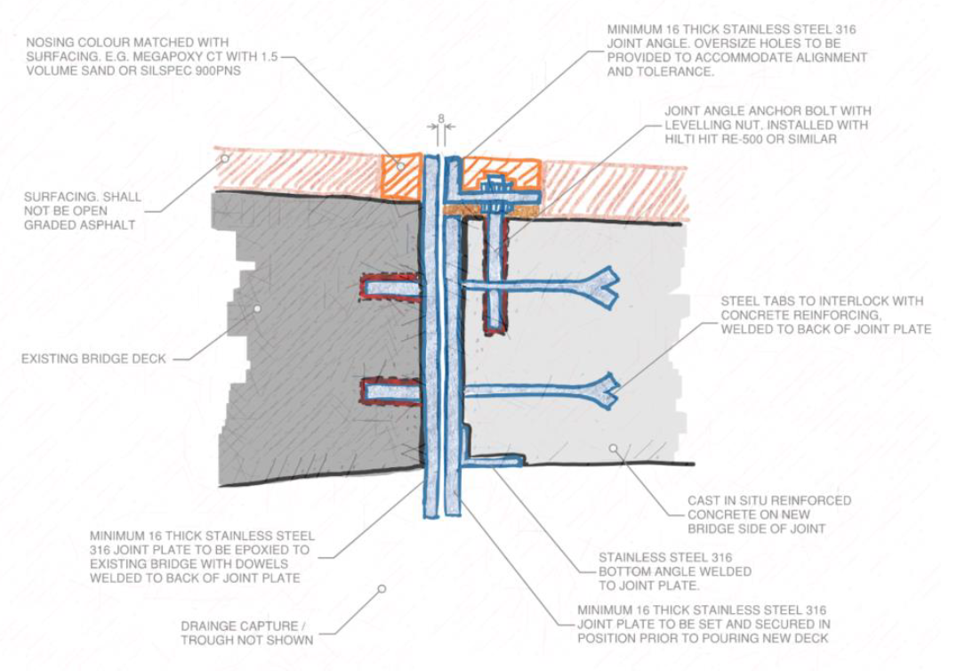

Figure 3 Longitudinal deck joint proposed as 'best practice' approach to detailing of the longitudinal deck joint.

# Future considerations

While this research presents a significant step toward understanding the role of longitudinal deck joints in bridge widening, it is crucial to recognise that the findings represent an ongoing discourse rather than a definitive conclusion. The primary aim is to explore the safe implementation of longitudinal deck joints while acknowledging the complexities involved. The research does not definitively advocate for their universal adoption.

## The importance of collaboration

As the field of bridge engineering progresses, the necessity for collaborative input from various stakeholders cannot be overstated. Engaging with experienced practitioners, clients, and government authorities will foster the exchange of ideas and innovations that can enhance the understanding and application of longitudinal deck joints. It is hoped the insights shared in this paper may catalyse dialogue around innovative solutions and improvements in current practices.

## Engaging with emerging technologies

In addition to collaborative research, the inclusion of emerging technologies in the study and application of longitudinal deck joints can unlock further potential benefits. Advanced monitoring systems that track the performance of bridge joints over time could yield real-time data, informing maintenance decisions and enhancing safety.

# Conclusion

In summary, this research highlights the potential for longitudinal deck joints to provide a flexible and viable alternative for bridge widening scenarios where traditional methods may be unsuitable. By addressing key concerns around user safety, maintenance requirements, and structural performance, the research and design advice note lays the groundwork for informed decision-making in future projects.

The outcomes presented here underscore the importance of thorough detailing and adherence to established criteria, suggesting that when implemented thoughtfully, longitudinal deck joints can significantly enhance the sustainability of bridge widening. Potentially saving some bridges from full replacement. As we look to the future of bridge engineering, ongoing engagement with the broader engineering community will be essential in refining these insights and ensuring that the solutions we advocate are not only effective but also resilient and sustainable.

## Call to action

Contributions to this dialogue are vital to enhancing our collective capacity to address the challenges posed by increasing traffic demands and aging infrastructure.Together, we have the opportunity to redefine how we approach bridge engineering and find solutions that truly meet the needs of our communities. Engaging in vibrant discussions, sharing experiences, and advocating for evidence-based approaches will pave the way for future success in this critical field.

# References

1. ACI (345 AC) (1998) *ACI 345.2R-98 Guide for Widening Highway Bridges*.
2. Caltrans (2010) *Memo to Designers 9-3 Widening Existing Bridges*,
3. Deery M (2014) 'Deck Widening Stitch Pours Under Live Traffic', *Austroads Bridge Conference*, 9th:13.
4. DOT C (Transport CDo) (2023) *Bridge Design Manual*,
5. Hatami A and Morcous G (2016) 'Deterministic and Probabilistic Lifecycle Cost Assessment: Applications to Nebraska Bridges', *Journal of performance of constructed facilities*, 30(2), doi:10.1061/(ASCE)CF.1943-5509.0000772.
6. Hong S and Park S-K (2015) 'Effect of vehicle-induced vibrations on early-age concrete during bridge widening', *Construction & building materials*, 77:179-186, doi:10.1016/j.conbuildmat.2014.12.043.
7. Niwa J, Fakhruddin, Matsumoto K, Sato Y, Yamada M and Yamauchi T (2016) 'Experimental study on shear behavior of the interface between old and new deck slabs', *Engineering structures*, 126:278-291, doi:10.1016/j.engstruct.2016.07.063.
8. RTA (Bridges) (2008a) *Bridge Deck Joint Selection, Design, Installation and Maintenance*,
9. RTA (Bridges) (2008b) *Bridge Technical Direction BTD2008/10*,
10. Vicroads (Vicroads) (2018) *Code of Practice Bridge Joints*, report number BTN 004,
11. Wu W, Zhang H, Liu Z and Wang Y (2022) 'Numerical analysis on transverse splicing structure for the widening of a long multi-span highway concrete continuous box girder bridge', *MDPI* 15(6805).

|  |
| --- |
| **Acknowledgments**  I wish to acknowledge Acciona and Tim Pittaway for supporting this research and in definition of the topic of interest. Additionally many thanks go to John Hilton and Ken O’Neill for their support through the Aurecon Design Academy and in development of this investigation. Lastly, to Ron and his team at RMIT, many thanks for the guidance. |

**Author contacts (optional –please delete if you would prefer this information not be included)**

**Geoff Thompson, Aurecon, Associate Bridge Engineer**

Geoff.thompson@aurecongroup.com, LinkedIn