Fatigue in shear reinforcement

John Hilton, Adjunct Professor, School of Civil and Environmental Engineering, UNSW,

Global Capability Leader Bridges, Aurecon, Sydney, Australia

Dr Jeevan Senthilvasan, Principal Engineer Bridges, Sydney Trains, Sydney, Australia

Geoff Thompson, Associate, Bridges and Structures, Aurecon, Sydney, Australia

|  |
| --- |
| **Abstract**  The structural assessment of two underbridges to Australian Standard AS 5100.5 indicated that the design fatigue life had been exceeded for steel shear stirrups forming part of the prestressed concrete girders comprising the superstructure of the bridge. A detailed inspection of the bridge showed no sign of cracking or distress and the strength load rating was satisfactory. In fact calculations indicated that the concrete was uncracked in shear under the design loading. The bridges were constructed around 30 years ago. Shear strengthening was impractical and superstructure replacement was costly, particularly as the two underbridges were representative of 21 similar structures. On this basis, Aurecon was engaged by Sydney Trains to undertake a detailed fatigue assessment including comparison of the provisions of AS 5100 with other international Standards (Eurocode, German DIN EN 1992-1-1/NA:2013-04, AREMA, AASHTO LRFD, Canadian CSA-S6-06 and the draft *fib* Model Code 2020). This work included contact with the AS 5100.5 Standards subcommittee.  The findings of the investigation noted that; it is valid to consider part of the concrete component in resisting shear (even when it is cracked) for fatigue loading, that the angle of inclination between the concrete compression strut and the longitudinal axis of the member should be modified due to the potential for working of the shear crack under repeated loading. This investigation informed on the amendment to AS 5100 and indicated that fatigue strength of the two bridges was satisfactory based on projected track usage, for at least the duration of its originally intended design life.  **Keywords:** bridge, fatigue, shear, stirrups, concrete |

# Introduction

The notion that the strength of a reinforced concrete flexural member can be reduced by repetitive loading producing fatigue damage to steel reinforcement is now well established. This has not always been the case. Although international standards and codes of practice have addressed fatigue design of structural steelwork for many years, requirements and guidance to readily assess fatigue in reinforcement and tendons have really only been provided since the late 1990’s.

As a result, the fatigue assessment of bridges designed prior to this time needs to be undertaken with care. Bridges particularly vulnerable are those subject to extreme stress variations or a large number of repetitive load cycles or both, such as short span rail underbridges.

This paper explores the fatigue assessment of the superstructure of two rail bridges (Pourmalong Creek Underbridge near Morriset and Awaba Creek Underbridge near Awaba, both on the NSW central coast) each designed in the early 1990’s and which showed vulnerability in shear reinforcement when reviewed in accordance with the provisions of the Australian Bridge Design Standard, AS 5100.5: 20171.

# Bridge Details

## Pourmalong Creek Underbridge

The Pourmalong Creek Underbridge superstructure comprises 7.3 metre simply supported spans of precast pretensioned concrete girders, supported on pre-existing mass brick piers and abutments.

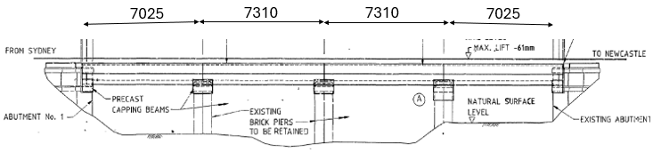 ***Figure 1 Elevation, Pourmalong Creek Underbridge***

## Awaba Creek Underbridge

The Awaba Creek Underbridge superstructure comprises 4.8 metre simply supported spans of precast pretensioned concrete girders, and similar to the Pourmalong Creek Underbridge is also supported on pre-existing mass brick piers and abutments.

Figure 2 Elevation, Awaba Creek Underbridge

Both bridges twin track are ballast top construction, designed to the 1974 ANZRC Bridge Design Manual. Details of the girders and superstructure are shown in Figures 3 and 4.

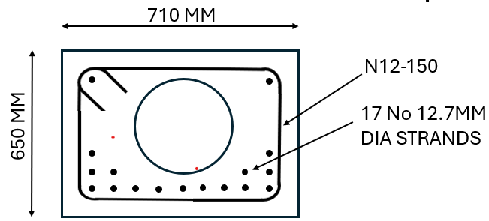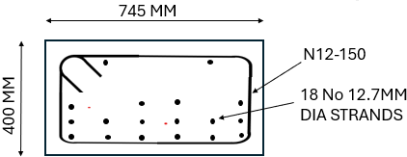***Figure 3 Girder critical cross sections***

Pourmalong Creek Underbridge Awaba Creek Underbridge

***Figure 4 Typical superstructure cross section, Pourmalong Creek Underbridge***

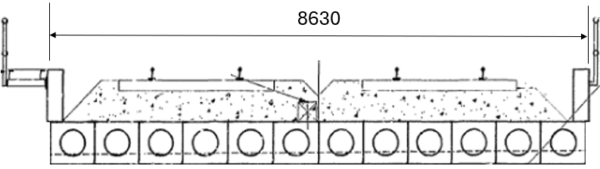

# Assessment to AS 5100

The fatigue assessment was undertaken in accordance with Clauses 2.2.5 and 2.2.6 of AS 5100.5. At the time of the assessment these clauses nominated the following;

* All the shear force is carried by the reinforcement (stirrups)
* A strut-tie approach was implied
* The angle between compression struts and the longitudinal axis of the member to be chosen to be between 350 and 550
* Permissible tensile stress range limit of the stirrups: 68 MPa, due to the strain hardening at the stirrup bend. (Note for straight bars the permissible stress range limit is 150 MPa)

On this basis calculations showed the stirrups had fully expended their fatigue life, with the implication that the superstructure (at the least) would need to be replaced.

Noting that these two bridges were representative of approximately 21 underbridges a more comprehensive investigation was undertaken. An investigation into real-world examples of shear fatigue failure of bridges was undertaken using an internet search. No relevant examples of such failure were encountered at all. A detailed inspection of the girders from a similar bridge was undertaken which showed no sign of cracking or distress due to shear stresses. The ultimate strength was satisfactory. The principle tensile stress at the critical section showed the concrete was uncracked under both service and ultimate loading, all indicating that the AS 5100 requirement that the concrete not contribute to the shear strength as very conservative in this instance.

# Comparison with International Standards

## A comparison with other international standards was undertaken principally to determine the treatment of the concrete in contributing to the shear strength, the nominated angle of the compression strut under fatigue loading and the required strength reduction at the stirrup bend.

## AS 3600 2018 Concrete structures

Unlike AS 5100.5, the requirement in AS 3600: 20182 that all shear force is carried by the reinforcement and tendons is not made and hence the concrete contribution can be included during shear fatigue analyses (although the Standard does not explicitly specify how this is to be done). When conducting fatigue assessment, the same ranges of the compression strut angle (35° to 55°) used in AS 5100.5 are nominated.

## AASHTO LRFD 2020 Highway bridges

The AASHTO LRFD Bridge Design Specification3 covers the fatigue limit state for concrete highway bridge structures. The most relevant information regarding the fatigue performance of shear reinforcement is contained in the Commentary (Clause C5.5.3.2) which states that “Design for shear does not typically include a fatigue check of the reinforcement as the member is expected to remain uncracked under service conditions and the stress range in the steel is minimal. No provisions for the fatigue design of stirrups are included in the Standard.” Fatigue assessment is limited to the longitudinal reinforcement in flexural members.

## Eurocode 2 (EN 1992-1-1 Concrete structures and EN 1992-2 Concrete bridges)

During ULS shear analysis and design, a truss modelling approach is adopted by EN 1992-1-1 Concrete structures4 and EN 1992-2 Concrete bridges5with the compressive strut angle (*θ* ) taken between 21° and 45°. When considering fatigue, a similar approach is taken however the compressive strut angle can either found from a strut and tie model or per the following equation.

$$\tan\left(θ_{fat}\right)= \sqrt{\tan\left(θ_{ULS}\right)}≤1$$

The above equation is used as it increases the steepness of the compressive strut angle which results in larger steel stresses under fatigue loading.

For stirrups and other bent bars, the reduction factor is the same as that encountered in AS 5100.5 to account for strain hardening.

## German DIN EN 1992-1-1/NA:2013-04 (German Annex to Eurocode 2 Concrete structures)

For the fatigue assessment of the shear reinforcement, the strut angle calculated for ULS assessment is increased by DIN EN 1992-1-1/NA:2013-046 as per Eurocode 2. The rationale behind this decision is to reduce the contribution from the crack friction force as it is envisaged that cyclical loading will erode the crack face and reduce the effect of aggregate interlock.

## Canadian CSA-S6-06 2006 Highway bridges

When considering reinforcing bars under fatigue loading, Canadian CSA-S6-06 20067 only considers the performance of reinforcement subject to flexural tension with no requirements for shear performance. For bent members such as stirrups, a uniform 65 MPa stress range is applied for residual life assessment, similar to the AS 5100.5 requirements.

## *fib* Model Code 2020

*fib* Model Code 20208 released in late 2024 is produced by the International Federation for Structural Concrete (*fib*). This highly regarded Standard provides the most recent treatment for the fatigue design of reinforcement and tendons.

For members with shear reinforcement the Code importantly states that “If it can be demonstrated that no shear cracks will occur under the relevant combinations of loads, fatigue in shear need not be verified”. This then comprises the first check, on compliance no further action is required. Where it is shown that shear cracking will occur, the *fib* model code does allow for a contribution from the concrete. The total shear resistance under cyclical loading ($V_{Max}$) therefore comprises the sum of the concrete shear resistance ($V_{Rd.c}$) and the shear reinforcement resistance ($V_{Rd.s}$).

$$V_{Max}= k_{c,f}∙V_{Rd,c}+ V_{Rd,s}$$

The factor $k_{c.f}$ is a reduction factor of 0.5 applied to the concrete component which accounts for the accumulation of damage induced by shear crack propagation which during cyclical loading. The compressive strut angle used during shear fatigue assessment is proportional to the ULS static value based on the following equation.

$$\tan\left(θ_{fat}\right)= \sqrt{\tan\left(θ_{ULS}\right)}$$

As with the Eurocode approach, this ensures that the strain on the shear reinforcement is increased further by increasing the compressive strut angle.

For bent bars, the same reduction factor encountered in AS 5100.5 is nominated to be applied to the limiting stress cycle values.

## Other technical literature

Research into the contribution of concrete to shear fatigue resistance in prestressed sections has been undertaken. An initial study by Teworte et al9 and subsequent works Hillebrand and Hegger (2020)10 and Hillebrand et al (2021)11 have all been produced on this issue. All three studies measured the experimental shear fatigue performance of prestressed concrete beams and compared them against the values calculated by DIN EN 1992-1-1/NA:2013-04.

In each study it was found that the fatigue life of the shear reinforcement calculated using this approach was underestimated by a considerable degree, ranging from six to seventy times below the experimental life. This indicates that there is a considerable contribution to fatigue resistance from the concrete strength which should be accounted for during design.

# Discussion

For the fatigue design of reinforced concrete in bending, ignoring the contribution of the concrete below the neutral axis is fundamental. The concrete will invariably crack and lose tensile strength well before the reinforcement has developed significant stress.

However, for the fatigue design of reinforced concrete in shear, there is strong evidence that a concrete contribution to the shear strength can be reliably achieved. None of the international Standards reviewed preclude this, although only the *fib* Model Code 2020 provides a means of quantification.

In many cases principle tensile stresses are insufficient to crack the concrete, even under ULS conditions. Until the concrete cracks in shear the stirrup reinforcement stresses are nominal (function as per the modular ratio) and fatigue will not govern the design.This is recognised in *fib* Model Code 2020 which notes that if this is the case then compliance is met and no further action is required.

This is supported by the work done by Teworte et al9 and subsequent works Hillebrand and Hegger (2020)10 and Hillebrand et al (2021)11 which provide clear evidence of a considerable contribution to fatigue resistance from the concrete.

On this basis a submission was made to the Australian Standards Subcommittee (BD-090-05) that for the fatigue design of shear stirrups to adopt a concrete contribution to the shear strength of 0.5 $V_{uc}$ where $V_{uc}$ is calculated using the provision in Clause 8.2 of AS 5100.5.

In addition, the submission proposed a compressive strut angle, $θ_{fat}=\arctan{\sqrt{\tan\left(θ_{ULS}\right)}}$ to allow for the working of the shear crack under repeated loading.

# Conclusions

The Australian Standards Subcommittee (BD-090-05) adopted the proposal and the changes were incorporated in Amendment 2, issued in early 2024.

Under the amendment the stirrups for both the Pourmalong Creek Underbridge and the Awaba Creek Underbridge were assessed as satisfactory based on projected track usage, for at least the duration of its originally intended design life.

It is noted that these provisions require that the minimum shear reinforcement nominated in AS 5100.5 is provided. If that is not the case then the stirrups will not have sufficient strength to counter the loss of the concrete tensile strength as the concrete cracks.

# References

1. AS 5100.5: 2017 Bridge design – Concrete
2. AS 3600: 2018 Concrete structures
3. AASHTO LRFD 2020 Bridge Design Specification
4. EN 1992-1-1 Concrete structures
5. EN 1992-2 Concrete bridges
6. DIN EN 1992-1-1/NA:2013-04
7. Canadian CSA-S6-06 2006 Highway bridges
8. fib Model Code 2020
9. Teworte, F., Herbrand, M. and Hegger, J., 2015. Structural assessment of concrete bridges in Germany - Shear resistance under static and fatigue loading. *Structural Engineering International*, *25*(3), pp.266-274
10. Hillebrand, M. and Hegger, J., 2020. Fatigue testing of shear reinforcement in prestressed concrete t-beams of bridges. *Applied Sciences*, *10*(16), p.5560
11. Hillebrand, M., Teworte, F. and Hegger, J., 2021. Shear fatigue of prestressed I‐beams with shear reinforcement. *Structural Concrete*, *22*(2), pp.1085-1099

|  |
| --- |
| **Acknowledgments**  The authors acknowledge the specialist input provided by Professor Stephen Foster (School of Civil and Environmental Engineering UNSW and former President of the International Federation for Structural Concrete (*fib*) and former Dean, UNSW Engineering. The authors thank Sydney Trains and Aurecon for permission to publish this paper. |

**Author contacts**

**John Hilton, Adjunct Professor, School of Civil and Environmental Engineering, UNSW,**

**Global Capability Leader Bridges, Aurecon, Sydney, Australia**

[John.Hilton@aurecongroup.com](mailto:John.Hilton@aurecongroup.com) [(7) John Hilton | LinkedIn](https://www.linkedin.com/in/johnhiltonaurecon/)

**Dr Jeevan Senthilvasan, Principal Engineer Bridges, Sydney Trains, Sydney, Australia**

[Jeevan.Senthilvasan@transport.nsw.gov.au](mailto:Jeevan.Senthilvasan@transport.nsw.gov.au) [(7) Dr. Jeevan Senthilvasan | LinkedIn](https://www.linkedin.com/in/dr-jeevan-senthilvasan-37524521/)

**Geoff Thompson, Associate, Bridges and Structures, Aurecon, Sydney, Australia**

[Geoff.Thompson@aurecongroup.com](mailto:Geoff.Thompson@aurecongroup.com) [(7) Geoffrey Thompson | LinkedIn](https://www.linkedin.com/in/geoff-thompson/)