Design of Super T girders with Ultra High Performance Concrete (UHPC) for rail loadings to replace steel girder superstructure for rail bridges.

Srivelan Kathirgaman, Technical Director, Aurecon

|  |
| --- |
| **Abstract**  Ultra-High Performance Concrete (UHPC) has been in use overseas since about 2000.Number of bridges have been built using UHPC including a bridge in New South Wales.  UHPC is a concrete with a minimum compressive strength of 150 MPa and pre and post cracking tensile strength of above 5 MPa. It comprises of a dense mix with discontinuous length of steel fibres resulting in minimizing the capillary pores.  UHPC consists of a combination of Portland cement, find sand, silica fume, steel fibres and water. There are no coarse aggregates in the mix to improve the homogeneity. The application of heat curing has a significant impact on the performance and mechanical properties of UHPC. It increases the compressive, and tensile cracking strength and modulus of elasticity.  Concrete only carrying compression is no longer valid for UHPC. Tensile behaviour is where UHPC significantly differ from that of a conventional concrete.  Currently for rail bridges carrying a 245LA rail loading, the go to solution for the simply supported superstructure is multiple super T girders with an in situ concrete decking upto 36m. For spans greater than 36m, steel trough girders made composite with a concrete deck is the main superstructure form for both simply and continuous supported structures. The cost of this form of superstructure is significantly higher than the super T girder solution and embedded carbon content is also significantly higher than an equivalent concrete option. Super T girders built with 150Mpa UHPC could easily replace the steel trough girders upto about 50m giving rise to major sustainable benefits.  To promote the growth of UHPC, local material specification is being developed to address the sensitivity of the material. Also, AS 5100 code committee is developing design guidance to give confidence to authorities, designers and contractors. With these initiatives, it is hoped that UHPC could be adopted as the construction material for both present uses and future exploitation for sustainable constructions.  **Keywords:** Super T girders, Steel trough girders, Ultra High Performance Concrete (UHPC) |

# Introduction

Ultra-High-Performance Concrete (UHPC) has been in use overseas since about 2000.Number of bridges have been built using UHPC. A road bridge using UHPC was built at Shepherds Gully Creek, NSW in about 2005 as shown in Figure 1. Also, on the same year a pedestrian bridge was built in New Zealand using UHPC as shown in Figure 1. Despite the significant development in UHPC, no other bridges have been built using UHPC. The availability of codes for design, material specifications & the high costs may have been the reasons for not constructing any more bridges.

Figure 1 – Shepherds Creek UHPC Bridge

# What is UHPC

UHPC is a concrete with a minimum compressive strength of 150 MPa and pre and post cracking tensile strength of above 5 MPa. It comprises of a dense mix as shown in Figure 2 resulting in minimizing the capillary pores. This improves the brittleness of the product and produces significantly improved durability performance.

Figure 2 Dense UHPC mix vs conventional concrete

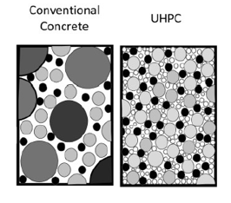

Generally, UHPC mix consists of discontinuous steel or other fibres to make it more ductile. Also, the dispersion and orientation of the steel fibre is critical for the mechanical performance of UHPC.

Therefore, the following four primary characteristics of UHPC distinguishes it from conventional concrete or high-performance concrete:

* High compressive strength,
* Higher tensile strength with ductility,
* Increase durability, longer service life and low maintenance, and
* Higher initial cost.

# Material Compositions of the UHPC

UHPC consists of a combination of portland cement, find sand, silica fume, steel fibres and water as shown in Figure 3. Admixtures are generally added to improve the workability of the mix. Generally, UHPC has high cementitious materials and a very low water cementitious ratio. There are no coarse aggregates in the mix to improve the homogeneity.

Figure 3 Material composition of UHPC  
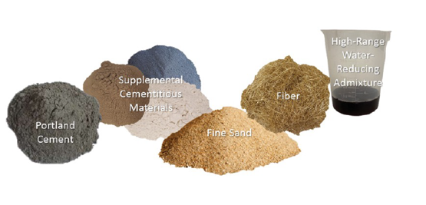

The production of UHPC is no longer in its infancy stage. It is a proven technology. After several decades of development, a wide range of UHPC formulations have been developed worldwide to satisfy the specific requirements with regard to durability, properties in fresh state and characteristics in hardened state and taking into account the material production process.

The key factor in producing UHPC is to improve the micro and macro properties of its mixture ingredients in order to ensure mechanical homogeneity, maximum particle packing density, minimum size of flaws and having as low as possible water/cement ratio.

It is no longer necessary to rely on proprietary UHPC products, which usually costs significantly and therefore deterring the use of the material. It is now possible to develop non-proprietary UHPC products based on wealth of research done over two decades.

Major Roads Projects Victoria has been developing a material specification to address the key issues related to UHPC. The release of this specification will give greater confidence to the industry to adopt this material in construction.

# Performance Expectations of the UHPC

Typical performance expectations of UHPC are as follows:

* Longer life cycle;
* Minimal shrinkage and creep;
* Good carbonation properties;
* Improved performance against chloride & water penetration;
* Superior impact resistance;
* Superior chloride diffusion properties;
* Greater frost and deicing salt resistance; and
* Lower maintenance.

The application of heat curing has a significant impact on the performance and mechanical properties of UHPC. It increases the compressive, and tensile cracking strength and modulus of elasticity. It also decreases creep and virtually eliminates shrinkage post curing. Therefore, curing treatment applied to concrete, which is always important, is even more important in the case of UHPC to attain the expected performances.

Typical performance requirements of UHPC as per the French Standard referred to in Section 8 is listed in Table 1.

Table 1 Typical Performance Requirements of UHPC as per French Standard (NF P 18-710)

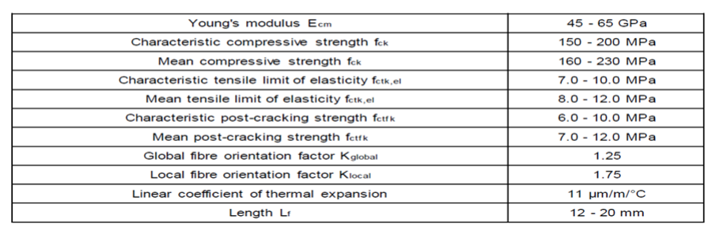

# **Distinct features of UHPC**

The UHPC production process usually involve heat treatment for it to reach its properties in mature hardened state as compared with conventional concrete. Possible heat treatments as specified in the French Standard referred to in Section 8 are:

* TT1 - “heat curing” or “acceleration of hydration by heat to bring forward the start of setting” and to accelerate setting and initial hardening in the mould by application of moderate heating.
* TT2 – “heat treatment several hours after it has set” it undergoes heat treatment at a relatively high temperature (of the order of 90°C) at a degree of humidity greater than 90% for several tens of hours.
* TT1+2 – “heat curing” + “heat treatment after setting”, this is when it has undergone both the heat treatments described above successively.

Concrete only carrying compression is no longer valid for UHPC. For the flexural design at ultimate limit state (ULS), the French Standard referred to in Section 8 propose a stress-strain relationship that is linear for the compressive stress range as shown in Figure 4. The ultimate strain computation is different to that of conventional concrete as it additionally considers the mean value of the post cracking tensile strength, and the orientation factor associated with the fibres for global effects.

Figure 4 stress- strain relationship for UHPC in compression for designs at ULS

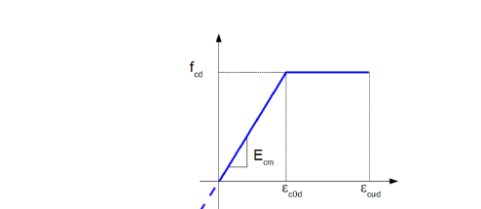

Tensile behaviour is where UHPC significantly differ from that of a conventional concrete. Post cracking tensile strength is the most relevant material parameter of the UHPC. To this end the orientation of the fibres is an important parameter in the development of the tensile relationship. This is accounted in the design by an orientation coefficient that accounts for the alignment of fibres that may occur during placement. A minimum fibre content and non-brittleness check is also required.

As mentioned earlier, post cracking strength together with crack width may determine the tensile relationship. Tensile behaviour of the material also varies depending on the strain hardening characteristics. In the French standard referred in Section 8 three (3) classes of material is defined as follows based on strain hardening:

* Class T1* - softening under direct tension
* Class T2* - exhibiting limited strain hardening
* Classs T3* - exhibiting significant strain hardening

In addition, the tensile behaviour varies depending on if the member is considered thick or thin based on its depth and length of the longest fibres.

Accordingly, the stress-strain relationship is multilinear in the tensile stress range to account for the various effects discussed above and the fibres as shown in Figure 5.

Figure 5 stress- strain relationship for UHPC Class T2* in tension for designs at ULS for a thick section

Another feature in UHPC is that it is used without any passive reinforcement. Very fine high strength steel fibres are able to withstand secondary tensile stress. Prestressing is the main tensile bars to resist bending. No minimum amount of steel reinforcement is required because the bridging action of the steel fibres provides the strength after cracking.

Shear strength is provided by the tensile strength of the UHPC. So typically, additional shear reinforcement is not required.

It is also to be noted that transfer length and development length of prestressing strands are much shorter in UHPC than in conventional concrete. Similarly, development lengths for deformed bars in tension and lap splices in tension are shorter than for conventional concrete. As mentioned before, UHPC comprises of a dense mix with minimal capillary pores which therefore leads to much lower cover requirements than the conventional concrete due to environmental exposures.

# Current state of affairs for design of short span rail bridges

Currently for rail bridges carrying a 245LA rail loading, the go to solution for the superstructure is multiple super T girders with an in situ concrete decking as shown in Figure 6.

Figure 6 Super T girder superstructure

The maximum depth of this super T girders that is currently available in the marketplace is 2100mm deep. But more common girder depths are 1500mm and 1800mm girders. Typical span lengths for simply supported four super T girder deck cross section with a composite 300mm thick deck are shown in Table 2 based on the Super T girders built with concrete having a compressive strength of 60 MPa and the deck consists of concrete of 40MPa compressive strength.

Table 2 – Potential span lengths for simply supported structure of different girder depths.

|  |  |
| --- | --- |
| SUPER T GIRDER DEPTH(MM) | SPAN LENGTHS (M) |
| 1500 | 28 |
| 1800 | 32 |
| 2100 | 36 |

This form of superstructure is chosen mainly because it is the most cost effective as well as the familiarity of the system for the authorities, designers and contractors. For spans greater the ones shown in Table 2, alternative superstructure form is necessary for a simply supported structure, which is the most common form.

# Current state of affairs for design of spans greater than 36m for rail bridges

The go to superstructure solution for spans greater than 36m is steel trough girders made composite with a concrete deck for a 245LA rail loading as shown in Figure 7. This form of superstructure can take the form of simply supported or continuous. There is no limitation for the span lengths for this form of superstructure as the girders are custom built to suit each of the project. Steel grade typically used for these girders are 350L0, which has a tensile strength of 340MPa. The cost of this form of superstructure is significantly higher than the super T girder solution. The embedded carbon content for this superstructure is also significantly higher than an equivalent concrete option.

Figure 7 Steel Trough Girder superstructure

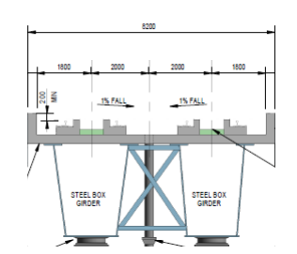

# Super T girders built with UHPC for rail bridges

Super T girders are a very popular form of superstructure for bridges. However, the current day super T girder span lengths are limited by the concrete strength. It is therefore possible to extend the span length of these super T girders by adopting UHPC for the construction of these girders so as to replace the more expensive steel trough girder superstructure form. An exploration of this possibility was done by adopting a UHPC with a compressive strength of 150 MPa.

The prevailing bridge design code AS 5100 only permits concrete compressive strength upto 100 MPa. Super T girders built with UHPC concrete compressive strength of 150 MPa cannot be designed with AS 5100. However, it is understood that AS 5100 Code Committee is working on incorporating provisions for design with UHPC and is expected to be released soon.

There are however many international standards available for design of UHPC. Two main and well recognised standards are the French & American standards as shown in Figure 8. French Standard consisting of 3 parts. Part 1provides design information for compressive strength, tensile strength, modulus of elasticity, Poisson’s ratio, coefficient of thermal expansion, shrinkage, creep, and impact behaviour. Mix design, mixing procedures, placement practices, and tests are also addressed. The design methods in the second part are based on the French codes for prestressed and reinforced concrete but takes into account the strength provided by the fibres. Part 3 is mainly concerned with the construction.

French standard was released in 2016 and the American standard was released in 2024.

Figure 8 French & American design standards for UHPC

American Standard



Both these standards adopt the same design philosophy and principles. As the French Standard was more established, the investigation of potential span lengths with super T girders built with UHPC was undertaken using this standard.

Even with this UHPC, the design can be carried out by the traditional methods. That is to say the flexural capacity is based on equilibrium of forces and strain compatibility using idealized stress- strain curves in compression and tension for UHPC as mentioned in Section 5. A typical stress and strain diagram for a super T girder using UHPC is as shown in Figure 9 based on the French Standard.

Figure 9 Stress and strain diagram for a typical super T girder built with UHPC based on French Standard.

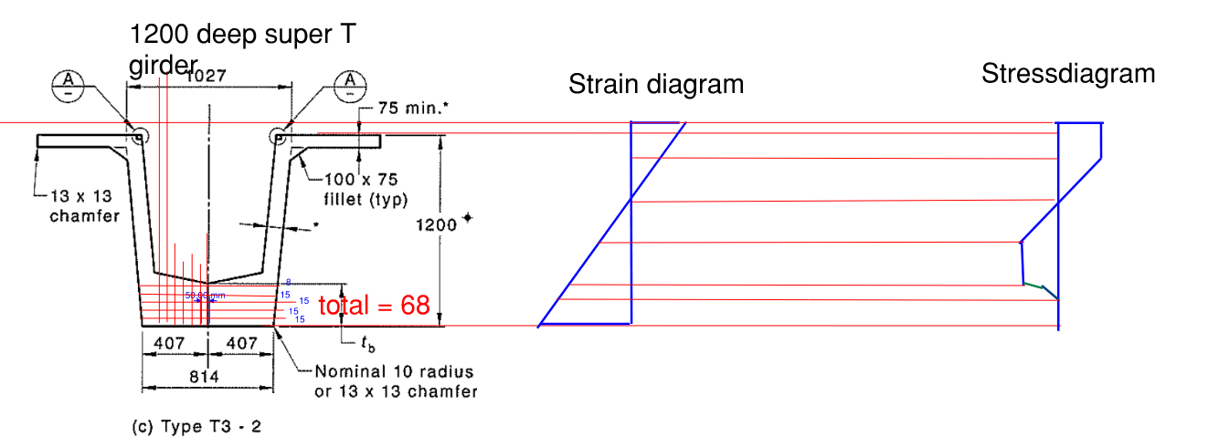

In addition, UHPC is used without any passive reinforcement. Very fine high strength steel fibres are able to withstand secondary tensile stress. Prestressing strands is the main tensile bars to resist bending.

Similarly, the shear strength of the UHPC girders is based on limiting the principal tensile stress at the centroidal axis or at the junction of the web and flange to a maximum value based on a section uncracked in flexure. Shear strength is then calculated as the summation of the shear resistances provided by the concrete, reinforcement, and fibres. Typically, no additional reinforcements are provided. Shear strength is provided by the tensile strength of the UHPC. The stresses at the serviceability limit state are addressed in the same way as conventional reinforced or prestressed structures.

French Standard requires, which is equally applicable to other standards, that number of selections in terms of material properties, production method has to be made prior to commencement of the design with UHPC. It is also required in the French Standard that these properties be proven by testing before adopting in design. For this investigation, the following have been assumed as per the French standard:

* Concrete classification – Type M
* Characteristic compressive strength – 150MPa
* Mean value of post cracking Tensile strength – 7MPa
* Characteristic value of the post-cracking strength for crack width of 0.3mm – 6MPa
* Characteristic post cracking tensile strength corresponding to a crack width of 0.01H where H is the height of the tested prism. – 4.8MPa
* Young modulus              - 50000MPa
* Dry density                   - 2500 Kg/m3
* Fibre strength - 2000 MPa
* Fibre length                  - 13mm
* Fibre content                - max of 2%
* Fibre orientation (vertical) - 1.25
* Heat treatment class    - TT1 ( Preheat) & TT2 (POST HEAT)
* Strain hardening class  - T2*
* Coefficient for long term effects – 0.85
* Partial factor for UHPC (tension) – 1.4 for TT2 & 1.3 for T3
* Partial factor for UHPC (compression) – 1.5 for TT2 & 1.3 for T3
* Permissible crack width – 0.3mm

Based on the above assumptions, a high-level preliminary analysis of the super T girders built with UHPC was undertaken for simply supported spans at ultimate limit state for flexure and shear. The bridge alignment was considered as straight without any skew. At the same time an analysis of the super T girder built with concrete compressive strength of 60 MPa was also undertaken in accordance with the current prevailing bridge design code AS 5100. The prestress quantities for each of the girders were kept the same for easy comparison. Table 3 presents the results for a 32m simply supported span for the conventional super T girder vs the UHPC super T girder.

Table 3 Comparison of results between conventional and UHPC super T girders spanning 32m

|  |  |  |
| --- | --- | --- |
| **Items** | **conventional Super T  girder** | **UHPC super T girder** |
| Span | 32m | 32m |
| alignment | straight | Straight |
| concrete grade for girder | 60MPa | 150MPa (lowest grade permissible in the French standard) |
| beam depth | 1800mm | 1200mm |
| Beam cross section |  |  |
| Flange width | 2100mm | 2100mm |
| beam weight | 75t | 42t |
| Prestress | 62Nos of 15,2 mm strands | 62Nos of 15,2 mm strands |
| Reinforcement | 250 Kg/M3 | 0 except may be at the end blocks. |
| Design standard | AS 5100 | NF P18 - 710  (French Standard) |

From Table 3, 1800 deep super T girder built with 60 MPa concrete will be necessary with heavy prestress and reinforcement to span 32m. However, 1200 deep super T girder built with 150MPa UHPC concrete is only necessary for the same amount of prestress but without a need for any reinforcement for shear.

Table 4 presents the results of the preliminary analysis for 1800mm & 2100mm deep super T girders built with 60 MPa & 150 MPa strength concrete.

Table 4 Comparison of results between conventional and UHPC super T girders

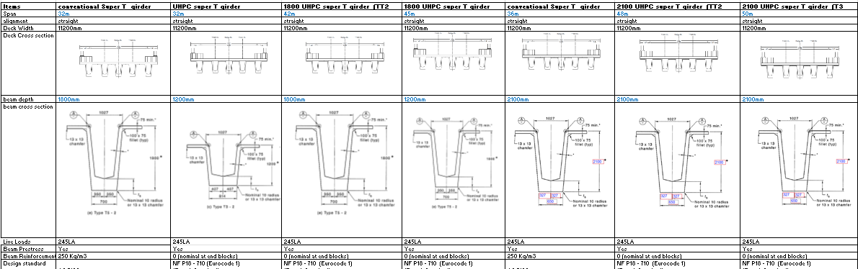

Table 4 has shown that UHPC again has a significant benefit. For a conventional 60MPa concrete, 1800 deep super T girder will be necessary with heavy prestress and reinforcement to span about 32m.

 A UHPC 150MPa concrete 1800 deep super T girder will span upto 45m with same amount of prestress but without a need for any reinforcement for shear. Similarly, a UHPC 150MPa concrete 2100 deep super T girder will span upto 50m with prestress but without a need for any reinforcement for shear as compared with a conventional super T girder spanning about 36m. This UHPC super T girders could easily replace the steel trough girders upto about 50m giving rise to major sustainable benefits.

The adoption of the super T girders built with UHPC will also result in additional benefits as listed below:

* Volume of concrete reduced for both super T girder as well as concrete deck;.
* Transportation cost reduced due to much lighter weight of the girder;
* Smaller cranage requirement for erection of girder;
* No reinforcement tying is required;.
* Reduce significantly site work;.
* Potential saving in site labour;
* Potential saving in time in the program;.
* Potential savings of Preliminaries and Overheads for Contractor due to shorter duration;
* Reduce foundation load and potential reduction in foundation; and
* Reduction in pier and crosshead sizes.

# Conclusions

Many bridges have been built using UHPC throughout the world. However, UHPC uptake is slow with barriers limiting its applications. High initial cost, absence of design codes and material specifications, and potentially complex fabrication technique has severely hampered its commercial development and application in Australia. To promote the growth of UHPC, local material specification is being developed to address the sensitivity of the material. Also, AS 5100 code committee is developing design guidance to give confidence to authorities, designers and contractors. With these initiatives, it is hoped that UHPC could be adopted as the construction material for both present uses and future exploitation for sustainable constructions.

|  |  |  |
| --- | --- | --- |
|  |  |  |

# References

1. Association Francaise de Normalisation (AFNOR) (2016) Design of concrete structures: specific rules for Ultra high performance Fibre reinforced concrete (NF P 18 – 710).
2. Nadarajah Gowripalan, Gilbert R.I. Design Guidelines for RPC Prestressed Concrete Beams, UNSW, Sydney.

**Author contacts**

**Srivelan Kathirgaman, Aurecon, Technical Director**

Srivelan.kathirgaman@aurecongroup.com