Low carbon small span rail bridges

John Hilton, Adjunct Professor, School of Civil and Environmental Engineering, UNSW,

Global Capability Leader Bridges, Aurecon, Sydney, Australia

Lucy Washer, Senior Consultant, Sustainability and Climate Change, Aurecon, Melbourne, Australia

|  |
| --- |
| **Abstract**  The The importance of minimising CO2 emissions caused by human activity is now well established. This paper summarises the findings of an investigation into the carbon content of a typical 11.0 metre span, double track rail underbridge for a wide range of material and structural types including: traditional wide and narrow prestressed concrete girders; steel girders; fibre reinforced polymer (FRP) prestressing strand and reinforcement; ultra-high performance concrete (UHPC) girders; concrete girders reinforced with the new higher strength steel (600N) and traditional stone arch construction.  General conclusions are drawn on the most appropriate option, assuming embodied carbon is a driving criteria for selection.  **Keywords:** bridge, carbon, concrete, steel, UHPC, fibre reinforced polymer |

# Introduction

Embodied carbon impacts of structural elements are not well defined by the industry. There is an opportunity to assess opportunities for emissions reduction through whole-of-life considerations in the early stages of a project. Simple design-related and cost-effective changes could be made that would have significant positive impacts on the carbon footprint of our bridge assets, such as material choice and structural form.

Embodied carbon emissions linked to Australian infrastructure, resulting from the production and transport of materials used in construction, contributed 5.9% (34.3 Mt CO2-e) of Australia’s total greenhouse gas (GHG) emissions in 2018 as noted in ClimateWorks Australia2.

As global populations continue to grow, material use is projected by the OECD3 to more than double from 79 Gt in 2011 to 167 Gt by 2060, all else being equal. This includes non-metallic minerals, such as sand, gravel and limestone, which are used widely in construction and represent more than half of total material use globally.

The following comprises a review of a range of different material and structure types for a typical small span rail bridge in order to compare the embodied carbon content for the construction of the superstructure.

# Methodology

## The Bridge Form

The bridge chosen for the comparison is shown in Figure 1. It comprises a double track ballast top rail underbridge in a rural setting crossing a small creek, a deck width 8.13 metres between ballast kerbs and of a single 11.0 metre span measured between centerlines of bearings. The bridge is on a straight alignment with zero skew and a nominal longitudinal grade. A steel maintenance walkway is provided. The substructure consists of reinforced concrete abutment beams and wingwalls supported by reinforced concrete cast in place piles. The bridge is assumed to be located in rural Australia within 150 kilometres of a capital city.

***Figure 1 Bridge elevation***

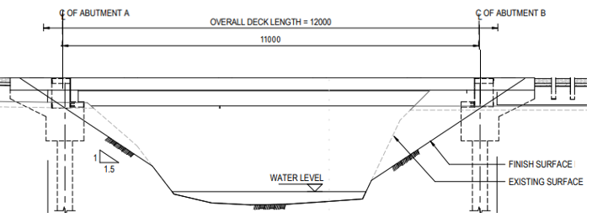

## Superstructure Types Considered

A total of nine different superstructure material/structure types were developed as concept designs as noted below and tabulated in Table 2. Designs were undertaken in accordance with the relevant provisions of Australian Standard AS 5100 2017 Bridge Design, with 300LA as the designated rail vehicle loading. The following elements were assumed to be common for all bridge options assessed unless particularly noted; earthworks and scour protection, maintenance walkway, ballast and track, deck waterproofing, abutment beams and wingwalls, and piles. Minor items not considered in the comparison included elastomeric bearings, mortar pads and treatment of movement joints.

### Option A: Precast, prestressed narrow width concrete girders (500N reinf.)

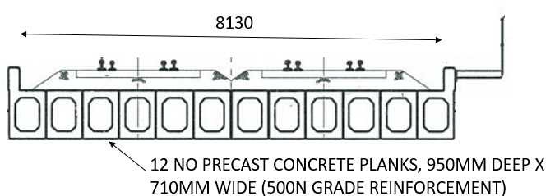For small span rail underbridges, a superstructure consisting of precast prestressed concrete planks laid nominally side by side and supporting the ballast and track is the most common form of bridge construction throughout Australia and also in many parts of the world. The fully precast superstructure allows rapid deck replacement during a track possession.

Figure 2

Two girder types are characterised by this form of construction; narrow width girders (say 710 mm wide) as described in this Option A and wide girders (say 2120 mm in width) as described in Option B.

For both options the deck is set flat in the transverse direction and follows the rail alignment in the longitudinal direction. The concrete has been assumed to comprise a 50 MPa mix with a cement material proportion of 70% GP cement and 30% fly ash. This blend is readily available.

On occasions both options utilises a cast insitu deck slab. This has not been considered as part of the current investigation. Cast insitu concrete precludes construction during most track possessions on line due to the extended construction duration (placing deck reinforcement, placing concrete, curing period etc) and generally leads to an increase in material quantities and hence additional embodied carbon produced.

Pretensioned strand to AS/NZS 4672.1, together with 500N grade reinforcement, provides the main flexural steel. For an 11.0 metre span a girder depth of 950 mm and a girder width of 710 mm is typical and was chosen. Therefore a total of twelve planks are provided of which the central four under each track are generally assumed to carry the live load.

### Option B: Precast, prestressed wide concrete girders, no deck slab

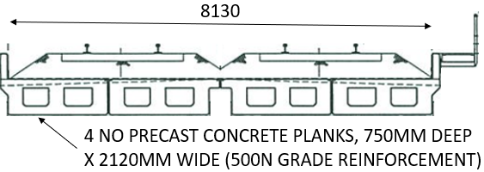This option utilises wide precast pretensioned girders. By widening the girders the number required reduces from twelve (as per Option A) to four.

Figure 3

Although a larger crane is required for installation, this option is more efficient due to the improved load distribution between the girders leading to a reduction in the quantity of PT, and particularly of concrete.

***Option C: Precast, prestressed narrow width concrete girders (600N reinf.)***

Figure 4

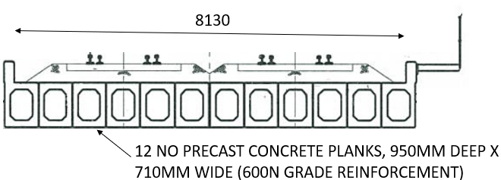Option C is similar to Option A but utilises the new higher strength D600N reinforcement in flexure and shear in lieu of the traditional D500N Grade. Higher strength steel was recently introduced into AS/NZS 4671 Steel reinforcing materials and is now included in AS 5100 Bridge Design Standard. For further details refer Ng and McGregor9.

When using higher strength reinforcement particular care is required to assess whether crack width provisions and deflections are critical in the design. In this instance a serviceability check indicates that these provisions don’t govern and the whole of the additional strength of the higher strength steel can be utilised.

### Option D: Precast, prestressed wide concrete girders (600N reinf.)

Similar to Option B but utilises the new higher strength D600N reinforcement as discussed in the description of Option C.

Figure 5

It is noted that D600N reinforcement is fabricated from 100% recycled steel and utilises EAF furnaces which reduces carbon content from 1.58t(CO2-eq)/t for 500N steel to 1.24t(CO2-eq)/t for D600N steel.

### Option E: Precast, Prestressed UHPC Girders (2% steel fibres)

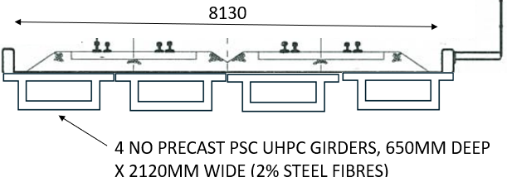UHPC (Ultra High Performance Concrete) was developed in the 1990s with typical compressive and flexural strengths of over 180 MPa and 40 MPa, respectively, refer Foster4. Typically, UHPC comprises Portland cement, silica fume, superplasticers, and steel fibres generally 1-2% by volume. UHPC has a very low binder/water ratio and no coarse aggregate is used.

Figure 6

Excellent durability of UHPC girders is achieved as a result of the increased particle packing density. The steel fibres produce a material of excellent ductility without relying on conventional non prestressed reinforcement to achieve this. The concept design shown in Figure 6 utilises a conventional reinforced concrete top flange overlying a UHPC U girder. It is noted that the only reinforcement provided for the girders is longitudinal prestressing to achieve the required flexural strength, and bars to achieve composite action with the conventionally reinforced concrete slab. No shear ligatures are provided; excellent ductility is provided by the steel fibres.

***Option F: Precast, Prestressed Wide Concrete Girders with FRP PT and reinforcement***

This Option is similar to Options B and D, except the PT and reinforcement consists of fibre reinforced polymer components. The bars are Grade 60 basalt fibre bars to AS 5204 and in accordance with ASTM D578/D578M. Benefits of FRP PT and reinforcement are; easier to handle and place (22% of the equivalent mass of steel bars) and longer life. The FRP PT is spliced to steel components for anchorage.

Figure 7

It is noted that additional care is required in the design of concrete members reinforced with FRP bars. The elastic modulus of FRP is in the order of 30% of steel, so the strains required to develop similar tensile stresses are several times that of steel and crack widths are correspondingly much larger. Specifically, cracking of the concrete will be more extensive and pronounced if the FRP reinforcement is used to its full strength potential. Although this cracking will not lead to corrosion the appearance will be affected. For this reason the service stress in the reinforcement has been limited.

***Option G: Steel girders (grade 300), cast insitu reinforced concrete deck***

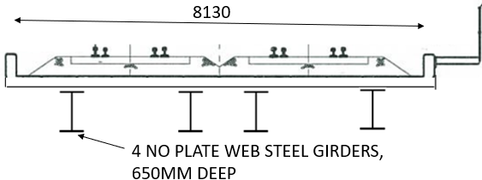This option comprises Grade 300 steel web girders supporting a conventionally reinforced cast in situ concrete deck. The deck provides the ballast trough and also acts compositely with the girders to resist live load and superimposed dead load. A coating system, such as polyurethane or epoxy, has been assumed to be applied to the girders and maintained over the life of the structure.

Figure 8

***Option H: Steel girders (grade 300), cast insitu reinforced concrete deck***

This Option is the same form as Option G, except weathering steel has been adopted as the structural steelwork, thus obviating the need for an applied coating system which needs to be maintained. Assuming a typical environment of urban inland (corrosivity category C2), AS 5100.6 requires a corrosion allowance of 1.0 mm per external surface and 0.5 mm per internal surface. In comparison with Option G therefore, the extra embodied energy required for this increase in section size is partly offset by the embodied energy produced by the manufacture and application of a coating system.

***Option J: Masonry arch, stone arch ring and stone spandrel walls and concrete slab on fill***

Figure 10

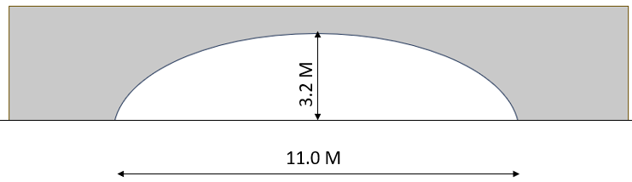This Option comprises a sandstone arch and spandrel walls enclosing earth fill and supporting a reinforced concrete on ground deck slab. Substantial temporary works consisting of reusable steel supports to prop the sandstone arch during construction will be required. The spandrel walls are assumed to be of gravity wall construction. Refer Figure 1o.

## Carbon Emissions

Embodied carbon emissions factors that were adopted for each of the various constituent material types are noted in Table 1, below. These factors account for the “as constructed” embodied carbon of the structure and do not take into account replacement or renewal of any elements. Where possible, Environmental Product Declarations (EPDs) were used. An EPD is an independently verified and registered document that communicates transparent and comparable data and other relevant environmental information about the life-cycle environmental impact of a product. Total carbon content for each option is noted in Table 2.

Table 1 Carbon emissions per material type

|  |  |  |  |
| --- | --- | --- | --- |
| Material | Options | Emission factor | Reference |
| 50 MPa Concrete (30% SCM) | All | 0.181 t(CO2-eq)/t | ISC6 |
| D500N Grade reinforcement | All (except C) | 1.58 t(CO2-eq)/t | InfraBuild5 |
| D600N Grade reinforcement | C | 1.24 t(CO2-eq)/t | InfraBuild5 |
| Prestressing steel | A, B, C, D, E | 1.98 t(CO2-eq)/t | InfraBuild5 |
| Fibre reinforced polymer (FRP) | F | 3.88 t(CO2-eq)/t | Wagners13 |
| UHPC | E | 0.498 t(CO2-eq)/t | Foster, Voo4 |
| Structural steel, grade 300 | G | 3.32 t(CO2-eq)/t | Liberty Steel7 |
| Weathering steel, grade 300 | H | 3.32 t(CO2-eq)/t | Liberty Steel7 |
| Dressed natural stone | J | 0.00496t(CO2-eq)/t | BGC Quarries1 |

Table 2 Total carbon content for each option

|  |  |  |
| --- | --- | --- |
| Option | Option description | Carbon content tonnes (CO2-eq) |
| A | Precast , Prestressed Narrow Width Concrete Girders, 500N reinforcement | 37.4 |
| B | Precast , Prestressed Wide Concrete Girders, 500N reinforcement | 29.0 |
| C | Precast , Prestressed Narrow Width Concrete Girders, 600N reinforcement | 35.5 |
| D | Precast , Prestressed Wide Concrete Girders, 600N reinforcement | 27.0 |
| E | Precast, Prestressed UHPC Girders (2% steel fibres) | 36.5 |
| F | Precast, Prestressed Wide Concrete Girders with FRP PT and reinforcement | 26.6 |
| G | Steel girders (grade 300), cast insitu reinforced concrete deck | 63.1 |
| H | Steel girders (grade 300, weathering steel), cast insitu reinforced concrete deck | 67.8 |
| J | Masonry arch, stone arch ring and stone spandrel walls and reinforced concrete slab on fill | 16.8 |

# Discussion

For small span rail underbridges, a superstructure consisting of precast prestressed concrete planks laid nominally side by side and supporting the ballast and track is the most common form of bridge construction throughout Australia and also in many parts of the world. This is a cost-effective solution, girder moulds and stressing beds exist from a range of suppliers throughout Australia states and construction methods are straightforward and well established. The principle components of; prestressing strand, 500N steel reinforcement and 50 MPa concrete are readily available. Supplementary cementitious materials (SCMs) such as fly ash (by-product of coal powered power stations) and ground granulated blast furnace slag (GGBS, a by-product of steel production) in a blended cement offer substantial advantages in reducing carbon content and concrete mix comprising 70% Portland cement and 30% fly ash has been assumed for both the precast and cast in situ concrete component in all options. Circular economy outcomes are also realised through the recycling of fly ash and GGBS as waste products into new materials.

This investigation showed a substantial embodied carbon premium (additional 28%) in adopting the narrow width girders (say 710 mm wide) as described in Option A rather than the wide girders (say 2120 mm) as described in Option B. This is principally due to the inferior load sharing between the narrow width girders.

It can be seen from Option D that the carbon content can be further improved by utilising the new high strength 600N reinforcement in lieu of traditional 500N reinforcement.

Substituting the steel prestressing and steel reinforcing in with FRP reinforcement (Option F) produced only a marginal carbon content reduction. This is partly due to limitations on serviceability stresses to limit crack widths due to the reduced elastic modulus of FRP reinforcing bars.

In this instance, the higher strength UHPC girders (Option E) did not produce a lower total carbon content. UHPC also has the advantage of a longer service life in comparison with concrete girder options (Option F and Option G), and a much lower lifted girder mass. The carbon content saving of UHPC compared to normal concrete is expected to substantially increase with increasing span due to the lower self-weight of UHPC.

Steel girders with a composite concrete deck (Options G and H) offer real advantages for longer span construction. However, it is evident that for short spans, solutions other than steel girders provide a lower carbon content. The investigation has also shown that although the use of weathering steel obviates the need for an applied corrosion protection the additional steel mass required to allow formation of the steel patina does not produce a significant overall reduction in the carbon content even allowing for ongoing maintenance of the applied corrosion protection over a 100 year service life.

Masonry arch construction (Option J) is a bridge type common in the 19th century. Quarried natural stone has a very low carbon equivalent, and the completed bridge has a low carbon content as a result. As the stone viaducts constructed by the Romans over two thousand years ago and still in use today testify this option has a very long service life, certainly the longest of all the options considered.

# Conclusions

This conversation is timely. Governments and private investors are spending record amounts of money on new infrastructure. At the same time, infrastructure is facing pressure to prepare for net zero emissions on two fronts:

• All Australian states and territories have set commitments or aspirations to achieve net zero emissions by 2050, or earlier; and

• Private investors are increasingly aligning investment portfolios with net zero emissions in order to future-proof economic value and investment returns. Refer ClimateWorks Australia2.

Most long life engineering projects are a compromise between initial cost, lifetime, and lifetime cost, and this same principle can be applied to carbon: initial embodied carbon (to supply and construct); embodied carbon in replacement and renewal; and lifetime carbon including transport of material to site, deconstruction and waste management carbon ‘costs’.

The assessment undertaken for this paper provides a summary of the as-constructed carbon “cost” of a variety of structures suitable to service the generic design considerations of the proxy bridge we are considering. This assessment is intended to serve as a starting point during options assessment, to be considered alongside both traditional cost factors, as well as the further considerations outlined in this paper.

# References

1. BGC Quarries, *Environmental Production Declaration: Aggregates*, EPD Registration no. S-P-05493, Version 1.0, 2022
2. ClimateWorks Australia, Reshaping Infrastructure for a Net Zero Emissions Future, 2020
3. Energy Transitions Commission, *Transport*, 2021
4. Foster, S., and Voo, Y.L., *Assessment on Environmental Impact Calculation (EIC) of Ultra High Performance Concrete Composite Bridges*, fib Symposium 2024, Christchurch, November 2024
5. InfraBuild, *Environmental Product Declaration: Reinforcing Rod, Bar and Wire*, EPD Registration number: S-P-00855, Version 1.2, 2022
6. ISC, Infrastructure Sustainability Materials Calculator (Australia) [TAB: LCI (2021)]. Infrastructure Sustainability Council, 2023
7. Liberty Steel, *Environmental Production Declaration: Hot Rolled Structural and Rail*, EPD registration number S-P-01547, Version 1.2, 2022
8. Manley, K., Australia’s first fibre-reinforced polymer bridge deck on the road network, CRC for Construction Innovation, 2004
9. Ng, A., and McGregor, G., High strength reinforcing steels: the benefits and how they are delivered, ASEC 2020, November 2020
10. OECD, Global Material Resources Outlook to 2060, 2021
11. T Glasby, J Day, M Kemp, J Aldred, *Earth Friendly Concrete – A sustainable option for tunnels requiring high durability*, Arabian Tunnelling Conference & Exhibition, Dubai, December 2013
12. TFC, Product Carbon Footprint Declaration: Wagners Earth Friendly Concrete Geopolymer Concrete, The Footprint Company, 2020
13. Wagners, Environmental Production Declaration: Square Hollow Pultruded GFRP Section WGN-S1000, EPD Registration No, S-P-10246, Version 1.0, 2023

**Author contacts**

**John Hilton, Adjunct Professor, School of Civil and Environmental Engineering, UNSW, Global Capability Leader Bridges, Aurecon, Sydney, Australia**

[John.Hilton@aurecongroup.com](mailto:John.Hilton@aurecongroup.com) [(7) John Hilton | LinkedIn](https://www.linkedin.com/in/johnhiltonaurecon/)

**Lucy Washer, Senior Consultant, Sustainability & Climate Change, Aurecon, Melbourne, Australia**

[Lucy.Washer@aurecongroup.com](mailto:Lucy.Washer@aurecongroup.com) [Lucy Washer | LinkedIn](https://www.linkedin.com/in/lucy-washer-392182139/)