Span 3 Replacement of the Caval Ridge Haul Road Overpass

Wayne Roberts, Engineering Manager Construction and Materials, Structures, TMR

Alan Voll, Principal Engineer (Network Performance – Mackay/Whitsunday District), TMR

Aaron Esplin, Manager Project Delivery, Minerals Australia / Coal Projects, BHP

Darren Gallet, Lead Project Delivery, CCAP, BHP.

Evan Lo A/Director (Planning and Delivery) Structures, TMR

Daniel Pinkney Principal Engineer (Mackay/Whitsunday District), TMR

|  |
| --- |
| **Abstract**  The Caval Ridge Mine Haul Road Overpass on the Peak Downs Highway is a four-span Super Tee Girder bridge constructed in 2013 to carry the Peak Downs Highway over an operating mine site. On Saturday 20 April 2024, Span 3 of the overpass suffered a major bridge strike, leading to extensive damage and the closure of the Peak Downs Highway at this location. Due to the damage sustained, the decision was subsequently made to completely replace Span 3 with a new span of Super Tee Girders.  This paper will provide an overview of the project, including the construction of a diversion road and the equipment and technology used to monitor the bridge span until it could be safely removed. The techniques and equipment used to remove the damaged span and the reconstruction process that led to the overpass being opened to traffic less than 6 months after the incident will also be detailed.  **Keywords:** Bridge Strike, Reconstruction, Super Tee Girder Bridge, Span Replacement |

# Introduction

On the 20th April 2024 a major bridge strike occurred to the Peak Downs Highway Caval Ridge Haul Road Overpass. This incident lead to the immediate closure of the Peak Downs Highway just west of the Moranbah turn off. Span 3 of the bridge was severely damaged and a diversion road was constructed around the bridge so that the damaged Span 3 could be removed and replaced. This paper provides an overview of the construction of the diversion road, and the removal and replacement of Span 3. The works were fast tracked and the reconstructed Span 3 was completed and the bridge re-opened less than 6 months after the incident.

# Background

The Peak Downs Highway (Figure 1(a)) connects Mackay and Clermont and is the primary access route for workers, fuel, machinery, and other supplies to the coal mines of the Bowen Basin.

The Caval Ridge Haul Road Overpass Bridge was constructed in 2013 and opened in 2014 as part of the development of the Caval Ridge Metallurgical coal mine which is operated by the BHP Mitsubishi Alliance (BMA). The bridge is a 4 span Super Tee Girder bridge constructed by Bechtel for the mine and carries the Peak Downs Highway over a series of access and haul roads for the Caval Ridge mine. The bridge is shown in Figure 1(b). Span 1 (Clermont End) of the bridge spans over a light vehicle access road, while Spans 2 and 3 span over the north and south bound haul roads for the mine respectively.

Figure 1 (a) Peak Downs Highway, (b) Caval Ridge Haul Road Overpass Bridge at completion of construction in 2013.

|  |  |
| --- | --- |
| undefined |  |
| (a) | (b) |

The elevation of the bridge is shown in further detail in Figure 2. Span 1 (Clermont End, Left side of Figure 2 is 35m, Span 2 and 3 are 36m and Span 4 is 22.6m. The superstructure consists of 5 Super Tee Girders with a cast insitu concrete deck. Over the piers, the spans are made continuous with link slabs, with an expansion joint at each abutment. Each span has cast insitu cross girders at each end and the girders are anchored to the piers with galvanised steel restraint angles. The abutments are founded on cast in place concrete piles, and the piers are founded on spread footings on rock. A unique feature of this bridge is the significant pier protection barriers to protect the piers from any potential collisions from haul road vehicles. The clearance to the underside of the bridge from the haul road is approximately 11m.

Figure 2 Caval Ridge Haul Road Overpass Bridge Elevation

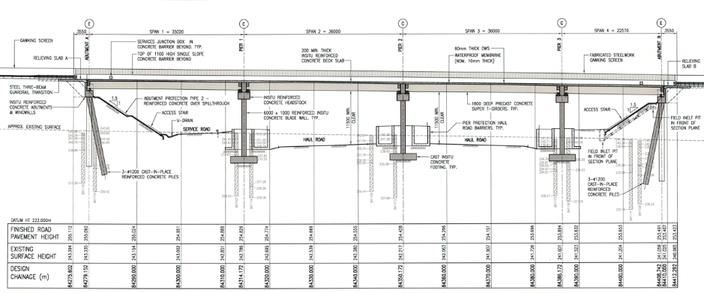

# Incident

In the evening of Saturday 20th April 2024, a severe bridge strike incident occurred when a mining float (combination of a haul truck prime mover and float trailer) loaded with a mining excavator travelling on the southbound haul road struck Span 3 of the bridge causing damage to the Super Tee Girders. As a result of this bridge strike the Peak Downs Highway was immediately closed in both directions to all traffic, the scene was preserved and the float and excavator stabilised to prevent any further movement. At this point, Span 3 was still in place and intact, but significantly damaged and not safe for traffic to pass over the bridge.

Figure 3 Span 3 Bridge Strike Incident.

|  |  |
| --- | --- |
|  |  |
| (a) | (b) |

A team including senior mine workers and management from BMA, and the Queensland Department of Transport and Main Roads (TMR) Structures representatives from Brisbane and Mackay, and relevant mining engineering support staff including RKF Engineering was mobilised to the site by 9:00am Monday morning, 22 April 2024, to further inspect the site and develop an action plan.

# Initial Management

## Redirection of Traffic

As the Peak Downs Highway was now completely closed just West of the Moranbah turnoff, traffic travelling from Moranbah to Clermont was redirected via Dysart which added 40km to the usual 120km trip from Moranbah to Clermont. Local traffic from Moranbah to areas just west of Moranbah and return was more inconvenienced with a trip which would normally be a couple of kilometres turning into a 280km trip

The immediate traffic diversions where managed by BMA, local Police, and TMR Mackay Office, and then RoadTek took over from the Police on Sunday 21 April 2024 establishing permanent 24 hour traffic control and VMS Signage. These traffic diversions were in place until the 6 May 2024 when a diversion road, which was built around the bridge by BMA as detailed in Section 6 opened to traffic.

BMA also established a temporary emergency vehicle detour through the mine site before the diversion road was complete, so that connectivity from Moranbah for police, fire and ambulance to the local community on the western side of the overpass was available if required.

## Initial Site Response

The initial mine site response focused on making sure the float and excavator were safe and stable and involved supporting the trailer with hydraulic jacks and stands and monitoring the tyre pressures in the trailer tyres.

To ensure safety an exclusion zone was also set up under Span 3 of the bridge and access was also restricted under Spans 2 and 4.

## Bridge Monitoring

The mine also redeployed their slope stability radar systems (illustrated in Figure 4 (a)) to continuously scan the scene to monitor for any movements. It is understood that this may have been the first time that this type of equipment was used to monitor structural movements and while it only measures movements along an axis between the radar and the point of contact of the radar signal, the ability to scan a point cloud at regular intervals still proved useful in determining whether the structure was stable or not. Later in the project, a number of total station survey systems (illustrated in Figure 4(b)) were deployed to more accurately measure displacements in 3 directions (X, Y and Z Planes) during the operation to remove Span 3.

It is also worth noting that a number of drones were used to capture high quality images of the damage during the early stages of the incident which also provided valuable information and important site context.

Figure 4 (a) slope stability radar system, 9b) total station survey monitoring system.

|  |  |
| --- | --- |
|  |  |
| (a) | (b) |

A Web interface (illustrated in Figure 5) with automatic notifications was also established which provided the project team with real time information on the state of the structure.

Figure 5 Example of Survey System Web Interface.

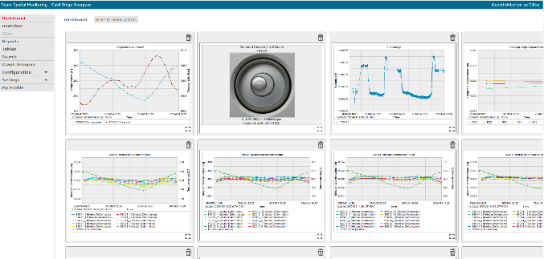

## Bridge Inspection

A detailed Level 2 bridge inspection commenced immediately on Spans 1, 2, and 4 of the bridge and the associated piers and abutments to determine if any of the bridge components, other than the Span 3 Super Tee Girders, had suffered any damage or had moved as a result of the bridge strike. This inspection indicated that other than the damage to the Span 3 Super Tee Girders the rest of the bridge had suffered no damage or permanent movement or deflection as a result of the bridge strike.

The cast insitu deck of Span 3 also appeared to have suffered little damage and the intact nature of the Span 3 cast insitu deck was a key factor in the methodology chosen to remove Span 3.

Once this inspection was complete and based on the findings, access under Span 1 was reinstated for light vehicles, and later access under Span 2 for the North bound haul road was also re-instated. At this time speed limits were imposed on the Span 2 haul road access, and limits on blast vibrations from drill and blast operations at the mine site were also imposed at the bridge site to limit any further damage or movement to the bridge.

# Repair or Replace Span 3

Once the initial response phase of the incident was complete, attention then turned to developing a strategy for the damaged Span 3. Four of the five Super Tee Girders had sustained significant damage with the degree of damage varying from almost total destruction and complete loss of section capacity near midspan, to significant local damage near midspan. On all but one of the girders it appeared, at the time, that a significant number of prestressing strands had been completely severed. Figure 6 shows a close up view of the Super Tee Girder with the most damage. It is worth noting that at this stage, inspection of the damaged Span 3 Girders, at close proximity, was only possible by drones as there was a complete exclusion zone under Span 3 for safety reasons.

During the initial stages of the incident, it was decided that while it may not be impossible to repair the damaged Span 3 Super Tee Girders, it was likely that this would be difficult, time consuming and expensive,.

Thus it was decided by the Tuesday 23 April 2024 (within 3 days of the incident) that a full removal and replacement of Span 3 was the best option, and by the following day a BHP project team was being assembled by BHP to execute the scope of works to remove and replace Span 3 of the bridge. Further information on the rationale for this decision is included in Section 7 of this paper.

Figure 6 Close up of typical damage to Super Tee Girders

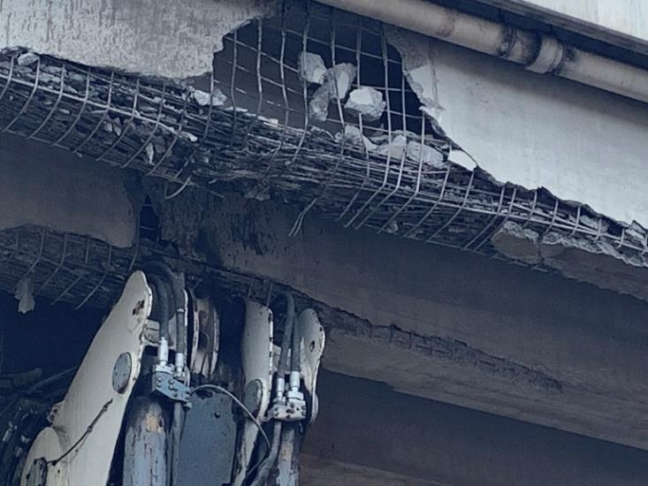

# Scope of Works

## Diversion Road

To minimise inconvenience to road users of the Peak Downs Highway during the removal and reconstruction of Span 3, a diversion road was constructed around the bridge. The route for the diversion road is illustrated in Figure 7 (yellow line). The diversion road was essentially a reconstruction of the formation of the diversion road that was put in when the bridge was originally constructed back in 2013 and essentially ran parallel to the Peak Downs Highway around the bridge site for a length of 2.3 km. The diversion road was a fully sealed two lane two-way road with line marking complete with an at grade intersection with the mine haul road. This intersection included traffic lights and boom gates and was manually operated and monitored by onsite personnel 24 hours per day. This diversion road was operational from 8 May 2024 until the completion of the reconstruction of Span 3 on 30 September 2024. The opening of this diversion road was a significant milestone for the project and was the result of a high level of cooperation between BMA and TMR with particular sensitivities around the regulatory safety aspects as well as the engineering and technical details.

Figure 7 Outline of the diversion road (yellow line)

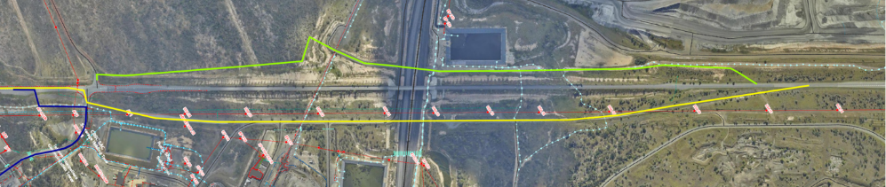

Figure 8 (a) Diversion road on the right side of the Peak Downs Highway (b) At grade intersection between diversion road and mine haul roads.

|  |  |
| --- | --- |
|  |  |
| (a) | (b) |

## Span 3 Removal

The scope of work for the Span 3 removal included using Self Propelled Modular Transporters (SPMT’s) supporting a jacking system to firstly support and stabilise Span 3 while the link slabs between Span 3 and the adjacent spans were cut. The SPMT’s and jacking system were supplied and operated by Mammoet with engineering undertaken by Jacobs.

Span 3 was then jacked up and the float loaded with the excavator was safely driven out without any further damage to the equipment. Span 3 was then driven out on the SPMT’s and then lowered down and placed temporarily on shipping containers adjacent to the bridge site, but out of the way of the Span 3 reconstruction. Two photos giving an overview of the process are included in Figure 9. The bridge with Span 3 removed, ready for reconstruction of Span 3 is shown in Figure 10.

Figure 9 Span 3 Removal process

|  |  |
| --- | --- |
|  |  |
| (a) | (b) |

Figure 10 Bridge with Span 3 removed

## Span 3 Reconstruction

With the original Span 3 safely removed, reconstruction of the span could commence. The reconstruction was typical of the normal conventional construction process for a Super Tee bridge span with the exception of linking the cast in-situ deck slabs into the existing Span 2 and 4 deck slabs. The reconstruction was from the level of the bearing pedestals upwards and included new elastomeric bearings and restraint angles, and new anti-gawk screens. Figure 11 shows some views of the reconstruction process including the crane that was mobilised to site and the temporary works scaffolding that was required.

These works were carried out by CPB Contractors engaged and managed by BMA.

Figure 11 Span 3 Reconstruction

|  |  |
| --- | --- |
|  |  |
| (a) | (b) |

Figure 12 shows the completed Span 3 reconstruction. All works were completed within 6 months of the initial incident.

Figure 12 Span 3 Reconstruction Complete

|  |  |
| --- | --- |
|  |  |
| (a) | (b) |

## Pavement Rehabilitation

While the bridge and road approaches were closed and the diversion road was in place, some repairs to the pavement on the bridge approaches were also undertaken to address some subsidence near the approach relieving slabs and some rutting on the eastern approach. The asphalt deck wearing surface on Span 3 obviously also had to be reinstated after the reconstruction of Span 3. Line marking was also required.

# Key Success Factors

Some of the key factors that led to the successful removal and reconstruction of the Span 3 of the Caval Ridge Mine Overpass bridge within 6 months are detailed in this section. Some of the challenges are also noted.

## Bridge Design

The bridge was a relatively recent design, with the original bridge design and construction being completed in 2013, and the original design completed to AS5100 (2004). Therefore a like for like design for the Span 3 replacement to the original as constructed drawings was deemed acceptable by TMR and was the chosen philosophy for the design of the Span 3 replacement. This decision was able to be made quickly in the very early stages of the project and immediately set up the design philosophy and scope for the project.

Because this like for like replacement option was acceptable, this meant that immediate procurement of critical items (within one week of the initial incident) could commence based on the original drawings. Items that were procured immediately based on the original project drawings included girders, bearings, and galvanised steel restraint angles.

## BMA Caval Ridge Team, BHP Project Team and BHP/BMA Capability

The BMA Caval Ridge team’s initial response to the incident was outstanding and the level of resources and engineering that was assigned to the initial response was a key factor in ensuring the safety and efficiency of the response.

BHP also has its own in-house project procurement, management and delivery team including significant engineering capability, and this was also a key factor in the success of the Span 3 removal and replacement. This team also had some first-hand experience with the construction of the original bridge and were very experienced with management of complex multi-disciplinary projects of this type.

The team also had experience with delivery of projects to TMR / TfNSW road authority specifications and requirements. BHP also have their own in house engineering team including structural engineers with previous TMR bridge design experience.

This experience and capability was a key factor in the project success and allowed the BMA/BHP team to proactively solve problems and successfully manage the technical and logistical aspects of the project while ensuring the requirements of all stakeholders were met.

## TMR Mackay and TMR Structures

From the initial day of the incident to the final completion of the reconstruction of Span 3 of the bridge, the TMR Mackay District staff (based in Mackay) and TMR Engineering and Technology Structures staff (based in Brisbane) worked closely and collaboratively with BMA/BHP, their subcontractors and Jacobs to develop the solution and deliver the project. This included regular site visits, and at least weekly online co-ordination meetings and technical discussion meetings as required. TMR was also able to draw in various subject matter experts and logistical and technical support as required throughout the Department.

## Jacobs Project Team

BMA engaged Jacobs to provide the engineering and design services required for the safe removal and reconstruction of Span 3 of the Caval Ridge Mine Overpass Bridge. The Jacobs team were intimately familiar with the bridge and the site as the designers of the original bridge and Darren Leeson who led the design of the original bridge when it was initially constructed was involved throughout the project. As well as engineering and design services, Jacobs also provided assistance to the BHP delivery team on site with various site visits and construction phase services as required. The Jacobs team were all based in Brisbane.

## Site conditions

A key factor in the successful removal and reconstruction of Span 3 was that the span was located over the Southbound mine haul road. This haul road practically provided a flat level working platform for the removal and reconstruction operations. There was some minor works required to improve the bearing capacity of the platform for some operations such as operation of the SPMT. The works conducted would have been significantly more expensive and/or time consuming if this effective working platform was not present. The northbound haul road under Span 2 was used throughout the reconstruction for two way operation of haul trucks and other heavy mine vehicles. Light vehicle traffic used the light vehicle service road under Span 1.

BMA were also able to demarcate the Span 3 reconstruction site from the operating mine, thereby allowing the Span 3 reconstruction site to operate as a civil construction site rather than a mine site. This meant that the Span 3 reconstruction operations could continue independent of the mine site and meant that induction and access requirements were similar to business as usual for civil construction.

## Mammoet Capability

The unique combination and capability of the Mammoet SPMT’s and the jacking system that was assembled on the SPMT’s was a key factor in the efficient and safe jacking up and removal of Span 3 without any further damage to the remainder of the bridge and without any further damage to the float and excavator. This equipment was mobilised from multiple states around Australia and was a key factor in the safe jacking and removal of Span 3 on the weekend of 24 and 25th of May 2024 approximately one month after the initial incident.

## CPB Contractors

CPB contractors were engaged by BMA to reconstruct Span 3 once the damaged span was removed. The CPB team had significant prior experience with construction of Super Tee Bridges to TMR requirements and specifications. CBP successfully completed the reconstruction of Span 3 in 4 months.

## Mining Accommodation Camp

BMA operates a significant mining accommodation camp nearby which meant that accommodation for staff working on the Span 3 reconstruction were easily able to be accommodated close to the bridge site.

## Weather

All works were conducted during late Autumn, Winter and early Spring in QLD when the weather is generally kindest for construction works. Generally there were no significant weather related delays to the project.

## Girder Supply

Stresscrete, a TMR registered precaster located in Rockhampton cast the girders when the bridge was originally constructed in 2013. Stresscrete were available to manufacture the girders for the Span 3 replacement at relatively short notice, and their experience with manufacturing the original girders and their availability to manufacture the Span 3 replacement girders was a key factor in the early decision to replace Span 3, and the overall success of the project. Stresscrete also delivered the girders to site and cast the precast concrete parapet shells. Stresscrete also had significant previous experience working with TMR, and mining and resource companies. Their experience and capability with transport of Super Tee Girders was also valuable to the project success.

# Challenges

## Span 3 Stability During Removal

The stability of the damaged Span 3 was a significant issue to consider. From the initial stages of the incident it was generally assumed that the excavator boom was supporting the damaged Span 3 of the bridge to some extent, and that until Span 3 was safely supported by some other means or an alternate load path was provided, it was decided not to move the excavator and the float that was transporting it. A possible progressive collapse of the bridge and / or damage to other spans and the piers and abutments, caused by the continuity of the link slab over the piers, was also high on the priority list to avoid and this would have been an unacceptable safety risk and would have also significantly increased the scope of the reconstruction.

## Girder Delivery

One of the significant challenges to the Span 3 reconstruction work program was the delivery of the girders to the site from Rockhampton. The initial route for the girder delivery included traversing a number of timber bridges on the Fitzroy Developmental Road which was the most direct route However one of the timber bridges on this route was damaged by a fire just before the girder delivery was due to commence. This meant that the girders had to be delivered via a longer route via Emerald and Clermont which also required a new route assessment and associated permits. There was also limited availability of suitable trucks to transport girders due to a large volume of girder transport work for TMR projects in South East QLD at the time.

## Reconnection of the Link Slabs

One of the technical and design challenges associated with the reconstruction of Span 3 was how to reconnect the cast in-situ decks from the newly constructed Span 3 into the existing cast in-situ decks in Span 2 and 4. Before Span 3 was removed, the link slabs were cut through full thickness either side of Span 3 with a diamond saw. To facilitate reconnection, sufficient concrete from the remaining sections of the adjacent Span 2 and Span 4 link slabs was hydro demolished and reinforcement for the new Span 3 link slabs was attached with welded lap splices.

# Conclusion

This paper has provided a summary of the response to a major bridge strike on the Caval Ridge Mine Haul Road Overpass Bridge. The response included the immediate closure of the bridge, construction of a diversion road, and the complete removal and replacement of Span 3. Some of the technical aspects of the project and some key factors which contributed to the success of the project are highlighted as well as some challenges. Span 3 was safely removed and reconstructed and the bridge re-opened to traffic within 6 months of the initial incident.

|  |
| --- |
| **Acknowledgments**  The Authors would like to acknowledge some of the key people who provided significant input and assistance or oversight for the engineering aspects of the project.  BHP Engineering – Megan Strong and Patrick Jin  BHP Caval Ridge – Alan Milani, Gavin Doherty, George Padwick, Babak Aghlmand  TMR Engineering and Technology – Torill Pape, Neville Janssen, Jason Jones, Budi Soetanto, Carrie Lin, Phoebe Tay, Ben Zhang, Mark Mitchell, Carlos Garcia, Graham Colilns, Bret Kershaw, Shane Crawford, Kevin Chung, Rhea Rivera, Helen Allpress.  TMR Mackay – Patrick April, Glenn Langfeldt, Vickie Wood, Patrick Doolan.  Jacobs – Darren Leeson, Andrew Reeves, Phil Stockwell, and Zeyn Suleman  Mammoet – Laura Ewen  RKF Engineering – Terrence Slattery, Maria Fordham  CPB Contractors |