Automation Tool for Bridge Network Analysis

Hai Le, BNA

|  |
| --- |
| **Abstract**  The majority of existing bridges in Australia were designed according to historical standards, where the design vehicles are significantly lighter than the current oversize over mass (OSOM) vehicles operating on our ageing bridge network. Furthermore, the traffic volumes of OSOM vehicles are increasing on the bridge networks. Consequently, to protect our bridge assets from deterioration and ensure public safety, OSOM operators must obtain heavy load permits from road authorities.  According to AS5100-2017 Part 7, bridge assessments must be performed by professional bridge engineers, including the assessment of heavy load permits, which requires considerable resources. To optimize the assessment process while limiting resource use, an automated assessment tool has been successfully developed using the Finite Element Method. This tool was demonstrated at the 11th Austroads Bridge Conference. However, some limitations of the previous version have been addressed through significant upgrades. The new features of the tool represent considerable improvements.  The aim of this paper is to introduce the upgraded tool, which incorporates new features such as combining line load analysis and the 2D-frame analysis module into a unified module. The tool can now perform structural analysis for various bridge types, including 2D grillage models, line beams, and all types of 2D frame bridges such as box culverts (both with and without fill), 2D truss bridges, and 2D arch bridges. This presentation also briefly discusses optimizing resources and targeting net-zero in software development of the bridge assets by efficiently utilizing appropriate databases and programming languages.  **Keywords:** Heavy load permit, Oversize Over Mass vehicle , Automation, The Finite Element, Structural analysis. |

# Introduction

It is estimated that across the national road network, there are over 50,000 bridges and a large number of culverts1. Around 25,000 bridge structures are managed by local council2. A large proportion of the existing bridges and culverts were designed for T44 and MS18 before AS5100-2004. In addition, according to the ABS's Motor Vehicle Census 2020, Australia has over 589,000 registered heavy vehicles. These registrations have continually grown between 2015 and 2020 by more than 7% over the past 5 years (Australian Bureau of Statistics, 2021)3.

These heavy vehicles need to apply for heavy load permits to travel on our road networks. When undertaking bridge assessments for heavy load permits, this is done by registered bridge engineers from engineering consultants, except where the bridge asset owners have their own professional bridge engineers to perform the task. The registered professional bridge engineers are may available at the stage road agencies, but they are not available for the local councils. The assessment process for heavy load permits is time-consuming and costly. The time frame for one heavy load permit for a heavy vehicle on a proposed route can range from a couple of days to a couple of months, depending on the assessment level and available resources. Basically, structural analysis is the important part of the bridge assessment, and this task is normally performed using available commercial computer programs such as Microstran, SpaceGass, Midas, Lusas, Strand7, etc. The simplest assessment method for a heavy load permit for a bridge is to compare the load effects of an application vehicle to those of the reference vehicle (original design vehicle) using a line load analysis model for a bridge or a 2D frame for a box culvert. A higher assessment tier needs to be performed when a bridge has available engineering drawings. The structural analysis of the high-level bridge assessment uses various approaches, such as 2D grillage, 3D frames, 3D brick models, Strut and Tie models, cracked section analysis, moment redistribution, non-linear analysis, etc.

To accelerate the load rating process for heavy load permits, the author has successfully developed the automation tool using the Finite Element Method (essentially FEM considers the displacement method) to perform structural analysis for multiple bridges along proposed routes, at the network level. The tool consists of two modules: (1) a combined 1D line and 2D frame structural analysis module, and (2) a 2D grillage model. Using module (1), the tool can quickly generate load ratings for multiple bridges on a route within a minute for up to a hundred bridges, while module (2) can provide load rating for 10 bridges within 10 minutes. The features of the automation tool will be discussed in the following sections of this paper

# Literature review

The rating of existing bridges to support heavy load permits is not only a requirement of modern bridge design standards but can also be found in superseded standards and specifications. The rating of existing bridges see was introduced in the old Section 10 of the Highway Bridge Design Specification (1957)4, (1960)5, Section 12 of the Highway Bridge Design Specification (1965)6  and (1970)7, and Section 11 of NAASRA (1976)8. The latest load rating that also can be used for heavy load permits based on the part 7 of AS5100 (2017) 9.

The load rating factor from Equation 14.1 of AS5100.7-2017 is reproduced as below

|  |  |  |  |
| --- | --- | --- | --- |
| $${RF}_{}=\frac{Available bridge capacity for traffic load effects}{Traffic load effect of nominated rating vehicle }$$ | | | 1 |
|  |  |  | |

It should be noted that the available bridge capacity for traffic load effects, as indicated in Equation 1 above, can only be calculated when a set of bridge drawings is available. Additionally, the structural analysis of a bridge must be performed using at least a 2D grillage model, without considering the interaction of combined actions. In cases where the capacity of a bridge member is calculated using the interaction equation for combined actions, such as the concrete and steel column capacity or the shear capacity of a steel beam, the available bridge capacity for traffic load effects cannot be determined. When the interaction equation is necessary, combined actions are derived from the maximum primary action and its coincident actions.

If the available bridge capacity cannot be determined due to insufficient information from the engineering drawings or the absence of drawings altogether, the available bridge capacity for traffic load effects can be calculated based on a Reference Vehicle (REV) that represents the bridge's "capability" 10.

The load rating for a bridge based on its capability is only applicable when the ground contact width of the application vehicle is the same as that of a Reference Vehicle.

Some automation tools have been developed and are used by state road authorities for the fast assessment of bridges at the route and network levels, such as the National Automated Access System (NAAS), the Heavy Vehicle Structural Assessment Permit System (HV-SAPS) in Victoria, and the Bridge Management System in Western Australia, etc11. However, the detailed developing structural analysis methodologies of these tools are not available for public review.

# Automation Tool for Bridge Network Analysis

The Automation Tool is developed using the Finite Element Method to perform structural analysis for various bridge types, utilizing both 2D frame and 2D grillage models. The 2D frame model is used for the structural analysis of beam bridges, arch bridges, tied-arch bridges, suspension bridges, box culverts, and other 2D elevation bridge types. Meanwhile, the 2D grillage model is capable of undertaking structural analysis for all bridge types on the 2D plane.

The features of the 2D grillage model are as follows:

* It can automatically calculate the number of lanes for a bridge or multiple bridges on a route.
* It has the capability to generate travel paths for bridges with both straight and curved alignments, with or without skew angles.
* It is capable of performing structural analysis for the most common types of bridge superstructures, including steel, composite, timber, normal reinforced concrete, pre-tensioned, and post-tensioned concrete bridges.
* It can automatically retrieve the section properties of members, including the second moment of areas, section areas, torsional constants, and material properties stored in the primary bridge database. Additionally, such information can be manually input from other commercial structural analysis programs, such as SpaceGass and Microstran, among others.
* The tool is capable of calculating the distribution of wheel loads across different grillage members under two cases: (1) wheel loads are distributed to all members, and (2) wheel loads are distributed to the primary beams. The program can also analyse heavy vehicles with more than 500 wheels.
* It can perform structural analysis for both a main vehicle and a coexisting vehicle on the bridge, considering the accompanying lane factors.
* It can generate enveloped load effects at the Ultimate Limit State (ULS) and Serviceability Limit State (SLS), including (1) maximum bending moments with coincident shear forces and torsional moments, (2) maximum shear forces with coincident bending moments and torsional moments, and (3) maximum torsional moments with coincident shear forces and bending moments. The program can also calculate the support reaction at a node and its corresponding reactions at other nodes.

The 2D frame module has been upgraded through the integration of the beam bridge module and 2D frame bridge module into a single unified model. The features of the 2D frame module as following:

* The module can analyse moving loads for both point loads (wheel loads) and uniformly distributed loads (distributed wheel loads through fill for box culverts and rail bridges)
* The module can calculate the load rating for critical locations on bridges and box culverts based on bridge capability or bridge capacity
* The module can perform load ratings for a single bridge or multiple bridges on a proposed route or at the network level.

The implementation of an Automation Tool for bridge analysis and load rating at the network level necessitates the structuring of all bridge-related data using normalized forms to enhance data integrity, ensure security, minimize inconsistencies, and accelerate data processing. The primary database can be stored in professional database management systems (DBMS), such as Microsoft SQL Server, Oracle, or Microsoft Access, among others.

The following sections will briefly outline the essential steps in selecting appropriate programming languages, in conjunction with the Finite Element Method, to develop the software component of the tool. This component is designed to facilitate the manipulation and management of the primary bridge database, with the goal of optimizing performance in large-scale database environments and supporting efforts toward net-zero operations.

# The Primary Bridge Database and Computer Languages

Due to the large volume of bridge data, it is essential to store the information in a structured database that includes logically organized tables. The table structures will follow a normalized format, ensuring efficient data management and retrieval.

* 1. **The Primary Bridge Database**

The primary bridge database is stored in six tables, utilizing professional database providers as mentioned above. Additionally, there are two tables used for storing vehicle codes and configurations, as shown below:

Table 1. Bridge Type

|  |  |  |  |  |  |  |  |  |  |  |
| --- | --- | --- | --- | --- | --- | --- | --- | --- | --- | --- |
| State  or  Council | Link ID | Bridge no | Fill (m) | Overall Width (m) | Beam width | Num member | Num node | Bridge type | Load type | Ref Vehicle |
| A | 1 | 1 | 0 | 8.4 | 2.4 | 7 | 8 | 1 | 1 | T44 |
| A | 1 | 2 | 0.95 | 10 | 1.2 | 3 | 4 | 2 | 2 | MS18 |
| A | 1 | 3 | 1.2 | 8.6 | 1.8 | 3 | 4 | 2 | 2 | T44 |
| … | … | … | … | … | … | … | … | … | … | … |
| A | 5 | 25 | 0.76 | 9.5 | 1.2 | 16 | 17 | 2 | 2 | T44 |
| A | 5 | 26 | 1.1 | 11.6 | 1.2 | 17 | 21 | 2 | 2 | T44 |

Note: “…” indicates that there are more rows above and below.

Table 1 above is used to store bridge information, including bridge locations, bridge types (beam bridges, box culverts, truss bridges, suspension bridges, etc.), load types (point loads, uniformly distributed loads), and the bridge reference vehicles.

Table 2. Council / State Link table

|  |  |  |
| --- | --- | --- |
| Council/State ID | LinkID | Link name |
| A | 1 | A23 |
| A | 2 | A25 |
| … | … | … |
| D | 1 | D11 |
| D | 2 | D12 |

Table 3. Member Data

|  |  |  |  |  |  |  |  |  |  |  |
| --- | --- | --- | --- | --- | --- | --- | --- | --- | --- | --- |
| State  or  Council | Link ID | Bridge no | Member  no | Node A | Node B | Section ID | Material  ID | Res A | Res B | Load |
| A | 1 | 1 | 1 | 1 | 2 | 1 | 1 | 1 | 1 | 1 |
| A | 1 | 1 | 2 | 2 | 3 | 1 | 1 | 1 | 0 | 1 |
| A | 1 | 1 | 3 | 3 | 4 | 1 | 1 | 1 | 1 | 1 |
| A | 1 | 1 | 4 | 4 | 5 | 1 | 1 | 0 | 1 | 1 |
| A | 1 | 1 | 5 | 5 | 6 | 1 | 1 | 1 | 1 | 1 |
| A | 1 | 1 | 6 | 2 | 7 | 1 | 1 | 1 | 1 | 0 |
| A | 1 | 1 | 7 | 5 | 8 | 1 | 1 | 1 | 1 | 0 |
| A | 1 | 2 | 1 | 1 | 2 | 1 | 1 | 1 | 1 | 1 |
| A | 1 | 2 | 2 | 1 | 3 | 2 | 2 | 1 | 1 | 0 |
| A | 1 | 2 | 3 | 2 | 4 | 2 | 2 | 1 | 1 | 0 |
| … | … | … | … | … | … | … | … | … | … | … |

Table 3 is used for storing bridge member data, which includes the “Member no” column. The “Node A” and “Node B” columns indicate the start and end nodes of the member, respectively. The “Res A” and “Res B” columns are used for storing member end restraints (fixed restraints or hinged restraints etc).

The “Node A” and “Node B” columns are used to connect to the corresponding "Node No" column in Table 4 to obtain node information (node coordinates and node restraints). The "Section ID" column is used to link with the "Section No" from Table 5 to obtain corresponding member information (cross-sectional areas, second moments, and torsional constants). The “Material ID” column is used to connect with the “Material” column of Table 6 to obtain material data, including elastic modulus, Poisson's ratio, etc. In addition, the "Load" column indicates whether the member directly supports a load from vehicle live loads.

Table . Node Data

|  |  |  |  |  |  |  |  |  |  |  |  |
| --- | --- | --- | --- | --- | --- | --- | --- | --- | --- | --- | --- |
| State  or  Council | Link ID | Bridge no | Node  no | X(m) | Y(m) | ResX | ResY | RotZ | Kx | Ky | Kz |
| A | 1 | 1 | 1 | 0 | 0 | 1 | 1 | 1 | 0 | 0 | 0 |
| A | 1 | 1 | 2 | 4 | 0 | 1 | 1 | 1 | 0 | 0 | 0 |
| A | 1 | 1 | 3 | 5.5 | 0 | 1 | 1 | 1 | 0 | 0 | 0 |
| A | 1 | 1 | 4 | 10.5 | 0 | 1 | 1 | 1 | 0 | 0 | 0 |
| A | 1 | 1 | 5 | 12 | 0 | 1 | 1 | 1 | 0 | 0 | 0 |
| A | 1 | 1 | 6 | 16 | 0 | 1 | 1 | 1 | 0 | 0 | 0 |
| A | 1 | 1 | 7 | 4 | -3 | 0 | 0 | 1 | 0 | 0 | 0 |
| A | 1 | 1 | 8 | 12 | -3 | 0 | 0 | 1 | 0 | 0 | 0 |
| A | 1 | 2 | 1 | 0 | 0 | 1 | 1 | 1 | 0 | 0 | 0 |
| A | 1 | 2 | 2 | 6 | 0 | 1 | 1 | 1 | 0 | 0 | 0 |
| A | 1 | 2 | 3 | 0 | -3 | 0 | 0 | 1 | 0 | 0 | 0 |
| A | 1 | 2 | 4 | 6 | -3 | 0 | 0 | 1 | 0 | 0 | 0 |
| … | … | … | … | … | … | … | … | … | … | … | … |

Table 5. Section property

|  |  |  |  |  |  |  |  |  |  |  |
| --- | --- | --- | --- | --- | --- | --- | --- | --- | --- | --- |
| State  or  Council | Link ID | Bridge no | Sec  ID | Name | Mark | Area | Jx* | IY* | IZ* | Jx factor |
| A | 1 | 1 | 1 | Sec 1 | S1 | 0.125 | 1.7 | 6.5 | 2.6 | 0.2 |
| A | 1 | 1 | 2 | Sec 2 | S2 | 0.75 | 7.5 | 625 | 3.5 | 0.2 |
| A | 1 | 2 | 1 | Sec 1 | S1 | 0.125 | 1.7 | 6.5 | 2.6 | 0.2 |
| A | 1 | 2 | 2 | Sec 2 | S2 | 0.75 | 7.5 | 625 | 35 | 0.2 |
| … | … | … | … | … | … | … | … | … | … | … |

(*) = value x 10-3

Table 6. Material property

|  |  |  |  |  |  |  |  |  |  |
| --- | --- | --- | --- | --- | --- | --- | --- | --- | --- |
| State  or  Council | Link ID | Bridge no | Material | Name | E(**) | P | Density | Thermal coefficient | Strength |
| A | 1 | 1 | 1 | Mat 1 | 26.7 | 0.2 | 2.4 | 0.00011 | 24 |
| A | 1 | 1 | 2 | Mat 2 | 32.8 | 0.2 | 2.5 | 0.00011 | 25 |
| A | 1 | 2 | 1 | Sec 1 | 26.7 | 0.2 | 2.4 | 0.00011 | 24 |
| A | 1 | 2 | 2 | Sec 2 | 32.8 | 0.2 | 2.5 | 0.00011 | 25 |
| … | … | … | … | … | … | … | … | … | … |

Note (**) = value x 103

Table 7. Vehicle code

|  |  |  |  |
| --- | --- | --- | --- |
| Name | DLA | LLF | No axle |
| V1 | 0.4 | 2 | 6 |
| V2 | 0.4 | 2 | 9 |
| … | … | … | … |
| V21 | 0.1 | 1.5 | 22 |
| … | … | … | … |

Table 8.Vehicle configuration

|  |  |  |  |  |  |  |  |  |  |  |  |
| --- | --- | --- | --- | --- | --- | --- | --- | --- | --- | --- | --- |
| Vehicle | Axle | P(kN) | Spacing | Acc Spacing | No  Wheel | Wheel  Width | GCW | X1 | X2 | X3 | X4 |
| … | … | … | … | … | … | … | … | … | … | … | … |
| V21 | 1 | 6 | 0 | 0 | 2 | 279 | 2.4 | -1.06 | 1.06 | 0 | 0 |
| V21 | 2 | 9.25 | 4 | 4 | 2 | 558 | 2.4 | -0.92 | 0.92 | 0 | 0 |
| V21 | 3 | 9.25 | 1.4 | 5.4 | 2 | 558 | 4.2 | -0.92 | 0.92 | 0 | 0 |
| V21 | 4 | 14 | 3.5 | 8.9 | 2 | 1160 | 4.2 | -1.52 | 1.52 | 0 | 0 |
| V21 | 5 | 14 | 1.25 | 10.15 | 2 | 1160 | 4.2 | -1.52 | 1.52 | 0 | 0 |
| V21 | 6 | 16.5 | 2.6 | 12.75 | 2 | 1160 | 4.2 | -1.52 | 1.52 | 0 | 0 |
| V21 | 7 | 16.5 | 1.8 | 14.55 | 2 | 1160 | 4.2 | -1.52 | 1.52 | 0 | 0 |
| V21 | 8 | 16.5 | 1.8 | 16.35 | 2 | 1160 | 4.2 | -1.52 | 1.52 | 0 | 0 |
| V21 | 9 | 16.5 | 1.8 | 18.15 | 2 | 1160 | 4.2 | -1.52 | 1.52 | 0 | 0 |
| … | … | … | … | … | … | … | … | … | … | 0 | 0 |
| V21 | 22 | 9.25 | 1.37 | 54.82 | 2 | 558 | 2.4 | … | … | 0 | 0 |

To facilitate interaction between bridge assessors and the primary bridge database, the graphic interface and programming language are employed as illustrated below:

Figure 1. 2D Frame Module Graphic Interface

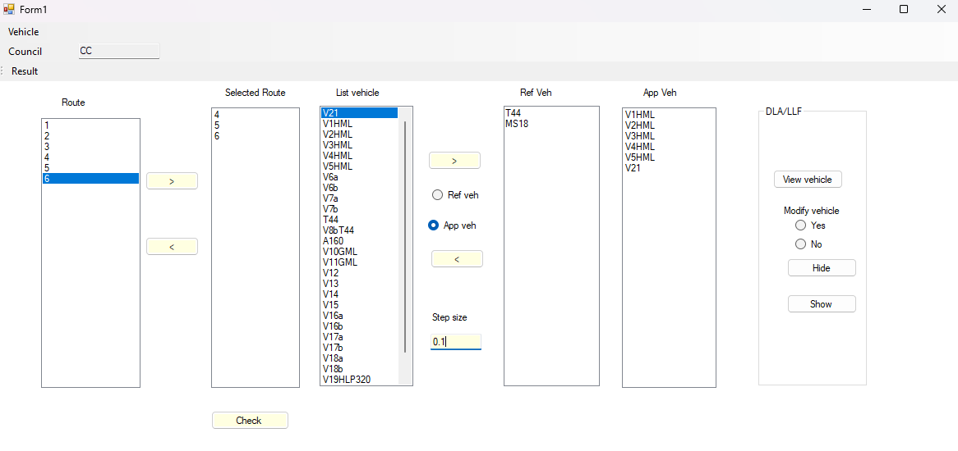

**4. 2 Graphic Interface and Computer Language**

The graphical interface, as shown in Figure 1, was designed for load rating assessors to interact with the primary database using a 2D frame model and the 2D grillage module. The primary bridge database is organized into eight tables with millions of rows, allowing users to manipulate relevant data related to bridge and vehicle configurations through an executable file that was written in a programming language.

When working with a large database, the most important aspect is to use suitable programming languages to write source code that optimizes program execution time. The programming languages can be classified as either compiled or interpreted. The benefit of compiled languages is that, once compiled, they run significantly faster than interpreted languages. To successfully implement bridge assessments and load ratings for a network consisting of hundreds of structures from a primary database containing thousands of bridges, a suitable programming language must be carefully chosen.

Additionally, if the large primary bridge database needs to be migrated and developed on a cloud server for remote access by multiple users, a professional database provider and the appropriate compiled programming languages are essential. By utilizing the right programming languages and database providers, the goal of achieving net-zero performance when working with large databases can be accomplished.

The graphical interface in Figure 1 allows users to select a route or links from the “Route” list box and assign them to the “Selected Route” list box. When users click the “Vehicle” icon located at the top left, a list of vehicles is automatically populated in the “List vehicle” list box. Users can then select multiple vehicles from this list and assign them to the Reference Vehicle (“Ref Veh”) and Application Vehicle (“App Veh”) list boxes. Furthermore, the interface enables users to modify the live load factors and dynamic live load allowances for the selected vehicles, as well as determine the equivalent static step size for placing vehicles on each bridge from the selected vehicle list. The “Check” command is used to verify that all relevant information has been filled in correctly. After that, the “Run” command will appear, and the tool will automatically compute live load actions, including bending moments, shear forces, and support reactions for multiple vehicles on a route or bridges at network level.

Figure 2. Moment at Ultimate Stage

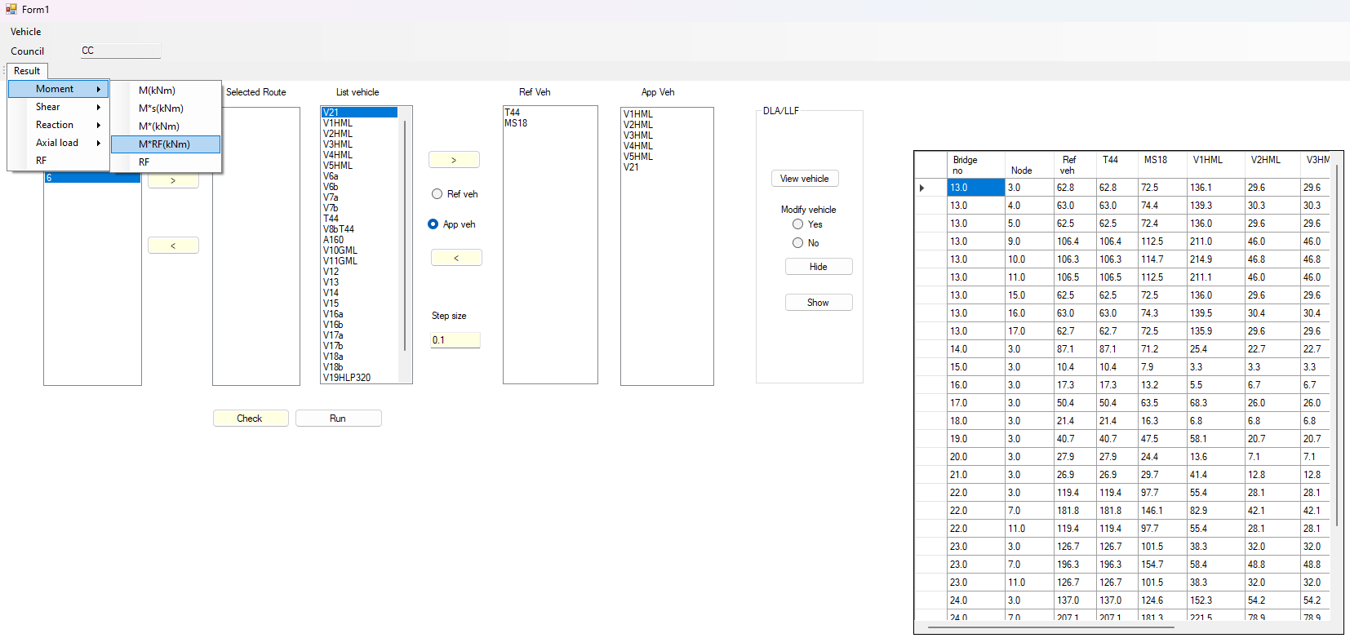

Figure 2 above presents structural analysis results for a selected route displayed in Figure 1. The report shown on the right side of Figure 2 displays the resulting bending moments for the vehicles listed under "Ref Veh" and "App Veh" at the critical locations for the selected multiple bridges at the Ultimate Stage when a user clicks “M*RF (kNm).” If a user clicks on the “RF” button in the Moment Strip Menu, the load ratings for the bending moments associated with the route will be presented. The load effects for shear forces, support reactions, and axial loads will appear if the user clicks on the relevant Result Strip Menu located at the top left of Figure 2. The final load rating for the route will be displayed when the user clicks on the “RF” button in the Result Strip Menu. This final load rating represents the envelope of load ratings for bending moments, shear forces, and support reactions, as illustrated in Figure 3 below.

Figure 3. Rating Factor

|  |  |  |  |
| --- | --- | --- | --- |
| Bending moment | Shear force | Support reaction | Result |
|  |  |  |  |

# Implementation

The original line load module that it now merged with the 2D frame module has been used to undertook structural analysis and quality assurance (QA) for 500 single-span bridges with 5,500 special purpose vehicles (SPVs) in Tasmania. The author completed the structural analysis for the entire package, including the initial setup and data input, in just 10 days.

If the structural analysis of the bridge for this task was to be performed using a current commercial structural analysis program, the estimated time and budget are outlined below:

Table . Cost Analysis Using a Commercial Program

|  |  |  |  |  |  |  |
| --- | --- | --- | --- | --- | --- | --- |
| Number of Bridges | Number of Vehicle | Time Analysis in Minutes per bridge | Total Time Analysis in Minutes | Total Time Analysis in Hours | Cost per hour (AUD) | Total cost in million |
| 500 | 5500 | 5 | 1375000 | 229166.7 | 120 | 27.55 |
| 500 | 5500 | 4 | 11000000 | 183333 | 120 | 22 |
| 500 | 5500 | 3 | 8250000 | 137500 | 120 | 16.5 |
| 500 | 5500 | 2 | 5500000 | 91667 | 120 | 11 |
| 500 | 5500 | 1 | 2750000 | 45833 | 120 | 5.5 |

A comparison of using the automation tool for performing structural analysis clearly shows that the task is much faster with the 2D frame module than with a commercial program. It is reasonable to assume that using the commercial program to undertake structural analysis including setting up a line model, assigning vehicles in the program, executing, and obtaining load effects for one bridge takes about 5 minutes. Assuming the direct charge rate for a bridge engineer is 120 AUD per hour, the total cost for completing this package is approximately 27.55 million AUD

In addition, the author used the 2D frame module to perform a heavy load permit analysis for a route consisting of 14 large box culverts (these consist of multiple cells with link slabs), with spans ranging from 4.2 to 5.1 meters and varying fill heights from 0.76 to 2.6 meters, accommodating a heavy platform with 22 axles. The detailed vehicle configuration is presented in Table 8 above (V21). The bridge database was stored in Microsoft Access, the vehicle configuration was imported into the 2D frame module. The time taken to undertake the structural analysis and perform load ratings was less than a minute, with the results shown in Figure 3.

Besides, the author directly supervised two bridge engineers and ensured quality control for their work using the Tier 1-NHVR approach for analysis and load rating of these 14 large box culverts above. The package was independently verified by another lead bridge engineer. The commercial program used was SpaceGass. The project was completed within one week, even though the SpaceGass models were reused from previous work.

# Conclusion

The Automation Tool will help bridge asset owners at state and local government levels in assessing special heavy load permit applications for multiple bridges on the nominated routes with minimal involvement from bridge engineers. The program has demonstrated the capability to undertake structural analyses of multiple bridges in a very short time. The program can be used for screening (using 2D frame module or detailed bridge assessments (using a 2D grillage model).

The program would be updated to automatically identify bridges that are on specific routes, based on the bridge database provided by the relevant road authorities. The required bridge data, unless they can be linked directly, needs to be input into the bridge database.

It is essential to harmonize bridge assessment and load rating at the network level for the national bridge database, which contains all types of bridge structures (line beams, box culverts, truss bridges, arch bridges, etc.). The Finite Element Method is the only approach that can be used for structural analysis, supporting a computer program to develop automation tools for this purpose. Particularly when migrating the bridge database to a cloud server, database providers should seriously consider using suitable programming languages for manipulating bridge information to prevent crashes among users.

To mitigate risks associated with the failure to develop automation assessment tools or programs, as witnessed by the author in the past for heavy load permits, it is suggested that bridge asset owners adopt programs and tools that have been developed and successfully tested.

# References

1. Caprani, C. (2018). *‘Are Australian bridges safe, and can we do better? Retrieved from the Conversation*’, [https://theconversation.com/are-australian-bridges-safe-and-can-we-do - better-101825](https://theconversation.com/are-australian-bridges-safe-and-can-we-do%20-%20better-101825).
2. Wellard T. (2022) *‘Opportunities to Optimise Heavy Vehicle Access on the Local Road Network’.* International Public Works Conference, Adelaide 1-5 May 2022.
3. Finch, A. (2021).*’ Are load limit signs relevant for local councils in 2021?’*. IPWEQ SEQ Branche Conference February 2021.
4. The Highway Bridge Design Specification (1953)
5. The Highway Bridge Design Specification (1957)
6. The Highway Bridge Design Specification (1965)
7. The Highway Bridge Design Specification (1970)
8. National Association of Australian Stage Road Authorities (1976)
9. AS5100 (2017) - the part 7 Bridge Assessment
10. Guideline for the Tier 1 Assessment of Heavy Vehicle Bridge Access. [Strategic Local Government Asset Assessment Project (SLGAAP) | NHVR](https://www.nhvr.gov.au/road-access/local-government-road-managers/strategic-local-government-asset-assessment-project)
11. [Strategic Local Government Asset Assessment Project (SLGAAP) | NHVR](https://www.nhvr.gov.au/road-access/local-government-road-managers/strategic-local-government-asset-assessment-project)
12. Hai L. (2022) ‘Bridge Analysis Program’. Austroads Bridge Conference, Adelaide 2022.

**Author contacts**

**Hai Le**

M:0469609730 LinkedIn:[(3) Hai Le | LinkedIn](https://www.linkedin.com/in/hai-le-56872752/)