Limiting the P-Δ Effect on the Slender Bridge Column Supported by Mono Pile
Hari Pokharel, Associate Technical Director, Arcadis Australia

Abstract
Monopile bridge foundations have the potential to significantly reduce construction costs compared to conventional pile group foundations. However, this bridge configuration leads to increased slenderness, lateral deflection, and a shift towards instability as the mode of failure before reaching material strength capacities. AS5100.5 mandates a nonlinear analysis for a sway frame when the lateral deflection of a compression member between end supports exceeds Lu/250 from linear elastic analysis. The absence of a specified lateral deflection limit in the code complicates the demonstration of design compliance. This paper aims to underscore design issues, the lack of a compliance demonstration mechanism, and propose a lateral deflection limit to ensure robustness by controlling the P-Δ effect.
Keywords: Monopile, Slender Column, Non-Linear Analysis, Deflection Limits, Instability

Introduction
Bridge foundations utilising monopiles, as depicted in Figure-1, offer cost-effective solutions compared to traditional pile group foundations with a pile cap. In urban environments, the omission of a pile cap allows for better placement of utilities, enhancing space utilisation.

Figure-1: Examples of Mono Piled Foundation for Bridges
- Railway Bridge (b) Highway Bridge
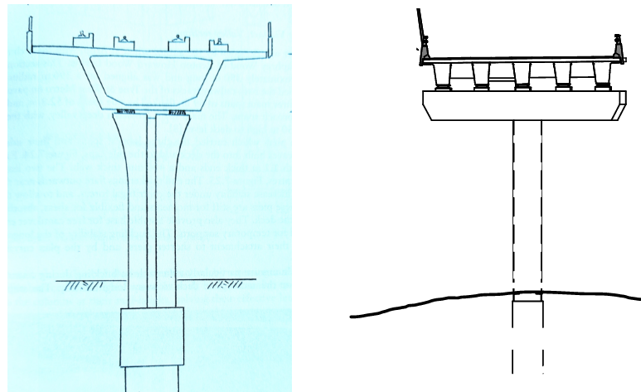
Columns supported by monopiles exhibit larger lateral deflection compared to those supported by pile group with a pile cap. Linear elastic analysis suffices for minor deflections, neglecting secondary effects, while nonlinear analysis becomes imperative for larger deflections to incorporate these effects.
The design bending moment of slender columns is determined by multiplying the linear elastic analysis bending moment by δ, termed the moment magnification factor. The derivation of δ hinges on the buckling load capacity of the column, Nc, significantly affected by the effective length, Le, as detailed in section 10.4 of AS5100.5 (1).
Nonlinear analysis accounts for the nonlinear behaviour of concrete material, foundation, and geometry. Observations (3,4,8) reveal that slender columns supported by monopiles may experience instability before reaching the ultimate limit state of material strength, presenting challenges for designers to develop design solution and demonstrate compliance.
Complex structures are being designed based on sound engineering principles even during the development of design codes. Nonetheless, conflicting views among project teams arise when meeting design compliance requirements. A clear mechanism is vital to resolve such differences, with the recommendation being the specification of lateral deflection limits.

Liner Elastic Analysis of Slender Column and Secondary Effect
A simplified structural model for analysing bridge columns supported by monopiles is depicted in Figure-2. Loads comprising axial force, bending moment, and lateral force on top of the column are shown. The monopile foundation is laterally supported by ground pressure, maintaining equilibrium represented by springs at the nodes.

Figure-2: Behaviour of Bridge Pier Supported by Monopile.
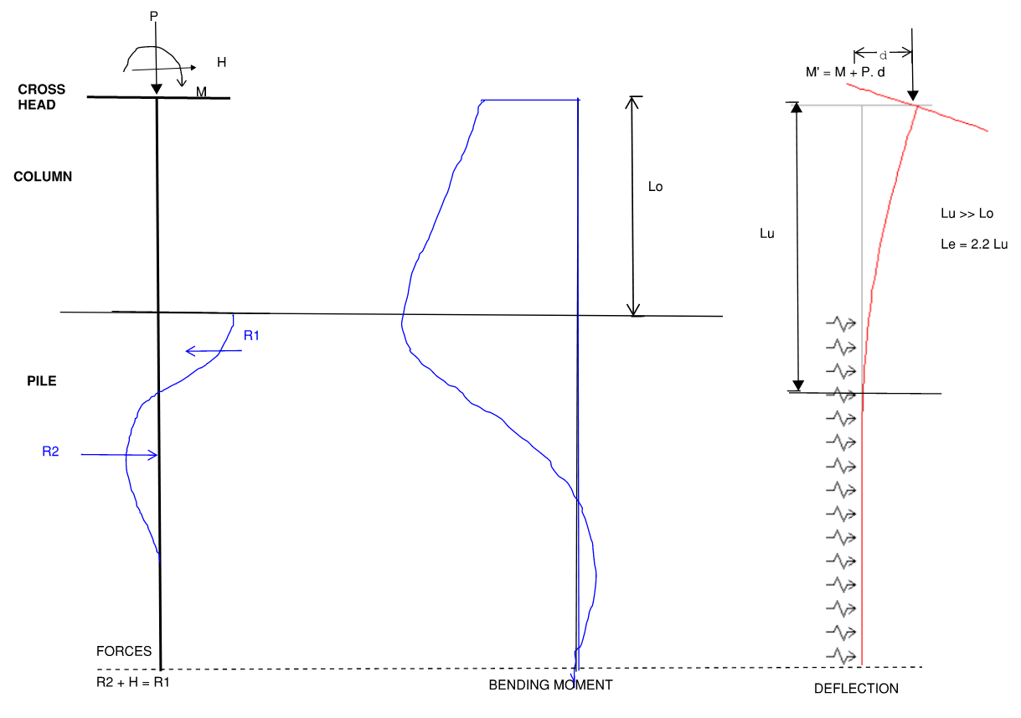
Input parameter for pile and column requires section area, A, elastic modulus of elasticity Ec, moment of inertia I, and elastic springs representing modulus of subgrade reaction. Results of the analysis for bending moment and deflection along the length are illustrated.
To derive the design bending moment M*, considering secondary effects, the linear analysis bending moment is multiplied by the moment magnification factor, δ, which relies on the buckling load, Nc. Maximum value of δ is limited to 1.5 (1). The effective length Le is pivotal in determining Nc. In pile group foundations, columns are generally fixed against bending on top of the pile cap, simplifying the derivation of effective length. Conversely, in columns supported by monopiles, selecting the effective length factor k using Figure-3 necessitates careful assessment of end restraint.

Figure – 3: Effective Length factor for Column Supported by Monopile
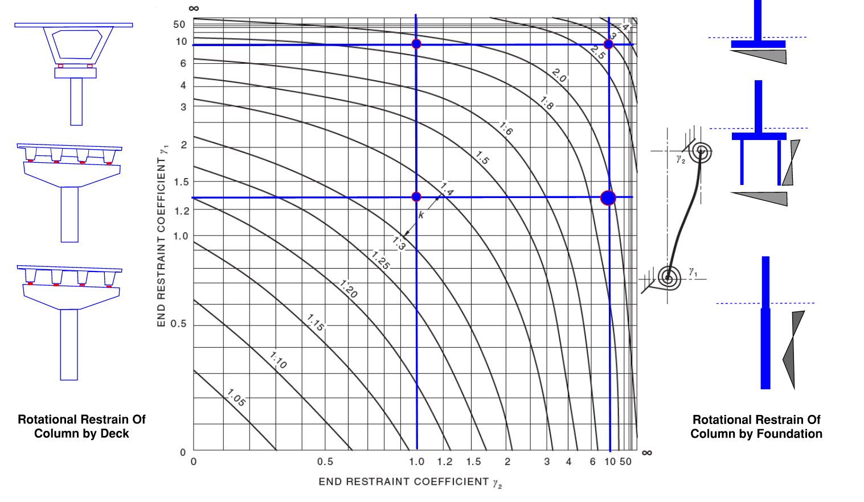
Source: Australian Standard AS5100.5-2017: Figure 10.5.3 (C) (1)

End restraint of the column at both ends can be interpreted differently based on the experience and individual judgment of engineers. In Figure-3, considering the load path and resistance provided by different foundation types, the end restraint coefficient of a column supported by mono pile is relatively large, with a suggested maximum value 10(1). The end restraint at the top depends on the torsional stiffness of deck, loading arrangement adjacent to the pier and how effectively the deck interacts with the column. The effective length factor, k, estimated as 1.4 by one engineer could be interpreted as 2.5 by another engineer, leading to potential differences in the outcome of δ. This leads differences of slenderness ratio Le/r, complicating compliance to the maximum limit 120, specified (1).
Davidson and Robinson (7) developed a procedure to determine the unsupported length of a partially embedded cantilever pile and its buckling load. This procedure was incorporated in the commentary of the Austroads Bridge Design Code Section 3 in 1992(10). However, it has limitations in assessing instability caused by the co-existence of bending moment and axial forces. The unsupported length varies based on the factors such as the flexural stiffness EI of the pile, the pile diameter, and the subgrade modulus of the surrounding soil.
Hence, there are inherent complexities in the current code that hinder the ability to demonstrate design compliance. These complexities arise from factors including the lack of a clear definition of the unsupported length Lu in the case of a column supported by monopile, the effective length factor k that influences Le, the challenge of accurately determining soil stiffness since soil is not an elastics material, and, consequently, the determination of the buckling load Nc.

Rigorous Non-Linear Elastic Analysis and Secondary Effect
Common software tools such as Microstran, Space Gass, and Midas-Civil are capable of performing non-linear analysis, which require input parameters such as moment of inertia I, modulus of elasticity of concrete Ec, and the subgrade modulus Ks. These parameters vary depending on the loading conditions in the analysis model, as shown in Figure 2. Iterative analysis with updated input parameter is necessary to achieve accurate results. Some software, such as Pyrus (11), incorporates the nonlinear properties of concrete to enhance analysis.
Section analysis for determining the moment-curvature relation for column and pile design involves considering a range of axial loads to develop stiffness as illustrated in Figure-4. The effective stiffness EI is derived based on the magnitude of axial load and bending moment. The process aids in iterative deflection calculations to account for and confirm the final additional bending moment resulting from the secondary effects.
$$∆M=P. ∆$$
$$M'=M+∆ M$$
The analysis output depends on how accurately the relative lateral displacement between the pile toe and the top of the column, Δ, is computed. The lateral pressure of soil on the pile shaft near the ground surface becomes ineffective due to the rattling effect, which alters the effective unsupported length as the loading changes.

Figure – 4: Behaviour of Reinforced Concrete Column
- Moment Curvature of Column (b) Bending Moment and Max Deflection
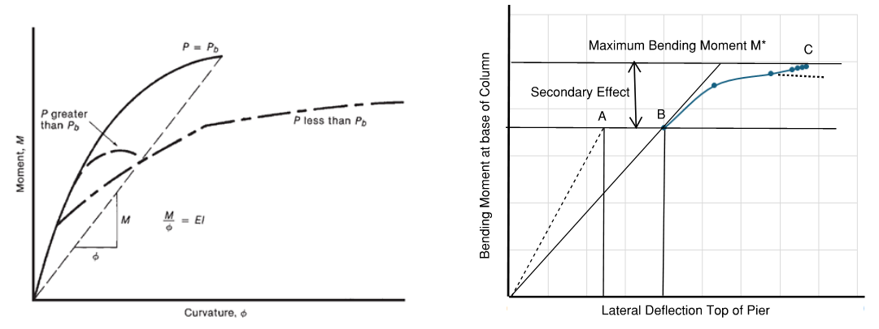
Source: (a) James Wright and James G. MacGregor (6)

The behaviour of structural arrangement shown in Figure 2 is assessed in Figure 4 (b) which illustrates the lateral deflection and bending moment, including the secondary effects. Point A represents the result of a linear elastic analysis using the gross moment of inertia, which shifts to point B when the effective moment of inertia, based on the cracked section, is considered. Nonlinear analysis, incorporating P-Δ effect (secondary effect), begins at point A and iterates to C, using the effective stiffness derived from the moment-curvature relationship shown in Figure 4(a) and considering the deformation of the foundation below ground. Dashed lines near point C indicate the potential for column instability, when the solution fails to converge.
This method of analysis introduces variability from four sources:
(a) The nonlinear stress-strain behaviour of reinforced concrete.
(b) The changing elastic modulus of concrete due to factors such as shrinkage and creep over time.
(c) The geotechnical variability of soil stiffness.
(d) The unsupported length Lu, which varies depending on the degree of loading.

Recent research by Strauss et al (8) has highlighted that design based on material and geometric nonlinear analysis remain controversial, as stability failures often occurring before the material capacity is reached.
Consequently, there is a need for additional clarification regarding the strength reduction factors specified in AS5100.5 Code Table 2.2.3 and Table 2.3.5. Additional factor for instability against overturning seems necessary.

Lateral Deflection Limits of Bridge Code AS5100
AS5100 bridge design code necessitates the assessment of deflections. While vertical deflection limits are specified for road bridge decks and lateral deflection limits for signposts and noise walls (2), there is notable absence of lateral deflection limits for bridge columns. In the case of railway bridges, although explicit lateral deflection limits are not specified, constraints on stresses in the rail from rail-structure interaction indirectly regulate lateral deflections. Additionally, building structures worldwide commonly limit lateral deflections to H/500 under service load combinations – a guideline that is notably absent for bridges.

Figure – 5: Stability Failure and Deflection Index of Slender Column
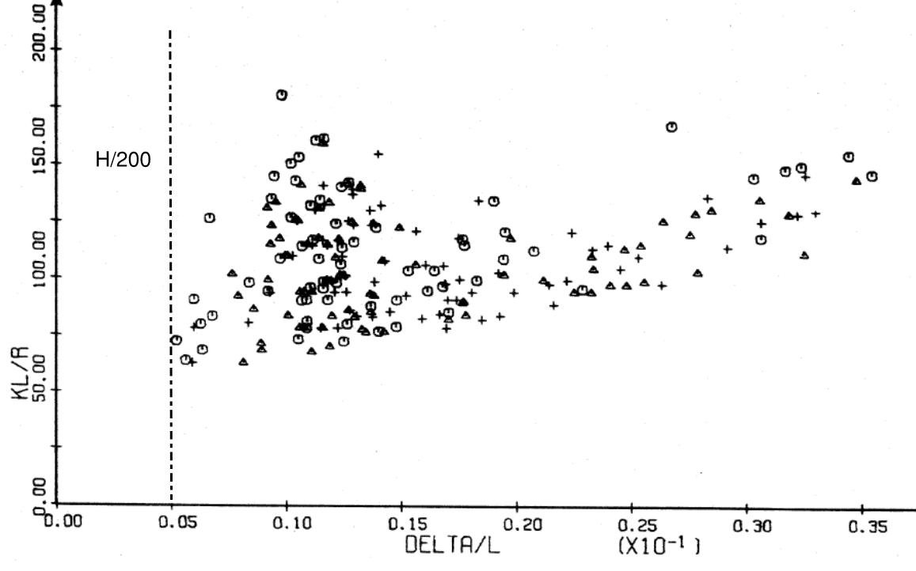
Source: S.E. Hage (4)

A study by Hage and MacGregor (4,5), conducted in 1974 and 1977, presented the outcome of their analysis for three types of sway frames commonly used in building structures, as shown in Figure-5. The study concluded that stability failure occurs at relatively large deflections, with no stability failure observed for lateral deflection below height/200. In such cases, material failure is the expected mode of failure rather than stability failure.
Deflection assessment for nonlinear iteration in Figure 4 shows an increase from Point A to Point C, which can become significant, even while maintaining equilibrium. However, the analysis is highly sensitive. Therefore, limiting lateral deflection is crucial to ensure the stability and robustness of slender columns.

Over the past fifty years, numerous researchers (e.g.,3,6,8, 9 and others) have conducted experimental and analytical studies on slender columns highlighting the importance of this subject.

Conclusion
Designing slender columns supported by monopiles using linear elastic analysis poses significant challenges in achieving compliance with current codes. The uncertainties in defining the effective length and accurately determining buckling loads further exacerbate these difficulties.
Nonlinear analysis of such columns introduces additional complexities, emphasising the need for engineers representing asset owners to carefully define and specify design requirements, especially in the design-build type contracts.
Limiting lateral deflection is a practical and effective approach to ensuring the stability and robustness in bridge structures. Depending on the importance of the bridge, past performance data from similar configurations, the number of traffic lanes, and the height of the column, a lateral deflection limit of height/200 to height/100 at ultimate limit state conditions is recommended to be considered for columns supported by monopiles.

References
- Standards Australia (2024) AS5100.5:2017 Bridge Design Part 5: Concrete
- Standards Australia (2024) AS5100.2:2017 Bridge Design Part 2: Design Loads
- Anibal A., Manzelli and Issam E. Harik (1993), Approximate Moment Curvature Relationship for Slender Column, Journal of Structural Engineering, ASCE 119(4) 1114-1132.
- Sven Egil Hage (1974), The second Order Analysis of reinforced Concrete Frames, A Thesis Submitted to the Faculty of Graduate Studies and Research for the Degree of Master of Science, Department of Civil Engineering, The University of Alberta.
- James G. MacGregor and Sven E. Hage (1977) Stability Analysis and Design of Concrete Frames, Journal of Structural Division, Proceeding of the American Society of Civil Engineers, Vol. 103, No. ST10, October 1977
- James K. Wright and James G. Mac Gregor (2012) Reinforced Concrete: Mechanics and Design, 6th Edition Pearson Education, Inc., Upper Saddle River, New Jersey 07458
- Davidson M.T. and Robinson K.E ((1965) Bending and Buckling of Partially Embedded Pile, Proceeding of the 6th International Conference, International Society for Soil Mechanics and Geotechnical Engineering.
- Alfred Strauss, Michael Hauser, Benjamin Taubling, Ana M. Ivankovic, Dominik Skokandic, Jose Matos, Neryvaldo, Valdimir Benko, Jakub Dobry, Roman Wan-Wender, Kesmir Nincevic and Andre Oresi, Probabilistic and Semi-Probabilistic Analysis of Slender Columns Frequently Used in Structural Engineering, Journal of Applied Science 2021, Vol 11
- Mohana Kumar Suthan and Mikhael Sleman (2022), Reinforced Concrete Slender Bridge Column Design Review – Australian and International Standards, Austroads Bridge Conference 2022.
- Austroads (1992) Bridge Design Code Section 3 Foundations Commentary
- Pyrus-9, Software Manual English, Cubus Engineering Software

Acknowledgments – The author acknowledges Arcadis Australia for providing opportunities to work on interesting projects and sponsoring attendance at Austroads25. The author also thanks colleagues and anonymous reviewers for their constructive input.

Disclaimer: The views expressed in this paper are those of the author and do not represent the opinions of Arcadis.

