Bluescope Composite Steel Road Bridges – Updating a Design Guide

Sabina Piras, Technical Principal - Bridge Engineering, WSP NZ Ltd

Raed El Sarraf, Technical Principal - Asset Integrity Management, WSP NZ Ltd

Rob Danis, National Business Development Lead, BlueScope Steel

abstract

Steel is used extensively for bridges around the world in various structural arrangements or systems. One of the increasingly popular systems for bridge superstructures is the combination of steel girders (multi-girders, ladder deck, through girders or box girders) and concrete deck slabs acting as a composite member.

This paper presents an overview of the updates made to the original 1998 BHP Composite Bridge Guide. The newly developed Composite Steel Road Bridges: Guidelines and Charts has been prepared to assist bridge designers with the preliminary design of economical composite steel multi-girder bridges. The information contained in the new guide will enable the fast design of steel multi-girder bridges to be carried out with adequate accuracy for preliminary cost estimating. The document encapsulates valuable information derived from years of collective experience, ensuring that the design process is not only efficient but also aligns with contemporary industry standards.

# Introduction

Steel is a popular material for the construction of steel bridges worldwide. Steel bridges offer numerous advantages due to the inherent properties of steel, such as its high strength-to-weight ratio, which is particularly beneficial for longer spans. This results in lower dead loads, leading to more efficient structures and reduced foundation costs. The lightweight nature of steel, combined with its ease of inspection, predictable performance, and low maintenance requirements, gives steel bridges an edge over concrete ones.

Figure 1- Fitzroy River Bridge in Western Australia which is a weathering steel multi-girder bridge.

This paper describes the updated Composite Steel Road Bridges: Guidelines and Charts, which was prepared to assist bridge designers with the preliminary design of economical multi-girder composite steel bridges using Australian Bridge Design code (AS 5100.2 and AS/NZS 5100.6). The guide is written for all bridge engineers or asset owners, irrespective of their experience in composite steel design. The guide includes easy-to-use design charts and tables for various simply-supported and continuous bridge configurations. Most importantly, the design guide includes key inputs from BlueScope to improve construction efficiencies and costs.

This paper will summarise the key updates to the design guide, summarise some key factors that can reduce steel bridge fabrication and construction costs, and present the design tables and charts that were developed to undertake preliminary design of multi-girder road bridges. Examples are provided to demonstrate how the design tables and charts are utilised.

# Background

The BHP Composite Bridge Guide was published in 1998 and was prepared to assist bridge designers with the preliminary design of economical I-girder steel bridges using the 1996 Australian Bridge Design Code. The BHP Composite Bridge Guide contains design table and charts, like that shown in Figure 2, to enable fast structural design of bridge superstructures for preliminary cost estimating. In addition, the Guide provides brief guidelines on aspects which influence the economics of steel bridges.

This design guide has been recently updated to reflect the changes in AS 5100:2007. The changes to the guide are discussed in Section 3.

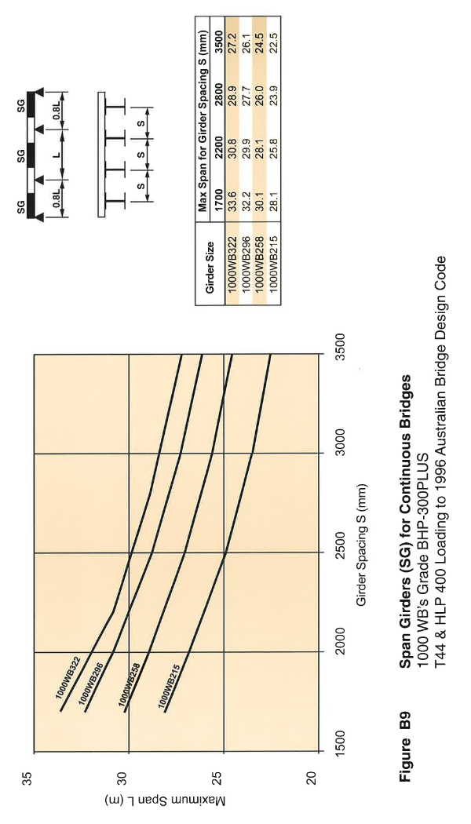

Figure 2- Design chart and table from the 1998 BHP Composite Bridge Guide (Rapattoni et al. 1998).

# Design Guide Updates

The updates to the Composite Steel Road Bridges Guide reflect both updates to Australian bridge standards (AS 5100) and design practice since 1998. Key updates include and are summarised in Table 1:

* Updated live load to AS 5100.2
* Increased live loads have resulted in thicker deck slab requirements
* Updated provisions for high-performance barrier systems
* The inclusion of weathering steel

With a global shift to building more efficient infrastructure, more emphasis has been placed on providing recommendations for a more economical structure.

Figure 3 illustrates the effects of higher live loads in the current Australian Bridge Standards.

Table 1: Updates to the 1998 Composite Steel Road Bridges Guide

| Element | Original 1998 Guide | Updated Design Guide |
| --- | --- | --- |
| Design standard | 1996 Australian Bridge Code | Australian Standard AS 5100 |
| Live load | T44 & HLP400 | SM1600 & HLP320/400 |
| Girder spacing | 1700mm – 3500mm | 1700mm – 4000mm |
| Materials | Mild Steel | Mild Steel  REDCOR® Weathering Steel |
| Steel Grades | Grade 300, 350, 400 Mild Steel | Grade 300, 400 Mild Steel  Grade 350, 400 Weathering Steel |
| Sections | Universal Beams  Welded Beams  Welded Plate Girders | Welded Beams  Welded Plate Girders |
| Deck Slab | 180-230mm thick | 250-350mm thick |

Figure 3- Comparing the 1998 and 2024 design chart for grade 300, simply-supported 1000WB sections.

# Economic Bridge Design Practice

The bridge system adopted and the detailing of the superstructure have a major impact on costs and must be considered with care. To optimise the design for maximum economy, the designer must consider all factors affecting cost, including steel mass, fabrication, surface protection, transport, erection and site construction costs. Undue focus on reducing steel girder mass could be counterproductive as it may lead to much higher fabrication and erection costs.

Some brief guidelines to minimise costs are as follows:

* Smaller girder sizes may be used for internal girders in some cases, depending on the bridge width, type of barrier and girder location. Generally, external girders should not be smaller than internal ones to allow for possible future bridge widening.
* The use of fewer widely spaced steel girders leads to cost savings.
* The use of jointless bridges with integral abutments (bridge superstructure cast monolithically with abutments eliminates bearings, which require routine maintenance and inspection.
* Unstiffened webs are generally more economical as the extra fabrication cost of stiffeners usually outweighs any saving in steel cost achievable by reducing the web thickness.
* Changing the plate thickness along the girder should be examined closely. It may be more economical to extend the thicker flange as the cost of the splice may exceed the additional material cost.
* Bolt splices are usually faster and more economical compared to welded splices, especially when the splice is made in place at the bridge site. Welding is preferred and may be more economical, for launched bridges when the splice is usually made on the ground, behind the launching abutment. Welded splices allow easier launching, without packing over temporary bearings.
* Use fillet welds in lieu of butt welds wherever possible. Fillet welds can be used for web-to-flange connections and for most other welds.
* The maximum size fillet weld for a single pass is 8mm. A 10mm fillet weld can take 3 runs and takes 3 times as long to fabricate compared to a single 6mm or 8mm fillet weld.
* The use of elastomeric bearing pads designed to AS 5100.4 are preferred over pot bearings which are more expensive and have longer procurement times.

Figure 4 suggests the recommended economical span ranges for various steel and concrete bridge types. As previously suggested, steel bridges are more economical for long-span applications. Although concrete box girders can achieve similar span lengths as steel box girders, they are significantly heavier than steel and cannot be prefabricated.

Figure 4- Span and superstructure type for road bridges (El Sarraf et al. 2013)

# Concept Design Tables and Charts

Design tables and charts were developed for the preliminary design of steel-concrete composite multi-girder road bridges with spans of up to 60 metres. Typically, these bridges would be used for highways or main roads where the bridge solution with the lowest cost is usually adopted. Two bridge articulations were considered: simply-supported and three-span continuous where the end spans are 80% of the internal span, as illustrated in Figure 5.

|  |  |
| --- | --- |
|  |  |
| **(a) Simply-supported span configuration** | **(b) Continuous span configuration** |

Figure 5- Two span articulations considered in the Composite Steel Road Bridges Guide design tables and charts

The design tables and charts the Composite Steel Road Bridges Guide include standard BlueScope Welded Beams and REDCOR® welded beams and welded plate beams for longer spans. The designs are based on using four or more girders in the multi-girder system spaced 1.7m to 4m.

The girder sizes obtained are preliminary estimates only. The Designer will need to carry out a completed design check to ensure that the girders are adequate for the span configuration and design loadings being used.

A number of assumptions have been made to limit the work to a practice level in developing the concept design tables and charts, which include:

* Concrete deck is 350mm total with 100mm thick precast slab.
* Girders are straight, parallel and have no skew. For horizontally curved bridges, the minimum depth is likely to increase by 10 to 20%.
* No haunches to steel girders or deck slab.
* Girders are unpropped and non-composite under self-weight. Girders are composite when the deck is cast.
* Lateral bracing is spaced at quarter points.
* Constant web and flange thickness and width along span length.
* For weathering steel sections, a 3mm section loss is assumed for the bottom flange and web, and a 1.5mm section loss is assumed for top flange. This assumes a 1.5mm section loss per face of exposed section.

The loads used to develop the design tables and charts were taken from AS 5100.2 and include dead and superimposed dead loads, SM1600 and HLP live loading, construction loading, temperature and shrinkage.

In developing the design tables and charts, the beams were checked against stresses at the serviceability limit state (SLS), and shear and moment at the ultimate limit state (ULS).

## Selecting a girder size

General guidelines when selecting a girder size from the design tables or charts include:

* Use the lightest girder possible but note that the choice of girder depth may be governed by site constraints.
* Use a similar girder depth throughout. The use of different girder depths for continuous bridges at the hog and sag regions will need special consideration of splicing detail and fabrication cost but may be appropriate in some cases.
* Use the minimum number of girders possible. Fewer, more widely spaced girders usually lead to cost reduction.

## Example 1 – short span simply-supported multi-girder bridge

In this example, a 24m long simply supported multi-girder steel bridge is to be designed. The bridge carries a two-lane single-carriageway road. The carriageway has 1m wide shoulders and 3.5m traffic lanes. The cross-section, which is illustrated in Figure 6, consists of four girders spaced 2.5m apart. The deck cantilevers 1.25m outside the centrelines of the outer girders. The bridge girders will be constructed using grade WR400 REDCOR weathering steel.

The bridge will be designed to AS 5100.2 and AS/NZS 5100.6 and will accommodate SM1600 and HLP live loads.

Figure 6- Bridge cross-section

For bridges with short spans (e.g. less than 30m), BlueScope’s standard WB sections can be utilised. Either the design chart in Figure 7 or Table 2 can be used to determine the most economical solution.

Grade 400WR 900WB240 provides the most economical girder size for the 24m long simply supported bridge.

The same process is followed for a continuous bridge; however, the designer shall use the tables and charts specific for a three-span continuous bridge.

Figure 7- Design chart for simply-supported grade WR400 REDCOR® girders

Table 2: Maximum span length for a given girder size and spacing. Table applies for simply-supported multi-girder beams using Bluescope standard WB beam range and grade WR400 REDCOR® weathering steel.

| Girder size | **Maximum span length for girder spacing S (m)** | | |
| --- | --- | --- | --- |
|  | **1.7** | **2.5** | **4** |
| 300WC305 | 20.5 | 18.4 | 16.2 |
| 600WB361 | 23.8 | 21.3 | 18.6 |
| 900WB420 | 27.1 | **24.12** | 21 |
| 1200WB471 | 29.7 | 26.2 | 23 |

Note: Table includes a 3mm section loss in the bottom flange and web, and a 1.5mm section loss in the top flange.

## Example 2 – long span simply-supported multi-girder bridge

In this example, a 55m simply supported multi-girder steel bridge is to be designed. The proposed cross-section is provided in Figure 6, and consists of four girders spaced 2.5m apart. The bridge girders will be constructed using grade 400 steel.

The bridge will be designed to AS 5100.2 and AS/NZS 5100.6 and will accommodate SM1600 and HLP live loads.

Since the bridge is longer than 30m, a welded plate girder will be considered. Figure 8 and Figure 9 are used to estimate the minimum flange and web area for the welded plate girder, respectively. For girders spaced 2.5m, a span-to-depth ratio (L/D) of 22 is recommended; therefore, a 55m span will have a 2.5m deep beam (excluding the concrete deck). Referring to the charts, the minimum flange and web area are 26,000mm2 and 69,000mm2, respectively.

A 40mm top and bottom flange thickness is proposed, which means the flange width must be 650mm. The web height is the total beam depth ( 2500mm) minus two times the flange thickness (2 x 40mm), which equates to 2420mm. The web thickness is the required web area (69,000mm2) divided by 2420mm, which equates to 28.5mm. Since 28.5m is not a standard plate thickness, a web thickness of 28mm is specified. Refer to Figure 10 for the welded plate girder.

The same process is followed for a continuous bridge; however, the designer shall use the charts specific for a three-span continuous bridge.

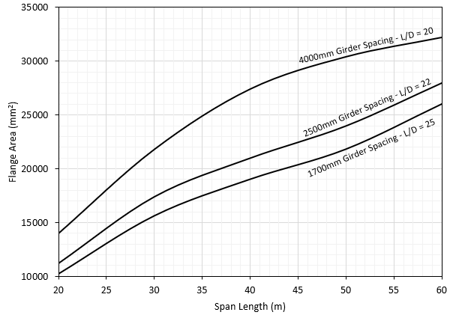

Figure 8- Flange area for simply-supported grade 400 welded plate girder

Figure 9- Web area for simply-supported grade 400 welded plate girder

Figure 10- Welded plate girder

# Conclusion

This paper presents the *BlueScope Composite Steel Road Bridges: Guidelines and Design Charts* which is written for designers to quickly design economic steel multi-girder bridges for preliminary design and costing. The design guide is an update to the 1998 BHP Composite Bridge Guide. This paper summarises of the key changes to the design guide and presents the design tables and charts through examples.

# References

* El Sarraf, R., Iles, D., Momtahan, A., Easey, D., & Hicks, S. (2013). *Steel-concrete composite bridge design guide* (No. 525).
* Rapattoni, F., Eastwood, D., Bennett, M., and Cheung, H. (1998). *Composite Steel Road Bridges: Concepts and Design Charts*. Port Kembla, Australia: BHP.
* Standards Australia (SA) (2017). *AS 5100 Bridge Standard, Including Amendment No.1 (2017)*. Sydney: Standards Australia.

# Acknowledgements

The authors of this paper would like to acknowledge the extensive input from industry leaders in Australia and New Zealand for the development of this publication.

# Author Biographies

**Sabina Piras** is a Technical Principal at WSP New Zealand Ltd. with over 14 years of work and design experience in the civil and structural engineering industry. Ms. Piras has provided designs for many large-scale infrastructure works in the United States, New Zealand, Australia and the Pacific Islands. She is a Chartered Professional Engineer in New Zealand and a licensed Professional Civil Engineer in the state of California with a Doctorate degree focused in Structural Engineering from the University of Canterbury.

**Raed El Sarraf** is a Technical Principal at WSP New Zealand Ltd. with over 20 years of experience relating to the design, construction and asset integrity management of steel bridges, as well as co-authoring a number of industry guidance relating to the management of steel bridges in Australasia. He is a Chartered Professional Engineer, a Fellow of Engineering NZ and the 2024 Senior Vice President of the Australasian Corrosion Association.

**Rob Danis** is the National Business Development Lead – Infrastructure at BlueScope. Rob possesses extensive expertise in engineering solutions for Road and Rail Infrastructure, as well as High Rise Residential and Commercial industries. At BlueScope, his primary concentration lies in the area of bridges, where he aims for incremental growth by guiding engineers to choose BlueScope REDCOR® Weathering Steel for appropriate bridge projects throughout Australia. This strategic choice ensures the creation of assets with minimal long-term maintenance requirements for their clients.