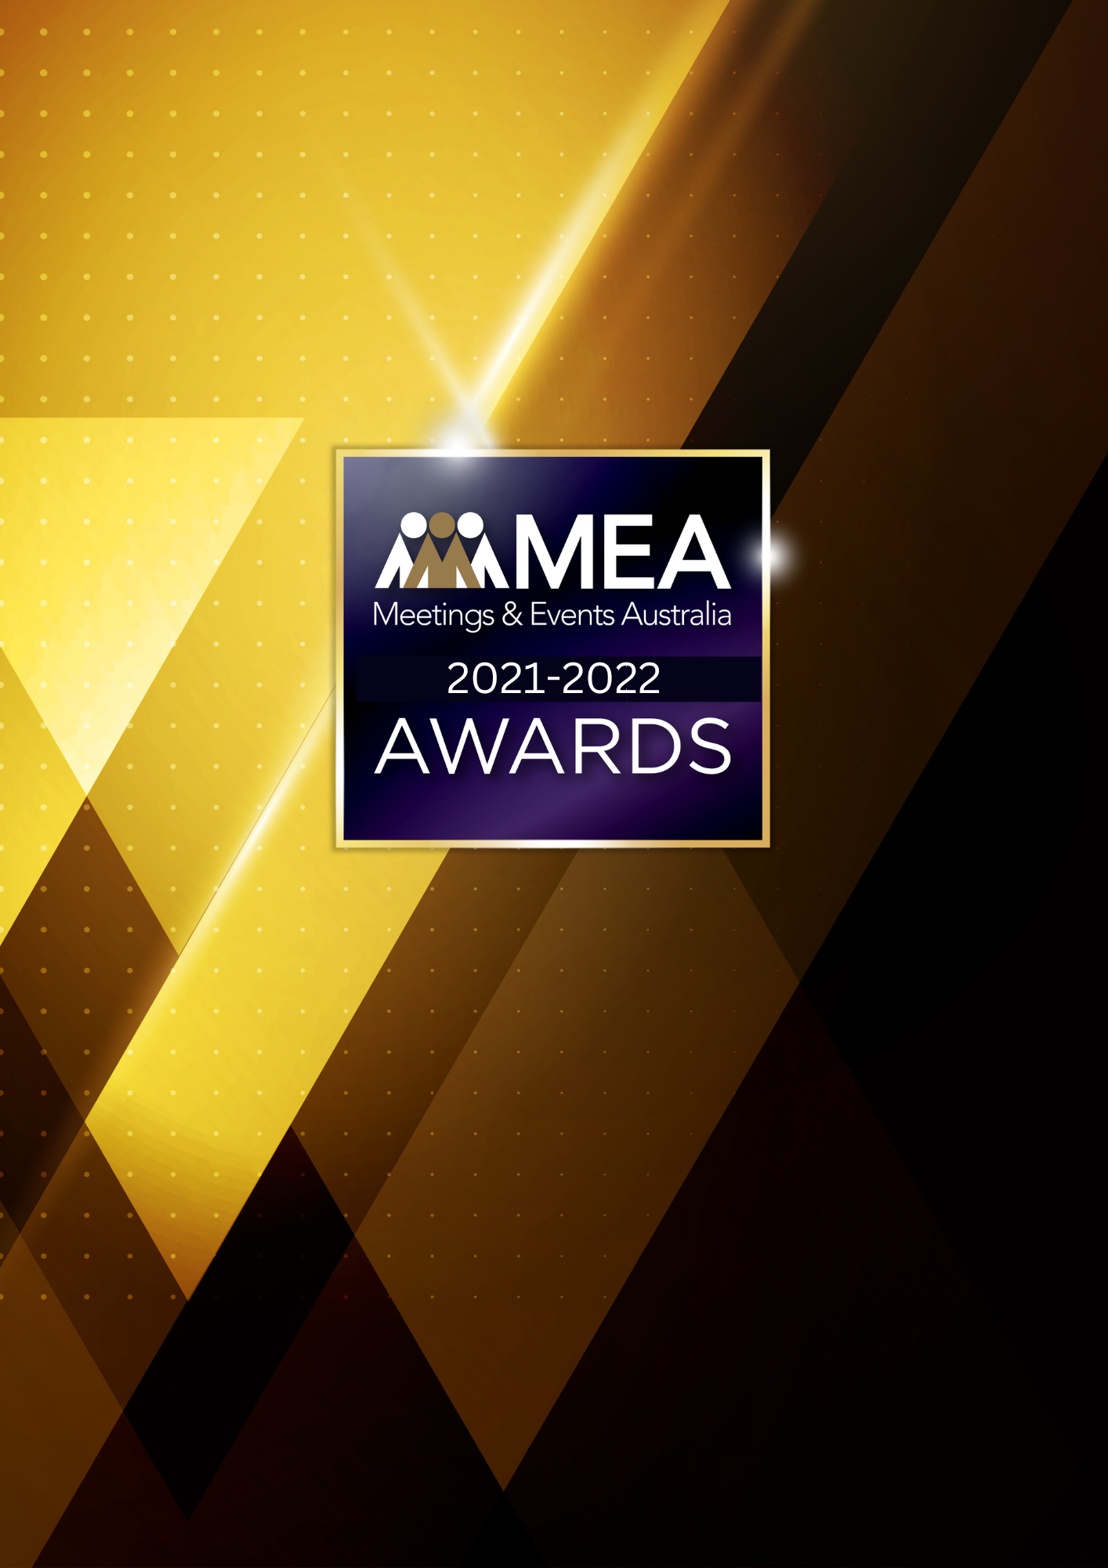
SPEAKERS, ENTERTAINERS AND TEAM BUILDERS AWARD
SUBMISSION FORM
2021-2022 MEA AWARDS
SPEAKERS, ENTERTAINERS AND TEAM BUILDERS AWARD
AWARD DESCRIPTION
The Speakers, Entertainers and Team Builders Award recognises the role that these individuals play in the delivery of physical or virtual events. The Award acknowledges excellence in the delivery of presentations and activities that inspire and motivate audiences, and that enhance, support, or positively impact the experience or outcomes of an event.

ELIGIBILITY
This Award is open to organisations or individuals that support the conference, meetings, special event and exhibition industry through the delivery of education and professional development, entertainment and/or team building activities to engage audiences.
Examples include MCs, speakers, entertainment agencies, entertainers, team building companies and speaker bureaux.
This Award will recognise the company as the recipient of the Award.
The National Winner of the Award will be eligible for MEA’s 2021-2022 Company of the Year Platinum Award.

GENERAL GUIDELINES
Ensure that your submission is restricted to the qualifying period 1 January 2021 – 31 December 2022.
- Answer all the questions. There is a maximum word count for all answers that cannot be exceeded. After completing each question, indicate your word count.
- The examples provided are suggestions only that provide some guidance as to what the judges will be seeking. Do not simply answer each of these evidence types in order.
- If your evidence takes form in charts, video links or graphs, there is a separate area within the submission portal to add these. Videos must not be longer than 1-minute (60 seconds). Please indicate in your submission if you have included additional attachments outside of the form below.
- All applications must be made using the below submission form in either Microsoft Word or PDF format. No external or specialised branding may be used in lieu of this submission form.
- Judges’ feedback will be provided to applicants as soon as possible after the conclusion of the National Awards Ceremony.
- Judges will look for evidence that you are well organised, your business is well managed, how you have adapted during COVID-19 to future-proof your business, and that you have systems and procedures that are appropriate and well-maintained.
- Judges do not want details of your financial accounts, but rather are seeking to understand how your business has operated during the qualifying period.
- All applications must be submitted prior to 28 February 2023 at 11:59pm AEDT.
2021-2022 MEA AWARDS
SPEAKERS, ENTERTAINERS AND TEAM BUILDERS AWARD
SCORING
How your submission is weighted:
- Business Planning & Resource Management – 30%
- Challenges & Responses – 40%
- Outcome & Evidence – 15%
- Contribution to the Industry – 5%
- Sustainability – 5%
- Final Statement – 5%

2021-2022 MEA AWARDS
SPEAKERS, ENTERTAINERS AND TEAM BUILDERS AWARD

NAME OF COMPANY
Insert the company’s name in the blank space above. Please note, this will be the name displayed on all relevant marketing and trophies, should your application be successful.

BUSINESS PROFILE
This section is not scored during judging but acts as an overview to provide context of your submission in the judging process.
Maximum word count for this section: 600

- PROVIDE A GENERAL DESCRIPTION OF YOUR BUSINESS AS IT RELATES TO EVENTS:
Examples could include but are not restricted to:
- Diversity of clients
- Diversity of speakers/entertainers/team building activities
- Number, size, and range of events serviced
- Range and diversity of projects undertaken, and products offered during COVID-19

- WHAT IS YOUR BUSINESS’S HISTORY OF INVOLVEMENT IN THE EVENTS INDUSTRY:
Examples could include but are not restricted to:
- Target markets
- Years of operation

- WHAT IS YOUR BUSINESS STRUCTURE, AS IT RELATES TO EVENTS:
Examples could include but are not restricted to:
- Number of employees
- Organisational chart (please attach in submission portal as a PDF)
- The number and type of internal departments

2021-2022 MEA AWARDS
SPEAKERS, ENTERTAINERS AND TEAM BUILDERS AWARD
- BUSINESS PLANNING & RESOURCE MANAGEMENT
Maximum word count for this section: 1,200

- Describe your business planning process undertaken in the qualifying period.

Examples could include but are not restricted to:
- Attracting new speakers
- How often you review your business plan
- How it is communicated to your team/organisation
- How you measure progress and performance
- How you structure the planning process (e.g. brainstorming workshops)
- Procedures created in response to COVID-19
- Timeline/schedule
- Tools used (e.g. SWOT analysis)
- Who is involved (e.g. staff and/or external consultants)

- Describe the ways you manage resources and staff to achieve the most effective outcomes over the qualifying period.

Examples could include but are not restricted to:
- Career pathing/succession planning
- Communication strategies
- How staff are consulted and involved
- Other resources that could include technology, specialist equipment or contractors and consultants
- Reward schemes
- Staff appraisals

2021-2022 MEA AWARDS
SPEAKERS, ENTERTAINERS AND TEAM BUILDERS AWARD
- CHALLENGES & RESPONSES
Maximum word count for this section: 1,200

Demonstrate your use of creativity, originality and innovation in managing challenges. Use up to 5 examples.

Examples could include but are not restricted to:
- Budgetary restraints
- Competition/competitor activity
- Complying with industry work health and safety requirements
- Creating maintaining a culture of innovation in your organisation
- Crisis management
- How you adjusted your products or services in response to COVID-19
- Maintaining industry best practice
- Maintaining/creating strategies to deliver exceptional experiences, products or programs for your clients.
- Marketing and brand awareness
- Remaining abreast of industry, product, or service developments
- Retaining and attracting business
- Speaker recruitment/retention
- Staff retention, career pathing/succession planning

2021-2022 MEA AWARDS
SPEAKERS, ENTERTAINERS AND TEAM BUILDERS AWARD
- OUTCOME & EVIDENCE
Maximum word count for this section: 600

- Share some of your organisation’s achievements during the qualifying period.

Examples could include but are not restricted to:
- Awards (corporate, team or individual)
- Improved management/staff relationships
- Media recognition
- Staff retention rates
- Successful outcomes delivered to clients
- Successful staff initiatives

- Provide evidence of your client/customer satisfaction. In addition to this, please upload one client/key supplier testimonial as a PDF to the submission portal.

Examples could include but are not restricted to:
- Client retention and referrals
- Feedback from a specific event/exhibition
- Media exposure
- Repeat business

2021-2022 MEA AWARDS
SPEAKERS, ENTERTAINERS AND TEAM BUILDERS AWARD
- CONTRIBUTION TO THE INDUSTRY
Maximum word count for this section: 300

Describe how your activities have contributed to the growth and professionalism of the exhibitions, meetings, and events industry overall.

Provide evidence for contributions within MEA and other industry organisations during the qualifying period, such as:
- Contribution to trade magazines/online forums
- Global partnerships/memberships
- Involvement in industry panels or committees
- Involvement with your local destination marketing organisation
- Mentoring
- Participation in industry forums or focus groups
- Presentations at industry briefings, webinars, conferences (physical or virtual)

2021-2022 MEA AWARDS
SPEAKERS, ENTERTAINERS AND TEAM BUILDERS AWARD
- SUSTAINABILITY
Maximum word count for this section: 300

Outline the sustainability policy that you implement within your organisation.

2021-2022 MEA AWARDS
SPEAKERS, ENTERTAINERS AND TEAM BUILDERS AWARD
- FINAL STATEMENT
Maximum word count for this section: 300

Summarise your submission and let us know why you should win the 2021-2022 Speakers, Entertainers and Team Builders Award.

