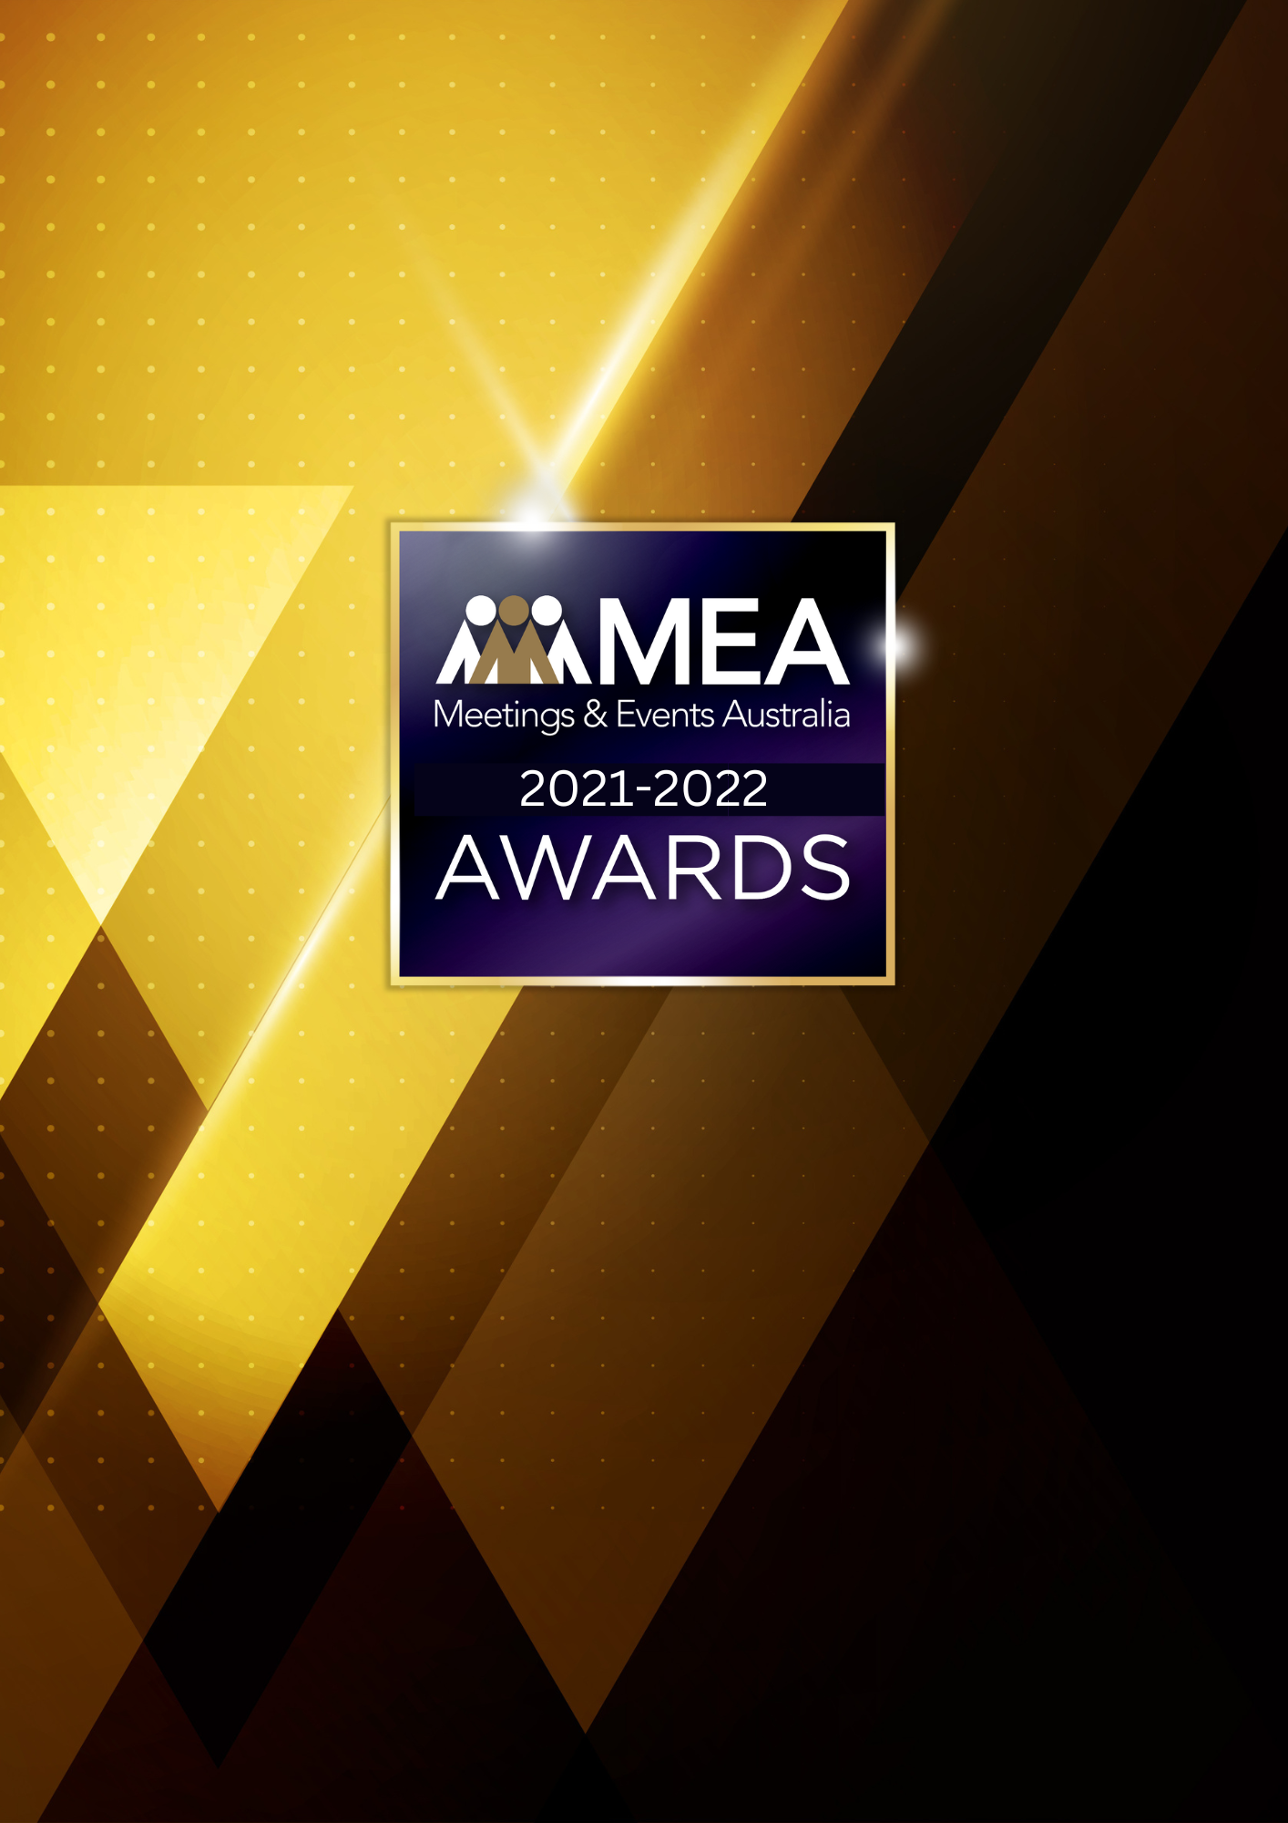

**CAUSE RELATED EVENT OF THE YEAR AWARD**

SUBMISSION FORM

**2021-2022 MEA AWARDS  
CAUSE RELATED EVENT OF THE YEAR AWARD**

**AWARD DESCRIPTION**

The Cause Related Event of the Year Award recognises the combined effort that is required to successfully plan, organise, and manage a fundraising or cause related event.

A cause related event is considered an event that is held with the direct purpose of raising awareness and/or raising funds for a charitable organisation or cause. This event can be a one-time or annual event. It can involve the team efforts of both a for-profit and not-for-profit organisation for the benefit of the charitable organisation.

The event must be considered significant through its multifaceted approach, in achieving objectives, through the imaginative use of resources, innovation and creativity.

If the event being submitted for this Award has been managed on behalf of an external client or organisation, the event owner must be made aware that a submission is being made and support the nomination.

**ARE YOU ELIGIBLE TO APPLY?**

If you are a special event management company, inbound tour operator, destination management company, event agency, PCO, production company or another supplier, you are eligible to apply.

The National Winner of this Award will be eligible for the MEA Platinum Event of the Year Award.

**GENERAL GUIDELINES**

Ensure that your submission is restricted to the qualifying period 1 January 2021 – 31 December 2022.

* Answer all the questions. There is a maximum word count for all answers that cannot be exceeded. After completing each question, indicate your word count.
* The examples provided are suggestions only that provide some guidance as to what the judges will be seeking. Do not simply answer each of these evidence types in order.
* If your evidence takes form in charts, video links or graphs, there is a separate area within the submission portal to add these. Videos must not be longer than 1-minute (60 seconds). Please indicate in your submission if you have included additional attachments outside of the form below.
* All applications must be made using the below submission form in either Microsoft Word or PDF format. No external or specialised branding may be used in lieu of this submission form.
* Judges’ feedback will be provided to applicants as soon as possible after the conclusion of the National Awards Ceremony.
* Judges will look for evidence that you are well organised, your business is well managed, how you have adapted during COVID-19 to future-proof your business, and that you have systems and procedures that are appropriate and well-maintained.

**2021-2022 MEA AWARDS  
CAUSE RELATED EVENT OF THE YEAR AWARD**

* Judges do not want details of your financial accounts, but rather are seeking to understand how your business has operated during the qualifying period.
* All applications must be submitted prior to **28 February 2023 at 11:59pm AEDT.**

**SCORING**

How your submission is weighted:

* Event Significance – 5%
* Financial Performance – 5%
* Sustainability – 5%
* Project Planning & Resource Management – 30%
* Challenges & Response – 30%
* Outcome & Evidence – 20%
* Final Statement – 5%

**2021-2022 MEA AWARDS  
CAUSE RELATED EVENT OF THE YEAR AWARD**

|  |
| --- |
| **NAME OF THE EVENT** |
| *Insert the name of your event in the blank space above. Please note, this will be the name displayed on all relevant marketing and trophies, should your application be successful.* |
| **NAME OF ORGANISATION** |
| *Insert the name of your organisation in the blank space above. Please note, this will be the name displayed on all relevant marketing and trophies, should your application be successful.* |

**EVENT PROFILE**

This section is not scored during judging but acts as an overview to provide context of your submission in the judging process.

**Maximum word count for this section: 600**

1. **OUTLINE THE MISSION STATEMENT FOR THE CHARITABLE ORGANISATION AND ITS OBJECTIVES.**
2. **PROVIDE AN OVERVIEW OF THE EVENT.**
3. **OUTLINE THE OBJECTIVES AND PURPOSE OF THE EVENT.**

*Examples could include but are not restricted to:*

* *Event history (if any)*
* *Expected outcomes*

**2021-2022 MEA AWARDS  
CAUSE RELATED EVENT OF THE YEAR AWARD**

1. **EVENT SIGNIFICANCE**

**Maximum word count for this section: 300**

**Detail the significance of the event and its impact.**

*Examples could include but are not restricted to:*

* *For the organisation/charity*
* *Stakeholders*
* *Social impact*
* *The wider public*

**2021-2022 MEA AWARDS  
CAUSE RELATED EVENT OF THE YEAR AWARD**

1. **FINANCIAL PERFORMANCE**

**Maximum word count for this section: 300**

**How did the event perform in a financial capacity?**

*Examples could include but are not restricted to:*

* *Budget forecast and actual results*
* *Profitability*
* *Increase in delegate attendance from previous event (if applicable)*
* *Increase in sponsorship/exhibition sales (if applicable)*

**2021-2022 MEA AWARDS  
CAUSE RELATED EVENT OF THE YEAR AWARD**

1. **SUSTAINABILITY**

**Maximum word count for this section: 300**

**Outline the sustainability policy and processes that you implement within your organisation.**

**2021-2022 MEA AWARDS  
CAUSE RELATED EVENT OF THE YEAR AWARD**

1. **PROJECT PLANNING & RESOURCE MANAGEMENT**

**Maximum word count for this section: 1,200**

**Provide insight into how you planned this project. Use examples.**

*Examples could include but are not restricted to:*

* *Engagement of contractors*
* *How your project plan adapted to the challenges of COVID-19*
* *How did you decide the composition of the project team?*
* *Identification of objectives*
* *Methods used in planning – both formal and informal*
* *Risk mitigation/crisis management*
* *The timeline, schedule, critical path or goal setting used*
* *Use of volunteers*
* *Who was involved*

**2021-2022 MEA AWARDS  
CAUSE RELATED EVENT OF THE YEAR AWARD**

1. **CHALLENGES & RESPONSE**

**Maximum word count for this section: 1,200**

**Demonstrate your use of creativity, originality, and innovation in managing challenges. Use up to 5 examples.**

*Examples could include but are not restricted to:*

* *Auction*
* *Budgeting*
* *Catering*
* *Committee management/liaison*
* *Donor fatigue*
* *Entertainment/MC*
* *Marketing/publicity*
* *Media support*
* *Ongoing client liaison*
* *Sponsorship*
* *Theming*
* *Ticketing*
* *Venue*

**2021-2022 MEA AWARDS  
CAUSE RELATED EVENT OF THE YEAR AWARD**

1. **OUTCOME & EVIDENCE**

**Maximum word count for this section: 900**

1. **How did the event increase community awareness of the cause and/or engagement with the cause?**
2. **Was the event successful? Provide your answer with measurable metrics.**

*Examples could include but are not restricted to:*

* *Client satisfaction*
* *Event budget*
* *Funds raised*
* *Guest numbers*
* *Guest satisfaction*
* *Media coverage*
* *Objectives met*
* *Ticket sales*

1. **Provide evidence of the host’s satisfaction. In addition to this, please upload one client/key supplier testimonial as a PDF to the submission portal.**

*Examples could include but are not restricted to:*

* *Legacies – see last page of this submission form*
* *Evidence of professional completion of all aspects of the project*
* *Relevant feedback received*
* *Opportunities for repeat business*

**2021-2022 MEA AWARDS  
CAUSE RELATED EVENT OF THE YEAR AWARD**

1. **FINAL STATEMENT**

**Maximum word count for this section: 300**

**Summarise your submission and let us know why you should win the 2021-2022 Cause Related Event of the Year Award.**

**2021-2022 MEA AWARDS  
CAUSE RELATED EVENT OF THE YEAR AWARD**

**OPTIONAL: EVENT LEGACY**

**MEA recognises the impact that events have on business, community, the local & Australian economy and on social outcomes.**

Each Award within the Event of the Year category includes an optional question on Event Legacy. There is no requirement to complete this question, as it does not add to your scoring for the Cause Related Event of the Year Award, and the legacy does not need to have occurred within the qualifying period. Event Legacy refers to an event that has a long-term positive impact on the host area, be this culturally, economically, or physically.

The below questions will be judged separately to go in the running for the specialised MEA Event Legacy Award. There is no additional fee associated with submitting an Award in this category if you have already submitted for an Event of the Year Award.

**QUESTIONS**

**Maximum word count for this section: 2,000**

1. What type of legacy did the event deliver?
2. Was the legacy planned from the outset, or did it arise by chance?
3. What was entailed in creating & delivering the legacy?
4. Did it meet ready approval by stakeholders, or were there challenges in getting them on board with the legacy objectives?
5. Were there any budgetary, time or personnel constraints?
6. Have any previous legacies been created?
7. What is the life expectancy of the legacy?
8. Did any difficulties arise in delivering the legacy and how were they overcome?
9. How was it measured?
10. What are the future outcomes from the legacy?