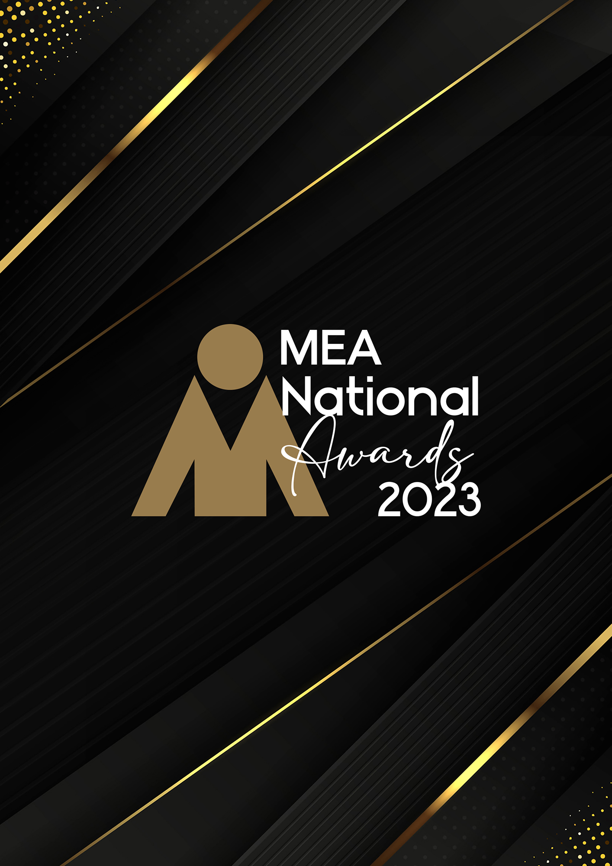

**MAJOR EVENT OR FESTIVAL**

**OF THE YEAR AWARD**

Submission Form

**AWARD DESCRIPTION**

The Major Event or Festival of the Year Award recognises the combined team effort that is required to successfully plan, organise, and manage a public event including major sporting events, and mass participation events and festivals, including but not limited to arts, cultural, technology, food and music festivals.

The event must be considered significant through its multifaceted approach, in achieving objectives, through the imaginative use of resources, innovation, and creativity.

Projects must have been completed in the qualifying period to be judged for this Award. Joint entries from the event “owner” or different parties involved in the organisation of this event such as production companies, exhibition organisers, event companies or other key suppliers are encouraged.

If the event being submitted for this Award has been managed on behalf of an external client or organisation, the event owner must be made aware that a submission is being made and support the nomination.

**ARE YOU ELIGIBLE TO APPLY?**

If you are an organisation working on the production and delivery of public events and festivals, you are eligible to apply.

This Award is open to organisers of public events or festivals which are not restricted by personal invitation of the event host; may involve the payment or fee for admission for the event, or for entertainment, or services provided at the event and are publicly advertised.

The National Winner of this Award will be eligible for the MEA Platinum Event of the Year Award.

**GENERAL GUIDELINES**

Ensure that your submission is restricted to the qualifying period 1 January 2023 – 31 December 2023.

* Answer all the questions. There is a maximum word count for all answers that cannot be exceeded. After completing each question, indicate your word count.
* The examples provided are suggestions only that provide some guidance as to what the judges will be seeking. Do not simply answer each of these evidence types in order.
* If your evidence takes form in charts, video links or graphs, there is a separate area within the submission portal to add these. Videos must not be longer than 1-minute (60 seconds). Please indicate in your submission if you have included additional attachments outside of the form below.
* All applications must be made using the below submission form in either Microsoft Word or PDF format. No external or specialised branding may be used in lieu of this submission form.
* Judges’ feedback will be provided to applicants as soon as possible after the conclusion of the National Awards Ceremony.
* Judges will look for evidence that you are well organised, your business is well managed, how you are future-proofing your business, and that you have systems and procedures that are appropriate and well-maintained.
* Judges do not want details of your financial accounts, but rather are seeking to understand how your business has operated during the qualifying period.

All applications must be submitted prior to **Monday 12 February 2024 at 11:59pm AEDT.**

**SCORING**

How your submission is weighted:

* Event Significance – 5%
* Financial Performance – 5%
* Sustainability – 5%
* Project Planning & Resource Management – 30%
* Challenges & Response – 30%
* Outcome & Evidence – 20%
* Final Statement – 5%

|  |  |
| --- | --- |
| **NAME OF THE EVENT** | |
| *Insert the name of your event in the blank space provided. Please note, this will be the name displayed on all relevant marketing and trophies, should your application be successful.* | Insert name here |
| **NAME OF ORGANISATION** | |
| *Insert the name of your organisation in the blank space provided. Please note, this will be the name displayed on all relevant marketing and trophies, should your application be successful.* | Insert name here |

**EVENT PROFILE**

This section is not scored during judging but acts as an overview to provide context of your submission in the judging process.

Maximum word count for this section: 600

1. **PROVIDE AN OVERVIEW OF THE EVENT**

Type response here. Space will expand.

1. **OUTLINE THE OBJECTIVES AND PURPOSE OF THE EVENT**

*Examples could include but are not restricted to:*

* *Event history (if any)*
* *Expected outcomes*

Type response here. Space will expand.

1. **EVENT SIGNIFICANCE**

Maximum word count for this section: 300

**Detail the significance of the event and its impact.**

*Examples could include but are not restricted to:*

* *The attendees*
* *The client*
* *The destination*
* *The events industry overall*
* *The major sponsors*
* *The parties involved in the organisation of the event*

Type response here. Space will expand.

1. **FINANCIAL PERFORMANCE**

Maximum word count for this section: 300

**How did the event perform in a financial capacity?**

*Examples could include but are not restricted to:*

* *Budget forecast and actual results*
* *Profitability*
* *Increase in visitor attendance from previous event*
* *Increase in sponsorship/exhibition sales*

Type response here. Space will expand.

1. **SUSTAINABILITY**

Maximum word count for this section: 300

**Outline the sustainability policy and processes that you implement within your organisation.**

Type response here. Space will expand.

1. **PROJECT PLANNING & RESOURCE MANAGEMENT**

Maximum word count for this section: 1,200

**Provide insight into how you planned this project. Use examples.**

*Examples could include but are not restricted to:*

* *Engagement of contractors*
* *Identification of objectives*
* *Methods used in planning – both formal and informal*
* *Risk mitigation/crisis management*
* *The timeline, schedule, critical path or goal setting used*
* *Who was involved*

Type response here. Space will expand.

1. **CHALLENGES & RESPONSE**

Maximum word count for this section: 1,200

**Demonstrate your use of creativity, originality, and innovation in managing challenges. Use up to 5 examples.**

*Examples could include but are not restricted to:*

* *Access and exit times*
* *Adverse weather*
* *Attracting and managing media*
* *Attracting and managing visitors*
* *Attracting sponsors and exhibitors*
* *Bidding*
* *Branding*
* *Budgeting*
* *Catering*
* *Crowd control*
* *Décor and signage*
* *Event design*
* *Ongoing client liaison*
* *Public safety*
* *Risk analysis*
* *Security*
* *Technology*
* *Ticketing*
* *Traffic management*
* *Venue liaison*
* *Visitor tracking*

Type response here. Space will expand.

1. **OUTCOME & EVIDENCE**

Maximum word count for this section: 900

1. **Was the event successful? Provide your answer with measurable metrics.**

*Examples could include but are not restricted to:*

* + *Visitor satisfaction*
  + *Client/sponsor satisfaction*
  + *Financials*
  + *Legacies created – refer to Event Legacy section on the last page of this form*
  + *Media coverage*
  + *Objectives met*
  + *Ticket sales*
  + *Visitor numbers*

Type response here. Space will expand.

1. **Provide evidence of the client/customer’s satisfaction. In addition to this, please upload one client/key supplier testimonial as a PDF to the submission portal.**

*Examples could include but are not restricted to:*

* + *Evidence of professional completion of all aspects of the project*
  + *Relevant feedback received (formal/informal)*
  + *Opportunities for repeat business (if applicable)*

Type response here. Space will expand.

1. **FINAL STATEMENT**

Maximum word count for this section: 300

**Summarise your submission and let us know why you should win the 2023 Major Event or Festival of the Year Award.**

Type response here. Space will expand.

**OPTIONAL: EVENT LEGACY**

**MEA recognises the impact that events have on business, community, the local & Australian economy and on social outcomes.**

Each Award within the Event of the Year category includes an optional question on Event Legacy. There is no requirement to complete this question, as it does not add to your scoring for the Major Event or Festival of the Year Award, and the legacy does not need to have occurred within the qualifying period. Event Legacy refers to an event that has a long-term positive impact on the host area, be this culturally, economically, or physically.

The below questions will be judged separately to go in the running for the specialised MEA Event Legacy Award. There is no additional fee associated with submitting an Award in this category if you have already submitted for an Event of the Year Award.

**QUESTIONS**

**Maximum word count for this section: 2,000**

1. What type of legacy did the event deliver?
2. Was the legacy planned from the outset, or did it arise by chance?
3. What was entailed in creating & delivering the legacy?
4. Did it meet ready approval by stakeholders, or were there challenges in getting them on board with the legacy objectives?
5. Were there any budgetary, time or personnel constraints?
6. Have any previous legacies been created?
7. What is the life expectancy of the legacy?
8. Did any difficulties arise in delivering the legacy and how were they overcome?
9. How was it measured?
10. What are the future outcomes from the legacy?

Type response here. Space will expand.