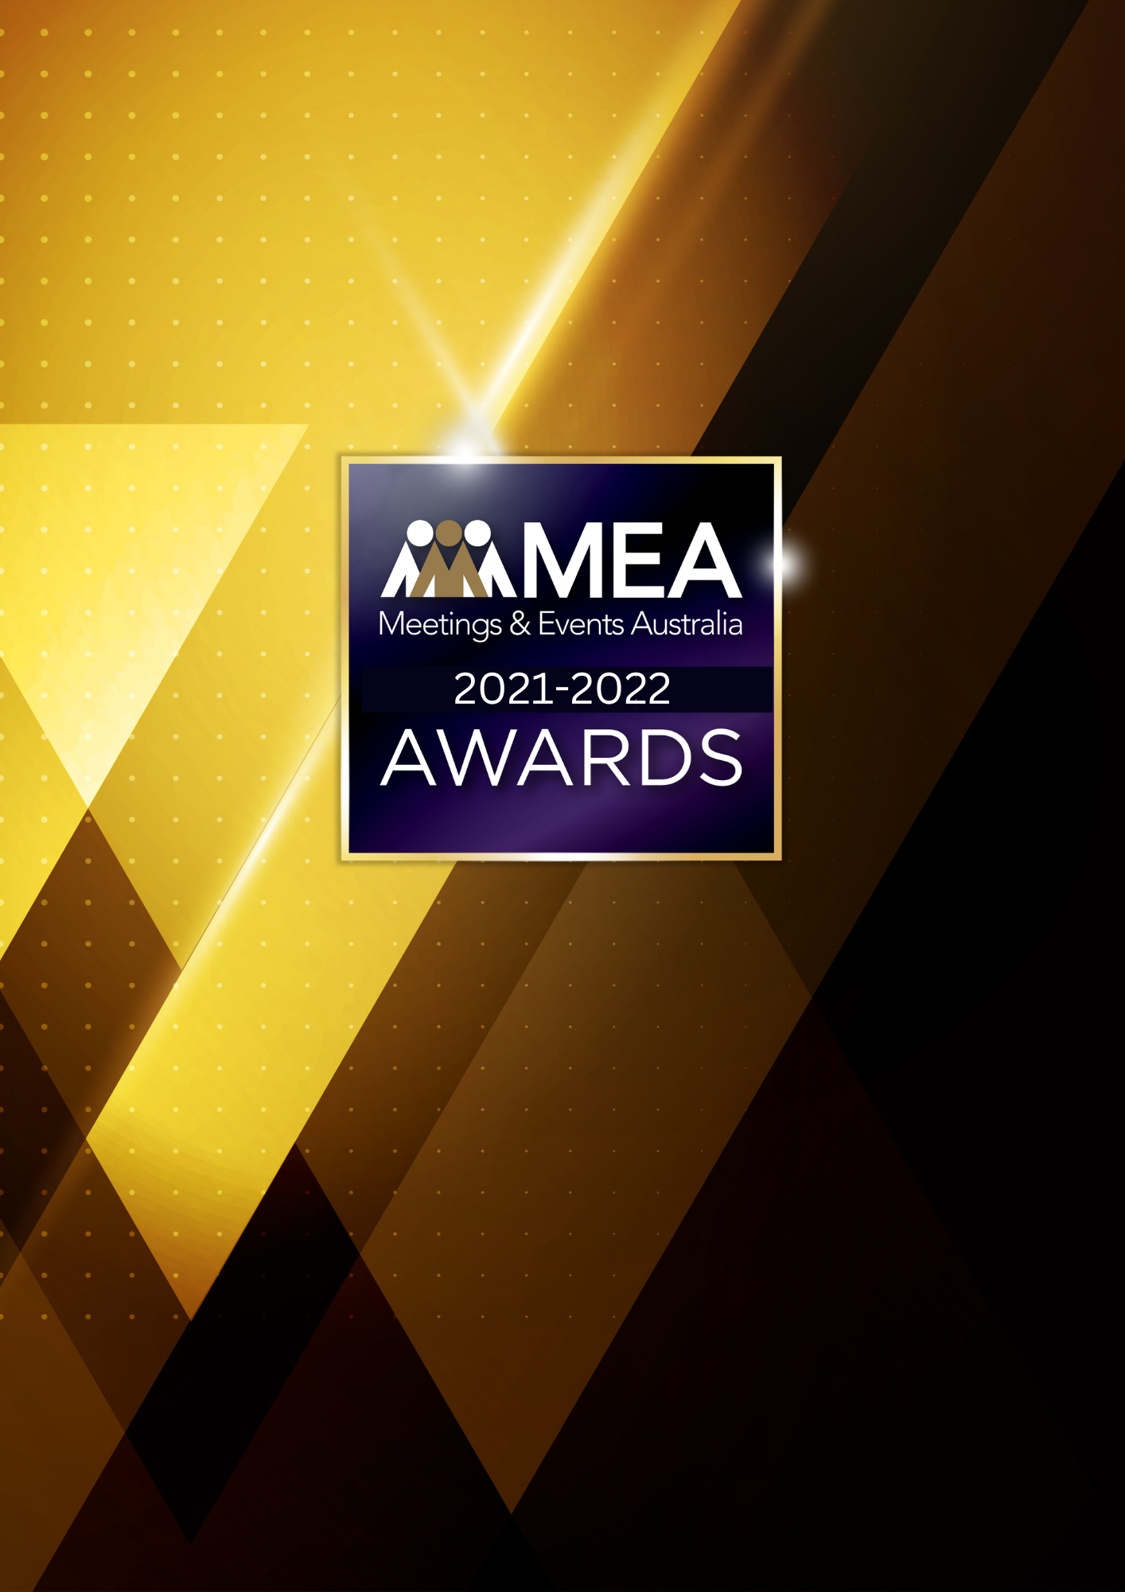
EVENT VENUE –
CAPACITY MORE THAN 1,000
SUBMISSION FORM
2021-2022 MEA AWARDS
EVENT VENUE – CAPACITY MORE THAN 1,000 AWARD
AWARD DESCRIPTION
The Event Venue – Capacity more than 1,000 Award recognises venues that have a capacity of more than 1,000 theatre-style and do not offer accommodation. There is no restriction on the number of function rooms or the maximum number of delegates that the venue can accommodate.
Submissions for this Award must be on behalf of a single venue and will not cover multiple venues for a group of companies.

ELIGIBILITY
This Award is open to event venues such as convention centres, function centres, university campuses, sporting stadiums, arenas, museums, art galleries, libraries, casinos, and cruise vessels where the largest event space has a capacity of more than 1,000 theatre-style.
Excludes: Hotels with meeting facilities.
The National Winner of the Award will be eligible for MEA’s 2021-2022 Company of the Year Platinum Award.

GENERAL GUIDELINES
Ensure that your submission is restricted to the qualifying period 1 January 2021 – 31 December 2022.
- Answer all the questions. There is a maximum word count for all answers that cannot be exceeded. After completing each question, indicate your word count.
- The examples provided are suggestions only that provide some guidance as to what the judges will be seeking. Do not simply answer each of these evidence types in order.
- If your evidence takes form in charts, video links or graphs, there is a separate area within the submission portal to add these. Videos must not be longer than 1-minute (60 seconds). Please indicate in your submission if you have included additional attachments outside of the form below.
- All applications must be made using the below submission form in either Microsoft Word or PDF format. No external or specialised branding may be used in lieu of this submission form.
- Judges’ feedback will be provided to applicants as soon as possible after the conclusion of the National Awards Ceremony.
- Judges will look for evidence that you are well organised, your business is well managed, how you have adapted during COVID-19 to future-proof your business, and that you have systems and procedures that are appropriate and well-maintained.
- Judges do not want details of your financial accounts, but rather are seeking to understand how your business has operated during the qualifying period.
- All applications must be submitted prior to 28 February 2023 at 11:59pm AEDT.

2021-2022 MEA AWARDS
EVENT VENUE – CAPACITY MORE THAN 1,000 AWARD
SCORING
How your submission is weighted:
- Business Planning & Resource Management – 20%
- Event Planning, Operations & Client Management – 30%
- Challenges & Responses – 20%
- Outcome & Evidence – 15%
- Contribution to the Industry – 5%
- Sustainability – 5%
- Final Statement – 5%

2021-2022 MEA AWARDS
EVENT VENUE – CAPACITY MORE THAN 1,000 AWARD

NAME OF VENUE
Insert the venue’s name in the blank space above. Please note, this will be the name displayed on all relevant marketing and trophies, should your application be successful.

BUSINESS PROFILE
This section is not scored during judging but acts as an overview to provide context of your submission in the judging process.
Maximum word count for this section: 600

- PROVIDE A GENERAL DESCRIPTION OF YOUR ORGANISATION AS IT RELATES TO EVENTS:
Examples could include but are not restricted to:
- Capacity of the venue for meetings
- Diversity of clients serviced, and any special cultural training undertaken by staff
- Location
- Number, size and range of events
- Range and diversity of projects undertaken
- Special considerations/services provided to events
- Types of products and services

- PROVIDE INSIGHT INTO THE VENUE’S HISTORY OF INVOLVMENT IN THE EVENTS INDUSTRY:
Examples could include but are not restricted to:
- Target markets
- Years of operation

- DESCRIBE THE VENUE’S ORGANISATIONAL STRUCTURE, AS IT RELATES TO EVENTS:
Examples could include but are not restricted to:
- Extent of outsourcing
- Number of employees
- Number and type of relevant internal departments
2021-2022 MEA AWARDS
EVENT VENUE – CAPACITY MORE THAN 1,000 AWARD
- BUSINESS PLANNING & RESOURCE MANAGEMENT
Maximum word count for this section: 900

- Describe your business planning review process.

Examples could include but are not restricted to:
- How it is communicated to your team/organisation
- How often you review your business plan
- How you measure progress and performance
- How you structure the planning process (e.g. brainstorming workshops)
- Procedures created in response to COVID-19
- Timeline/schedule
- Tools used (e.g. SWOT analysis)
- Who is involved (e.g. staff and/or external consultants)

- Describe the ways you manage resources and staff to achieve the most effective outcomes over the qualifying period.

Examples could include but are not restricted to:
- Career pathing/succession planning
- Communication strategies
- How staff are consulted and involved
- Other resources that could include technology, specialist equipment or contractors and consultants
- Reward schemes
- Staff appraisals

2021-2022 MEA AWARDS
EVENT VENUE – CAPACITY MORE THAN 1,000 AWARD
- EVENT PLANNING, OPERATIONS & CLIENT MANAGEMENT
Maximum word count for this section: 1,200

- Provide insight into how you manage your clients.

Examples could include but are not restricted to:
- Budgeting and financial management
- Methods used in planning, both formal and informal
- Risk mitigation/crisis management
- Timeline/schedule/critical path/goal setting
- Understanding your clients and their objectives

- Describe how you plan and deliver events within your venue.

Examples could include but are not restricted to:
- Management software
- Managing customer service including registration
- Managing risk and safety
- Resourcing and approach to roles and activities
- Staff briefing
- Systems and processes

2021-2022 MEA AWARDS
EVENT VENUE – CAPACITY MORE THAN 1,000 AWARD
- CHALLENGES & RESPONSES
Maximum word count for this section: 900

Demonstrate your use of creativity, originality and innovation in managing challenges. Use up to 5 examples.

Examples could include but are not restricted to:
- Attracting new business
- Bidding
- Budget and time constraints
- Capital expenditure
- Client retention
- Competition/Competitor activity
- Fluctuation in demand and supply
- How you adjusted your products or services in response to COVID-19
- Level of services; how did the team go above and beyond in the delivery of service
- Marketing and brand awareness
- Staff retention, career pathing/succession planning
- What other innovative solutions did your venue achieve in the face of COVID-19 challenges?
- What technology was adopted during periods of restrictions or in-person events?

2021-2022 MEA AWARDS
EVENT VENUE – CAPACITY MORE THAN 1,000 AWARD
- OUTCOME & EVIDENCE
Maximum word count for this section: 600

- Share some of your staff’s achievements during the qualifying period.

Examples could include but are not restricted to:
- Awards (corporate, team and individual)
- Financial success
- Improved management/staff relationships
- Repeat business
- Staff retention rates
- Successful staff initiatives
- Succession planning
- Winning new business

- Provide evidence of your client/customer satisfaction. In addition to this, please upload one client/key supplier testimonial as a PDF to the submission portal.

Examples could include but are not restricted to:
- Increased client referrals
- Feedback from a specific event
- Business from media exposure
- Improvements in marketing outcomes

2021-2022 MEA AWARDS
EVENT VENUE – CAPACITY MORE THAN 1,000 AWARD
- CONTRIBUTION TO THE INDUSTRY
Maximum word count for this section: 300

Describe how your activities have contributed to the growth and professionalism of the business events industry overall.

Provide evidence for contributions within MEA and other industry organisations during the qualifying period, such as:
- Global partnerships/memberships
- Involvement in industry panels or committees
- Involvement with your local destination marketing organisation/tourism office
- Mentoring
- Participation in industry forums or focus groups
- Presentations at industry briefings, workshops, webinars, conferences (physical or virtual)
- Published articles/columns in industry publications

2021-2022 MEA AWARDS
EVENT VENUE – CAPACITY MORE THAN 1,000 AWARD
- SUSTAINABILITY
Maximum word count for this section: 300

Outline the sustainability policy that you implement within your organisation.

2021-2022 MEA AWARDS
EVENT VENUE – CAPACITY MORE THAN 1,000 AWARD
- FINAL STATEMENT
Maximum word count for this section: 300

Summarise your submission and let us know why you should win the 2021-2022 Event Venue – Capacity more than 1,000 Award.

