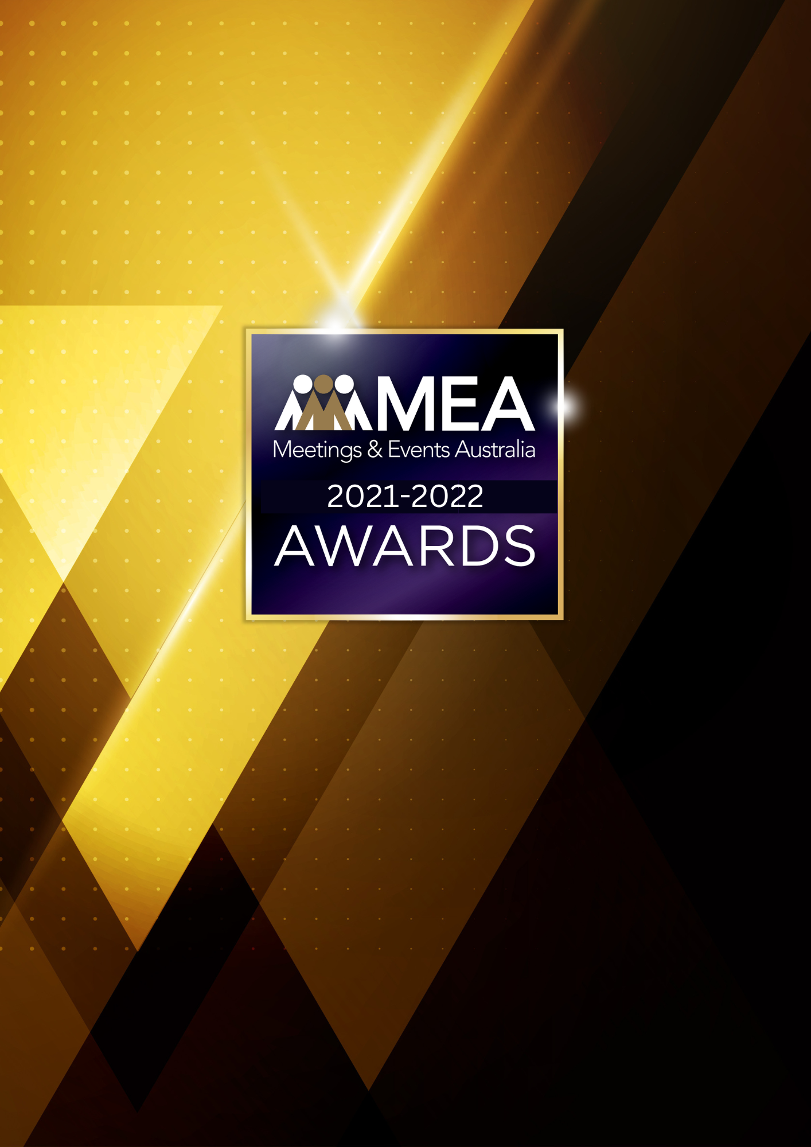

**EVENT TECHNOLOGY AWARD**

SUBMISSION FORM

**2021-2022 MEA AWARDS  
EVENT TECHNOLOGY AWARD**

**AWARD DESCRIPTION**

The Event Technology Award recognises the importance of technologies through the events industry, reliance on those technologies, their complexity and rapid adaption during the qualifying period with the impact of COVID-19.

**ELIGIBILITY**

This Award is open to those who provide event technology for the planning, staging, operation and management of events.

This includes event platforms, event management software and apps. It also includes technology or platforms for exhibitions but does not extend to configuration of the exhibition.

This Award excludes Audio Visual Services.

This Award will recognise the company as the recipient of the Award.

The National Winner of the Award will be eligible for MEA’s 2021-2022 Company of the Year Platinum Award.

**GENERAL GUIDELINES**

Ensure that your submission is restricted to the qualifying period 1 January 2021 – 31 December 2022.

* Answer all the questions. There is a maximum word count for all answers that cannot be exceeded. After completing each question, indicate your word count.
* The examples provided are suggestions only that provide some guidance as to what the judges will be seeking. Do not simply answer each of these evidence types in order.
* If your evidence takes form in charts, video links or graphs, there is a separate area within the submission portal to add these. Videos must not be longer than 1-minute (60 seconds). Please indicate in your submission if you have included additional attachments outside of the form below.
* All applications must be made using the below submission form in either Microsoft Word or PDF format. No external or specialised branding may be used in lieu of this submission form.
* Judges’ feedback will be provided to applicants as soon as possible after the conclusion of the National Awards Ceremony.
* Judges will look for evidence that you are well organised, your business is well managed, how you have adapted during COVID-19 to future-proof your business, and that you have systems and procedures that are appropriate and well-maintained.
* Judges do not want details of your financial accounts, but rather are seeking to understand how your business has operated during the qualifying period.
* All applications must be submitted prior to **28 February 2023 at 11:59pm AEDT**.

**2021-2022 MEA AWARDS  
EVENT TECHNOLOGY AWARD**

**SCORING**

How your submission is weighted:

* Business Planning & Resource Management – 30%
* Challenges & Responses – 40%
* Outcome & Evidence – 15%
* Contribution to the Industry – 5%
* Sustainability – 5%
* Final Statement – 5%

**2021-2022 MEA AWARDS  
EVENT TECHNOLOGY AWARD**

|  |
| --- |
| **NAME OF COMPANY** |
| *Insert the company’s name in the blank space above. Please note, this will be the name displayed on all relevant marketing and trophies, should your application be successful.* |

**BUSINESS PROFILE**

This section is not scored during judging but acts as an overview to provide context of your submission in the judging process.

**Maximum word count for this section: 600**

1. **PROVIDE A GENERAL DESCRIPTION OF YOUR BUSINESS:**

*Examples could include but are not restricted to:*

* *App solutions*
* *Interpreting systems*
* *New technology*
* *Presentation technologies*
* *Registration services*
* *Technology solutions for scientific meetings*
* *Tracking systems/beacons*
* *Voting systems*

1. **WHAT IS YOUR ORGANISATION’S HISTORY OF INVOLVEMENT IN THE EVENTS INDUSTRY:**

*Examples could include but are not restricted to:*

* *Growth year on year*
* *Years of operation*

1. **WHAT IS YOUR ORGANISATIONAL STRUCTURE, AS IT RELATES TO EVENTS:**

*Examples could include but are not restricted to:*

* *Number of employees*
* *Organisational chart (please attach in submission portal as a PDF)*
* *The number and type of internal departments*

**2021-2022 MEA AWARDS  
EVENT TECHNOLOGY AWARD**

1. **BUSINESS PLANNING & RESOURCE MANAGEMENT**

**Maximum word count for this section: 1,200**

1. **Describe your business planning process undertaken in the qualifying period.**

*Examples could include but are not restricted to:*

* *How it is communicated to your team/organisation*
* *How often you review your business plan*
* *How you measure progress and performance*
* *How you structure the planning process (e.g. brainstorming workshops)*
* *Procedures created in response to COVID-19*
* *Timeline/schedule*
* *Tools used (e.g. SWOT analysis)*
* *Who is involved (e.g. staff and/or external consultants)*

1. **Describe the ways you manage resources and staff to achieve the most effective outcomes over the qualifying period.**

*Examples could include but are not restricted to:*

* *Career pathing/succession planning*
* *Communication strategies*
* *How staff are consulted and involved*
* *Other resources that could include technology, specialist equipment or contractors and consultants*
* *Reward schemes*
* *Staff appraisals*

**2021-2022 MEA AWARDS  
EVENT TECHNOLOGY AWARD**

1. **CHALLENGES & RESPONSES**

**Maximum word count for this section: 1,200**

**Demonstrate your use of creativity, originality and innovation in managing challenges. Use up to 5 examples.**

*Examples could include but are not restricted to:*

* *Budgetary restraints*
* *Capital raising/expenditure*
* *Competition/competitor activity*
* *Gaining market acceptance*
* *How you adjusted your products or services in response to COVID-19*
* *Keeping abreast of changing technology*
* *Marketing and brand awareness*
* *Retaining and attracting business*
* *Staff retention, career pathing/succession planning*
* *Technology testing/adoption*

**2021-2022 MEA AWARDS  
EVENT TECHNOLOGY AWARD**

1. **OUTCOME & EVIDENCE**

**Maximum word count for this section: 600**

1. **Share some of your organisation’s achievements during the qualifying period.**

*Examples could include but are not restricted to:*

* *Achievement of sales targets*
* *Awards (corporate, team or individual)*
* *Business won and retained*
* *Crisis management*
* *Feedback from a specific event*
* *Financial success*
* *Improved management/staff relationships*
* *Increased number of client referrals*
* *Licensing agreements*
* *Staff retention rates*
* *Successful staff initiatives*

1. **Provide evidence of your client/customer satisfaction. In addition to this, please upload one client/key supplier testimonial as a PDF to the submission portal.**

*Examples could include but are not restricted to:*

* *How your service helped achieve client objectives*
* *Media exposure*

**2021-2022 MEA AWARDS  
EVENT TECHNOLOGY AWARD**

1. **CONTRIBUTION TO THE INDUSTRY**

**Maximum word count for this section: 300**

**Describe how your activities have contributed to the growth and professionalism of the events industry overall.**

*Provide evidence for contributions within MEA and other industry organisations during the qualifying period, such as:*

* *Contribution to trade magazines/online forums*
* *Global partnerships/memberships*
* *Involvement in industry panels or committees*
* *Involvement with your local destination marketing organisation*
* *Mentoring*
* *Participation in industry forums or focus groups*
* *Presentations at industry briefings, webinars, conferences (physical or virtual)*

**2021-2022 MEA AWARDS  
EVENT TECHNOLOGY AWARD**

1. **SUSTAINABILITY**

**Maximum word count for this section: 300**

**Outline the sustainability policy that you implement within your organisation.**

**2021-2022 MEA AWARDS  
EVENT TECHNOLOGY AWARD**

1. **FINAL STATEMENT**

**Maximum word count for this section: 300**

**Summarise your submission and let us know why you should win the 2021-2022 Event Technology Award.**